**Audit Course Task 1**

**Name : Swapnil Titkare**

**Roll No : 19102A0004**

**Branch : CMPN A**

**Project Name :** Rudra Travels (Travel website)

|  |  |
| --- | --- |
| Front End Tools | HTML 5, CSS3 |
| Project Leader | Swapnil Titkare |
| Project Language | English |
| Reference sites | [www.w3schools.com](http://www.w3schools.com) |
| Github Repository Link | https://github.com/swapniltitkare/travel-website |

**Project Description :** Rudra Travels is a business of Travels. The whole motive of this project is to create responsive website which helps customer to easily book trips, journey etc. The project is a part of Audit Course in which I have create this website using HTML and CSS only. I have attached some screenshots of my website below.

**Screenshots:**

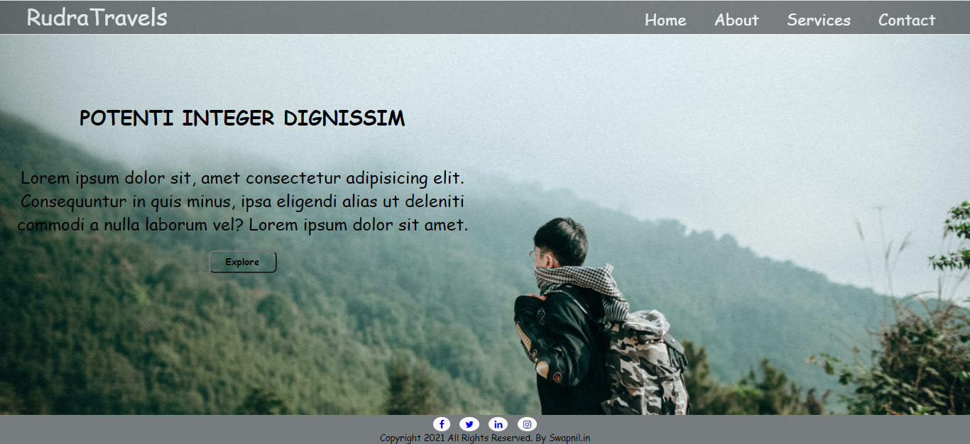

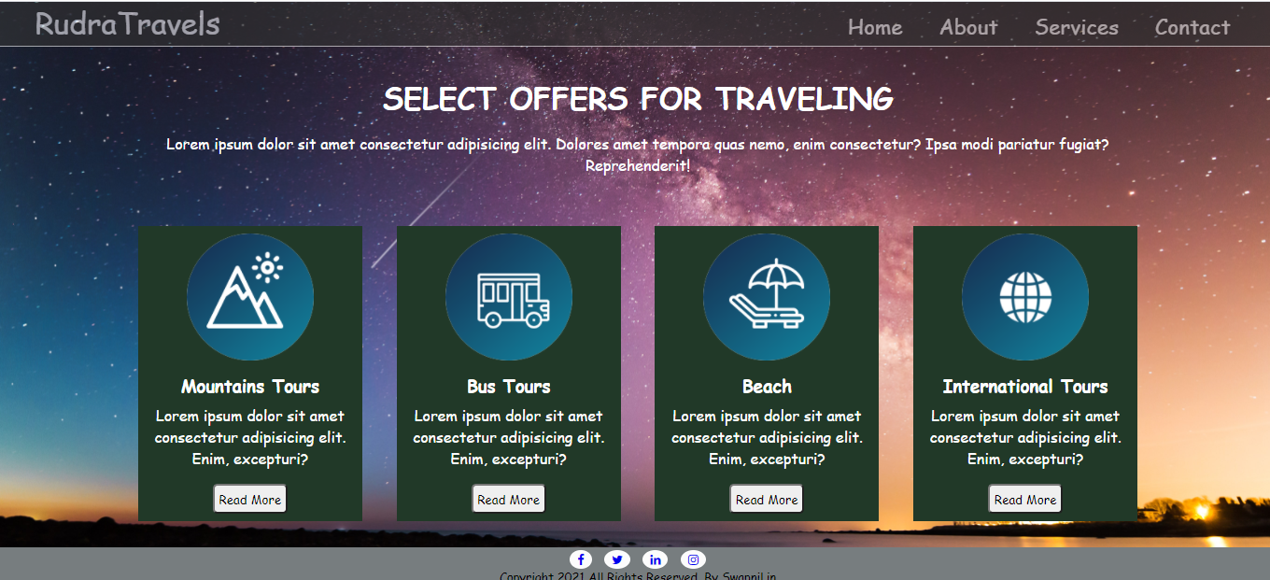

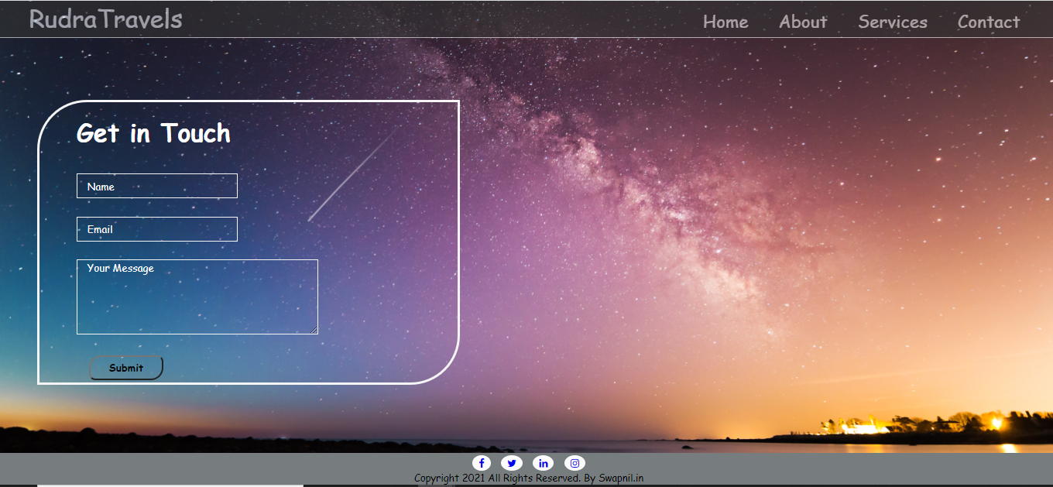

Github Repository Link : https://github.com/swapniltitkare/travel-website