SET 1   
FIELDS of table

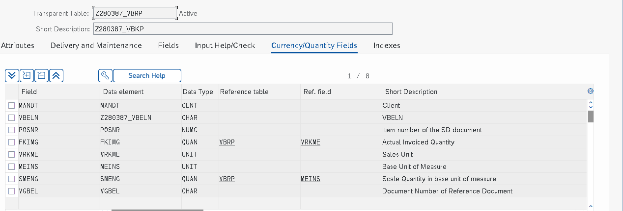  
TMG NEW ENTRIES  
