**Students Directory**

1. Participants List

URL - <http://localhost:8080/sms_app/student/list>

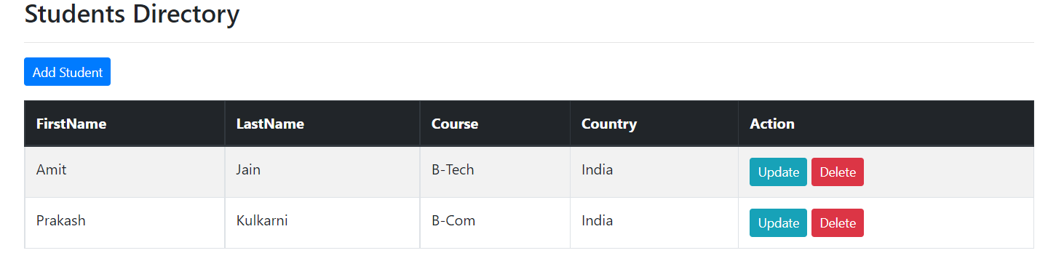

2. Participants details update

URL - <http://localhost:8080/sms_app/student/showFormForUpdate?studentId=1>

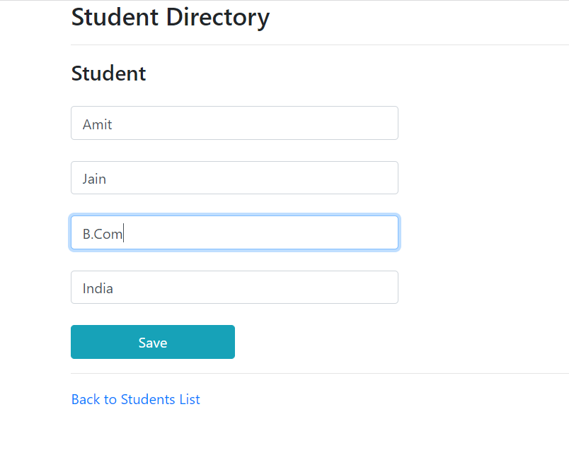

3. Updated Details

URL - <http://localhost:8080/sms_app/student/list>

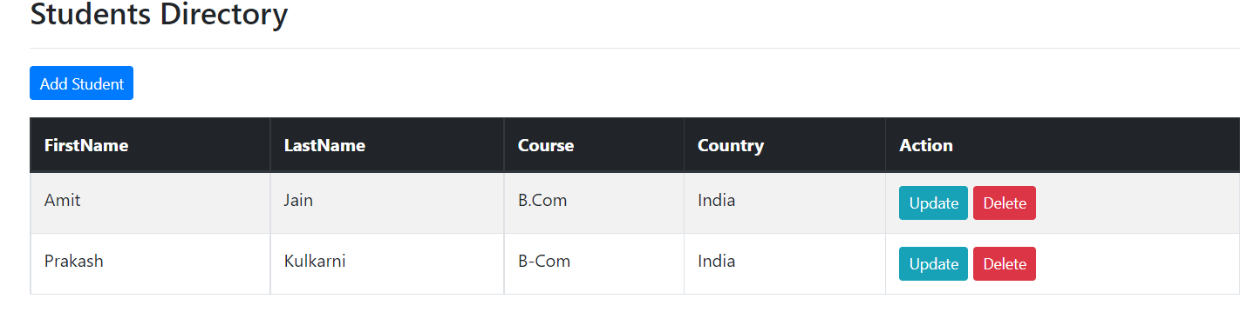

1. Delete Participant - Amit

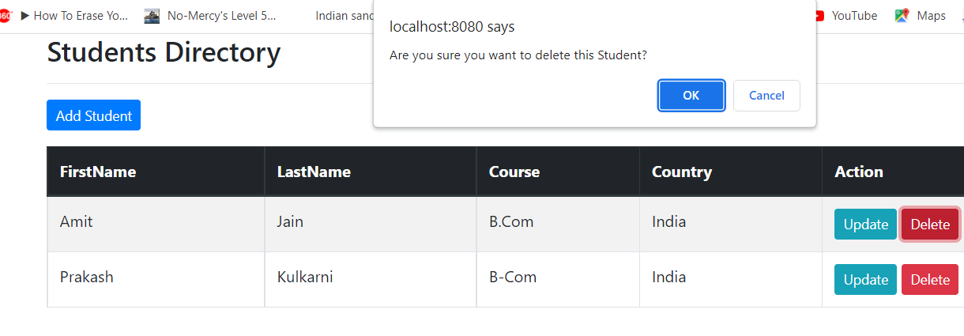

1. After delete Amit Jain

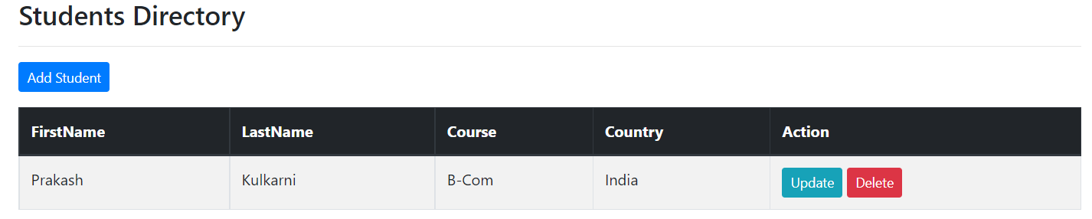

1. Add Participants

<http://localhost:8080/sms_app/student/showFormForAdd>

Student Data entry-form

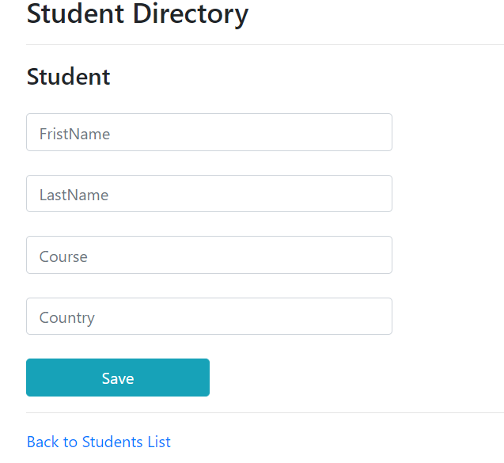

Required Fields filling

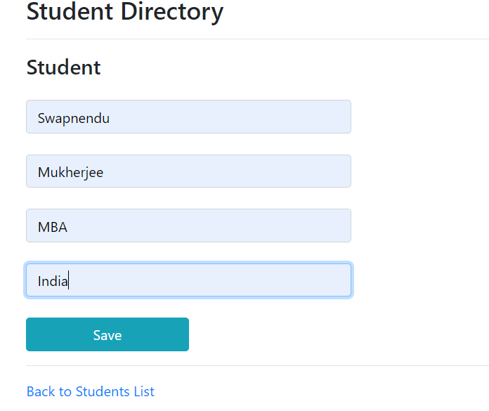

1. Student details after adding a participant

