Customer Relationship Management

Home Page URL: <http://localhost:8080/CustomerRelationshipManagement/customer/list>

1. While there is no data in DataBase.

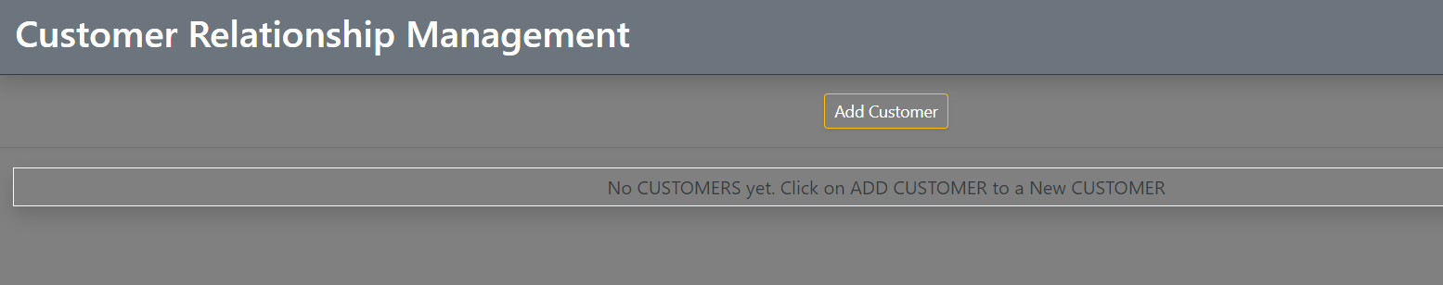

1. Adding Customer Details - Swapnendu

URL: <http://localhost:8080/CustomerRelationshipManagement/customer/showFormForAdd>

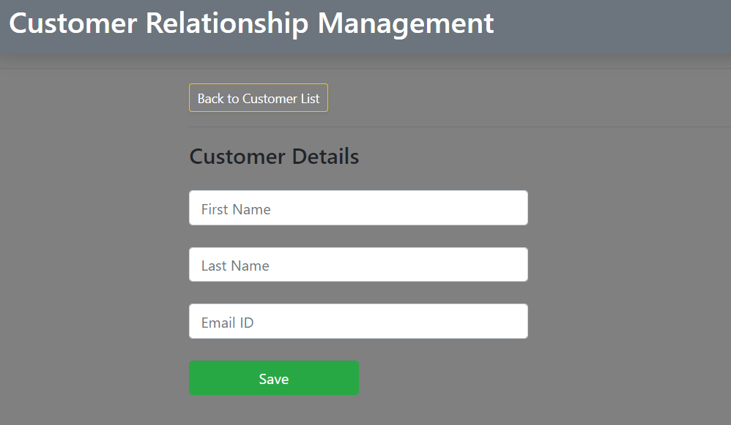

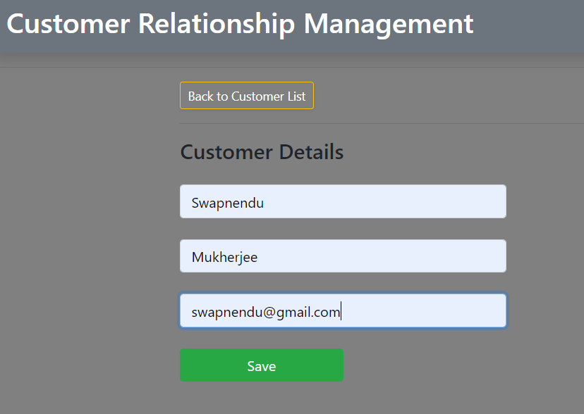

1. After adding Customer Details

URL: <http://localhost:8080/CustomerRelationshipManagement/customer/list>

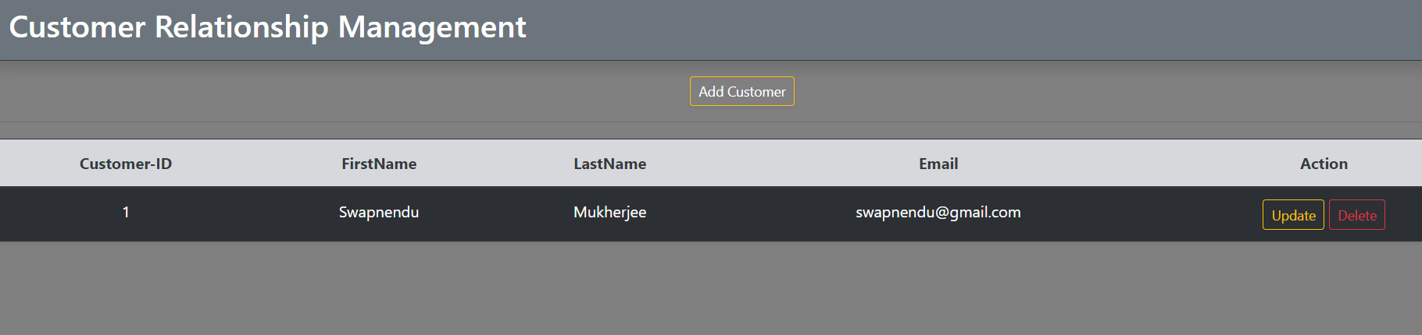

1. Database Screenshot after adding Swapnendu

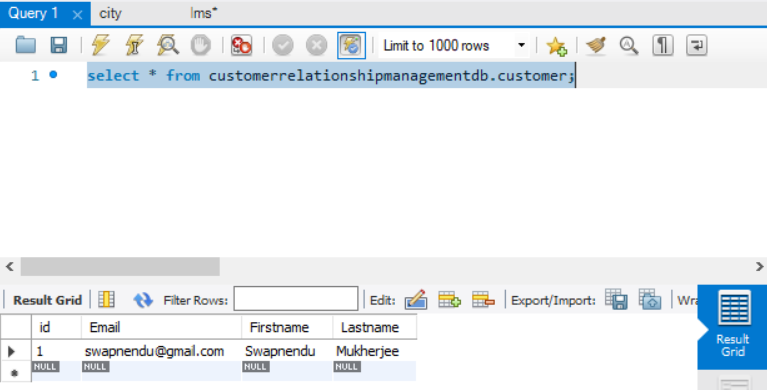

1. Updating Customer Details: Email from [swapnendu@gmail.com](mailto:swapnendu@gmail.com) to [swapnendu22@gmail.com](mailto:swapnendu22@gmail.com)

URL: <http://localhost:8080/CustomerRelationshipManagement/customer/showFormForUpdate?customerId=1>

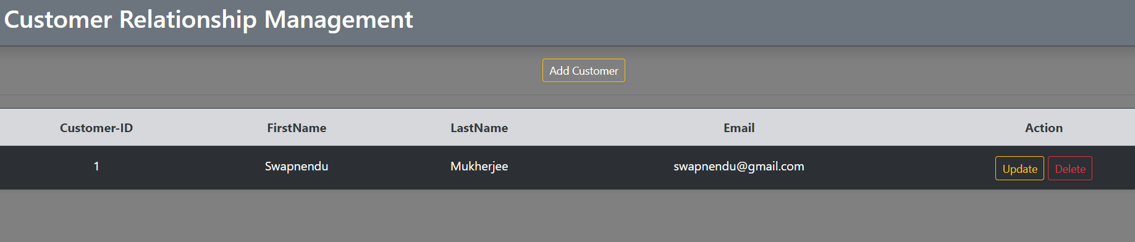

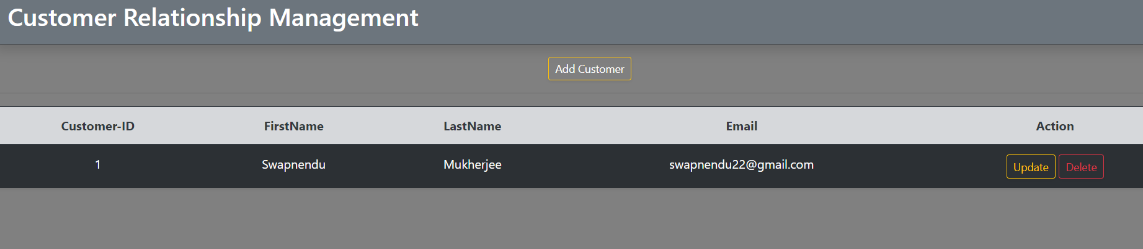

1. Deleting Customer Details - Swapnendu

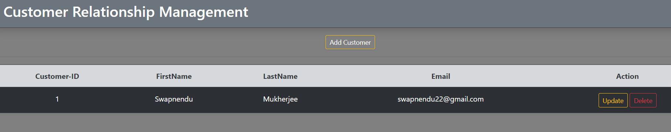

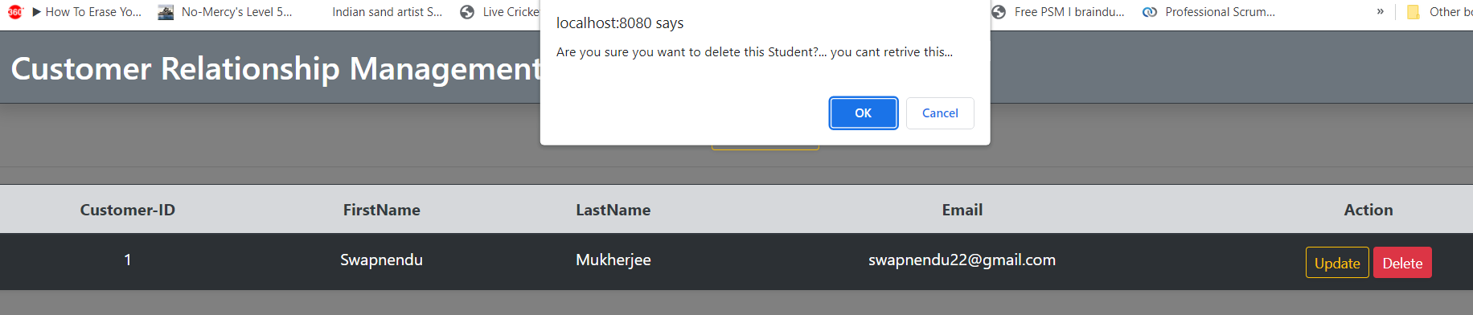

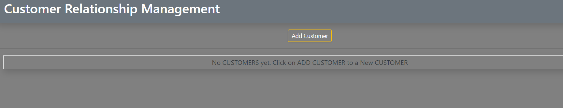

1. Adding a new Customer from DataBase - Pranav S

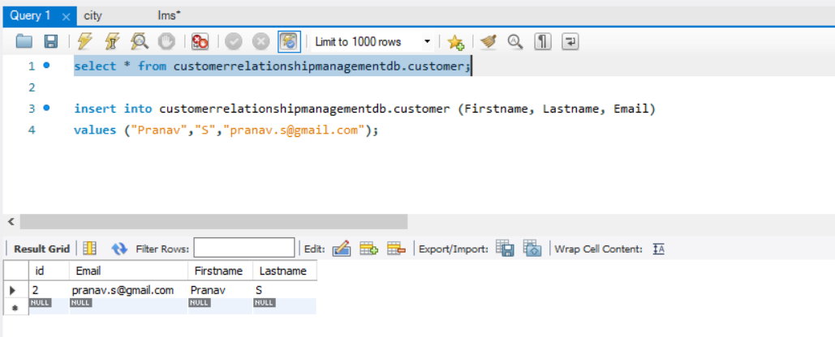

After adding new Customer “Pranav” from Database

URL : <http://localhost:8080/CustomerRelationshipManagement/customer/list>

