YOUTUBE TRENDING DATA PIPELINE
A Serverless AWS Data Engineering Project
Medallion Architecture (Bronze → Silver → Gold) using Lambda, Glue, Step Functions & Athena

Project Report & Study Guide
Prepared for personal revision & documentation
AWS Region: us-east-1 | Environment: dev

Table of Contents
Click any line to jump to that section (works in Word, Word Online, and Google Docs after upload).
1. Introduction & Objective
1.1 Goals
2. Solution Architecture
2.1 Medallion Data Lake Design
3. End-to-End Step-by-Step Walkthrough
4. AWS Services Used — Reference & Deep Dive
4.1 AWS Step Functions
4.2 AWS Lambda
4.3 AWS Glue
4.4 Amazon S3
4.5 Amazon Athena
4.6 Amazon CloudWatch
4.7 Amazon SNS (Simple Notification Service)
4.8 AWS IAM (Identity and Access Management)
5. S3 Bucket Structure
5.1 Buckets Created by Me
5.2 Bronze Layer Partitioning
6. IAM Roles & Policies
6.1 Glue Role — yt-data-pipeline-glue-role-dev
6.2 Lambda Role — yt-data-pipeline-lambda-role-dev
6.3 Step Functions Role — yt-data-pipeline-stepfunctions-dev
7. Orchestration — AWS Step Functions State Machine Detail
7.1 Key Design Choices
7.2 Definition Excerpt — Quality Gate
8. AWS Lambda Functions — Code Detail
8.1 yt-data-pipeline-youtube-ingestion-dev
8.2 yt-data-pipeline-json-to-parquet-dev
8.3 yt-data-pipeline-data-quality-dev
9. AWS Glue ETL Jobs — Code Detail
9.1 yt-data-pipeline-bronze-to-silver-dev
9.2 yt-data-pipeline-silver-gold-dev
10. Monitoring, Alerting & Querying
10.1 CloudWatch
10.2 SNS Alerts — yt-data-pipeline-alerts-dev
10.3 Amazon Athena
11. Key Improvements Over the Original Approach
12. Conclusion

1. Introduction & Objective
This project implements an end-to-end, serverless data pipeline on AWS that ingests trending video data from the YouTube Data API v3, processes it through a Bronze → Silver → Gold medallion architecture, and produces analytics-ready aggregated tables queryable through Amazon Athena. The pipeline is fully orchestrated by AWS Step Functions, is idempotent, incremental, and includes automated data quality gates and failure alerting.
The original approach relied on a static Kaggle CSV dataset and manual execution of individual scripts. This implementation replaces that with a live, automated, and production-style pipeline built on managed AWS services, designed to run on a schedule without manual intervention.

1.1 Goals
- Automate ingestion of live trending-video data for multiple regions.
- Apply a medallion (Bronze/Silver/Gold) architecture for progressive data refinement.
- Enforce schema, perform deduplication, and validate data quality before promoting data to Gold.
- Orchestrate every step with AWS Step Functions, including parallel branches, retries, and error handling.
- Expose curated Gold tables for ad-hoc analysis via Amazon Athena.
- Alert on any pipeline failure or data quality violation via Amazon SNS.
- Apply least-privilege IAM roles scoped per service (Glue, Lambda, Step Functions).

2. Solution Architecture
The diagram below shows the complete pipeline: ingestion from the YouTube API, orchestration via Step Functions, the compute layer (Lambda + Glue + Athena), the S3-based data lake, and the governance/monitoring layer (IAM, Glue Data Catalog, CloudWatch, SNS).
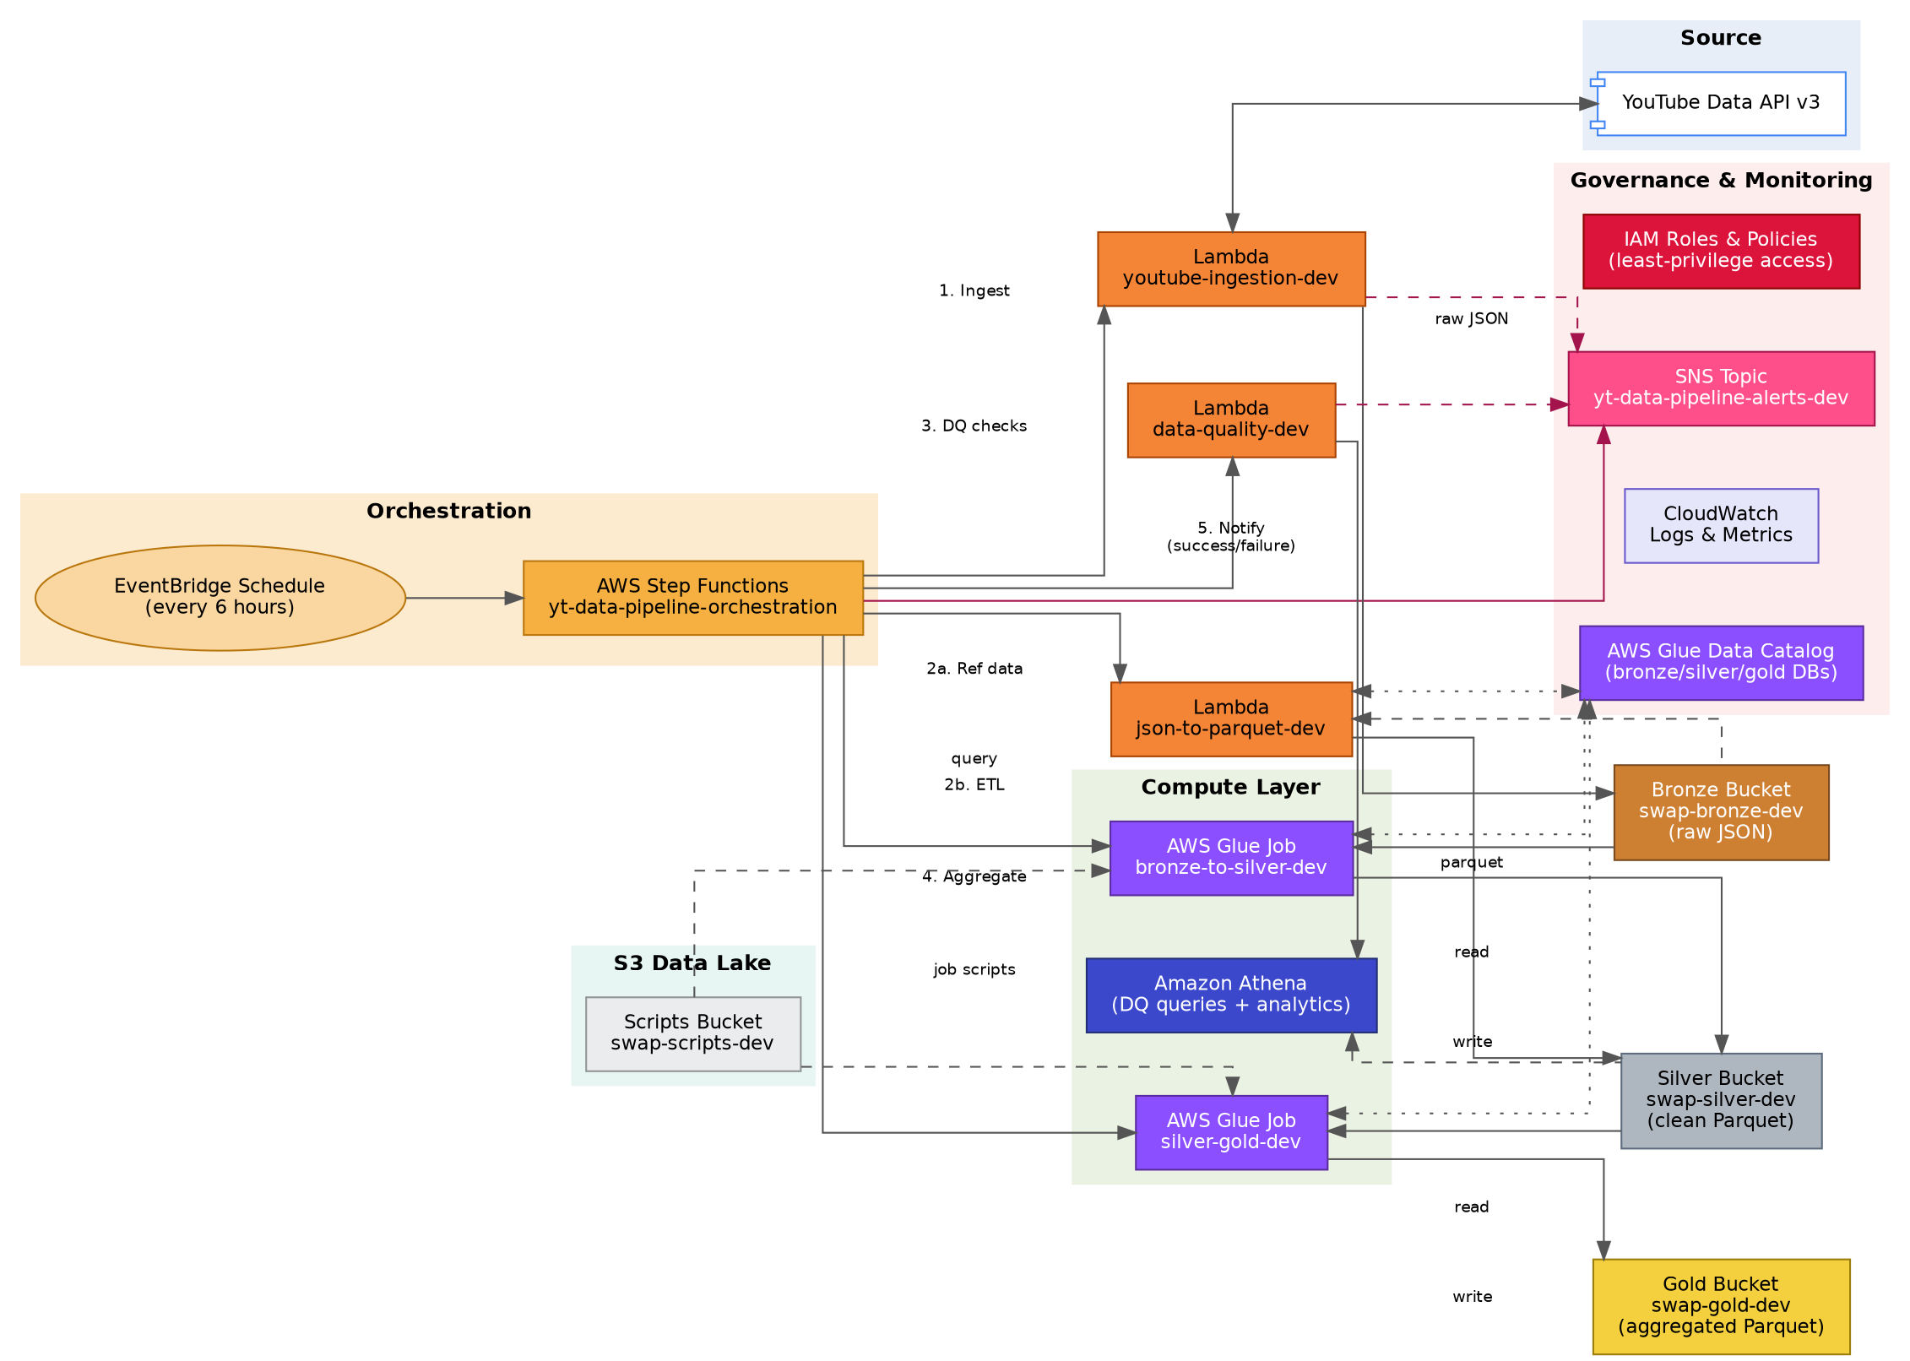
Figure 1 – End-to-end pipeline architecture

2.1 Medallion Data Lake Design
Raw data lands untouched in Bronze, is cleansed and standardized in Silver, and is aggregated into business-ready analytics tables in Gold. This layered approach is a widely used data-lake pattern because it lets you re-run any downstream stage without re-fetching source data, keeps a full audit trail of the original raw payloads, and lets each stage optimize for a different consumer (raw for reprocessing, clean for general use, aggregated for BI).
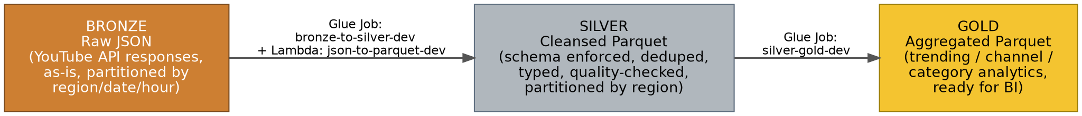
Figure 2 – Bronze / Silver / Gold data flow

3. End-to-End Step-by-Step Walkthrough
This section walks through exactly what happens on every scheduled pipeline run, in execution order, so you can trace a single run from trigger to notification. Each step names the AWS service responsible, its inputs/outputs, and how failures are handled.
STEP 1 — Scheduled Trigger
An Amazon EventBridge rule fires on a fixed schedule (every 6 hours) and starts a new execution of the yt-data-pipeline-orchestration Step Functions state machine.
- Service: Amazon EventBridge → AWS Step Functions.
- Why scheduled rather than manual: guarantees fresh trending data lands automatically with zero human intervention, replacing the old manual 'download from Kaggle' workflow.

STEP 2 — Ingestion from the YouTube API (Bronze write)
The state machine invokes the yt-data-pipeline-youtube-ingestion-dev Lambda. For every configured region code (US, GB, CA, DE, FR, IN, JP, KR, MX, RU) it calls two YouTube Data API v3 endpoints: videos.list (chart=mostPopular) for trending videos, and videoCategories.list for the category id→name mapping.
- Service: AWS Lambda (compute) writing to Amazon S3 (Bronze bucket).
- Output layout: youtube/raw_statistics/region=<region>/date=<yyyy-mm-dd>/hour=<hh>/<ingestion_id>.json
- Each response is tagged with pipeline metadata (ingestion_id, region, timestamp, video count) before being written, so every raw file is self-describing.
- Error handling: a failure fetching one region is caught and recorded, but does not stop the other regions from being processed. If any region fails, a partial-failure alert is published to SNS at the end of the function. If the Lambda itself throws (e.g. throttling), Step Functions retries up to 3 times with exponential backoff before routing to NotifyIngestionFailure.

STEP 3 — Wait for S3 Consistency
The state machine pauses for 10 seconds (a Wait state) before starting downstream reads.
- Service: AWS Step Functions (Wait state) — no compute cost, purely a timer.
- Why: guards against any edge-case propagation delay between the S3 write completing and the Glue/Lambda jobs listing/reading that same prefix immediately afterward.

STEP 4 — Parallel Processing — Bronze → Silver
A Parallel state runs two independent branches at the same time to reduce total pipeline runtime:
- Branch A — yt-data-pipeline-json-to-parquet-dev (Lambda): converts the category reference JSON into Parquet in Silver using AWS Data Wrangler, with an idempotent per-region 'overwrite_partitions' write so re-runs never duplicate data.
- Branch B — yt-data-pipeline-bronze-to-silver-dev (AWS Glue Spark job, invoked with the .sync integration so Step Functions waits for completion): reads raw statistics from the Bronze Glue Catalog table, normalizes schema (Kaggle CSV vs. live API JSON), cleanses and deduplicates records, computes engagement metrics, and writes partitioned Snappy Parquet to Silver with the Glue Data Catalog updated automatically.
- Error handling: any error in either branch is caught and routed to NotifyTransformFailure via SNS; the Glue job has its own retry policy for transient errors.

STEP 5 — Data Quality Checks
The yt-data-pipeline-data-quality-dev Lambda is invoked against the newly written Silver tables (clean_statistics, clean_reference_data). It queries a 10,000-row sample of each table through Amazon Athena and runs five categories of checks: row count, null percentage on critical columns, schema completeness, numeric value ranges (e.g. no negative or absurdly large view counts), and data freshness.
- Service: AWS Lambda → Amazon Athena (query engine) → Amazon S3 (Silver + Athena query-result bucket).
- Output: a single quality_passed boolean plus a detailed breakdown of every individual check, which is carried forward in the state machine's execution data.

STEP 6 — Quality Gate (Choice State)
The EvaluateDataQuality Choice state inspects $.dq_result.Payload.quality_passed. If true, the pipeline proceeds to Gold aggregation. If false, it routes straight to NotifyDQFailure and the run stops — bad data is never allowed to reach the Gold analytics layer.
- Service: AWS Step Functions (Choice state) — pure control flow, no compute.

STEP 7 — Silver → Gold Aggregation
The yt-data-pipeline-silver-gold-dev Glue Spark job (again invoked with .sync) reads the clean Silver tables, left-joins category names onto the statistics, and produces three Gold tables optimized for BI: trending_analytics (daily totals per region), channel_analytics (per-channel performance, ranked by total views within region using a window function), and category_analytics (per-category trend over time, including each category's percentage share of total views per region/day).
- Service: AWS Glue → Amazon S3 (Gold bucket) → AWS Glue Data Catalog (tables auto-registered).
- Error handling: any failure here is caught and routed to NotifyGoldFailure via SNS.

STEP 8 — Notification
At every terminal point in the state machine — full success, ingestion failure, transform failure, DQ failure, or Gold failure — a message is published to the single yt-data-pipeline-alerts-dev SNS topic, so there is always exactly one place to look for the outcome of a run.
- Service: Amazon SNS.

STEP 9 — Consumption
Once Gold tables are refreshed, analysts (or the user themselves) can query them directly through Amazon Athena using standard SQL, or connect a BI tool such as Amazon QuickSight on top of the same Glue Data Catalog tables for dashboards.
- Service: Amazon Athena (and optionally QuickSight).

4. AWS Services Used — Reference & Deep Dive
Quick-reference table first, followed by a study-style breakdown of each service: what it is generally, why it was chosen for this specific pipeline, and exactly how it is configured here.
Service | Role in the Pipeline
AWS Step Functions | Orchestrates the full pipeline (yt-data-pipeline-orchestration state machine).
AWS Lambda | Runs ingestion, JSON→Parquet transform, and data quality checks.
AWS Glue | Runs Spark ETL jobs (Bronze→Silver, Silver→Gold) and hosts the Data Catalog.
Amazon S3 | Data lake storage for Bronze, Silver, Gold, scripts and Athena query results.
Amazon Athena | Serverless SQL queries used for data quality checks and ad-hoc analytics.
Amazon CloudWatch | Centralized logs and metrics for Lambda, Glue and Step Functions.
Amazon SNS | Publishes success/failure alerts (yt-data-pipeline-alerts-dev topic).
AWS IAM | Least-privilege roles/policies scoped to Glue, Lambda and Step Functions.

4.1 AWS Step Functions
AWS Step Functions
What it is: A serverless orchestration service that lets you define a workflow as a state machine using the Amazon States Language (JSON), coordinating multiple AWS services in a defined sequence, in parallel, or conditionally.
Why it's used here: It replaces manually running each Lambda/Glue script in order. It gives built-in retries, error catching, parallel branches, and full execution history/visualization — exactly what a multi-step ETL pipeline needs, without writing custom scheduling or error-handling code.
How it's configured in this project: The yt-data-pipeline-orchestration state machine uses Task states (lambda:invoke, glue:startJobRun.sync, sns:publish), a Wait state, a Parallel state, and a Choice state. Retry blocks with backoff handle transient Lambda/Glue errors; Catch blocks route every failure type to its own SNS notification state. It runs under the yt-data-pipeline-stepfunctions-dev IAM role.

4.2 AWS Lambda
AWS Lambda
What it is: A serverless, event-driven compute service that runs your code in response to triggers without provisioning or managing servers. You pay only for execution time, measured in milliseconds.
Why it's used here: Ideal for short, bursty, stateless tasks: calling an external API, transforming a small JSON file, or running validation queries. None of these need a persistent server or a Spark cluster, so Lambda keeps cost and operational overhead near zero.
How it's configured in this project: Three functions are used: yt-data-pipeline-youtube-ingestion-dev (API calls → S3), yt-data-pipeline-json-to-parquet-dev (S3-event or Step-Functions-triggered JSON→Parquet conversion), and yt-data-pipeline-data-quality-dev (Athena-backed validation). All three run under the yt-data-pipeline-lambda-role-dev IAM role and read configuration from environment variables (e.g. YOUTUBE_API_KEY, S3_BUCKET_BRONZE, SNS_ALERT_TOPIC_ARN).

4.3 AWS Glue
AWS Glue
What it is: A managed, serverless data-integration service built on Apache Spark, combined with the Glue Data Catalog — a central, Hive-compatible metadata store that tracks table schemas, locations, and partitions across your data lake.
Why it's used here: Bronze→Silver and Silver→Gold transformations involve full-table scans, joins, window functions and aggregations across potentially large volumes of data — workloads that benefit from Spark's distributed processing far more than a single Lambda invocation would. The Glue Data Catalog also means Athena, Lambda and Glue all share one consistent view of table schemas and partitions.
How it's configured in this project: Two Glue Jobs are defined: yt-data-pipeline-bronze-to-silver-dev and yt-data-pipeline-silver-gold-dev, both written in PySpark and run under the yt-data-pipeline-glue-role-dev IAM role. Both use glueContext.getSink(...) with enableUpdateCatalog=True so every write automatically registers or updates the corresponding Glue Catalog table — no separate crawler is required.

4.4 Amazon S3
Amazon S3 (Simple Storage Service)
What it is: Highly durable, virtually unlimited object storage, organized as buckets and keys rather than a traditional filesystem.
Why it's used here: S3 is the natural foundation for a data lake: cheap, durable, decoupled from compute, and natively supported by every service in this pipeline (Lambda, Glue, Athena). Storing data as Parquet in S3 also makes Athena queries dramatically cheaper and faster than querying raw JSON.
How it's configured in this project: Five buckets are used, one per data-lake layer plus one for job scripts and one for Athena query output (see Section 6 for the full list). All Bronze/Silver/Gold prefixes use Hive-style partitioning (region=.../date=.../hour=...) so that both Glue and Athena can prune irrelevant partitions instead of scanning entire buckets.

4.5 Amazon Athena
Amazon Athena
What it is: A serverless, interactive query service that runs standard SQL directly against data stored in S3, using the Glue Data Catalog for table/schema definitions. You pay per byte of data scanned, with no clusters to manage.
Why it's used here: It provides SQL access to the data lake without spinning up a database or a Spark cluster, which is exactly what the Data Quality Lambda needs for quick sampling queries, and exactly what an analyst needs for ad-hoc exploration of the Gold tables afterward.
How it's configured in this project: The Data Quality Lambda runs SELECT * FROM "<table>" LIMIT 10000 through awswrangler.athena.read_sql_query, with an explicit S3 output location (s3://yt-data-pipeline-swap-glue-athena-query-result/) and workgroup so results always land in a dedicated bucket rather than Athena's default location.

4.6 Amazon CloudWatch
Amazon CloudWatch
What it is: AWS's native logging, metrics and alarms service. Every Lambda invocation and Glue job run automatically streams logs and basic execution metrics here.
Why it's used here: It's the first place to look when a step fails or behaves unexpectedly — no extra setup is required to get logs, since Lambda and Glue write to CloudWatch by default.
How it's configured in this project: Used passively in this project: each Lambda function and Glue job has its own CloudWatch Log Group, and Step Functions execution history is separately viewable in the AWS console. No custom CloudWatch Alarms were configured in this version, but the log groups are a natural place to add them later (e.g. alarm on Lambda error rate).

4.7 Amazon SNS (Simple Notification Service)
Amazon SNS
What it is: A fully managed publish/subscribe messaging service. Publishers send messages to a 'topic'; any number of subscribers (email, SMS, Lambda, SQS, HTTP endpoints) can receive them without the publisher knowing who's listening.
Why it's used here: It decouples 'something went wrong' from 'how someone finds out about it'. The pipeline can simply publish a message and not care whether the person monitoring it is subscribed by email today or by a Slack webhook tomorrow.
How it's configured in this project: A single topic, yt-data-pipeline-alerts-dev, is used for every notification: ingestion failure, transform failure, DQ failure, Gold failure, and overall success. Both Step Functions (via the sns:publish task type) and two of the Lambda functions publish directly to this same topic ARN.

4.8 AWS IAM (Identity and Access Management)
AWS IAM
What it is: The service that controls who (which user, role, or service) can do what (which actions) on which resources in an AWS account, via JSON policy documents attached to users, groups, or roles.
Why it's used here: Every AWS service that acts on your behalf needs a role with permission to do so. Using one dedicated role per service (rather than one broad admin role) limits the blast radius if any single component is ever compromised or misconfigured — the standard 'least privilege' principle.
How it's configured in this project: Three service roles are defined — yt-data-pipeline-glue-role-dev, yt-data-pipeline-lambda-role-dev, and yt-data-pipeline-stepfunctions-dev — each with an inline policy scoped only to the specific buckets, tables, functions, jobs, and SNS topic it actually needs (full JSON policies in Section 7). A separate IAM user, aws_cli_local, with AdministratorAccess was used only for local CLI development and deployment, never by the running pipeline itself.

5. S3 Bucket Structure

5.1 Buckets Created by Me
Bucket | Purpose
yt-data-pipeline-swap-bronze-dev | Raw JSON from the YouTube API (statistics + category reference data).
yt-data-pipeline-swap-silver-dev | Cleansed, deduplicated Parquet (clean_statistics, clean_reference_data).
yt-data-pipeline-swap-gold-dev | Aggregated analytics tables (trending / channel / category).
yt-data-pipeline-swap-scripts-dev | Glue job scripts (PySpark).
yt-data-pipeline-swap-glue-athena-query-result | Athena query result location for DQ checks & analytics.
aws-glue-assets-903126308419-us-east-1 was auto-created by AWS Glue for job assets and is not manually managed.

5.2 Bronze Layer Partitioning
s3://yt-data-pipeline-swap-bronze-dev/
youtube/raw_statistics/region=<region>/date=<yyyy-mm-dd>/hour=<hh>/<ingestion_id>.json
youtube/raw_statistics_reference_data/region=<region>/date=<yyyy-mm-dd>/<region>_category_id.json
Hive-style partitioning written by the ingestion Lambda.

6. IAM Roles & Policies
Each compute service has a dedicated role scoped only to the resources it needs, following least-privilege principles.

6.1 Glue Role — yt-data-pipeline-glue-role-dev
Policy: yt-data-pipeline-glue-access — grants full object-level S3 access limited to the four pipeline buckets. Glue needs read (GetObject/ListBucket), write (PutObject) and delete (DeleteObject) because its Spark jobs both read Bronze/Silver source data and overwrite Silver/Gold output partitions.
{
"Version": "2012-10-17",
"Statement": [{
"Sid": "S3FullAccess",
"Effect": "Allow",
"Action": ["s3:GetObject","s3:PutObject","s3:ListBucket","s3:DeleteObject"],
"Resource": [
"arn:aws:s3:::yt-data-pipeline-swap-bronze-dev/*",
"arn:aws:s3:::yt-data-pipeline-swap-silver-dev/*",
"arn:aws:s3:::yt-data-pipeline-swap-gold-dev/*",
"arn:aws:s3:::yt-data-pipeline-swap-scripts-dev/*"
]
}]
}

6.2 Lambda Role — yt-data-pipeline-lambda-role-dev
Policy: s3_lambda_yt_pipeline_policy — grants scoped S3, Glue Catalog, Athena and SNS publish permissions needed by all three Lambda functions. Each Sid maps to a specific need: S3 access to read/write Bronze & Silver and read the Athena results bucket; Glue Catalog access so the JSON→Parquet Lambda can create/update tables; Athena access so the DQ Lambda can run validation queries; SNS access so any Lambda can raise an alert.
{
"Version": "2012-10-17",
"Statement": [
{ "Sid": "S3BucketAccess", "Effect": "Allow",
"Action": ["s3:ListBucket","s3:GetBucketLocation"],
"Resource": ["arn:aws:s3:::yt-data-pipeline-swap-bronze-dev", "...silver-dev", "...athena-query-result"] },
{ "Sid": "S3ObjectAccess", "Effect": "Allow",
"Action": ["s3:GetObject","s3:PutObject"],
"Resource": ["arn:aws:s3:::yt-data-pipeline-swap-bronze-dev/*", "...silver-dev/*", "...query-result/*"] },
{ "Sid": "GlueAccess", "Effect": "Allow",
"Action": ["glue:GetTable","glue:GetDatabase","glue:CreateTable","glue:UpdateTable",
"glue:GetPartitions","glue:CreatePartition","glue:BatchCreatePartition"],
"Resource": "*" },
{ "Sid": "SNSAccess", "Effect": "Allow", "Action": "sns:Publish",
"Resource": "arn:aws:sns:us-east-1:903126308419:yt-data-pipeline-alerts-dev" },
{ "Sid": "AthenaAccess", "Effect": "Allow",
"Action": ["athena:GetWorkGroup","athena:StartQueryExecution","athena:GetQueryExecution","athena:GetQueryResults"],
"Resource": "*" }
]
}

6.3 Step Functions Role — yt-data-pipeline-stepfunctions-dev
Policy: yt-pipeline-sfn-access — allows invoking pipeline Lambdas, running/monitoring Glue jobs, and publishing to the alerts topic. Resource ARNs use wildcards scoped to the yt-data-pipeline-* naming prefix rather than * everywhere, so this role cannot touch unrelated Lambdas or SNS topics in the account.
{
"Version": "2012-10-17",
"Statement": [
{ "Effect": "Allow", "Action": "lambda:InvokeFunction",
"Resource": "arn:aws:lambda:us-east-1:903126308419:function:yt-data-pipeline-*" },
{ "Effect": "Allow",
"Action": ["glue:StartJobRun","glue:GetJobRun","glue:GetJobRuns","glue:BatchStopJobRun"],
"Resource": "*" },
{ "Effect": "Allow", "Action": "sns:Publish",
"Resource": "arn:aws:sns:us-east-1:903126308419:yt-data-pipeline-*" }
]
}
aws_cli_local (IAM user, AdministratorAccess) was used only for local CLI development/deployment, not by the running pipeline itself.

7. Orchestration — AWS Step Functions State Machine Detail
The state machine yt-data-pipeline-orchestration drives the entire pipeline end-to-end: ingestion, parallel transforms, a data-quality gate, Gold aggregation, and SNS notifications at every possible failure point. This section is a closer look at the state machine itself, complementing the narrative walkthrough in Section 3.
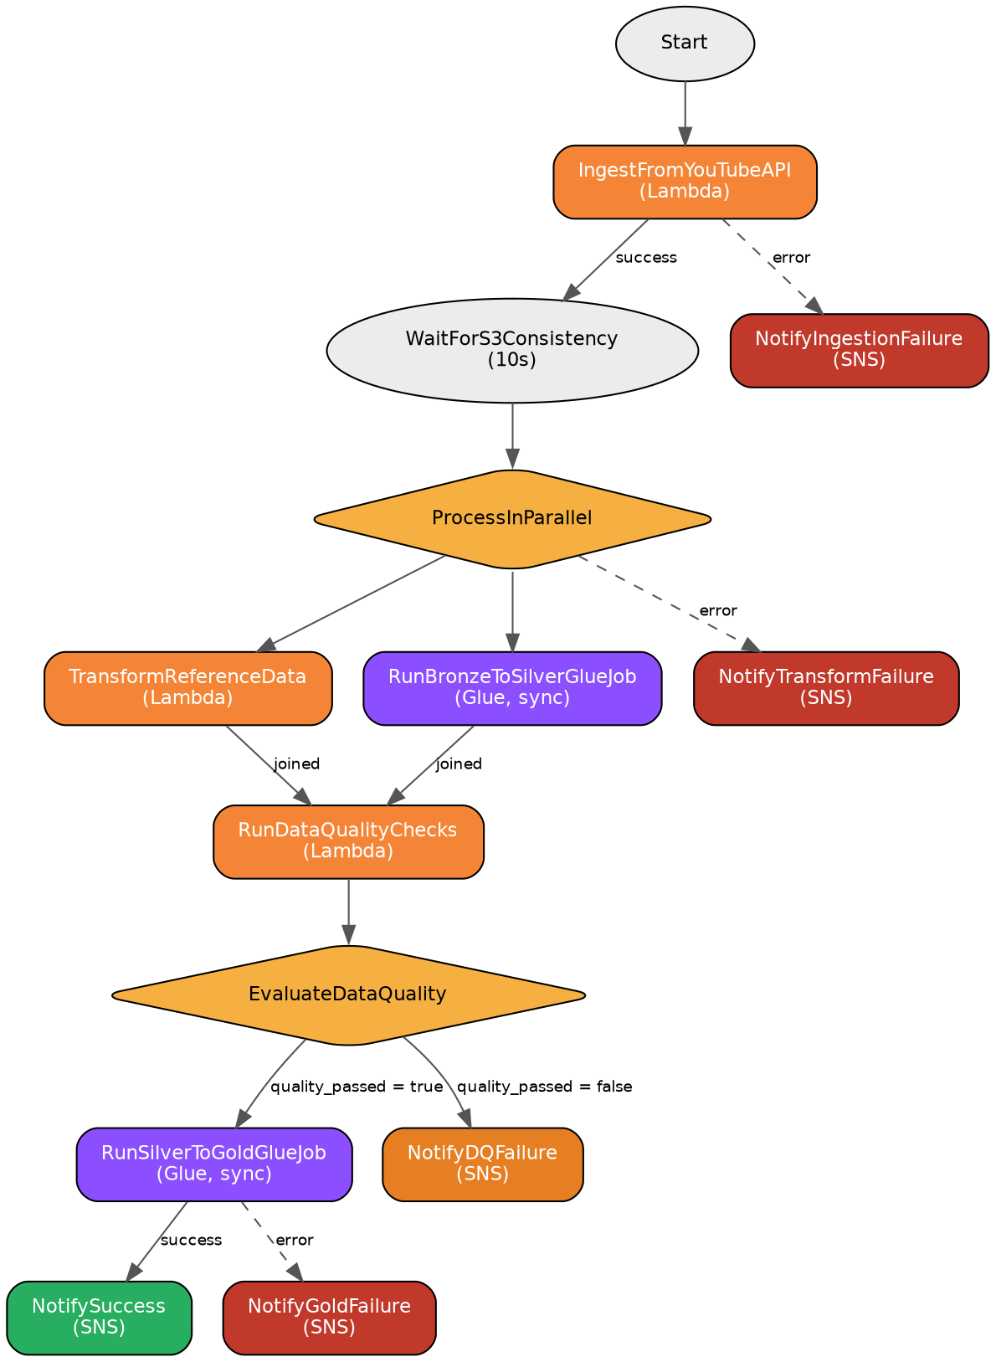
Figure 3 – Step Functions state machine

7.1 Key Design Choices
- Retry blocks with exponential backoff on Lambda throttling and Glue transient errors.
- Catch blocks route every failure to a dedicated SNS notification state so failures are never silent.
- Glue jobs are invoked with the .sync integration so Step Functions waits for job completion before proceeding.
- A Parallel state runs the reference-data transform and the Bronze→Silver Glue job simultaneously to reduce total runtime.
- A Choice state (EvaluateDataQuality) gates Gold aggregation on the quality_passed flag returned by the DQ Lambda.

7.2 Definition Excerpt — Quality Gate
"EvaluateDataQuality": {
"Type": "Choice",
"Choices": [
{ "Variable": "$.dq_result.Payload.quality_passed",
"BooleanEquals": true, "Next": "RunSilverToGoldGlueJob" }
],
"Default": "NotifyDQFailure"
}

8. AWS Lambda Functions — Code Detail

8.1 yt-data-pipeline-youtube-ingestion-dev
Triggered on a schedule via Step Functions/EventBridge. For each configured region it calls the YouTube Data API (videos.list – chart=mostPopular, and videoCategories.list), tags the payload with pipeline metadata, and writes raw JSON to the Bronze bucket using Hive-style partitioning. Any per-region failure is captured and reported without stopping other regions; partial failures trigger an SNS alert.
def lambda_handler(event, context):
now = datetime.now(timezone.utc)
ingestion_id = now.strftime("%Y%m%d_%H%M%S")
results = {"success": [], "failed": []}

for region in REGIONS:
region = region.strip().lower()
try:
trending_data = fetch_trending_videos(region)
trending_data["_pipeline_metadata"] = {
"ingestion_id": ingestion_id, "region": region,
"ingestion_timestamp": now.isoformat(),
"video_count": len(trending_data.get("items", [])),
}
s3_key = (f"youtube/raw_statistics/region={region}/"
f"date={now:%Y-%m-%d}/hour={now:%H}/{ingestion_id}.json")
write_to_s3(trending_data, BUCKET, s3_key)
except (HTTPError, URLError) as e:
results["failed"].append({"region": region, "type": "trending", "error": str(e)})
continue
results["success"].append(region)

if results["failed"]:
send_alert("[YT Pipeline] Ingestion partial failure", json.dumps(results))
return {"statusCode": 200, "ingestion_id": ingestion_id, "results": results}
Simplified handler – full function also fetches category reference data per region.

8.2 yt-data-pipeline-json-to-parquet-dev
Triggered by an S3 event when new category-reference JSON lands in Bronze. Reads the object with boto3 (not awswrangler.s3.read_json, which fails on this file's mixed-type structure), normalizes the items array with pandas, deduplicates by category id, and writes idempotent per-region Parquet partitions to Silver using AWS Data Wrangler.
raw_data = read_json_from_s3(bucket, key) # boto3 + json.loads
df = pd.json_normalize(raw_data["items"]) # flatten "items" array
df = validate_category_data(df) # dedupe by "id"
df["region"] = region # parsed from the S3 key

wr.s3.to_parquet(
df=df, path=SILVER_PATH, dataset=True,
database=GLUE_DB, table=GLUE_TABLE,
partition_cols=["region"],
mode="overwrite_partitions", # idempotent per region
schema_evolution=True,
)

8.3 yt-data-pipeline-data-quality-dev
Called by Step Functions after the Silver layer is built. Runs five categories of checks against a 10,000-row Athena sample of each Silver table and returns an overall pass/fail flag that gates Gold aggregation.
- Row count — table must have at least the configured minimum rows.
- Null percentage — critical columns must stay under the configured null threshold.
- Schema validation — all expected columns must be present.
- Value range — view counts must not be negative or unrealistically large.
- Freshness — latest record must be within the configured freshness window.
df = wr.athena.read_sql_query(
sql=f'SELECT * FROM "{table_name}" LIMIT 10000',
database=database, ctas_approach=False,
s3_output=ATHENA_S3_OUTPUT, workgroup=ATHENA_WORKGROUP,
)
checks = [check_row_count(df, table_name), *check_null_percentage(df, table_name),
check_schema(df, table_name), *check_value_ranges(df, table_name),
check_freshness(df, table_name)]
overall_passed = all(c["passed"] for c in checks)
if not overall_passed:
sns_client.publish(TopicArn=SNS_TOPIC,
Subject="[YT Pipeline] Data quality checks FAILED",
Message=json.dumps([c for c in checks if not c["passed"]]))

9. AWS Glue ETL Jobs — Code Detail

9.1 yt-data-pipeline-bronze-to-silver-dev
Reads raw statistics from the Bronze Glue Catalog with a region push-down predicate, auto-detects Kaggle CSV vs. live YouTube API JSON schema and normalizes both into one schema, cleans and standardizes the data, adds derived engagement metrics, deduplicates by video/region/date, runs inline data-quality logging, then writes partitioned Snappy Parquet to Silver with catalog auto-update.
# Schema normalization: handle both Kaggle CSV and YouTube API JSON
if "snippet.title" in columns or "snippet__title" in columns:
df = df.select(
F.col("id").alias("video_id"),
F.col("`snippet.title`").alias("title"),
F.col("`statistics.viewCount`").cast(LongType()).alias("views"),
F.col("`statistics.likeCount`").cast(LongType()).alias("likes"), ...)
else:
df = df.select(F.col("video_id"), F.col("title"), F.col("views").cast(LongType()), ...)

# Derived metrics
df = df.withColumn("like_ratio",
F.when(F.col("views") > 0, F.round(F.col("likes")/F.col("views")*100, 4)).otherwise(0.0))
df = df.withColumn("engagement_rate",
F.when(F.col("views") > 0,
F.round((F.col("likes")+F.col("dislikes")+F.col("comment_count"))/F.col("views")*100, 4)
).otherwise(0.0))

# Dedup: keep latest record per video_id + region + trending_date
window = Window.partitionBy("video_id","region","trending_date_parsed").orderBy(F.col("_processed_at").desc())
df = df.withColumn("_row_num",
F.row_number().over(window)).filter(F.col("_row_num")==1).drop("_row_num")
Full script also includes trending_date parsing (yy.dd.MM → date), null coalescing on numeric columns, and a Glue-native S3 sink with enableUpdateCatalog=True.

9.2 yt-data-pipeline-silver-gold-dev
Reads clean_statistics and clean_reference_data from Silver, left-joins category names onto the statistics, then builds three Gold tables optimized for BI consumption in Athena/QuickSight.
Gold Table | Grain / Purpose
trending_analytics | Daily totals per region — total videos, views, likes, comments, avg engagement.
channel_analytics | Per-channel performance, ranked by total views within region.
category_analytics | Per-category trend over time, incl. view-share % within region/day.
trending = stats_df.groupBy("region","trending_date_parsed").agg(
F.count("video_id").alias("total_videos"), F.sum("views").alias("total_views"),
F.avg("engagement_rate").alias("avg_engagement_rate"),
F.countDistinct("channel_title").alias("unique_channels"))

window_rank = Window.partitionBy("region").orderBy(F.col("total_views").desc())
channel = channel.withColumn("rank_in_region", F.row_number().over(window_rank))

window_total = Window.partitionBy("region","trending_date_parsed")
category = category.withColumn("view_share_pct",
F.round(F.col("total_views") / F.sum("total_views").over(window_total) * 100, 2))

10. Monitoring, Alerting & Querying

10.1 CloudWatch
All Lambda and Glue execution logs are captured automatically in CloudWatch Logs, giving per-invocation visibility into ingestion counts, DQ check results, and job durations.

10.2 SNS Alerts — yt-data-pipeline-alerts-dev
A single SNS topic centralizes all pipeline notifications. Step Functions publishes directly to it on Ingestion/Transform/Gold failure, DQ failure, and overall success; the ingestion and DQ Lambdas also publish directly for finer-grained failure detail.

10.3 Amazon Athena
Athena provides serverless SQL access to every layer of the data lake via the Glue Data Catalog. It is used by the Data Quality Lambda for validation queries and is the primary interface for ad-hoc analysis of Gold tables.
Athena query result location:
s3://yt-data-pipeline-swap-glue-athena-query-result/

11. Key Improvements Over the Original Approach
- Replaced manual Kaggle CSV download + aws s3 cp with live, scheduled YouTube API ingestion.
- Replaced manual script execution with full Step Functions orchestration, including retries and error routing.
- Added row-level data quality checks with configurable thresholds and automatic SNS alerting.
- Added deduplication logic to handle the same video appearing across multiple ingestions.
- Made Silver/Gold writes idempotent (overwrite_partitions / catalog update) to allow safe re-runs.
- Partitioned data by region and date for materially faster and cheaper Athena queries.
- Scoped IAM policies per-service (Glue / Lambda / Step Functions) instead of one broad role.

12. Conclusion
This project delivers a fully automated, serverless YouTube trending-data pipeline on AWS that mirrors real-world production patterns: scheduled ingestion, a governed medallion data lake, orchestrated ETL with quality gates, and proactive failure alerting. It demonstrates practical use of Step Functions, Lambda, Glue, S3, Athena, IAM, CloudWatch and SNS working together as a cohesive system, and provides a solid foundation for future enhancements such as QuickSight dashboards, CI/CD deployment, and multi-environment (dev/stage/prod) promotion.

