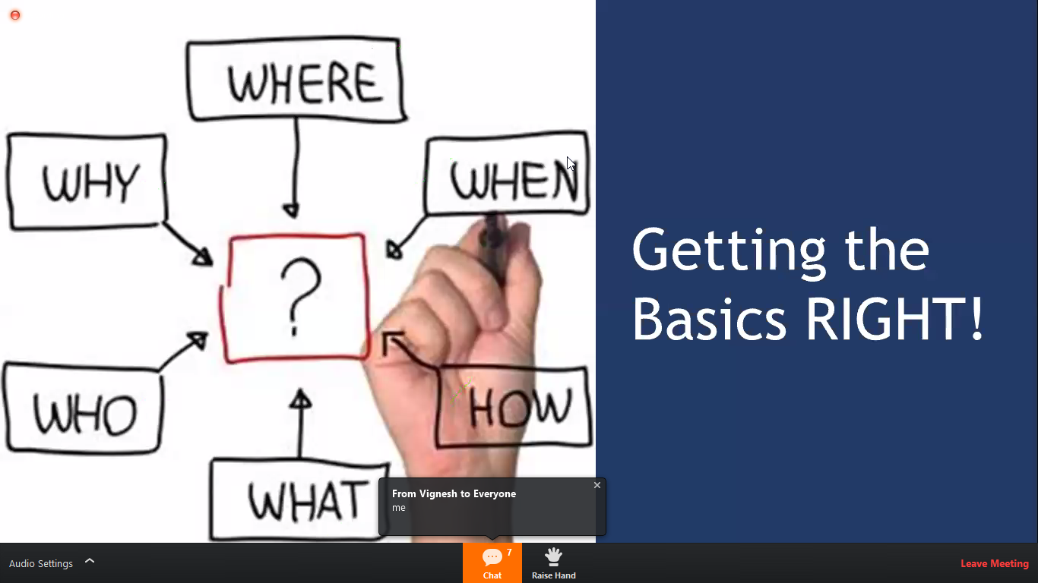

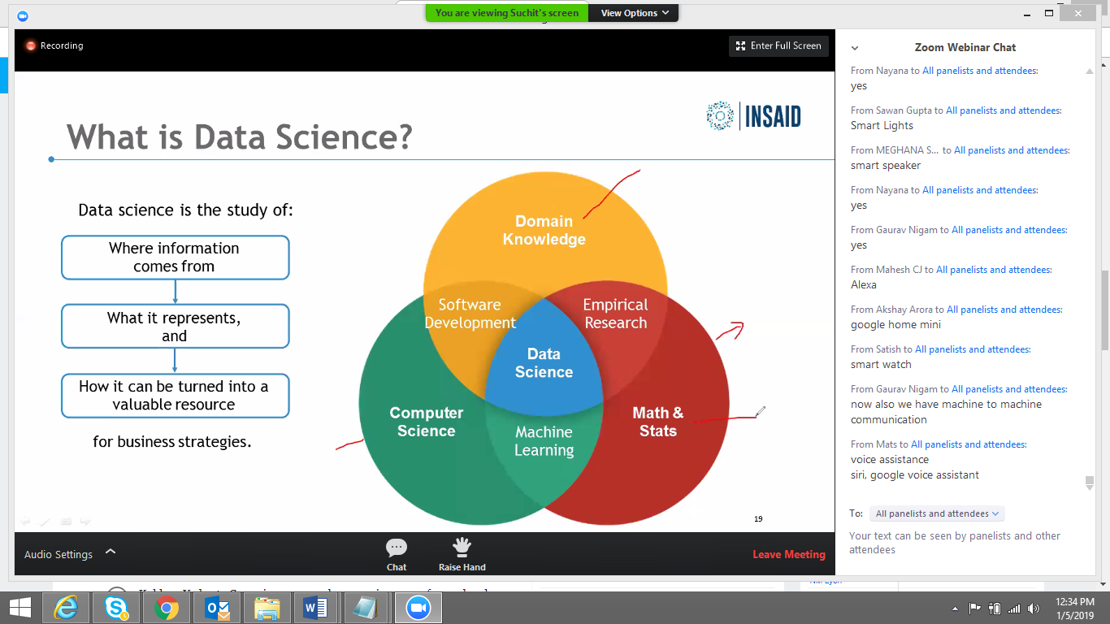

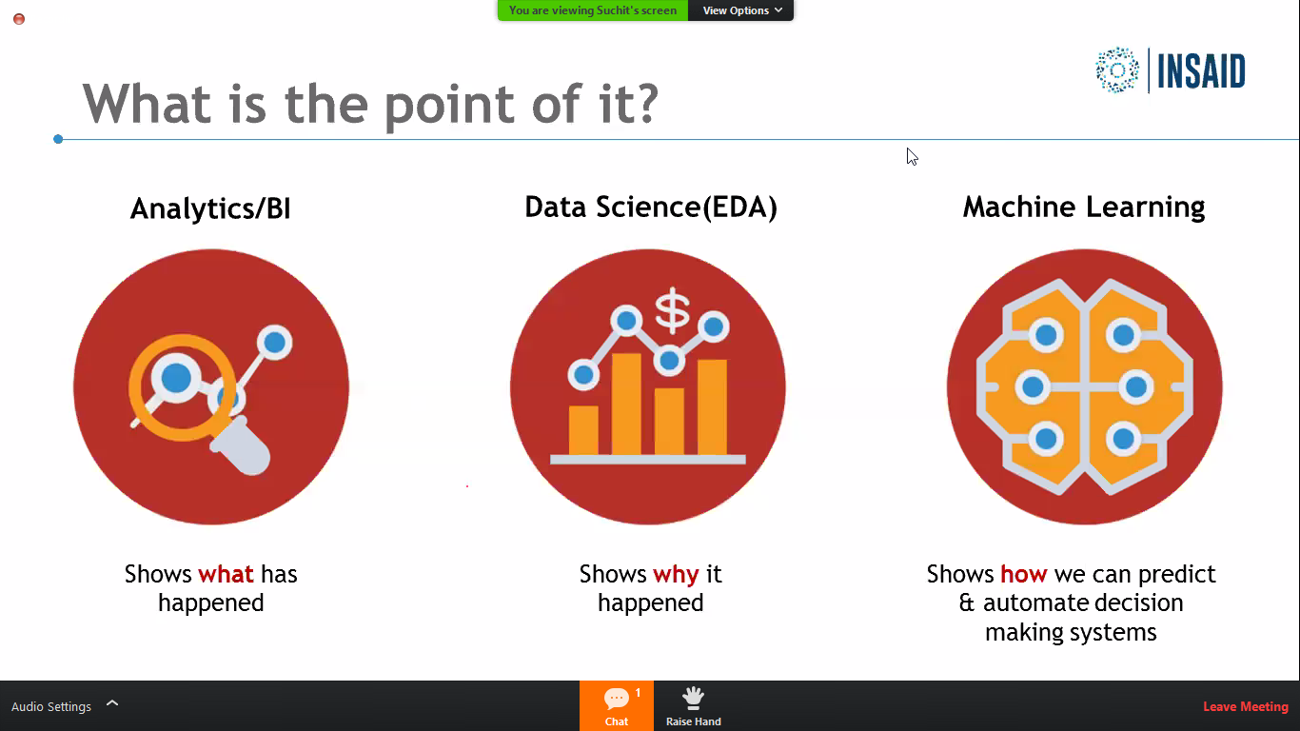

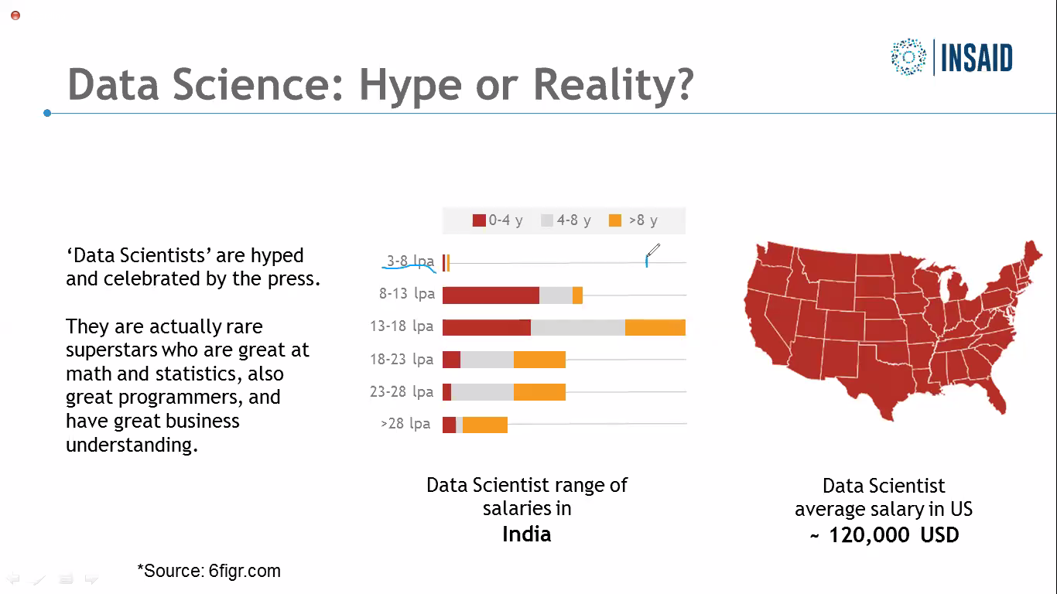

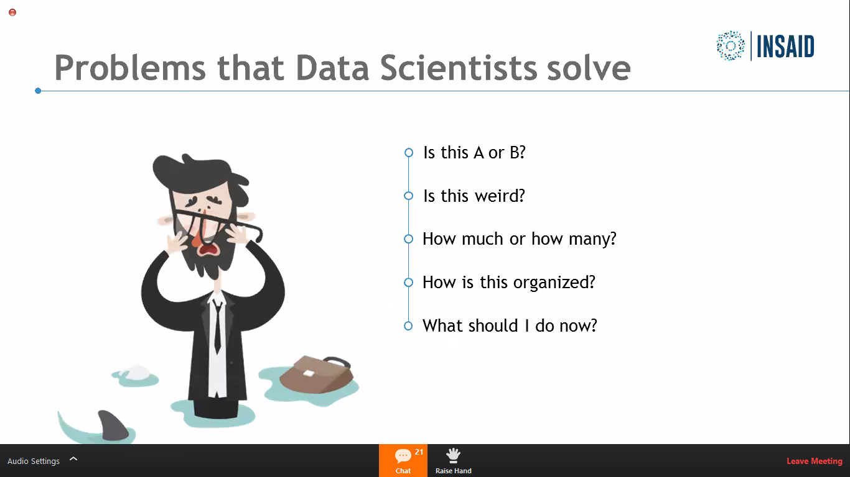

Why to do scaling in machine learning?

To convert values in range like -1 to 1. This reduces time for processing for CPU

Why to use GPU than cPU?

GPU are having high precision calculation power for floating values. They are précised. 99% to 99.9999% they make hugh difference when its comparing images. It is necessary while comparing images. resolutions.

What is random state in train_test_split?

Its juts a unique identifier. To check – how to set only specific set each time. This can be used.

Default division is 75% to 25% in training and test.