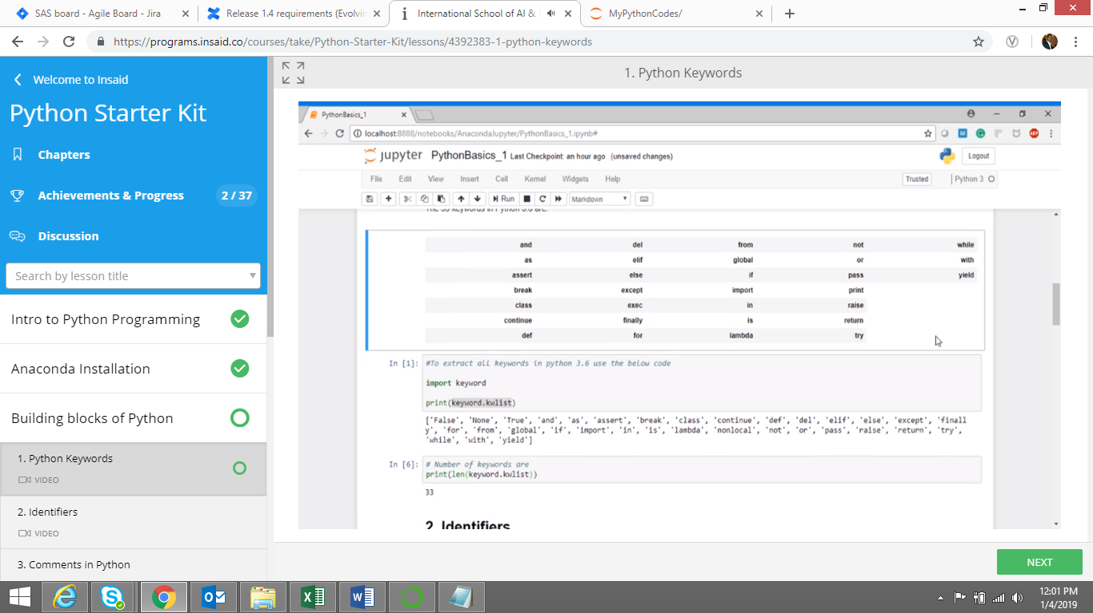

1. Import keyword

Print keyword.kwlist

Len(keyword.kwlist)

1. Comments: “”” comments “”” … comments …

Print (square.__Doc__)

Square Shift+tab to see comments..

1. Storage location

Print(Id(VarName))

Data types

Numbers: int float complex

