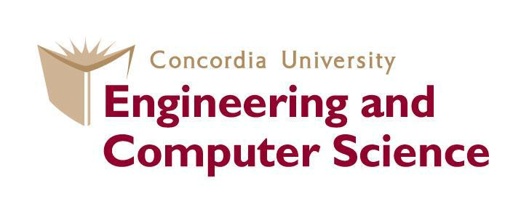

SOEN 6841 – Software Project Management

Prof – Pankaj Kamthan

(Topic Analysis and Synthesis)

**13. How does project management differ between hardware and software projects?**

Report By: **Swapnil Kamleshkumar Rana**

Student ID: **40194262**

**TABLE OF CONTENTS:**

Abstract………………………………………………………………………………………. 3

1. Introduction…………………………………………………………………………... 4
   1. Problem Statement……………………………………………………………….. 4
   2. Motivation………………………………………………………………………... 4
   3. Objectives……………...…………………………………………………………. 5
2. Background…………………………………………………………………………... 5
   1. Life Cycle Variations……………………………………………………………...5
   2. Agile Life Cycles in Software……………………………………………………..5
   3. Waterfall-Type Life Cycles in Hardware…………………………………………6
   4. Naming Life-Cycle Phases………………………………………………………...6
3. Methodologies…………………………………………………………………………7
   1. Technological Expertise in Hardware Projects……………………………………7
   2. Technological Expertise Of Project Leaders In Software And Hardware Projects.7
   3. People Leadership Skills for Effective Software Project Leaders………………...7
   4. Scoping in hardware and software projects……………………………………….8
   5. Testing in hardware and software projects………………………………………..8
4. Results Obtained………………………………………………………………………9
5. Future work……………………………………………………………………………9
6. Conclusion……………………………………………………………………………10
7. References……………………………………………………………………………11

**TABLE OF FIGUES:**

1. Waterfall Model in Software Development Life Cycle……………………………….6
2. Scope Plan in software and hardware projects………………………………………...8
3. Hardware Development Life Cycle versus Software Development Life Cycle..……10

**ABSTRACT**

Managing projects in hardware and software development involves addressing unique challenges and employing distinct techniques due to inherent differences between the two domains. Hardware projects involve the physical creation of tangible components, while software projects focus on crafting intangible code and algorithms. These differences extend beyond the physical nature of the final products, influencing various aspects of project planning, execution, and oversight. Recognizing these discrepancy is crucial, allowing project managers to decide their approaches based on the characteristics of each side.

The success of any project relies on understanding of several important factors, including project size, complexity, and the nature of deliverables [1]. In the case of larger projects with numerous components, a more formalized approach and stringent management is necessary. On the other side, smaller projects could benefit from a more agile and adaptive method. The difference between tangible hardware deliverables and intangible software deliverables introduces unique challenges that project managers must carefully navigate. Acknowledging with these challenges ensures that project management methods are finely tuned to address the particular requirements and intricacies of each project.

In the domain of hardware projects, where physical components are fashioned, project managers need to implement accurate planning and execution [2]. This may involve coordinating various teams and resources to ensure that each hardware element comes together seamlessly. On the software development side, where the focus is on coding and algorithms, flexibility becomes a profit. Agile methodologies, which emphasize adaptability and collaboration, may prove more suitable for managing the dynamic nature of software projects.

The concise understanding of project size, complexity, and deliverables is pivotal for effective project management. By tailoring strategies to the specific needs of hardware and software development, project managers can navigate the challenges unique to each domain, ultimately ensuring the successful completion of diverse projects.

**1.** **INTRODUCTION**

**1.1 Problem Statement**

The problem at hand revolves around the inadequacy of a uniform project management approach for both hardware and software development. Failure to recognize and address the inherent differences between these domains can lead to suboptimal project outcomes, missed deadlines, and increased costs. The problem statement acknowledges that project managers may face difficulties if they apply identical methodologies to hardware and software projects without considering the unique demands posed by each.

The challenge lies in the potential oversight of critical factors such as project size, complexity, and the nature of deliverables. Without a tailored approach, project managers may struggle to efficiently coordinate teams, allocate resources, and meet project objectives. The problem is accentuated by the dynamic and rapidly evolving nature of technology, necessitating a proactive response to the challenges presented by both hardware and software projects.

**1.2 Motivation**

The motivation behind exploring the nuanced differences between hardware and software project management stems from the growing complexity and diversity of projects in the fields of technology and development. As organizations increasingly engage in both hardware and software endeavours, project managers are confronted with the challenge of navigating unique intricacies inherent to each domain. The motivation is to empower project managers with a comprehensive understanding of the distinctive characteristics of hardware and software projects, enabling them to make informed decisions and adopt tailored approaches for successful project execution.

Understanding the motivation involves recognizing that a one-size-fits-all project management strategy is insufficient when dealing with the varied nature of hardware and software development [3]. The motivation is grounded in the belief that a nuanced understanding of project size, complexity, and deliverables is pivotal for effective project management. By shedding light on the specific challenges and requirements associated with hardware and software projects, the aim is to equip project managers with the knowledge and tools necessary to optimize project outcomes and ensure success in diverse technological endeavors.

**1.3 Objectives**

The objectives of this exploration are multifield. Firstly, it aims to establish a clear understanding of the fundamental principles of project management that are applicable across both hardware and software projects. By identifying commonalities, the objective is to provide project managers with a foundational framework that can be adapted to suit the specific requirements of each domain.

Secondly, the exploration seeks to highlight the differences between hardware and software projects based on project size, complexity, and deliverables. The objectives include delineating the challenges associated with managing tangible hardware components versus intangible software code, and the implications of these differences on project management strategies.

Furthermore, the objectives involve delving into the life cycles of hardware and software projects, examining methodologies for establishing processes and roles, and assessing the impact of technological evolution and expertise on project management. Ultimately, the overarching objective is to equip project managers with the insights and knowledge needed to navigate the complexities of hardware and software projects successfully.

**2.** **BACKGROUND**

Because of the scale and nature of the projects, hardware and software initiatives are distinct. They both have fundamental project guidelines, but they approach things differently as they progress through the stages.

**2.1 Life Cycle Variations:**

Managing hardware and software projects entails traversing several paths, such as taking a regimented walk down a waterfall or choosing a more flexible and adaptable trip. Hardware projects proceed through specified stages, each having a distinct purpose, similar to a deliberate decline[4]. Decisions are formal and strategic in nature. In contrast, software projects, particularly smaller ones, value agility. It's like constructing with LEGOs, taking baby steps, tweaking, and making sure every piece fits perfectly. This technique provides for flexibility, which is important when the strategy may need to alter due to ongoing discoveries or changing demands.

**2.2 Agile Life Cycles in Software:**

Each chapter of a software project unfolds with creativity and flexibility, much like a dynamic storybook. Agile, like sampling a cake as it's baking, entails constructing, testing, and changing in small increments[5]. It's a pleasant discussion with the project, with room for revisions as ideas emerge. This flexibility is similar to conversing with your storybook characters, enabling their personalities to change the tale as you go, ensuring the ultimate outcome is exactly what was intended.

**2.3 Waterfall-Type Life Cycles in Hardware:**

Consider creating a large structure in which every detail is painstakingly planned before the first brick is set [6]. This is the essence of hardware development. Changes are uncommon, similar to following a recipe step by step, and there are tight decision-making processes in place to assess if revisions are required. The deliberate advancement through phases is analogous to the painstaking construction of a structure, ensuring that each step is completed precisely before going on to the next.

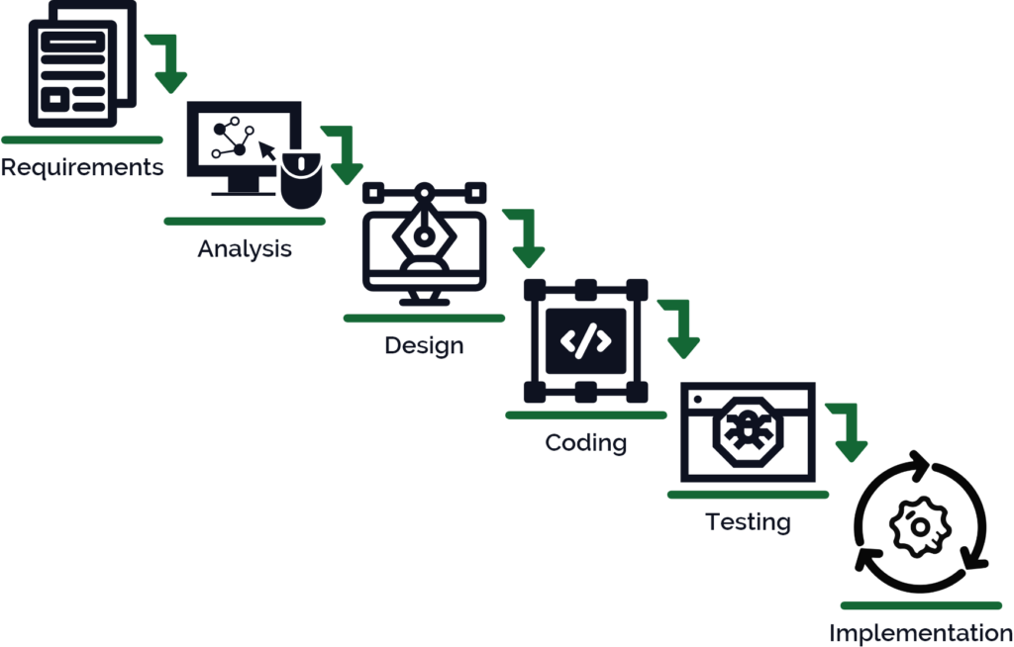

Fig 1. Waterfall Model in Software Development Life Cycle

**2.4 Naming Life-Cycle Phases:**

Consider the creation of a storybook or a blockbuster film. In hardware, the tale begins with planning and analysis, similar to how the first storyline is crafted. The decision to proceed is taken early on, similar to the commitment to write the complete book. In the case of software, the story begins with selling the idea, then moves quickly to the creative process. While the stages' names may differ, the spirit stays the same for both hardware and software projects strive to turn visionary concepts into actual and significant realities.

Effective scoping and change management are critical in both hardware and software projects. While hardware projects often have fewer frequent changes and a more formalised change management process, software projects, due to their dynamic nature, may require a more flexible strategy to react to changing requirements. Furthermore, testing practises and the requisite leadership abilities may differ, with hardware projects frequently undertaking rigorous testing at the end and hardware project leaders possessing deeper technical experience. Due to the cross-functional nature of their teams, software project leaders require strong people leadership abilities.

**3. METHODOLOGIES**

**3.1 Technological Expertise in Hardware Projects:**

Hardware initiatives, such as the development of physical devices, frequently evolve at a slower rate than their software counterparts. Unlike software, where updates and enhancements may be deployed quickly, hardware evolves at a slower pace. Because hardware project managers can anticipate a more stable technology landscape, this disparity affects project deadlines and planning [7]. Software projects, on the other hand, must adapt to rapid changes, necessitating agile approaches to handle regular updates and upgrades.

**3.2 Technological Expertise Of Project Leaders In Software And Hardware Projects:**

Project leaders overseeing hardware development possess a deeper knowledge base due to the comparatively gradual evolution of hardware technologies. The prolonged lifespan of hardware components allows project leaders to accumulate extensive expertise, understanding the intricacies of the technologies involved [8]. This depth of knowledge is crucial for making informed decisions throughout the project lifecycle, from design to implementation, ensuring the project aligns with long-term technological considerations.

In contrast to hardware initiatives, project leaders' technical ability in software projects frequently relies substantially on the specialised backgrounds of their team members. Rapid developments in software development necessitate a collaborative approach in which each team member brings unique abilities. To stay current of the latest technologies and industry trends, project leaders must negotiate a dynamic terrain, relying on the diverse skills within their team.

**3.3 People Leadership Skills for Effective Software Project Leaders:**

Effective leadership in software projects goes beyond technical expertise, emphasising the importance of strong people management skills [9]. Project leaders must excel in communication, teamwork, and team motivation due to the cross-functional nature of software development and the reliance on varied team members. Success in software projects is dependent not only on technical understanding, but also on the ability to inspire and manage people with diverse backgrounds and skill sets. As the software business advances at a quick pace, project directors' agility and interpersonal skills become critical to project success.

**3.4 Scoping in hardware and software projects**

Scoping modifications are clearly specified and controlled in hardware projects, with a structured framework in place to address them. Changes are expected to be few and few between, and their influence on the project is carefully considered. This formal method helps to keep the project plan stable and minimises disruptions caused by scope changes. From the start, the emphasis is on a well-defined scope, and any changes are subject to a thorough evaluation procedure.

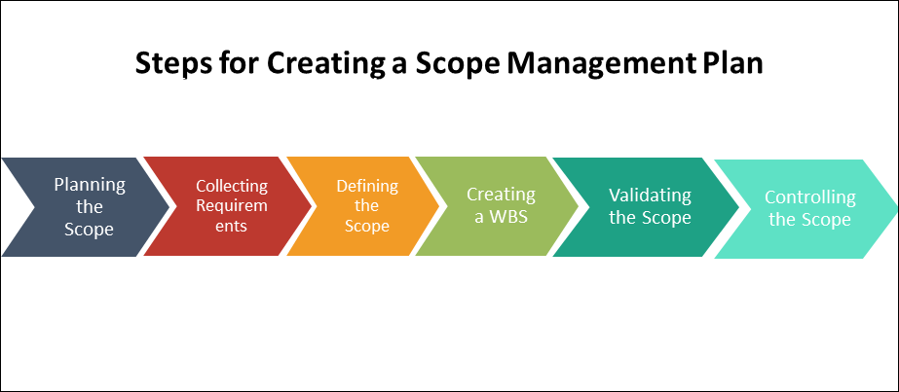

Fig 2. Scope Plan in software and hardware projects

Software projects, on the other hand, tend to take a more casual approach to scoping changes [10]. While scoping management practises remain vital, changes are becoming more common and are regarded as less expensive and disruptive. The ability to adapt to changes is a hallmark of software development, particularly in the early phases. Because of this versatility, the project requirements will get a more dynamic response without imposing significant constraints.

**3.5 Testing in hardware and software projects**

Testing methods in hardware projects are often planned close project completion, with a focus on reviewing unit tests of complicated system deliverables [11]. The nature of hardware projects, in which components are only brought together for testing towards the finish, necessitates a concentrated testing effort near the end of the project. This method ensures that the integrated system is properly tested before it is delivered.

Software projects, on the other hand, require continuous testing throughout the project's lifecycle. Several interim deliverables are tested and evaluated at various levels. The nature of software development drives this continuous testing method, where incremental progress is regularly examined to catch and address errors early. The ability to test and change throughout the project helps to software's dynamic and iterative nature of software development methodologies [12].

Generally, hardware projects place a premium on formal scoping and intense testing near the end of the project, whereas software projects value adaptability through informal scope adjustments and continual testing throughout the project. These distinctions represent the distinct characteristics of each area and have an impact on the approaches used in project management.

**4. RESULTS OBTAINED**

The findings highlight the key differences between hardware and software project management, emphasising the importance of specialised approaches based on project size, complexity, and deliverables. It demonstrates the different life cycle variants, with hardware projects progressing in a deliberate, regimented manner and software projects embracing agile, flexible techniques. In contrast to the collaborative, dynamic character of software project leadership, the study emphasises the depth of technological competence required for hardware project directors. It also emphasises the critical relevance of people leadership abilities in software initiatives. The findings provide significant insights, leading project managers through the complexities of each area and achieving successful outcomes in a variety of technical endeavours.

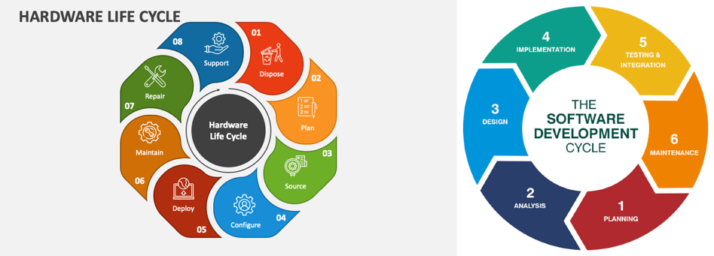

Fig 3. Hardware Development Life Cycle versus Software Development Life Cycle

**4. LIMITATION AND FUTURE WORK**

The study focuses mostly on the significant differences between hardware and software project management. However, it does not go into detail on the specific issues that project managers encounter in each domain. Furthermore, real-world case studies could be used to provide practical insights into resolving these problems.

Future research could elaborate on the highlighted discrepancies, providing more thorough advice for hardware and software development project managers. Exploring emerging project management approaches particular to each area, as well as investigating the increasing role of technology in affecting project dynamics, would improve the findings' application. Furthermore, including feedback from experienced project managers may provide significant practical views for enhancing project management methodologies in both hardware and software environments.

**5. CONCLUSION**

Finally, managing hardware and software projects entails understanding their distinct differences and adjusting techniques accordingly. Hardware projects are concerned with the creation of tangible objects, such as physical equipment, whereas software projects are concerned with the creation of intangible code and algorithms. These distinctions have an impact on how projects are planned, completed, and managed. Project managers must grasp issues such as project size, complexity, and deliverables since they influence the techniques used. A more organised approach is required for larger projects with many components, but agile methods that allow for adaptation can help smaller projects. The distinction between tangible hardware deliverables and immaterial software deliverables raises issues for project managers. Recognising these obstacles ensures that project management strategies are tailored to the unique requirements of each project.

Precision planning and execution are critical in hardware initiatives that involve the creation of actual components. This entails coordinating teams to guarantee that each hardware element is seamlessly integrated. Flexibility is essential on the software side, which focuses on coding and algorithms. Agile approaches, which emphasise adaptability, are ideal for handling the volatile nature of software projects. Understanding the size, complexity, and deliverables of a project is critical for good project management. Project managers can successfully navigate hurdles by adjusting solutions to the distinct needs of hardware and software development. Recognising and accepting the distinctions between hardware and software projects is critical to obtaining effective outcomes in different projects in today's ever-changing technological landscape.

**5. REFERENCES**

**[1]** Bannerman, P.L., 2008, July. Defining project success: a multilevel framework. In *Proceedings of the Project Management Institute Research Conference* (pp. 1-14).

**[2]** Rosenau, M.D. and Githens, G.D., 2011. *Successful project management: a step-by-step approach with practical examples*. John Wiley & Sons.

**[3]** Ciric, D., Lalic, B., Gracanin, D., Palcic, I. and Zivlak, N., 2018, March. Agile project management in new product development and innovation processes: challenges and benefits beyond software domain. In *2018 IEEE International Symposium on Innovation and Entrepreneurship (TEMS-ISIE)* (pp. 1-9). IEEE.

**[4]** Teich, J., 2012. Hardware/software codesign: The past, the present, and predicting the future. *Proceedings of the IEEE*, *100*(Special Centennial Issue), pp.1411-1430.

**[5]** Leau, Y.B., Loo, W.K., Tham, W.Y. and Tan, S.F., 2012. Software development life cycle AGILE vs traditional approaches. In *International Conference on Information and Network Technology* (Vol. 37, No. 1, pp. 162-167).

**[6]** Alshamrani, A. and Bahattab, A., 2015. A comparison between three SDLC models waterfall model, spiral model, and Incremental/Iterative model. *International Journal of Computer Science Issues (IJCSI)*, *12*(1), p.106.

**[7]** Huang, P.M., Darrin, A.G. and Knuth, A.A., 2012, March. Agile hardware and software system engineering for innovation. In *2012 IEEE Aerospace conference* (pp. 1-10). IEEE.

**[8]** Durney, C.P. and Donnelly, R.G., 2015. Managing the effects of rapid technological change on complex information technology projects. *Journal of the Knowledge Economy*, *6*, pp.641-664.

**[9]** Agrawal, N.M. and Thite, M., 2003. Nature and importance of soft skills in software project leaders. *IIM Bangalore Research Paper*, (214).

**[10]** Sulgrove, R.N., 1996. Scoping software projects. *AT&T technical journal*, *75*(1), pp.35-45.

**[11]** Himmler, A., 2013, January. Hardware-in-the-loop technology enabling flexible testing processes. In *51st AIAA Aerospace Sciences Meeting including the New Horizons Forum and Aerospace Exposition* (p. 816).

**[12]** Dias-Neto, A.C. and Travassos, G.H., 2009. Model-based testing approaches selection for software projects. *Information and Software Technology*, *51*(11), pp.1487-1504.