Assignment no 1

Scripts for first job

#installing httpd

yum install httpd -y

#start httpd start

systemctl start httpd

#enable httpd service

systemctl enable httpd

#creating index.html in this directory

cd /var/www/html

echo "welcome to velocity.this is our first job" >> index.html

#change the permission of index.html make it executable

chmod -R 777 index.html

#you can access content of web server using curl command and giving public ip of a server.

curl 65.0.97.31

**console output using curl command:**

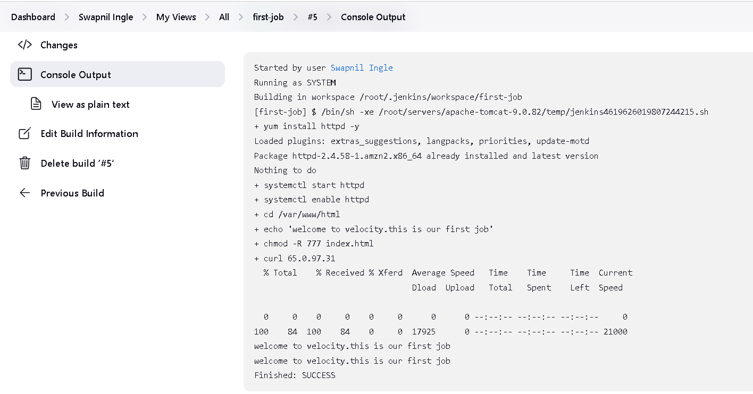

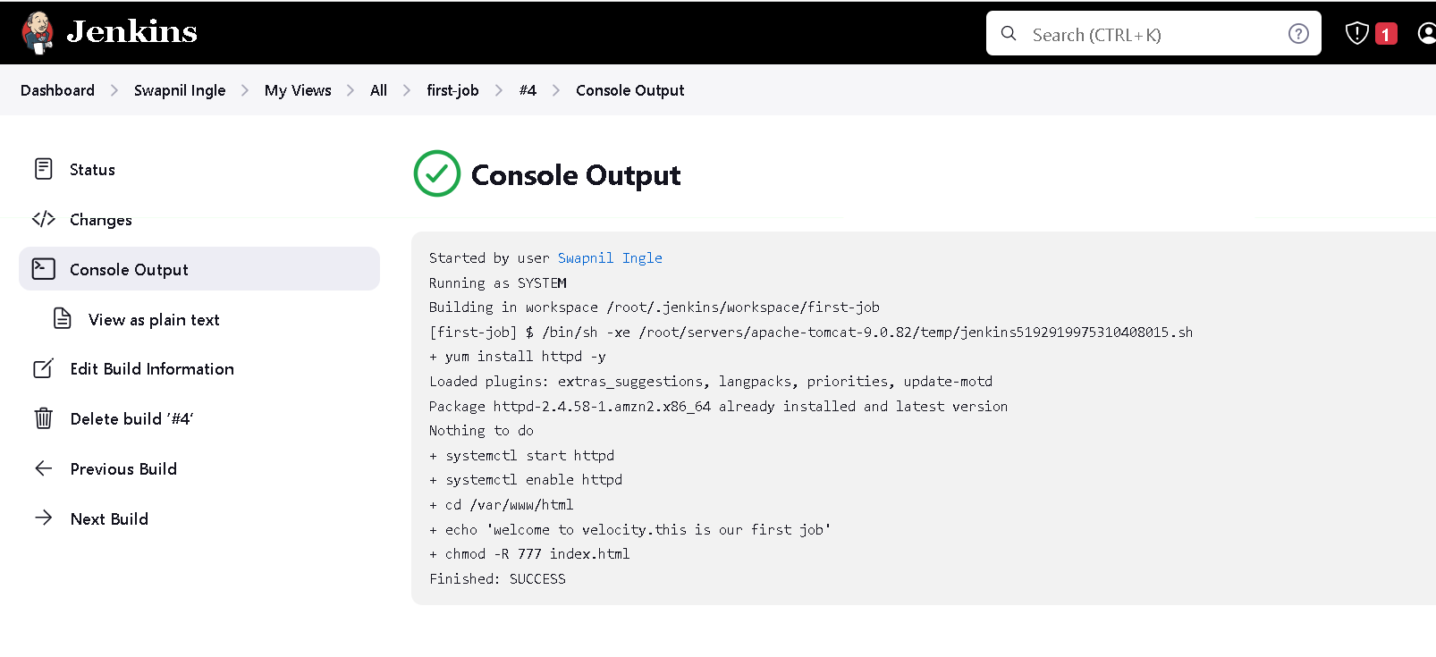

**console output without curl command:**

