Name: Swar Sawalkar

23104B0023

Assignment 3

Bucket details:

Logs:

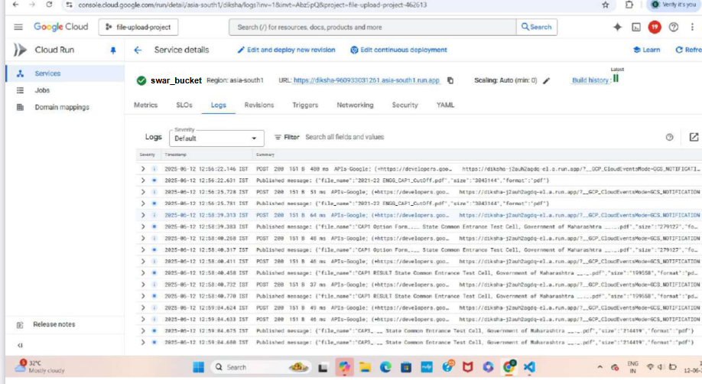

Pubsub-

