Date:26/10/2026

Student Basic Information
Name of the student | Swar Sawalkar | Roll No. | 23104B0023
Branch | CMPN | Semester | VII

Industry/ Organization Details
Name of Industry/Organization | UpSkill Campus | Internship nature: Stipend / Free / Paid | Free
Address of Industry/Organization | Noida | Department | Web Development (Java Programming)
Name of Industrial Supervisor | Prabha Singh | Designation | HR Manager
Supervisor Email | enquiry@upskillcampus.com | Contact No. of Supervisor | NA
Name of faculty coordinator from the Institute: Prof. Amit Aylani

Internship details
Internship Title/ Profile | Java Intern | Industry domain | Web Development
Dates of Internship | 30/03/2026 | To:30/04/2026
Give a brief description of your internship work

During my internship as a Core Java Intern at Upskill Campus in collaboration with UniConverge Technologies Pvt. Ltd., I gained knowledge of fundamental Java programming concepts, including object-oriented programming (OOP), data types, variables, operators, conditional statements, loops, arrays, strings, and methods. The internship helped me understand Java syntax, program structure, and the importance of writing clear, readable, and efficient code.
I also learned about exception handling, Java Collections Framework, and basic debugging techniques to identify and resolve programming errors. Through coding exercises and practical problem-solving activities, I strengthened my logical thinking and programming skills. This internship provided a foundation for understanding software development practices and improved my ability to approach programming challenges systematically.
Overall, the internship enhanced my technical knowledge and confidence in Core Java programming. It helped me connect theoretical concepts with practical applications and prepared me to explore advanced Java topics, application development, and future opportunities in software engineering.

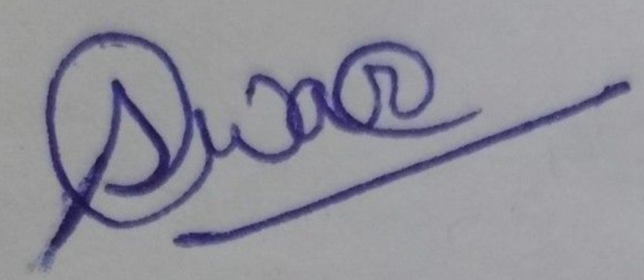
Indicate your response on the scale 0 to 4with the following statements.

Sr. No. | Do you think that this internship experience ….. | Poor  (0) | Not quite satisfactory  (1) | Satisfactory  (2) | Good  (3) | Excellent  (4)
1 | Shall helped to explore career opportunities? |  | ✔
2 | Helped you to apply theory to practice? |  | ✔
3 | Helped you to enhance problem-solving skills? |  |  | ✔
4 | Shall help you in expanding your knowledge to understand the needs of employment? |  |  | ✔
5 | Helped you to enhance written and oral communication skills? |  |  |  | ✔
6 | Helped in expanding your sensitivity to the ethical implications of the work involved? |  |  | ✔
7 | Helped you in enhancing leadership skills and teamwork spirit? |  | ✔

