Sanjivani University
Department of Computer Science and Engineering
SOFTWARE COPYRIGHT DOCUMENTATION
DropX
Smart Water Sanitation System (SWSS)
Purify. Monitor. Predict. Protect.
Submitted by
Swara Avinash Dawkhar
Snehal Ashok Shinde
Radhika Rahul Wable
Mrunal Dipak Walke

TABLE OF CONTENTS

List of Figures and Tables
Figure 1: Overall system architecture (provisional)
Figure 2: Data flow diagram, Level 1 (provisional)
Table 1: Particulars of the work
Table 2: Module and feature status
Table 3: Technologies (confirm each against the source code)
Table 4: Hardware components
Table 5: Parameters
Table 6: API endpoints (confirm)
Table 7: Original components
Table 8: Third-party components
Table 9: Checklist
About this document: It collects the project information needed to prepare a software copyright application for DropX SWSS. Implementation claims are labelled with their status, and proposed features are kept separate from implemented ones. This document is not legal advice and is not a copyright certificate. No registration number is claimed here.

1. Details of the Work
Table 1: Particulars of the work
Item | Details
Title of the work | DropX - Smart Water Sanitation System (SWSS)
Tagline | Purify. Monitor. Predict. Protect.
Nature of the work | Computer software (computer program) with documentation, diagrams and embedded-device code
Domain | Internet of Things, water-quality monitoring, embedded systems, web development
Authors | Swara Avinash Dawkhar; Snehal Ashok Shinde; Radhika Rahul Wable; Mrunal Dipak Walke
University | Sanjivani University
Department | Computer Science and Engineering
Registration status | No registration number is claimed in this document

2. Brief Description of the Work
DropX is a smart water monitoring and sanitation management system. It is designed to combine water-quality sensors, an ESP32-based controller, internet connectivity and a web dashboard. The system collects water-quality readings, compares them with configured thresholds, displays the results and generates alerts when abnormal conditions are detected.
The long-term vision includes automated responses and AI-based predictive analysis. These are future-scope features unless they are shown to be implemented in the submitted source code.
Important: A software demonstration does not prove that physical sensors or automated purification are working. This document keeps the proposed system, the software prototype and future features separate.

3. Problem Statement and Objectives

3.1 Problem Statement
Existing water monitoring often depends on periodic manual testing and limited local supervision. This can delay the identification of abnormal water-quality conditions and equipment problems. There is a need for an integrated system that monitors relevant parameters, evaluates readings, gives timely alerts and supports remote monitoring.
Limitations of conventional monitoring include periodic testing, delayed detection, limited remote access, reactive maintenance, limited historical analysis, possible water wastage and lack of centralised monitoring.

3.2 Objectives
- To develop a smart water monitoring and sanitation management system.
- To monitor selected water-quality parameters using suitable sensors.
- To collect readings through an ESP32-based controller and send them over a network.
- To display water-quality information on a user-friendly dashboard.
- To compare readings with configurable thresholds and generate alerts.
- To keep water-quality records where persistent storage is implemented.
- To support remote monitoring of connected water units.
- To explore automated responses and, in future, AI-based prediction and preventive maintenance.

4. Proposed System and Working Principle

4.1 Proposed Water-Treatment Arrangement
A possible treatment arrangement is: Raw Water, Pre-filtration, Activated Carbon, Reverse Osmosis (RO), UV Treatment, Mineral Cartridge (if applicable), Storage Tank, Dispensing. These are proposed stages. They are not proof that the prototype physically contains all of them.

4.2 Working Principle
The system follows the sequence: Sense, Process, Communicate, Analyze, Alert, Act.
- Sense: sensors collect readings from the water.
- Process: the ESP32 reads and validates sensor values.
- Communicate: readings are sent to the backend using the implemented method (for example HTTP).
- Analyze: the backend compares readings with configured thresholds.
- Alert: the application notifies the user about abnormal conditions.
- Act: a pump or valve response is possible only if control hardware and safety logic are implemented and tested.
Status labels such as Safe, Warning and Unsafe are software classifications based on configured rules. They are not laboratory certification of water safety.

5. System Architecture
The system has four layers: the device layer (ESP32 and sensors), the communication layer (Wi-Fi and API), the backend layer (validation, thresholds, alerts, API) and the presentation layer (web dashboard). Figures 1 and 2 are provisional and must be corrected to match the final source code.
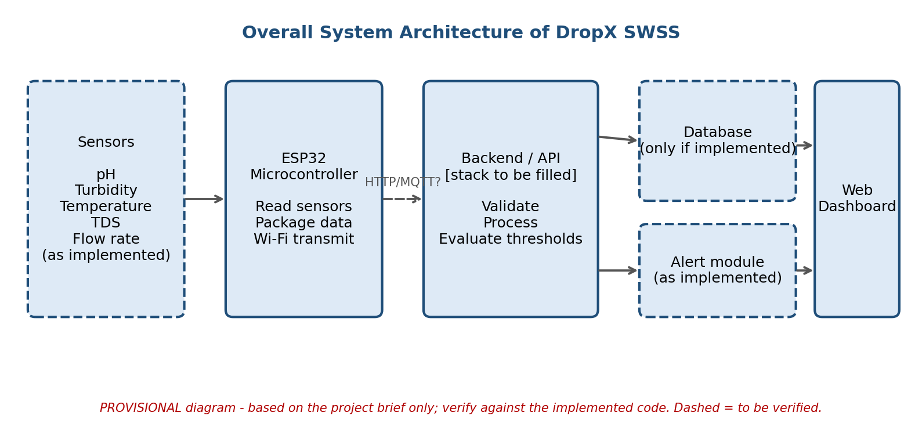
Figure 1: Overall system architecture (provisional)
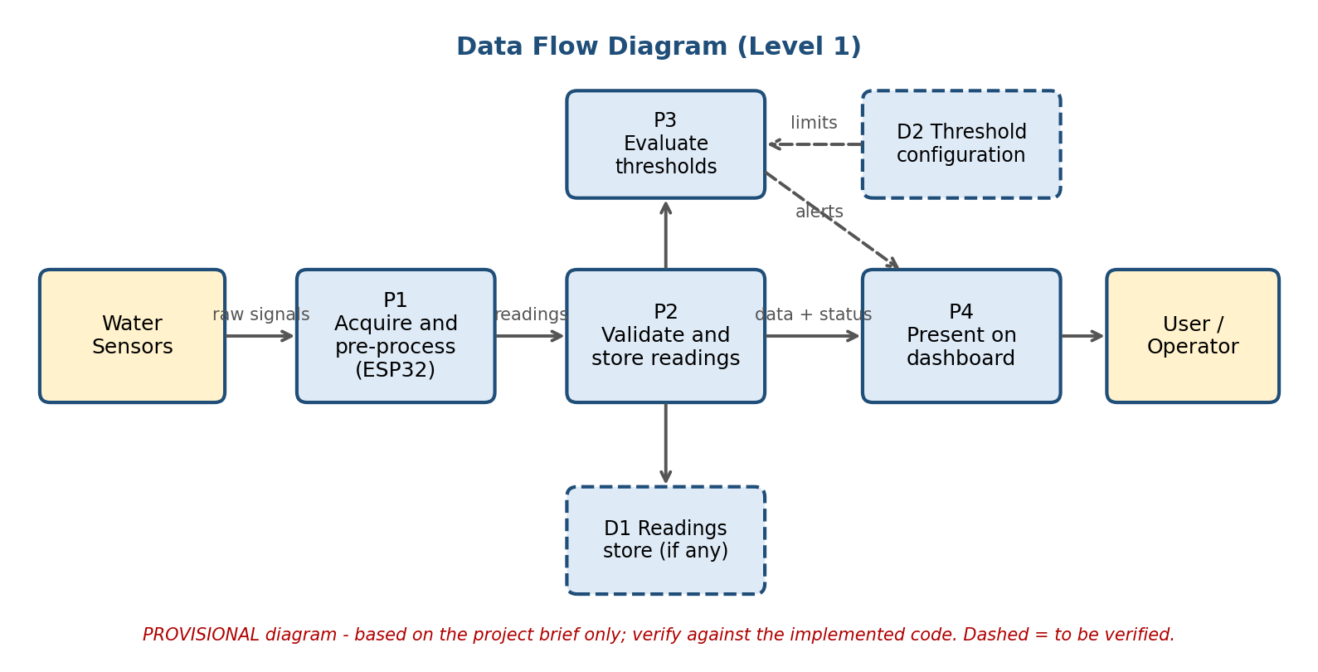
Figure 2: Data flow diagram, Level 1 (provisional)

6. Modules and Implementation Status
This table separates what is established from what must still be verified. Two software contexts have been mentioned in the project notes: an earlier, more developed project (built in Antigravity) and a newer starter scaffold. The authors must confirm which codebase is being submitted and describe only that one.
Table 2: Module and feature status
Module / feature | What is reported | Status to confirm
Project concept and design | Defined | Documented
React/Vite web dashboard | Present in the starter scaffold with demonstration readings | Not independently verified
Demonstration readings | Simulated data, not real measurements | Simulated
Node.js / Express backend | Present in the starter scaffold as a demonstration API | Not independently verified
Storage | Temporary in-memory storage in the starter scaffold | Prototype limitation
Persistent database (e.g. MongoDB) | Not established | Not independently verified
ESP32 example program | Contains placeholder sensor values | Example only
Real sensor acquisition | Not established for the starter scaffold | Not independently verified
Hardware-to-dashboard integration | Not established for the starter scaffold | Not independently verified
Threshold evaluation and alerts | Reported in the earlier project; deduplication and acknowledge/resolve operations mentioned | Not independently verified
Automatic pump or valve control | Not established | Future scope unless tested
AI prediction | Not established | Future scope unless a model is built and evaluated

For the copyright application, describe the program that the deposited source code actually contains. Do not copy claims from the starter scaffold into the earlier project, or the reverse.

7. Technology Stack
Table 3: Technologies (confirm each against the source code)
Technology | Role
React | Frontend interface
Vite | Frontend development and build tooling
JavaScript | Frontend and backend logic
Node.js | Backend runtime
Express.js | HTTP API
REST API | Communication between dashboard, backend and devices
ESP32 firmware | Embedded device interface
MongoDB / Mongoose | Possible persistent storage; verify use
Git and GitHub | Version control and hosting

8. Hardware Components (Proposed)
Mark a component as implemented only if it is present and tested in the prototype.
Table 4: Hardware components
Component | Purpose
ESP32 development board | Reads sensors; Wi-Fi connectivity
pH sensor | Acidity or alkalinity
TDS sensor | Estimated dissolved solids
Turbidity sensor | Cloudiness from suspended particles
Temperature sensor | Water temperature
Water-level sensor | Tank level
Flow / pressure sensor (optional) | Flow and line pressure
LCD/OLED display | Local display
Relay, pump, solenoid valve | Control of water movement
Power supply and Wi-Fi | Power and connectivity

pH, TDS and turbidity readings alone cannot prove that water is safe to drink. TDS gives an estimate of dissolved solids and does not identify contaminants. Safety needs proper testing against applicable standards.

9. Water-Quality Parameters
Table 5: Parameters
Parameter | Meaning | Purpose
pH | Acidity or alkalinity | Detect readings outside configured limits
TDS | Estimated total dissolved solids | Monitor dissolved-solids changes
Turbidity | Cloudiness from suspended particles | Monitor water clarity
Temperature | Water temperature | Context and operating conditions
Water level | Tank water level | Storage monitoring
Flow, pressure, ORP, conductivity | Optional extensions | List only if implemented

Thresholds used by the software: defined in the source code. Do not present software limits as proof of drinking-water safety.

10. Backend and API Description
The backend receives monitoring data, validates it, applies threshold rules, serves readings to the dashboard, accepts device data and can apply API-key authentication where configured. The routes below come from the starter scaffold and must be confirmed against the submitted code.
Table 6: API endpoints (confirm)
Endpoint | Method | Purpose
/api/health | GET | Check that the backend responds
/api/readings | GET | Retrieve readings
/api/devices | GET | Retrieve device information
/api/ingest | POST | Submit new monitoring data

Illustrative request body (an example, not a real measurement):
{
"deviceId": "DROPX-ESP32-001",
"ph": 7.0,
"tds": 250,
"turbidity": 1.2,
"temperature": 25
}

Security measures to confirm: API-key authentication, environment variables for secrets, request validation, rejection of malformed or unauthorised requests, and error logging.

11. Alert Management
Possible alert conditions are a reading crossing a configured limit, a sensor or device that stops reporting, and abnormal tank level, flow or pressure if those sensors exist. The lifecycle is: reading received, threshold evaluation, abnormal condition detected, alert created, user reviews, acknowledged or resolved.

12. Limitations
- Sensor accuracy depends on quality, calibration, installation and maintenance.
- Threshold classification cannot identify every contaminant, and cannot show microbiological safety.
- Demonstration data do not represent real water measurements.
- In-memory storage does not give durable records.
- Real hardware integration needs further testing.
- AI prediction and automated control need data, validation and safety mechanisms before they can be claimed.

13. Applications and Future Scope
Possible applications: homes, campuses, hostels, hospitals, purification installations, community water points and industrial monitoring. These are potential uses, not existing deployments.
Future scope: persistent cloud database, mobile application, AI anomaly detection, predictive maintenance, more sensors, protected pump and valve control, multi-device management, low-power or renewable operation, downloadable reports and calibration against reference instruments.

14. Originality, Authorship and Third-Party Components

14.1 Original Work
Copyright protects original code, documentation, diagrams and other eligible creative expression. It does not protect the abstract idea of monitoring water quality. List below the original parts created by the authors.
Table 7: Original components
Component | Created by
Frontend source code | Project team
Backend source code | Project team
ESP32 firmware | Project team
Documentation and report | Project team
Diagrams and UI design | Project team

14.2 Third-Party Libraries and Tools
Table 8: Third-party components
Name | Note
React | Open-source library; licence as published by the package
Vite | Open-source tool; licence as published by the package
Express | Open-source library; licence as published by the package
Other packages (see package.json) | Licences as published by each package
ESP32 libraries | Licences as published by each library

14.3 Use of AI Assistance
If AI tools helped generate any code or text, this should be disclosed honestly. Check the current rules of the Copyright Office and your institution on authorship and disclosure.

15. Evidence and Source-Code Deposit Checklist
Confirm the current requirements with the Copyright Office or a qualified advisor. Typical material includes the following.
Table 9: Checklist
Done | Item
☐ | Title, version and description of the software
☐ | Names, addresses, nationality and roles of all authors and the owner
☐ | Dates of creation and first publication
☐ | Languages, platform and tools used
☐ | Clean source code with comments and no secrets (keys, passwords, tokens removed)
☐ | Source-code extract in the required format (check the current page rule, often the first and last pages)
☐ | Git commit history or other dated development records
☐ | Real screenshots of the running software and photos of the prototype
☐ | List of third-party code and licences
☐ | Statement of originality and of any reused parts
☐ | Consent or no-objection from every co-author and any institution that may own rights
☐ | This document, the project report and the README
☐ | Applicable application form and fee

16. Declaration
We declare that the information in this document is true to the best of our knowledge, that the work described is our original creation except for the third-party components listed above, and that no statement here claims a feature that the submitted source code does not contain.

Swara Avinash Dawkhar Signature: ______________ Date: ____________
Snehal Ashok Shinde Signature: ______________ Date: ____________
Radhika Rahul Wable Signature: ______________ Date: ____________
Mrunal Dipak Walke Signature: ______________ Date: ____________
Institution acknowledgement (if required): ______________ Signature: ______________

17. Annexures
- Annexure A: Source-code listing or extract
- Annexure B: Screenshots of the working software
- Annexure C: Hardware photographs and circuit diagram
- Annexure D: Test cases and real test results
- Annexure E: Third-party licence list
DOCUMENT VERSION 1.0 | 25 OCTOBER 2026

