Name: Swarai Wath
Roll No.14
PRN No:1252090014

Visualize the data using Python by plotting the graphs for assignment no. 1 and 2. Consider a suitable data set. Use Scatter plot, Bar plot, Box plot, Pie chart, Line Chart.
import
pandas
as
pd
# Sample Student Data
data = pd.DataFrame
({

"StudentID"
:

[
1
,

2
,

3
,

4
,

5
]
,

"Name"
:

[
"A"
,

"B"
,

"C"
,

"D"
,

"E"
]
,

"Marks"
:

[
80
,

75
,

90
,

60
,

85
]
,

"Attendance"
:

[
90
,

85
,

95
,

70
,

88
]
,

"Stream"
:

[
"Science"
,

"Arts"
,

"Science"
,

"Arts"
,

"Science"
]
})
print
(
data
)
StudentID Name Marks Attendance Stream
0
1 A 80 90 Science
1
2 B 75 85 Arts
2
3 C 90 95 Science
3
4 D 60 70 Arts
4
5 E 85 88 Science
Scatter Plot
Purpose: Relationship between two numerical variables (Maths vs Science)
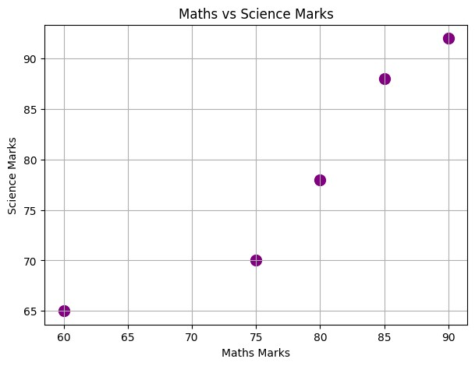
import
pandas
as
pd
import
matplotlib.pyplot
as
plt
# Previous dataset with added subject marks
data = pd.DataFrame
({

"StudentID"
:

[
1
,

2
,

3
,

4
,

5
]
,

"Name"
:

[
"A"
,

"B"
,

"C"
,

"D"
,

"E"
]
,

"Maths"
:

[
80
,

75
,

90
,

60
,

85
]
,

"Science"
:

[
78
,

70
,

92
,

65
,

88
]
,

"Attendance"
:

[
90
,

85
,

95
,

70
,

88
]
,

"Stream"
:

[
"Science"
,

"Arts"
,

"Science"
,

"Arts"
,

"Science"
]
})
plt.figure
(
figsize=
(
7
,
5
))
plt.scatter
(
data
[
"Maths"
]
,
data
[
"Science"
]
,
color=
'purple'
,
s=
100
)
plt.title
(
"Maths vs Science Marks"
)
plt.xlabel
(
"Maths Marks"
)
plt.ylabel
(
"Science Marks"
)
plt.grid
(
True
)
plt.show
()
Bar Plot
Purpose: Compare marks of students in Maths
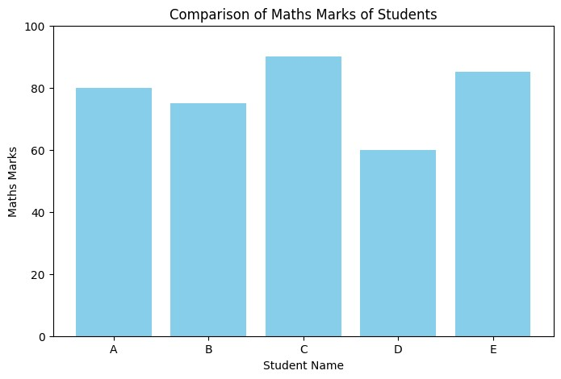
import
matplotlib.pyplot
as
plt
# Bar plot for Maths marks
plt.figure
(
figsize=
(
8
,
5
)
)
plt.bar
(
data
[
"Name"
]
,
data
[
"Maths"
]
,
color=
'skyblue'
)
plt.title
(
"Comparison of Maths Marks of Students"
)
plt.xlabel
(
"Student Name"
)
plt.ylabel
(
"Maths Marks"
)
plt.ylim
(
0
,

100
)

# optional: set y-axis limit
plt.show
(
)
Box Plot
Purpose: Show distribution and outliers of marks
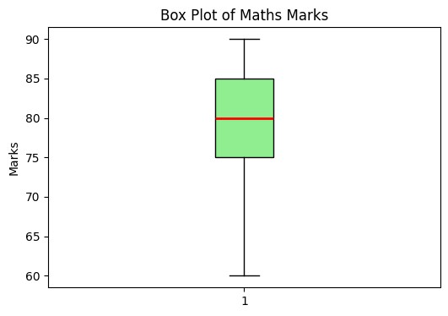
import
matplotlib.pyplot
as
plt
# Box plot for Maths marks
plt.figure
(
figsize=
(
6
,
4
))
plt.boxplot
(
data
[
"Maths"
]
,
patch_artist=
True
,
boxprops=
dict
(
facecolor=
"lightgreen"
)
,
medianprops=
dict
(
color=
"red"
,
linewidth=
2
)
,
flierprops=
dict
(
marker=
'o'
,
markerfacecolor=
'blue'
,
markersize=
8
))
plt.title
(
"Box Plot of Maths Marks"
)
plt.ylabel
(
"Marks"
)
plt.show
()
Pie Chart
Purpose: Percentage contribution of total marks by subject (average)
import
matplotlib.pyplot
as
plt
# Line chart for Maths marks trend
plt.figure
(
figsize=
(
8
,
5
))
plt.plot
(
data
[
"StudentID"
]
,
data
[
"Maths"
]
,
marker=
'o'
,
linestyle=
'-'
,
color=
'blue'
,
label=
'Maths'
)
plt.plot
(
data
[
"StudentID"
]
,
data
[
"Science"
]
,
marker=
's'
,
linestyle=
'--'
,
color=
'green'
,
label=
'Science'
)
plt.title
(
"Trend of Marks Across Students"
)
plt.xlabel
(
"StudentID"
)
plt.ylabel
(
"Marks"
)
plt.xticks
(
data
[
"StudentID"
])
plt.ylim
(
0
,

100
)
plt.grid
(
True
)
plt.legend
()
plt.show
()
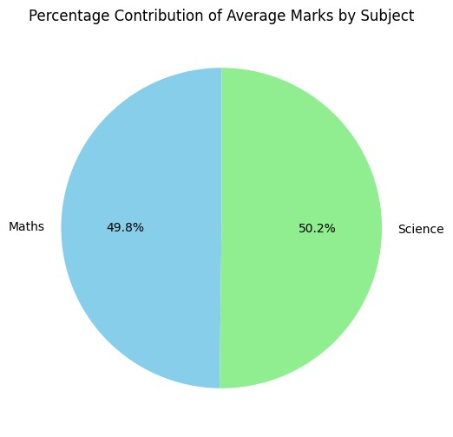
import
matplotlib.pyplot
as
plt
# Calculate average marks per subject
avg_marks = data
[[
"Maths"
,

"Science"
]]
.mean
()
# Pie chart
plt.figure
(
figsize=
(
6
,
6
))
plt.pie
(
avg_marks
,
labels=avg_marks.index
,
autopct=
'%1.1f%%'
,
colors=
[
'skyblue'
,

'lightgreen'
]
,
startangle=
90
)
plt.title
(
"Percentage Contribution of Average Marks by Subje
ct"
)
plt.show
()
Line Chart
Purpose: Trend of marks across students
