CHAPTER 1
INTRODUCTION & PROJECT OVERVIEW
1.1 Project Title
UrbanChill AI: A Geo-Intelligent Digital Twin Platform for Urban Heat Resilience

1.1 Proposed Solution
UrbanChill AI proposes a comprehensive Geo-Intelligent Digital Twin Platform capable of monitoring, analyzing, and predicting urban heat conditions.
The platform combines satellite imagery, GIS technologies, spatial databases, and machine learning into a single interactive application.
The workflow begins with a realistic 3D Earth visualization where users can explore the globe and select any city. Once a city is selected, the platform retrieves satellite imagery, calculates Land Surface Temperature (LST) and NDVI, performs spatial analysis, predicts heat-risk levels using machine learning, and presents results through an interactive planning dashboard.
The system further enables planners to simulate urban cooling strategies, compare environmental indicators, and generate analytical reports for informed decision-making.
The proposed platform shifts urban heat management from reactive observation toward proactive planning.

1.2 Scope of the Project
The scope of UrbanChill AI includes:
Included
- Interactive 3D Earth visualization.
- Global city search and navigation.
- Satellite image processing.
- Land Surface Temperature analysis.
- NDVI calculation.
- Heat hotspot detection.
- GIS visualization.
- Heat-risk prediction.
- Interactive dashboard.
- Spatial database management.
- Report generation.
- Deployment as a cloud-based web application.

1.3 Expected Outcome
The final system will provide a modern web-based platform capable of:
- Displaying a realistic rotating 3D Earth.
- Allowing users to navigate seamlessly to any city.
- Processing satellite imagery automatically.
- Identifying urban heat hotspots.
- Calculating environmental indicators.
- Predicting heat-risk levels.
- Supporting planners through interactive spatial analysis.
- Generating professional reports for urban planning.
The completed system will demonstrate the integration of GIS, remote sensing, machine learning, cloud computing, and interactive visualization into a unified urban planning platform.

1.4 Target Users
The primary users of UrbanChill AI include:
- Urban planners
- Municipal corporations
- Smart city authorities
- Environmental agencies
- Government organizations
- Climate researchers
- GIS professionals
- Academic researchers
- University students

CHAPTER 2
TECHNOLOGY STACK & SYSTEM DESIGN

2.1 Overall Technology Stack
Category | Technology
Frontend | React + TypeScript
UI Framework | Tailwind CSS + Shadcn UI
3D Visualization | CesiumJS
Backend | FastAPI
Programming Language | Python
Satellite Data | Google Earth Engine
Spatial Processing | GeoPandas, Rasterio, Shapely, Rioxarray, GDAL
Database | PostgreSQL + PostGIS
Machine Learning | Scikit-learn
ML Model | Random Forest
Model Storage | Joblib
Charts | Recharts
API Communication | Axios
State Management | React Query
Report Generation | ReportLab
Frontend Deployment | Vercel
Backend Deployment | Render

2.2 Frontend Technologies
React
Purpose
Develop the complete user interface.
Why React?
- Component-based architecture.
- Fast rendering using Virtual DOM.
- Large developer community.
- Easy maintenance.
- Industry-standard frontend framework.

2.4 Why CesiumJS?
CesiumJS is the core visualization engine of UrbanChill AI.
Unlike traditional mapping libraries, CesiumJS renders a realistic 3D globe that enables users to explore the Earth from space before navigating to individual cities.
Why CesiumJS was Selected
- Realistic 3D Earth.
- Smooth camera fly animations.
- Terrain visualization.
- Global-scale rendering.
- High-performance WebGL rendering.
- Supports GeoJSON, imagery layers, and terrain.
- Suitable for Digital Twin applications.
Responsibilities
- Display rotating Earth.
- Search and navigate cities.
- Camera fly animation.
- Display GIS layers.
- Display buildings.
- Display heatmap overlays.
- Display NDVI layers.

2.6 Backend Technology
FastAPI
Responsibilities
- Receive city requests.
- Process analysis requests.
- Connect to Google Earth Engine.
- Run machine learning models.
- Return processed results.
2.7 Google Earth Engine
Purpose
Satellite image processing.
Google Earth Engine provides cloud-based access to petabytes of satellite imagery without requiring local storage.
Datasets Used
- Landsat-8
- Sentinel-2
Used For
- Land Surface Temperature (LST)
- NDVI
- Satellite imagery
- Region clipping
- Cloud masking
2.8 Spatial Processing Libraries
GeoPandas
Purpose
Vector data processing.
Used For
- Administrative boundaries.
- Roads.
- Buildings.
- Parks.
- Spatial joins.
Rasterio
Purpose
Raster processing.
Used For
- Reading GeoTIFF files.
- Raster calculations.
- Image transformations.

Rioxarray
Purpose
Large raster handling.
Used For
- Raster clipping.
- Coordinate transformations.
Shapely
Purpose
Geometry operations.
Used For
- Buffer analysis.
- Polygon operations.
- Distance calculations.
GDAL
Purpose
Geospatial data conversion.
Used For
- Format conversion.
- Coordinate transformations.
- Raster processing.

2.9 Database
PostgreSQL
Purpose
Store application data.
Stores
- Users
- Analysis history
- Reports
- Metadata

PostGIS
Purpose
Spatial database extension.
Stores
- Buildings
- Roads
- Parks
- Water bodies
- Administrative boundaries

2.10 Machine Learning
Scikit-learn
Purpose
Machine Learning framework.
Responsibilities
- Data preprocessing.
- Feature engineering.
- Model training.
- Model evaluation.

Random Forest
Purpose
Predict heat-risk levels.
Input Features
- Land Surface Temperature
- NDVI
- Building Density
- Population Density
- Road Density
- Green Cover
- Distance to Water Bodies (optional)
- Elevation (optional)
2.11 Data Flow
The complete data flow of UrbanChill AI is shown below.
User opens application
↓
Rotating Earth appears
↓
User searches or clicks a city
↓
CesiumJS sends city coordinates
↓
FastAPI receives request
↓
Google Earth Engine retrieves satellite imagery
↓
Satellite data is processed
↓
Land Surface Temperature calculated
↓
NDVI calculated
↓
Spatial features extracted
↓
Random Forest predicts heat risk
↓
Results stored in PostgreSQL
↓
Dashboard updated
↓
User interacts with layers and analytics

CHAPTER 3
SYSTEM ARCHITECTURE & PROJECT WORKFLOW

3.1 Introduction
UrbanChill AI is designed as a modular, scalable, and cloud-based Geo-Intelligent Digital Twin Platform. Instead of combining all functionalities into a single application layer, the system is divided into multiple independent modules. Each module performs a specific task such as satellite image retrieval, spatial processing, machine learning, or report generation.
This modular architecture improves maintainability, scalability, and allows different team members to work independently.

3.2 Overall System Architecture
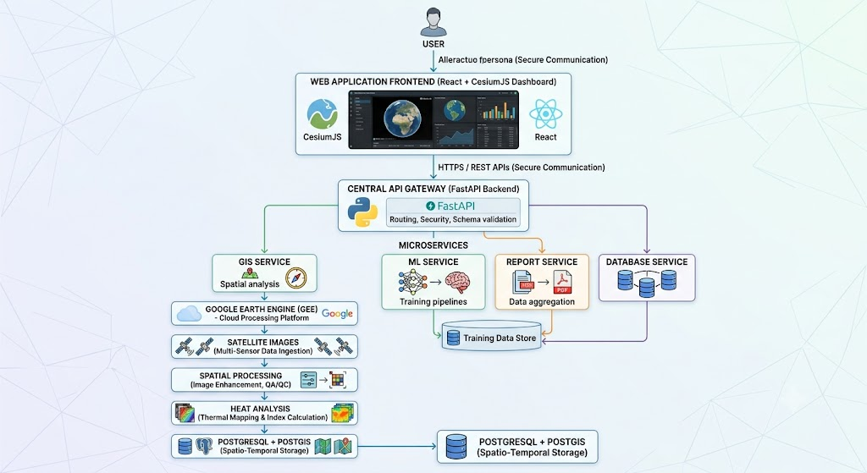

3.3 Architecture Layers
The application follows a five-layer architecture.
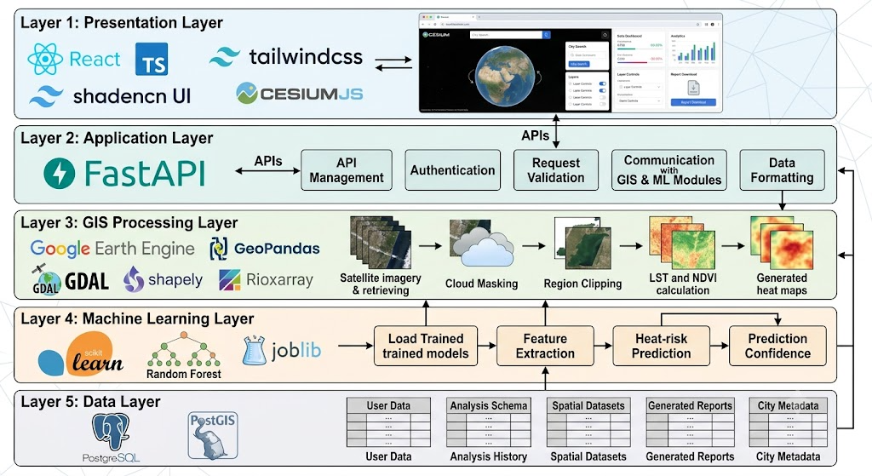
Layer 1 – Presentation Layer
Responsible for user interaction.
Components:
- React
- TypeScript
- Tailwind CSS
- Shadcn UI
- CesiumJS
Responsibilities:
- Display rotating Earth
- Search cities
- Show dashboard
- Display analytics
- Layer controls
- Report download

Layer 2 – Application Layer
Responsible for business logic.
Technology:
- FastAPI
Responsibilities:
- API management
- Authentication (future)
- Request validation
- Communication with GIS and ML modules
- Data formatting
Layer 3 – GIS Processing Layer
Responsible for satellite data analysis.
Technologies:
- Google Earth Engine
- Rasterio
- GeoPandas
- GDAL
- Shapely
- Rioxarray
Responsibilities:
- Retrieve satellite imagery
- Cloud masking
- Region clipping
- Calculate LST
- Calculate NDVI
- Generate heat maps
- Prepare GIS layers
Layer 4 – Machine Learning Layer
Technology:
- Scikit-learn
- Random Forest
- Joblib
Responsibilities:
- Load trained model
- Feature extraction
- Heat-risk prediction
- Prediction confidence

Layer 5 – Data Layer
Technology:
- PostgreSQL
- PostGIS
Stores:
- User data
- Analysis history
- Spatial datasets
- Generated reports
- City metadata

3.4 User Workflow
The user journey begins with an immersive globe and ends with detailed urban heat analysis.
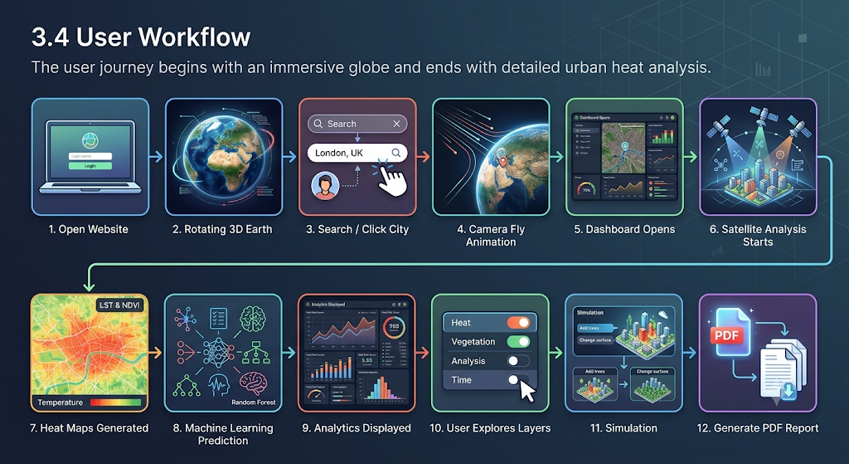
3.5 Landing Page Workflow
When users first open the application, they should experience a modern, immersive interface rather than a traditional dashboard.
Interface Elements
- Space background
- Rotating Earth
- Atmospheric lighting
- Search bar
- Project title
- Start Analysis button (optional)
The user can:
- Rotate the globe
- Zoom
- Search any city
- Click directly on the globe
No dashboard is displayed initially.

3.6 City Selection Workflow
The user has two options:
Option 1 : Search for a city.
Example:
Search
↓
Pune
↓
Camera Fly
Option 2
Rotate Earth
↓
Click City
↓
Camera Fly

3.7 Camera Fly Animation
Instead of loading a new page, CesiumJS performs a smooth camera animation.
Example:
Earth
↓
Asia
↓
India
↓
Maharashtra
↓
Pune
↓
City View

3.8 Dashboard Loading
Once the camera reaches the city:
The dashboard slides into view.
---------------------------------------------------------
Layers | 3D City View | Analytics
---------------------------------------------------------
Heat | | Temperature
NDVI | | NDVI
Buildings | CesiumJS Map | Heat Risk
Roads | | Reports
Parks | | Simulation
---------------------------------------------------------
The dashboard remains synchronized with the map.

3.9 Backend Processing Workflow
After city selection:
City Coordinates
↓
FastAPI
↓
Google Earth Engine
↓
Satellite Images
↓
Cloud Removal
↓
Clip Study Area
↓
LST
↓
NDVI
↓
Spatial Analysis
↓
Random Forest
↓
Results
↓
Frontend

3.10 GIS Processing Workflow
Region Selected
↓
Landsat-8
↓
Sentinel-2
↓
Satellite Bands
↓
Cloud Mask
↓
Clip ROI
↓
Calculate NDVI
↓
Calculate LST
↓
Export Results
Output:
- Temperature raster
- Vegetation raster
- Heat map
- Spatial layers

3.11 Machine Learning Workflow
Processed GIS Data
↓
Feature Extraction
↓
Random Forest Model
↓
Heat Risk Prediction
↓
Prediction Score
↓
Dashboard
Input Features:
- Land Surface Temperature
- NDVI
- Building Density
- Road Density
- Population Density
- Green Cover
Output:
- Low Risk
- Medium Risk
- High Risk
3.12 Report Generation Workflow
Dashboard
↓
Generate Report
↓
Backend
↓
Charts
↓
Maps
↓
Statistics
↓
PDF Report
↓
Download
The generated report includes:
- Heat map
- NDVI map
- Heat-risk classification
- Key statistics
- Planning recommendations
- Date and location
3.14 Module Responsibilities
Frontend Module
Responsibilities:
- User interface
- Cesium globe
- Dashboard
- Charts
- Layer controls

Backend Module
Responsibilities:
- APIs
- Request handling
- Data validation
- Service orchestration

GIS Module
Responsibilities:
- Satellite processing
- LST
- NDVI
- Spatial analysis

Machine Learning Module
Responsibilities:
- Heat-risk prediction
- Model loading
- Feature processing

Database Module
Responsibilities:
- Store users
- Store analyses
- Store spatial metadata
- Store reports
3.15 Proposed Advanced Features
Feature 1: Historical Time Slider
Objective
Allow users to compare urban heat conditions over different years.
Description
Users can move a timeline slider to visualize historical changes in:
- Land Surface Temperature (LST)
- NDVI
- Urban Expansion
- Green Cover
- Built-up Areas
Example:
2018 ─────────●──────── 2026
As the slider moves, the map updates automatically.
Technologies Used
- Google Earth Engine
- CesiumJS
- React
Feature 2: Multi-Layer GIS Visualization
Objective
Enable planners to visualize multiple environmental datasets simultaneously.
Available Layers
- Land Surface Temperature
- NDVI
- Buildings
- Roads
- Parks
- Water Bodies
- Population Density
- Administrative Boundaries
- Heat Risk Zones
Users can enable or disable each layer independently.
Technologies Used
- CesiumJS
- GeoJSON
- PostGIS
Feature 3: Interactive Heat Analysis
Objective
Provide detailed information for any selected location.
Description
When a user clicks any point on the map, the system displays:
- Temperature
- NDVI
- Heat Risk Level
- Building Density
- Green Cover Percentage
- Population Density
This provides localized environmental analysis without requiring additional searches.
Feature 4: Heat-Risk Prediction
Objective
Predict the severity of urban heat for the selected region.
Input Parameters
- Land Surface Temperature
- NDVI
- Building Density
- Road Density
- Population Density
- Green Cover
Technology
- Scikit-learn
- Random Forest
Output
- Low Risk
- Medium Risk
- High Risk
The predicted heat-risk layer is displayed directly on the map.

Feature 5: What-If Simulation
Objective
Evaluate the impact of proposed cooling interventions.
Simulation Options
- Increase tree plantation
- Add urban parks
- Install cool roofs
- Increase green cover
- Expand water bodies
The system recalculates environmental indicators after each simulation.
Output
- Estimated temperature reduction
- Updated heat-risk level
- Estimated increase in vegetation
- Comparison before and after intervention

Feature 6: Comparative City Analysis
Objective
Compare environmental conditions between two cities.
Example
Pune vs Hyderabad
The dashboard compares:
- Average LST
- NDVI
- Green Cover
- Building Density
- Heat Risk
This helps planners evaluate urban planning strategies across cities.

Feature 7: Spatial Analytics Dashboard
The dashboard displays:
- Average Temperature
- Maximum Temperature
- Minimum Temperature
- Average NDVI
- Green Cover Percentage
- Built-up Area Percentage
- Heat-Risk Distribution
Charts update automatically when the selected city changes.
Technologies Used
- Recharts
- React
- FastAPI

Feature 8: PDF Report Generation
Generate a professional report containing:
- Selected City
- Date of Analysis
- Heat Map
- NDVI Map
- Heat-Risk Classification
- Environmental Statistics
- Suggested Mitigation Measures
The report can be downloaded for planning and documentation purposes.
Technology : ReportLab
Feature 9: Saved Analysis History
Users can save completed analyses for future comparison.
Stored Information
- City
- Date
- Heat Map
- NDVI
- Heat Risk
- Report
Technology
- PostgreSQL
- PostGIS

Feature 10: Responsive Dashboard
The dashboard is fully responsive and optimized for:
- Desktop
- Laptop
- Tablet
All maps, charts, and panels automatically adjust based on screen size.

Feature 11: Real-Time Layer Controls
Users can dynamically switch between map layers without reloading the application.
Supported Layers
- Satellite Imagery
- Terrain
- Heat Map
- NDVI
- Buildings
- Roads
- Water Bodies
- Parks
- Population Density
This improves usability and allows planners to focus on specific datasets.

Feature 12: Enterprise-Style User Experience
UrbanChill AI is designed to provide a seamless workflow:
- Open the application.
- Explore the rotating 3D Earth.
- Search or click a city.
- Experience a smooth camera fly-to animation.
- Watch the Urban Intelligence Workspace appear.
- View heat maps, NDVI, analytics, and predictions.
- Simulate mitigation strategies.
- Export reports for planning and decision-making.
This workflow offers a modern, intuitive, and immersive experience suitable for professional GIS applications.

CHAPTER 4
USER INTERFACE (UI/UX) DESIGN & USER WORKFLOW

4.1 Introduction
The User Interface (UI) of UrbanChill AI is designed to provide an immersive and intuitive experience for urban planners, researchers, and environmental analysts. Unlike conventional GIS applications that open directly to a static map, UrbanChill AI begins with an interactive 3D Earth, allowing users to navigate naturally from a global view to city-level analysis.
The design follows the principles of simplicity, responsiveness, consistency, and accessibility while maintaining a professional enterprise-style appearance.

4.2 UI Design Objectives
The interface is designed to:
- Provide an engaging first impression.
- Simplify city selection and navigation.
- Present complex spatial information in an easy-to-understand manner.
- Minimize user interaction steps.
- Support interactive exploration of environmental data.
- Deliver a responsive experience across devices.

4.3 Complete User Journey
The complete user workflow is illustrated below.
Open Website
│
▼
Landing Page
│
▼
3D Rotating Earth
│
▼
Search or Click City
│
▼
Camera Fly Animation
│
▼
Urban Intelligence Workspace Opens
│
▼
Satellite Analysis Starts
│
▼
Heat Layers & Analytics Displayed
│
▼
User Explores Layers
│
▼
Run Simulation
│
▼
Export Report

4.4 Landing Page Design
The landing page is the first screen users interact with.
Purpose
Provide an immersive introduction while allowing users to immediately begin exploring the Earth.
Components
- Space background
- Rotating 3D Earth
- Project title
- Project description
- Search bar
- Navigation menu

Example Layout:
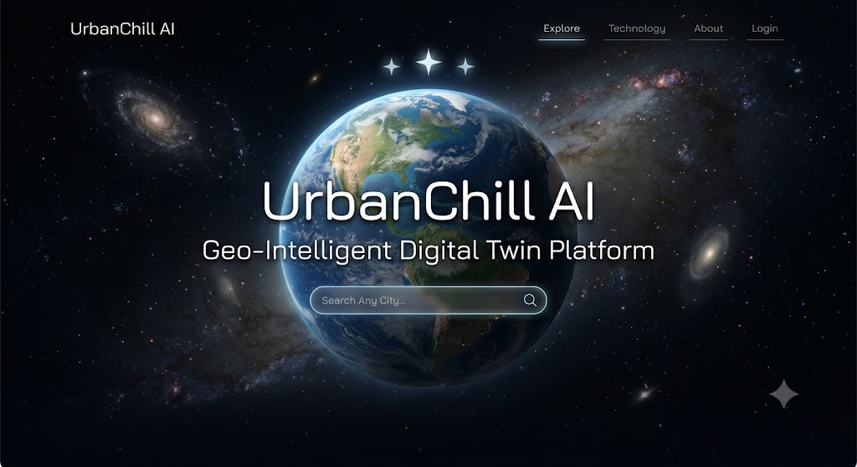
Technologies Used
- React
- CesiumJS
- Tailwind CSS

4.5 Earth Interaction
Users can directly interact with the Earth.
Supported interactions include:
- Rotate globe
- Zoom in
- Zoom out
- Pan
- Search cities
- Click any city
The Earth continues rotating slowly until the user interacts with it.

4.6 City Search
Users may search for any city using the search bar.

Workflow
Enter City Name
↓
Search Suggestions
↓
Select City
↓
Camera Fly Animation
The selected city's geographic coordinates are sent to the backend for analysis.

4.7 Camera Fly Animation
Rather than opening a new page, the camera smoothly transitions from space to the selected city.
Example
Earth
↓
Asia
↓
India
↓
State
↓
City
↓
3D City View
This creates a seamless navigation experience similar to professional digital globe applications.

4.8 Urban Intelligence Workspace
After reaching the selected city, the dashboard appears.
The layout consists of three sections.

Left Sidebar
Purpose
Layer management and tools.
Modules
- Heat Map
- NDVI
- Buildings
- Roads
- Parks
- Water Bodies
- Population Density
- Heat Risk
- Time Slider
- Simulation
- Reports

Center Panel
Displays the interactive Cesium map.
Features
- Satellite imagery
- Terrain
- Buildings
- Heatmap
- NDVI
- Administrative boundaries
- Camera controls

Right Sidebar
Displays analytics.
Information shown
- Selected City
- Average Temperature
- Maximum Temperature
- NDVI
- Green Cover
- Building Density
- Heat Risk
- Analysis Summary

4.9 Dashboard Layout
---------------------------------------------------------------
| Navigation Bar |
---------------------------------------------------------------
| Layers | | Analytics |
| | | |
| Heat | | Avg Temp |
| NDVI | | Max Temp |
| Roads | CesiumJS Viewer | NDVI |
| Parks | | Heat Risk |
| Water | | Reports |
| Time | | Summary |
---------------------------------------------------------------

4.10 Layer Controls
Users can enable or disable individual layers.
Available Layers
- Satellite
- Terrain
- Buildings
- Roads
- Parks
- Water Bodies
- NDVI
- Heat Map
- Heat Risk
- Population Density
Multiple layers can be displayed simultaneously.

4.11 Historical Time Slider
The time slider allows comparison of environmental conditions across different years.
Example
2018 ────────●──────── 2026
Updating the slider refreshes:
- LST
- NDVI
- Heat Map
- Built-up Areas
This helps analyze long-term urban development.

4.12 Interactive Map Analysis
Users may click any point on the map.
A popup displays:
- Latitude
- Longitude
- Temperature
- NDVI
- Heat Risk
- Building Density
- Green Cover
This enables localized environmental analysis.

4.13 Heat Analysis Panel
The analytics panel presents processed environmental information.
Displayed Metrics
- Average Temperature
- Maximum Temperature
- Minimum Temperature
- Average NDVI
- Green Cover
- Built-up Area
- Heat Risk
- Population Density
Values update automatically when a new city is selected.

4.14 Simulation Interface
The simulation module allows planners to evaluate proposed mitigation measures.
Available Simulations
- Add Trees
- Increase Green Cover
- Install Cool Roofs
- Add Parks
- Expand Water Bodies
The system recalculates projected environmental indicators after each simulation.

4.15 Comparative Analysis
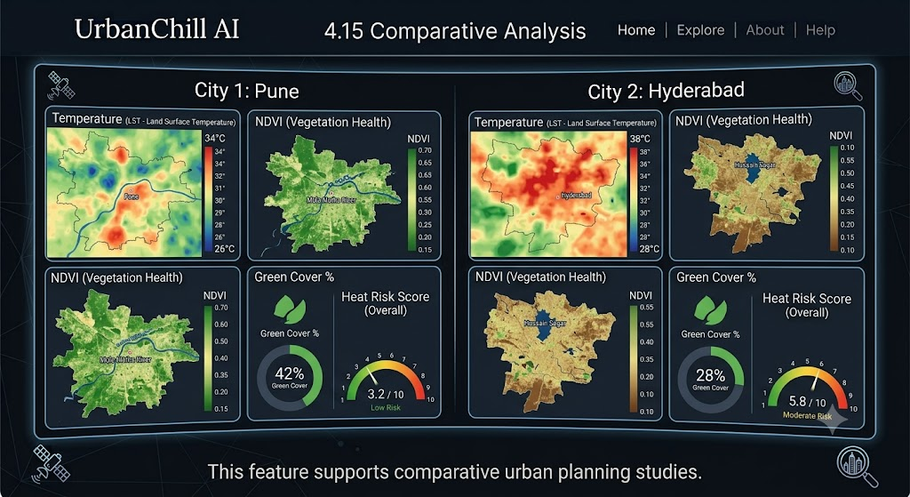
4.16 Report Generation
Users can export analysis results as a PDF report.
The report includes:
- Selected City
- Satellite Image
- Heat Map
- NDVI Map
- Environmental Statistics
- Heat-Risk Classification
- Simulation Results
- Recommendations

4.17 Responsive Design
The interface is optimized for:
- Desktop
- Laptop
- Tablet
Responsive design ensures that all maps, charts, and controls remain accessible across supported devices.

4.18 UI Design Principles
UrbanChill AI follows these principles:
- Simple navigation
- Minimal learning curve
- Consistent design language
- Responsive layouts
- Interactive visualization
- Fast user feedback
- Professional enterprise appearance

CHAPTER 5
FEATURE IMPLEMENTATION

5.1 Introduction
This chapter provides a brief overview of how each feature of UrbanChill AI will be implemented. It explains the implementation approach, technologies involved, and expected outputs.

5.2 Historical Time Slider
Implementation
The historical time slider allows users to compare environmental conditions across different years. When the selected year changes, a request is sent to the backend, which retrieves satellite imagery from Google Earth Engine. The system recalculates LST and NDVI for the selected year and updates the CesiumJS map and dashboard.
Technologies
- React
- CesiumJS
- FastAPI
- Google Earth Engine
Output
- Historical Heat Map
- Historical NDVI
- Updated Analytics

5.3 Multi-Layer GIS Visualization
Implementation
The application displays multiple GIS layers that users can enable or disable independently. Each layer is loaded dynamically from the backend and rendered on the CesiumJS globe.
Layers
- Heat Map
- NDVI
- Buildings
- Roads
- Parks
- Water Bodies
- Population Density
Technologies
- CesiumJS
- GeoJSON
- PostGIS

5.4 Interactive Heat Analysis
Implementation
Users can click any location on the map to view detailed environmental information. The backend retrieves the spatial attributes for the selected location and displays them in a popup.
Displayed Information
- Temperature
- NDVI
- Heat Risk
- Building Density
- Green Cover
- Population Density

5.5 Heat-Risk Prediction
Implementation
The backend extracts environmental features and passes them to a trained Random Forest model. The model predicts the heat-risk level, and the result is displayed on the dashboard.
Input
- LST
- NDVI
- Building Density
- Road Density
- Population Density
- Green Cover
Output
- Low Risk
- Medium Risk
- High Risk
Technologies
- Scikit-learn
- Random Forest
- Joblib

5.6 What-If Simulation
Implementation
Users can simulate urban cooling strategies such as increasing tree cover or adding cool roofs. The system recalculates the estimated environmental impact and updates the visualizations.
Simulation Options
- Tree Plantation
- Urban Parks
- Cool Roofs
- Green Cover
- Water Bodies
Output
- Estimated Temperature Reduction
- Updated Heat Risk
- Comparison Results

5.7 Comparative City Analysis
Implementation
Users can compare environmental conditions between two selected cities. The dashboard displays key indicators side by side to support comparative analysis.
Comparison Parameters
- Average Temperature
- NDVI
- Green Cover
- Building Density
- Heat Risk

5.8 Spatial Analytics Dashboard
Implementation
The dashboard presents important environmental statistics using interactive charts and summary cards. Data is updated automatically whenever a new city is analyzed.
Dashboard Metrics
- Average Temperature
- Maximum Temperature
- Minimum Temperature
- Average NDVI
- Green Cover
- Built-up Area
- Heat-Risk Distribution
Technologies
- React
- Recharts
- FastAPI

5.9 PDF Report Generation
Implementation
The system generates a downloadable PDF report containing the analysis results, maps, and key statistics for the selected city.
Report Includes
- City Information
- Heat Map
- NDVI Map
- Heat-Risk Classification
- Environmental Statistics
- Simulation Results
Technology
- ReportLab

5.10 Saved Analysis History
Implementation
The system stores previous analyses in the PostgreSQL database, allowing users to review earlier results without rerunning the analysis.
Stored Data
- City Name
- Analysis Date
- LST
- NDVI
- Heat Risk
- Report Reference
Technologies
- PostgreSQL
- PostGIS

5.11 Responsive Dashboard
Implementation
The interface adapts automatically to different screen sizes while maintaining usability and readability.
Supported Devices
- Desktop
- Laptop
- Tablet

5.12 Real-Time Layer Controls
Implementation
Users can dynamically show or hide map layers without refreshing the application. Layer visibility is managed directly within the CesiumJS viewer.
Supported Layers
- Satellite Imagery
- Terrain
- Heat Map
- NDVI
- Buildings
- Roads
- Parks
- Water Bodies
- Population Density

5.13 Enterprise-Style User Experience
Implementation Workflow
Open Website
│
▼
Rotating 3D Earth
│
▼
Search or Select City
│
▼
Camera Fly Animation
│
▼
Satellite Analysis
│
▼
Heat Maps & Analytics
│
▼
Run Simulations
│
▼
Download Report
This workflow provides an intuitive and professional user experience while supporting effective urban heat analysis.

CHAPTER 6
Database Design
6.1 Introduction
UrbanChill AI uses PostgreSQL with the PostGIS extension to store spatial and application data. PostGIS enables efficient storage and querying of geographic information such as city boundaries, analysis results, and spatial layers.

6.2 Database Technologies
- PostgreSQL
- PostGIS

6.3 Database Tables
Table | Purpose
Users | Store user information
Cities | Store city details and coordinates
Analysis | Store heat analysis results
Reports | Store generated report metadata

6.4 Stored Data
- City Name
- Latitude & Longitude
- Analysis Date
- LST
- NDVI
- Heat Risk
- Report Path

CHAPTER 7
API Design & Backend Services
7.1 Introduction
The backend is developed using FastAPI, which provides REST APIs for communication between the frontend, machine learning model, database, and Google Earth Engine.

7.2 API Workflow
React Dashboard
│
▼
FastAPI
│
┌──────┼───────┐
▼ ▼ ▼
GEE ML PostgreSQL

7.3 Main APIs
API | Method | Purpose
/analyze | POST | Analyze selected city
/heatmap | GET | Return heat map
/ndvi | GET | Return NDVI layer
/prediction | GET | Predict heat risk
/timeline | GET | Historical analysis
/report | POST | Generate PDF report

7.4 Advantages
- High performance
- Easy integration with Python
- Automatic API documentation
- Scalable architecture

CHAPTER 8
Machine Learning Pipeline
8.1 Introduction
UrbanChill AI uses a Random Forest model to predict the heat-risk level of urban regions using environmental and spatial features.

8.2 Dataset Features
- Land Surface Temperature (LST)
- NDVI
- Building Density
- Road Density
- Population Density
- Green Cover

8.3 Workflow
Dataset
│
▼
Preprocessing
│
▼
Feature Engineering
│
▼
Random Forest Training
│
▼
Model Saved (Joblib)
│
▼
Prediction

8.4 Output
The model classifies areas into:
- Low Risk
- Medium Risk
- High Risk

CHAPTER 8
Machine Learning Pipeline
8.1 Introduction
UrbanChill AI uses a Random Forest model to predict the heat-risk level of urban regions using environmental and spatial features.
8.2 Dataset Features
- Land Surface Temperature (LST)
- NDVI
- Building Density
- Road Density
- Population Density
- Green Cover
8.3 Workflow
Dataset
│
▼
Preprocessing
│
▼
Feature Engineering
│
▼
Random Forest Training
│
▼
Model Saved (Joblib)
│
▼
Prediction

  - Output
The model classifies areas into: Low Risk, Medium Risk, High Risk

CHAPTER 9
Google Earth Engine & GIS Processing
9.1 Introduction
Google Earth Engine (GEE) is used to access and process satellite imagery in the cloud. It provides historical and current Earth observation data required for environmental analysis.
9.2 Satellite Datasets
- Landsat-8
- Sentinel-2
9.3 Processing Workflow
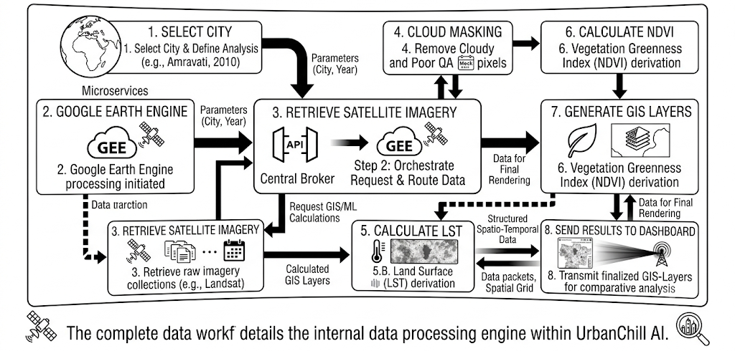
9.4 Outputs
- Land Surface Temperature (LST)
- NDVI
- Heat Map
- Vegetation Map
- Spatial Layers

