

NETFLIX DATASET ANALYSIS

Name: Gagan Dhanapune Email: gagandhanapune@gmail.com
1. Project Overview
This project provides a comprehensive analysis of the Netflix content dataset from Kaggle. The goal is to process a raw dataset, uncover meaningful insights through analysis and visualization, and apply machine learning models to discover patterns and make predictions. The project is structured into distinct phases, starting from data preparation and moving through to advanced analytics.
Project Modules:
- Data Cleaning & Preprocessing: Handling missing values and standardizing data.
- Data Normalization: Preparing categorical data for analysis and modeling.
- Exploratory Data Analysis (EDA) & Feature Engineering: Visualizing trends and creating new, insightful features.
- Modeling & Advanced Analytics: Applying unsupervised and supervised learning to discover patterns and make predictions.

2. Phase 1: Data Cleaning
Objective: To transform the raw dataset into a clean, consistent, and reliable format suitable for analysis.
Steps Performed:
- Loading the Dataset: The initial netflix_titles.csv dataset, containing 8,807 rows and 12 columns, was loaded into a pandas DataFrame.
- Handling Missing Values: A significant number of missing values were identified in the director, cast, and country columns. These were filled with the placeholder "NA" to ensure no data was lost while acknowledging the absence of information.
- Removing Duplicates: All duplicate rows were identified and removed to ensure the integrity and accuracy of the analysis.
- Duration Extraction: The duration column (e.g., "90 min", "2 Seasons") was split into two new columns:
  - duration_num: A numeric value (e.g., 90, 2).
  - duration_type: The unit of duration (e.g., "min", "Season").
- Date Formatting: The date_added column was converted to a standard datetime format to enable time-based analysis.
- Text Standardization: Extra leading/trailing spaces were removed from text columns like title to ensure consistency.
Outcome: The result of this phase was a clean and structured dataset, ready for normalization and exploratory analysis.

3. Phase 2: Data Normalization
Objective: To convert categorical data into a numerical format, making it suitable for mathematical and statistical modeling.
Steps Performed:
- Encoding Categorical Features:
  - Genres (listed_in): This column often contained multiple genres. It was one-hot encoded using MultiLabelBinarizer to create separate binary columns for each genre (e.g., is_Drama, is_Comedy).
  - Rating: The rating column was ordinally encoded based on content maturity levels (e.g., G, PG, TV-MA).
  - Country: The country column was label-encoded to convert country names into unique numeric codes.
- Feature Engineering:
  - The type column was encoded into two binary columns: is_movie and is_tv_show.
Outcome: This phase produced a fully numeric, normalized dataset (netflix_normalized.csv) prepared for advanced analysis and machine learning.

4. Phase 3: Exploratory Data Analysis (EDA)
Objective: To visualize and understand the key trends, distributions, and relationships within the cleaned dataset.
Key Insights from EDA:
- Content Type Distribution:
  - The Netflix library is predominantly composed of Movies, which account for 69.4% of the content.
  - TV Shows make up the remaining 30.6%, indicating a clear focus on feature-length films.
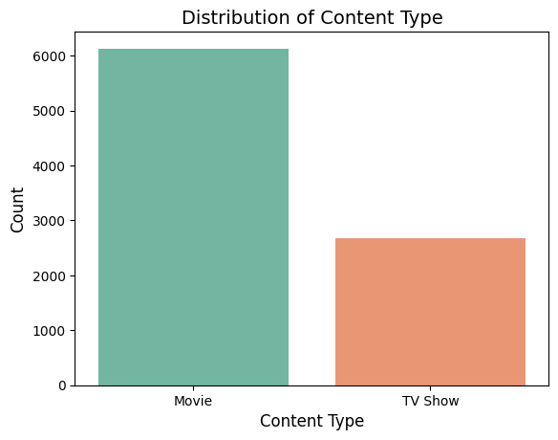

- Content Growth Over Time:
  - A dramatic increase in content addition began around 2015.
  - The peak years for adding new titles were 2018 and 2019, showing a period of aggressive content acquisition.
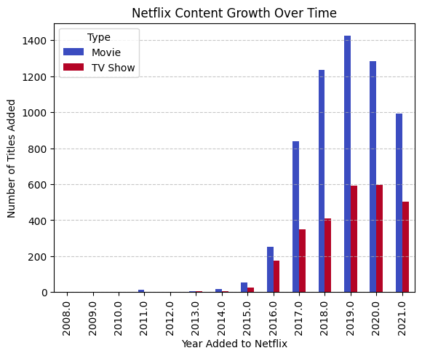

- Release Year Trends:
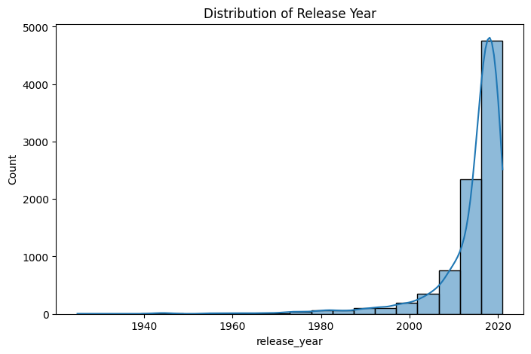
  - The majority of content on Netflix is recent, with most titles produced after 2010.
  - The median release year is 2017, suggesting the catalog is kept fresh with modern content.

- Rating Analysis:
  - The most common ratings are TV-MA (Mature Audiences) and TV-14 (Parents Strongly Cautioned).
  - This shows that Netflix's content is heavily skewed towards mature and young adult audiences.
  - Content for young children (TV-Y, TV-G) is significantly less common.
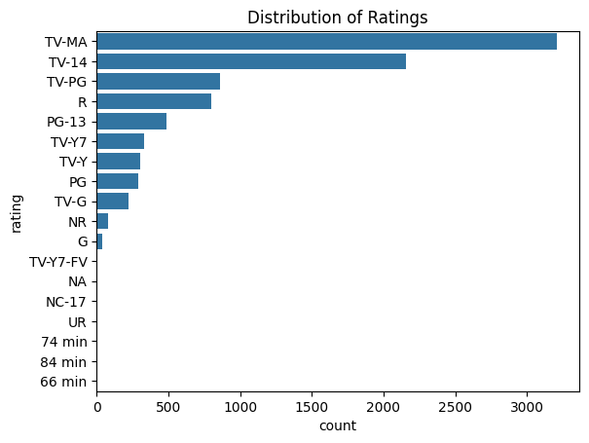

- Geographical Distribution:
  - The United States is the largest contributor of content to the Netflix library by a wide margin.
  - India ranks as the second-largest contributor, highlighting the importance of its film industry.
  - The United Kingdom is third, followed by other key markets like Canada and South Korea.
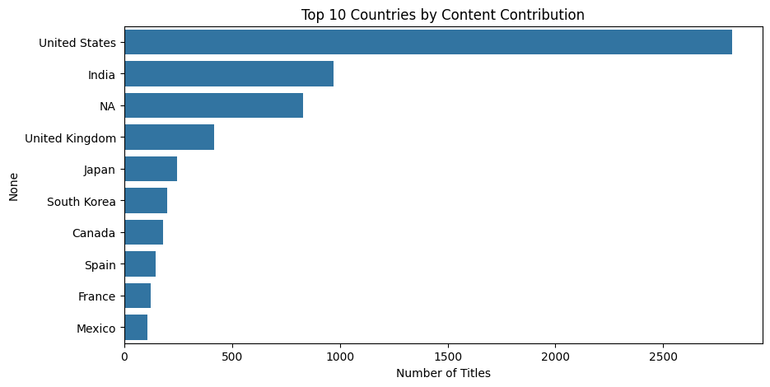
- Duration Analysis:
  - On average, the duration of a movie is significantly longer (in minutes) than the number of seasons for a TV show.
  - For TV shows, there is a trend that more recently released shows tend to have fewer seasons.

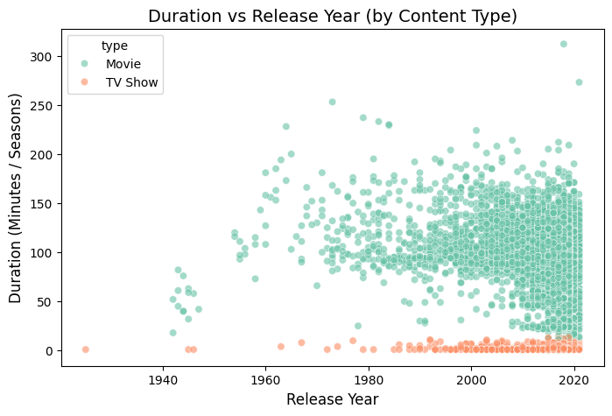
5. Phase 4: Feature Engineering
Objective: To create new, meaningful features from the existing data to enhance the modeling phase and derive deeper business insights.
New Features Created:
- Content_Length_Category: Categorized titles into groups like "Short," "Medium," and "Long" based on their duration (minutes for movies, seasons for TV shows).
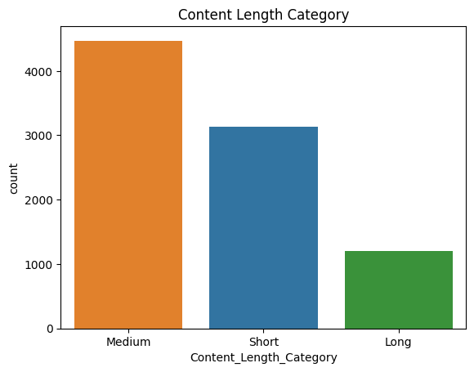

- Content_Type: Differentiated between "Original" and "Licensed" content, which is a key business metric.
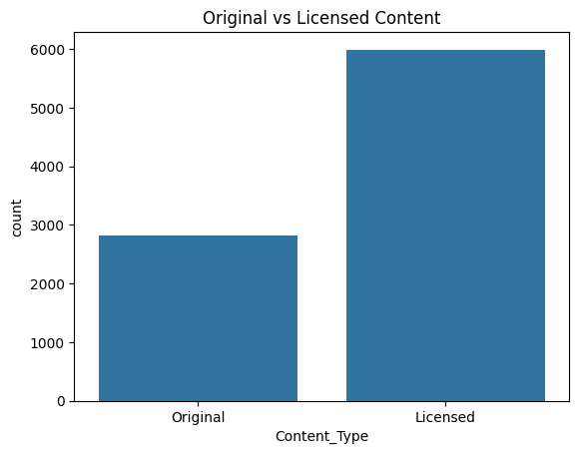
- Content_Age_Group: Simplified the rating column into broader audience categories: "Kids," "Teens," and "Adults."
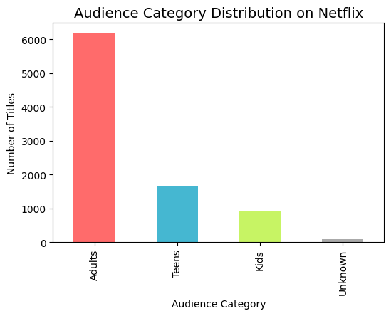
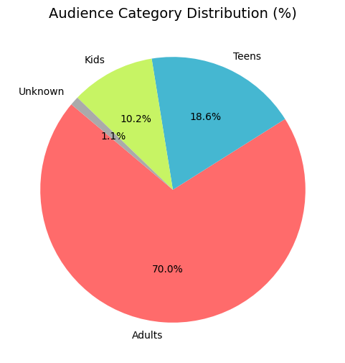
- Region: Mapped countries of production to geographical regions like "North America," "Asia," and "Europe."
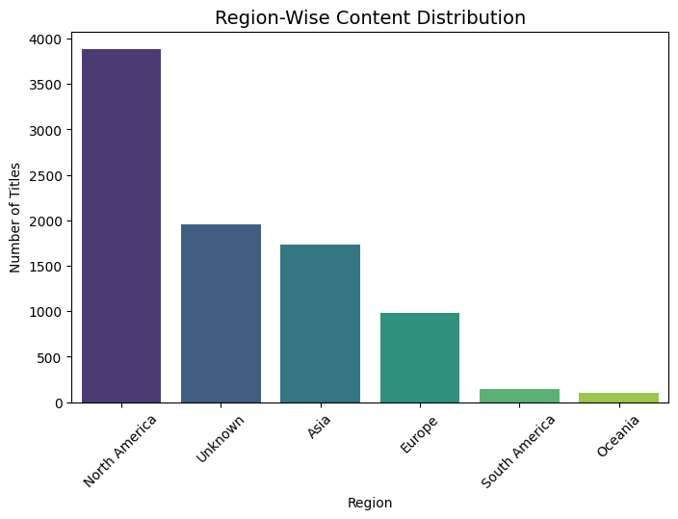
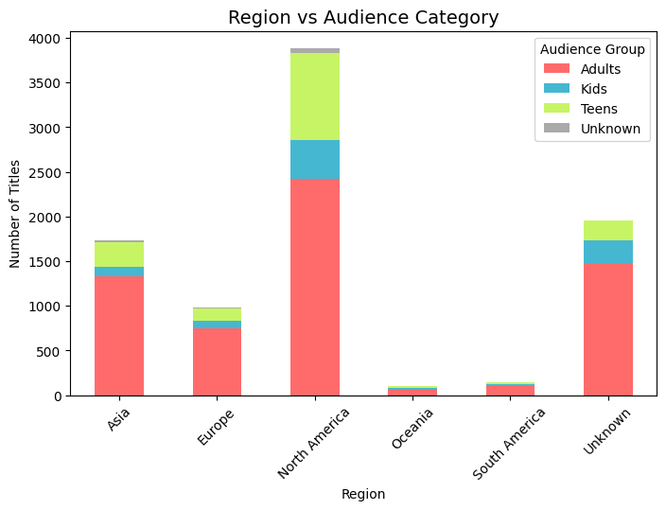
- Time-Based Features: Extracted year_added and month_added from the date_added column to analyze temporal trends.
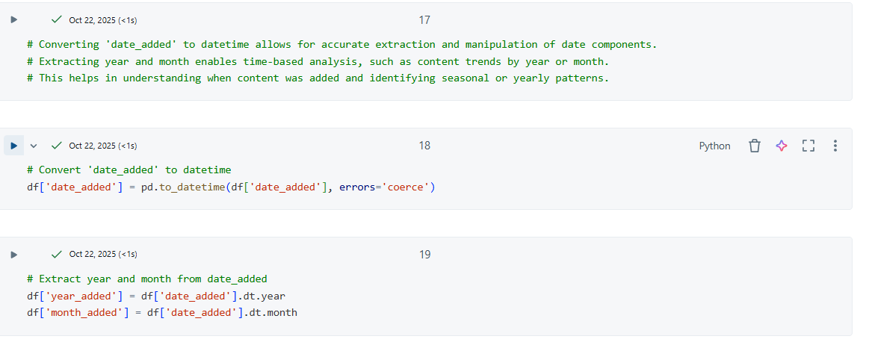
Outcome: This phase produced a feature-rich dataset (Netflix_FE_Data.csv) that provides a much deeper understanding of the content library.

6. Phase 5: Modeling & Advanced Analytics
Objective: To apply machine learning algorithms to uncover hidden patterns (clustering) and build a predictive model (classification).
Part A: Clustering (Unsupervised Learning)
Goal: To group similar Netflix titles based on their genre, duration, and rating. Since the data is unlabeled, K-Means clustering was used to identify natural groupings.
Process:
- Feature Selection: Chose listed_in (genre), duration_num, and rating as the features for clustering.
- Data Preparation:
  - Genres were one-hot encoded.
  - TV show season counts were converted to an approximate minute-equivalent to standardize the duration feature.
  - Ratings were label-encoded into numerical values.
- Scaling: All features were scaled using StandardScaler to ensure that no single feature dominated the clustering algorithm due to its scale.
- Modeling: A K-Means model was trained to group the data into 5 distinct clusters.

Results & Insights:
- The clustering successfully grouped the titles. Cluster 2 was the largest, containing 70% of the content.
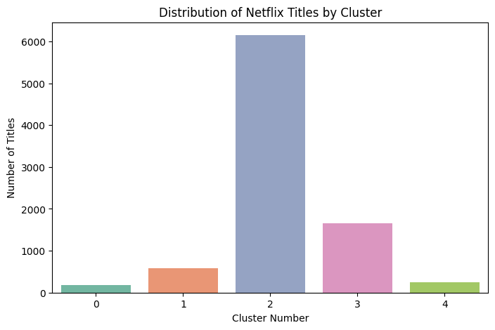
- Cluster Interpretation:
  - Cluster 0, 3, 4: Primarily contained TV Shows with TV-MA ratings.
  - Cluster 1 & 2: Predominantly consisted of Movies with TV-MA ratings.
- The model effectively separated Movies and TV Shows, indicating that duration was a strong differentiating factor.

Part B: Classification (Supervised Learning)
Goal: To build a model that can predict whether a piece of content is a Movie or a TV Show based on its features.
Process:
- Feature & Target Selection:
  - Features (X): release_year, duration_num, rating.
  - Target (y): type (Movie/TV Show).
- Data Preparation: The categorical rating and type columns were converted into numerical format using LabelEncoder.
- Train-Test Split: The data was split into a training set (80%) and a testing set (20%).
- Modeling: A Random Forest Classifier was trained on the training data.

Results & Insights:
- Model Performance: The model achieved an outstanding accuracy of 99.9% on the test set.
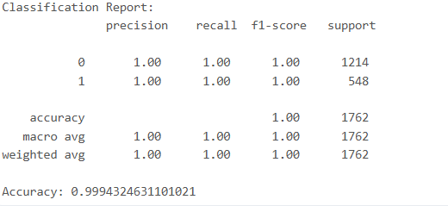

- Confusion Matrix: The matrix showed that the model made almost no errors, correctly classifying 1214 movies and 547 TV shows, with only one misclassification.
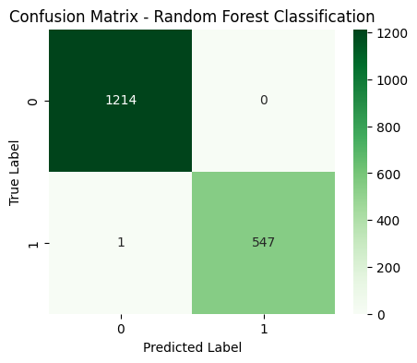
- Feature Importance: The analysis revealed that duration_num was by far the most important feature for distinguishing between movies and TV shows. This is intuitive, as movies are measured in minutes (e.g., 90-150) while TV shows are measured in seasons (e.g., 1-10). Rating and release_year had minimal impact on the prediction.

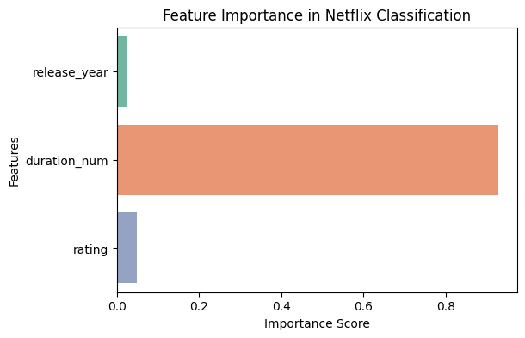
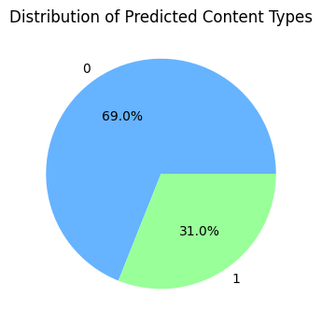
7. Phase 6: Modeling & Advanced Analytics
Part C: Advanced Analysis (Content Availability Drivers)
Model Used: Logistic Regression. This algorithm is specifically chosen not just for prediction, but for the interpretability of its Coefficient values, which directly indicate the magnitude and direction (positive or negative) of a feature's impact on the outcome.
Feature Impact Analysis (Logistic Regression Coefficients):
Feature | Coefficient | Interpretation
duration | +0.0006 | The effect is very small, but slightly positive, suggesting a marginally higher likelihood of longer content being from a top country.
rating | -0.0785 | A negative correlation, indicating that titles with higher (more restrictive) maturity ratings are slightly less likely to be from a top country.
content_age_years | 0.0000 | This feature showed no discernible linear impact on the likelihood of a title being from a top country.
is_top_genre | -0.6141 | The largest impact. The negative coefficient indicates that being in a 'Top Genre' decreases the likelihood of a title being from a Top Country.

Key Insights from Advanced Analysis:
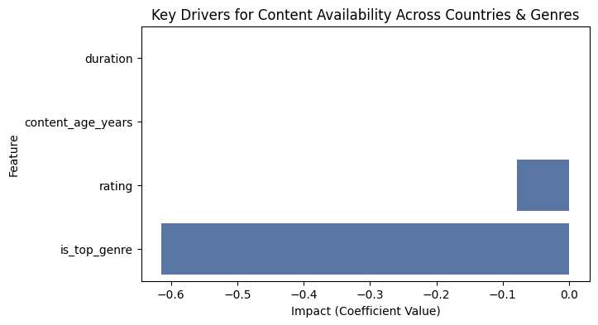
- Diversification in Top Countries: The strongest driver (is_top_genre) is negatively correlated with a title being from a top country. This suggests that top-contributing countries (like the United States and India) produce a massive, diverse volume of content across many different genres. Their output is not disproportionately dominated by just the Top 10 most common genres, while non-top countries may be more specialized in a handful of top genres.

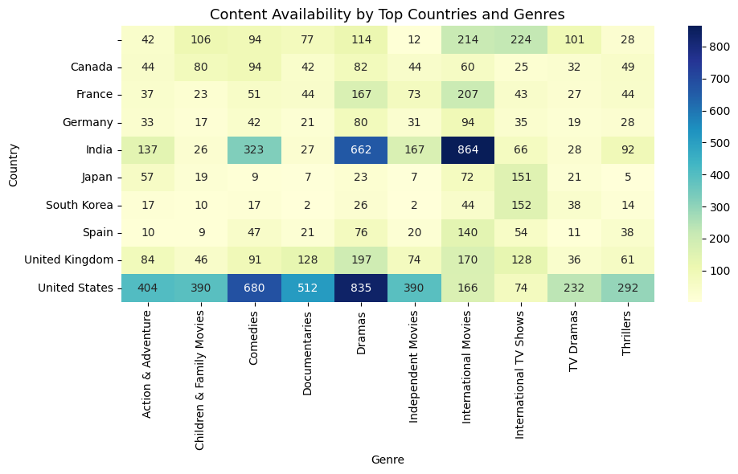
- Genre-Country Concentration (Heatmap): A detailed analysis of top country-genre pairings reinforces the focus areas:

  - India dominates International Movies (864 titles).
  - The United States shows the highest volume in Dramas (835) and Comedies (680).
  - This visualization clearly maps where Netflix can expect volume for specific genres.

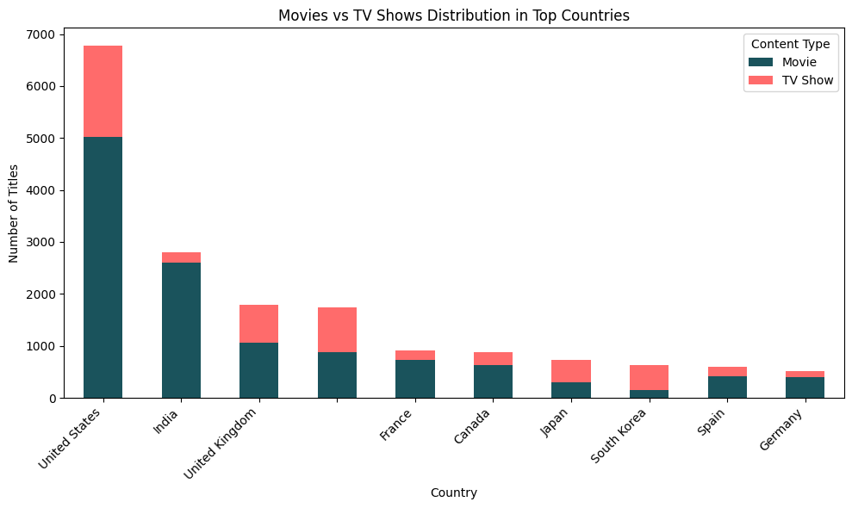
- Country Content Focus (Type Distribution):
  - The United States and India are heavily dominant in Movie production.
  - Countries like the United Kingdom, Japan, and South Korea show a relatively higher proportion of TV Show content in their top-10 total contribution compared to US/India, indicating a specific regional focus on series production.
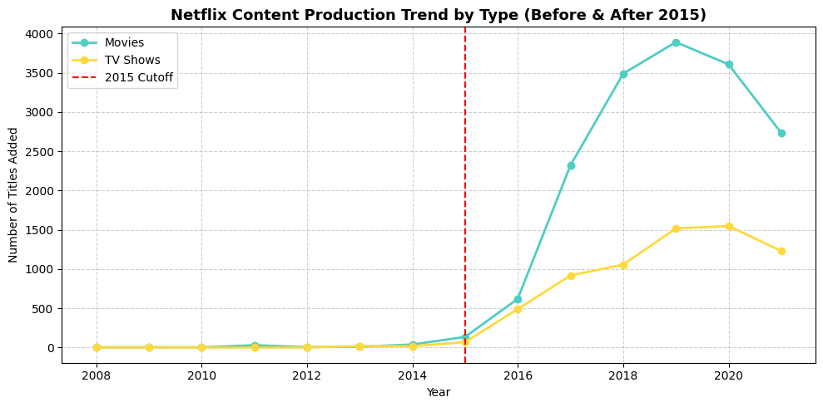
- Post-2015 Growth Trend: The line plot confirms that the period after 2015 marked a dramatic and sustained increase in the addition of both Movies and TV Shows to the Netflix platform, signifying a major shift towards aggressive global content acquisition.
