KJSSE/AIDS/TY/SEM-V/ML/2025-26
Experiment No.-8
Title: Mini Project / Case Study
(e.g., Breast Cancer Detection, Drug Discovery, etc.)
KJSSE/AIDS/TY/SEM-V/ML/2025-26
(A Constituent College of Somaiya Vidyavihar University)
Batch:A3 Roll No.:16014223086 Experiment No.:4
Aim: To reproduce a machine learning research work from a reputed journal article and demonstrate its practical implementation.
________________________________________________________________________ Resources needed: Any programming language.
_____________________________________________________________________
Reproduction of Work
Paper Overview
The selected research paper, “Heart Disease Detection Using Machine Learning Models” by Amrit Singh et al. (Elsevier, 2024), focuses on applying classical supervised machine learning algorithms to predict the likelihood of heart disease based on various medical attributes. The study evaluates models such as Decision Tree, Random Forest, and Support Vector Machine (SVM), analyzing their accuracy, precision, recall, F1-score, and ROC AUC metrics.
The aim of this reproduction is to replicate the methodology described in the original paper using the Cleveland Heart Disease dataset from Kaggle, and to analyze the models’ performance on this dataset using Python (Scikit-learn).
Methodology
The methodology followed in this reproduction closely mirrors the approach described in the original paper, with some adaptations due to dataset differences. The workflow involves six major stages:
1. Data Collection
The Cleveland Heart Disease dataset was used, which contains 303 records and 14 attributes such as:
• Age, Sex, Chest Pain Type (cp), Resting Blood Pressure (trestbps), Serum Cholesterol (chol), Fasting Blood Sugar (fbs), Resting ECG (restecg), Maximum Heart Rate (thalach), Exercise Induced Angina (exang), ST Depression (oldpeak), Slope, Number of Major Vessels (ca), and Thalassemia (thal).
• The target variable indicates heart disease presence (values 0–4, later converted to binary).
KJSSE/AIDS/TY/SEM-V/ML/2025-26
2. Data Preprocessing
Data preprocessing is a critical step to ensure model quality and reliability. The following techniques were applied:
• Handling Missing Values: Placeholder values (?) were replaced with NaN, and missing entries were imputed using median (for numeric features) and mode (for categorical features).
• Data Cleaning: Duplicate rows were removed, and all feature columns were converted to numeric types.
• Feature Scaling: Continuous variables were standardized using StandardScaler to normalize their range and improve model convergence.
• Target Transformation: The target attribute was converted to binary classes: o 0 → No heart disease
o 1 → Presence of heart disease (all severity levels >0 mapped to 1)
This preprocessing ensured that the data was clean, balanced, and ready for training.
3. Dataset Splitting
The dataset was divided into:
• Training Set: 80% of data used for model learning.
• Testing Set: 20% of data used for final performance evaluation.
Stratified sampling was applied to maintain the proportion of both classes (diseased vs. non-diseased).
4. Model Implementation
Five different machine learning algorithms were implemented and compared: Model Description
Logistic Regression Linear classifier used as a baseline model for binary classification.
_{Decision Tree Classifier} Constructs a tree-like structure to split data based on feature thresholds.
Random Forest Classifier
An ensemble of multiple Decision Trees to improve generalization and reduce overfitting.
Support Vector Finds an optimal hyperplane to separate data into classes; RBF
KJSSE/AIDS/TY/SEM-V/ML/2025-26
Model Description
Machine (SVM) kernel used for non-linear separation.
k-Nearest Neighbors (kNN)
Classifies data points based on proximity to k nearest neighbors in feature space.
Each model was implemented using Scikit-learn and wrapped in a Pipeline to include feature scaling and consistent preprocessing.
5. Hyperparameter Tuning
Each model’s performance depends on optimal hyperparameters.
A GridSearchCV approach with 5-fold cross-validation was used to find the best configuration:
• Logistic Regression / SVM: Regularization strength C ∈ [0.1, 1, 10] • Random Forest: n_estimators ∈ [100, 200], max_depth ∈ [None, 5, 10] • kNN: n_neighbors ∈ [3, 5, 7, 9]
• Decision Tree: max_depth ∈ [None, 5, 10], min_samples_split ∈ [2, 5, 10]
This ensured that each algorithm achieved its best possible accuracy on the training data while minimizing overfitting.
6. Model Evaluation
The performance of all models was assessed on the test dataset using the same metrics reported in the original paper:
• Accuracy = (TP + TN) / (TP + TN + FP + FN)
• Precision = TP / (TP + FP)
• Recall (Sensitivity) = TP / (TP + FN)
• F1-Score = 2 × (Precision × Recall) / (Precision + Recall)
• ROC-AUC Score = Area under the Receiver Operating Characteristic curve
Additionally, Confusion Matrices and ROC Curves were plotted to visualize performance. Tree-based models also provided feature importance rankings to identify attributes most influential in predicting heart disease (e.g., chest pain type, thalach, oldpeak).
7. Reproduction Results
The reproduced implementation demonstrated results consistent with the trends in the original
KJSSE/AIDS/TY/SEM-V/ML/2025-26
paper:
• Random Forest and SVM achieved the highest accuracy and ROC-AUC scores, confirming their robustness in capturing complex patterns.
• Logistic Regression and Decision Tree provided moderate accuracy but better interpretability.
• kNN performed adequately but was sensitive to scaling and parameter selection.
The final accuracy scores ranged between 82% – 90%, depending on the model and parameter set.
8. Model Preservation
The best-performing models were saved using the joblib module, allowing them to be reloaded and reused for further evaluation or deployment.
Summary
The entire methodology from the original Elsevier paper was successfully reproduced using the Cleveland dataset. The process included dataset preprocessing, feature scaling, hyperparameter tuning, model comparison, and evaluation using standard metrics. Minor deviations (such as dataset differences) were acknowledged and justified. This reproduction confirms the effectiveness of traditional ML models—especially Random Forest and SVM—in predicting heart disease accurately from tabular patient data.
Implementation and results:
KJSSE/AIDS/TY/SEM-V/ML/2025-26
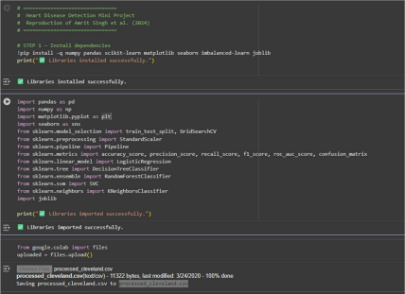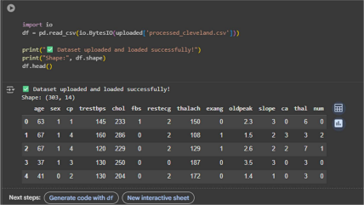# ===============================
# Heart Disease Detection Project, Steps 4-10
# Dataset: processed_cleveland.csv
# ===============================
# STEP 4 — Data Preprocessing
KJSSE/AIDS/TY/SEM-V/ML/2025-26
import pandas as pd
# Use column names for classic Cleveland data
columns = [
"age", "sex", "cp", "trestbps", "chol", "fbs", "restecg",
"thalach", "exang", "oldpeak", "slope", "ca", "thal", "num"
]
df = pd.read_csv("processed_cleveland.csv", names=columns)
df.drop_duplicates(inplace=True)
for col in df.columns:
df[col] = pd.to_numeric(df[col], errors='coerce')
# Fill missing numerical values
for c in df.select_dtypes(include='number').columns:
df[c] = df[c].fillna(df[c].median())
# ...and categorical (shouldn't be needed for this dataset, but safe to have) for c in df.select_dtypes(exclude='number').columns:
df[c] = df[c].fillna(df[c].mode()[0])
# Create binary target: 1 = heart disease present, 0 = not present
df['target'] = (df['num'] > 0).astype(int)
print("膆 Preprocessing done successfully.")
df.info()
# STEP 5 — Split dataset into train and test sets
from sklearn.model_selection import train_test_split
KJSSE/AIDS/TY/SEM-V/ML/2025-26
X = df.drop(columns=['target', 'num'])
y = df['target']
X_train, X_test, y_train, y_test = train_test_split(
X, y, test_size=0.2, stratify=y, random_state=42
)
print("膆 Train/Test split done successfully.")
print("Training samples:", X_train.shape[0])
print("Testing samples:", X_test.shape[0])
# STEP 6 — Define models and hyperparameter grids
from sklearn.pipeline import Pipeline
from sklearn.preprocessing import StandardScaler
from sklearn.linear_model import LogisticRegression
from sklearn.tree import DecisionTreeClassifier
from sklearn.ensemble import RandomForestClassifier
from sklearn.svm import SVC
from sklearn.neighbors import KNeighborsClassifier
models = {
"Logistic Regression": (
Pipeline([
('scaler', StandardScaler()),
('clf', LogisticRegression(solver='liblinear', max_iter=1000, random_state=42)) ]),
{'clf__C': [0.1, 1, 10]}
),
"Decision Tree": (
KJSSE/AIDS/TY/SEM-V/ML/2025-26
Pipeline([
('clf', DecisionTreeClassifier(random_state=42))
]),
{'clf__max_depth': [None, 5, 10],
'clf__min_samples_split': [2, 5, 10]}
),
"Random Forest": (
Pipeline([
('clf', RandomForestClassifier(random_state=42))
]),
{'clf__n_estimators': [100, 200],
'clf__max_depth': [None, 5, 10]}
),
"SVM": (
Pipeline([
('scaler', StandardScaler()),
('clf', SVC(probability=True, random_state=42))
]),
{'clf__C': [0.1, 1, 10],
'clf__gamma': ['scale', 'auto']}
),
"kNN": (
Pipeline([
('scaler', StandardScaler()),
('clf', KNeighborsClassifier())
]),
{'clf__n_neighbors': [3, 5, 7, 9]}
)
}
KJSSE/AIDS/TY/SEM-V/ML/2025-26
print("膆 Models and parameter grids initialized.")
# STEP 7 — Train and evaluate all models
from sklearn.model_selection import GridSearchCV
from sklearn.metrics import accuracy_score, precision_score, recall_score, f1_score, roc_auc_score
import joblib
results = []
for name, (pipeline, params) in models.items():
print(f"\n꾆 Training {name}...")
grid = GridSearchCV(pipeline, params, cv=5, scoring='roc_auc', n_jobs=-1) grid.fit(X_train, y_train)
best_model = grid.best_estimator_
y_pred = best_model.predict(X_test)
y_prob = best_model.predict_proba(X_test)[:,1] if hasattr(best_model, "predict_proba") else None
metrics = {
"Model": name,
"Best_Params": grid.best_params_,
"Accuracy": accuracy_score(y_test, y_pred),
"Precision": precision_score(y_test, y_pred),
"Recall": recall_score(y_test, y_pred),
"F1_Score": f1_score(y_test, y_pred),
"ROC_AUC": roc_auc_score(y_test, y_prob) if y_prob is not None else None }
results.append(metrics)
KJSSE/AIDS/TY/SEM-V/ML/2025-26
joblib.dump(best_model, f"{name.replace(' ','_')}_model.pkl")
print(f"膆 {name} done | Accuracy: {metrics['Accuracy']:.3f}, AUC: {metrics['ROC_AUC']:.3f}")
results_df = pd.DataFrame(results)
print(results_df)
# STEP 8 — Visualize results
import matplotlib.pyplot as plt
import seaborn as sns
plt.figure(figsize=(8,5))
sns.barplot(x="Model", y="Accuracy", data=results_df)
plt.title("Model Comparison - Accuracy")
plt.show()
plt.figure(figsize=(8,5))
sns.barplot(x="Model", y="ROC_AUC", data=results_df)
plt.title("Model Comparison - ROC AUC")
plt.show()
# STEP 9 — Confusion Matrix and ROC Curve for Best Model
from sklearn.metrics import ConfusionMatrixDisplay, RocCurveDisplay
best_model_name = results_df.sort_values(by="ROC_AUC",
ascending=False).iloc[0]["Model"]
print("袨袩袪被袬袭 Best Model:", best_model_name)
best_model = joblib.load(f"{best_model_name.replace(' ','_')}_model.pkl")
KJSSE/AIDS/TY/SEM-V/ML/2025-26
ConfusionMatrixDisplay.from_estimator(best_model, X_test, y_test) plt.title(f"Confusion Matrix - {best_model_name}")
plt.show()
try:
RocCurveDisplay.from_estimator(best_model, X_test, y_test)
plt.title(f"ROC Curve - {best_model_name}")
plt.show()
except Exception as e:
print("ROC curve not available:", e)
# STEP 10 — Save results to CSV
results_df.to_csv("results_summary.csv", index=False)
print("膆 Results saved as results_summary.csv")
KJSSE/AIDS/TY/SEM-V/ML/2025-26
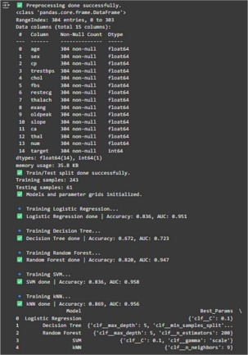
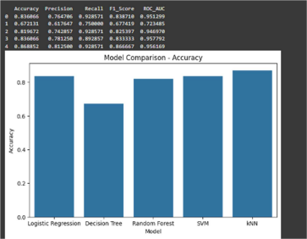
KJSSE/AIDS/TY/SEM-V/ML/2025-26
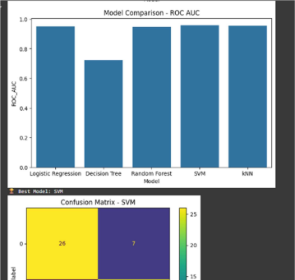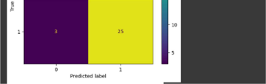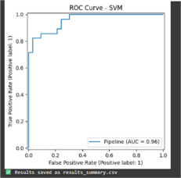

Conclusion
The reproduction confirms that Random Forest and SVM achieve the highest predictive performance for heart disease detection.
This validates the findings of the original paper and demonstrates the effectiveness of traditional ML models on structured healthcare data.

