**Introduction to Mathematical preliminaries**

**Introduction of Set theory**

A **Set**is an unordered collection of objects, known as elements or members of the set.  
An element ‘a’ belong to a set A can be written as ‘a ∈ A’, ‘a ∉ A’ denotes that a is not an element of the set A.

**Representation of a Set**  
A set can be represented by various methods. 3 common methods used for representing set:  
1. Statement form.  
2. Roaster form or tabular form method.  
3. Set Builder method.

**Statement form**  
In this representation, the well-defined description of the elements of the set is given. Below are some examples of the same.

1. The set of all even numbers less than 10.  
2. The set of the number less than 10 and more than 1.

**Roster form**  
In this representation, elements are listed within the pair of brackets {} and are separated by commas. Below are two examples.

1. Let N is the set of natural numbers less than 5.  
N = { 1 , 2 , 3, 4 }.

2. The set of all vowels in the English alphabet.  
V = { a , e , i , o , u }.

**Set builder form**  
In Set-builder set is described by a property that its member must satisfy.

1. {x : x is even number divisible by 6 and less than 100}.  
2. {x : x is natural number less than 10}.

**Equal sets**  
Two sets are said to be equal if both have same elements. For example A = {1, 3, 9, 7} and B = {3, 1, 7, 9} are equal sets.

**Subset**

A set A is said to be **subset**of another set B if and only if every element of set A is also a part of other set B.  
Denoted by ‘**⊆**‘.  
‘A ⊆ B ‘ denotes A is a subset of B.

To prove A is the subset of B, we need to simply show that if x belongs to A then x also belongs to B.  
To prove A is not a subset of B, we need to find out one element which is part of set A but not belong to set B.

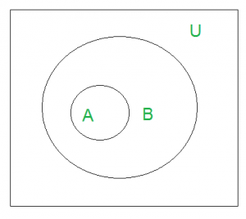

U’ denotes the universal set.  
Above Venn Diagram shows that A is a subset of B.

**Size of a Set**

Size of a set can be finite or infinite.

For example

Finite set: Set of natural numbers less than 100.

Infinite set: Set of real numbers.

Size of the set S is known as **Cardinality number**, denoted as |S|.

Example: Let A be a set of odd positive integers less than 10.  
Solution: A = {1,3, 5,7,9}, Cardinality of the set is 5, i.e.,|A| = 5.

Note: Cardinality of a null set is 0.

**Power Sets**  
The power set is the set all possible subset of the set S. Denoted by P(S).

Example: What is the power set of {0,1,2}?  
Solution: All possible subsets  
{∅}, {0}, {1}, {2}, {0,1}, {0,2}, {1,2}, {0,1,2}.  
Note: Empty set and set itself is also the member of this set of subsets.

# Mathematics | Set Operations (Set theory)

### ****Union****

Union of the sets A and B, denoted by A ∪ B, is the set of distinct elements that belong to set A or set B, or both.

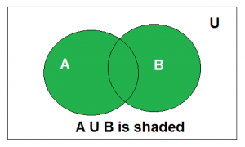

***Example***: Find the union of A = {2, 3, 4} and B = {3, 4, 5};

Solution : A ∪ B = {2, 3, 4, 5}.

### ****Intersection****

The intersection of the sets A and B, denoted by A ∩ B, is the set of elements that belong to both A and B i.e. set of the common elements in A and B.

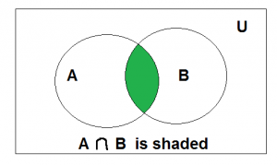

***Example***: Find the intersection of A = {2, 3, 4} and B = {3, 4, 5}

Solution: A ∩ B = {3, 4}.

### ****Disjoint****

Two sets are said to be disjoint if their intersection is the empty set. i.e, sets have no common elements.

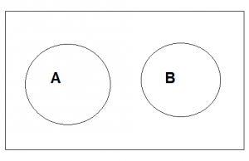

***Example***: Let A = {1, 3, 5, 7, 9} and B = { 2, 4, 6, 8}

A and B are disjoint sets since both of them have no common elements.

### ****Set Difference****

The difference between sets is denoted by ‘A – B’, which is the set containing elements that are in A but not in B. i.e., all elements of A except the element of B.

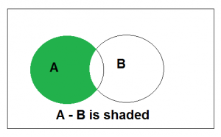

### Complement

The complement of a set A, denoted by ACis the set of all the elements except the elements in A. Complement of the set A is U – A.

 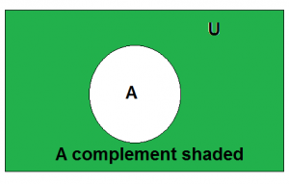

***Example***: Let U = {1, 2, 3, 4, 5, 6, 7, 8, 9, 10} and A = {2, 4, 6, 8}.

Find AC

Solution: AC = U-A = {1, 3, 5, 7, 9, 10}

**Cartesian Products**

Let A and B be two sets. Cartesian product of A and B is denoted by A × B, is the set of all ordered pairs (a,b), where a belong to A and b belong to B.

A × B = {(a, b) | a ∈ A ∧ b ∈ B}.

Example 1. What is Cartesian product of A = {1,2} and B = {p, q, r}.  
Solution : A × B ={(1, p), (1, q), (1, r), (2, p), (2, q), (2, r) };

### Set Identities

### Identity Laws

A∪∅=A,A∩U=A

### Domination Laws

A∪U=U,A∩∅=∅

### Idempotent Laws

A∪A=A,A∩A=A

### Complement Laws

A∪Ac=U,A∩Ac=∅

### Double Complement Law

(Ac)c=A

### Commutative Laws

A∪B=B∪A,A∩B=B∩A

### Associative Laws

A∪(B∪C)=(A∪B)∪C,A∩(B∩C)=(A∩B)∩C

### Distributive Laws

A∪(B∩C)=(A∪B)∩(A∪C),A∩(B∪C)=(A∩B)∪(A∩C)

### De Morgan's Laws

(A∪B)c=Ac∩Bc,(A∩B)c=Ac∪Bc

### Absorption Laws

A∪(A∩B)=A,A∩(A∪B)=A

### Complements of U and ∅

Uc=∅,∅c=U

## Algebraic Structure

A non empty set S is called an algebraic structure w.r.t binary operation (*) if it follows following axioms:

* **Closure:** (a*b) belongs to S for all a,b ∈ S.

**Ex:** S = {1,-1} is algebraic structure under *

As 1*1 = 1, 1*-1 = -1, -1*-1 = 1 all results belongs to S.

But above is not algebraic structure under + as 1+ (-1) = 0 not belongs to S.

## Semi Group

A non-empty set S, (S,*) is called a semi group if it follows the following axiom:

* **Closure :**(a*b) belongs to S for all a,b ∈ S.
* **Associatively:** a*(b*c) = (a*b)*c ∀ a,b,c belongs to S.

**Note:** A semi group is always an algebraic structure.

**Ex:** (Set of integers, +), and (Matrix,*) are examples of semi group.

## Monoid

A non-empty set S, (S,*) is called a monoid if it follows the following axiom:

* **Closure :**(a*b) belongs to S for all a,b ∈ S.
* **Associativity:** a*(b*c) = (a*b)*c ∀ a,b,c belongs to S.
* **Identity Element:** There exists e ∈ S such that a*e = e*a = a ∀ a ∈ S

**Note:** A monoid is always a semi-group and algebraic structure.

**Ex :** (Set of integers,*) is Monoid as 1 is an integer which is also identity element .  
(Set of natural numbers, +) is not Monoid as there doesn’t exist any identity element. But this is Semi group.  
But (Set of whole numbers, +) is Monoid with 0 as identity element.

## Group

A non-empty set G, (G,*) is called a group if it follows the following axiom:

* **Closure :**(a*b) belongs to G for all a,b ∈ G.
* **Associativity:** a*(b*c) = (a*b)*c ∀ a,b,c belongs to G.
* **Identity Element:** There exists e ∈ G such that a*e = e*a = a ∀ a ∈ G
* **Inverses:**∀ a ∈ G there exists a-1 ∈ G such that a*a-1 = a-1*a = e

**Note:**

1. A group is always a monoid, semigroup, and algebraic structure.
2. (Z,+) and Matrix multiplication is example of group.

## Abelian Group or Commutative group

A non-empty set S, (S,*) is called a Abelian group if it follows the following axiom:

* **Closure :**( a*b) belongs to S for all a,b ∈ S.
* **Associativity:** a*(b*c) = (a*b)*c ∀ a, b, c belongs to S.
* **Identity Element:** There exists e ∈ S such that a*e = e*a = a ∀ a ∈ S
* **Inverses:**∀ a ∈ S there exists a-1 ∈ S such that a*a-1 = a-1*a = e
* **Commutative:** a*b = b*a for all a,b ∈ S

**Note :**(Z,+) is a example of Abelian Group but Matrix multiplication is not abelian group as it is not commutative.

Relations

## Definition and Properties

A binary relation R from set x to y (written as xRy or R(x,y)) is a subset of the Cartesian product x×y. If the ordered pair of G is reversed, the relation also changes.

Generally an n-ary relation R between sets A1,…, and An is a subset of the n-ary product A1×⋯×An. The minimum cardinality of a relation R is Zero and maximum is n2 in this case.

A binary relation R on a single set A is a subset of A×A.

For two distinct sets, A and B, having cardinalities *m* and *n* respectively, the maximum cardinality of a relation R from A to B is *mn*.

## Domain and Range

If there are two sets A and B, and relation R have order pair (x, y), then −

* The **domain** of R, Dom(R), is the set {x|(x,y)∈R for some y in B}
* The **range** of R, Ran(R), is the set {y|(x,y)∈R for some x in A}

### Examples

Let, A={1,2,9}  and B={1,3,7}

Case 1 − If relation R is 'equal to' then R={(1,1),(3,3)}R={(1,1),(3,3)}

Dom(R) = {1,3},Ran(R)={1,3}{1,3},Ran(R)={1,3}

Case 2 − If relation R is 'less than' then R={(1,3),(1,7),(2,3),(2,7)}

Dom(R) = {1,2},Ran(R)={3,7}

Case 3 − If relation R is 'greater than' then R={(2,1),(9,1),(9,3),(9,7)}

Dom(R) = {2,9},Ran(R)={1,3,7}

## Types of Relations

* The **Empty Relation** between sets X and Y, or on E, is the empty set ∅
* The **Full Relation** between sets X and Y is the set X×Y
* The **Identity Relation** on set X is the set {(x,x)|x∈X}
* The Inverse Relation R' of a relation R is defined as − R′={(b,a)|(a,b)∈R}

**Example** − If R={(1,2),(2,3)} then R′R′ will be {(2,1),(3,2)}

* A relation R on set A is called **Reflexive** if ∀a∈A is related to a (aRa holds)

**Example** − The relation R={(a,a),(b,b)} on set X={a,b} } is reflexive.

* A relation R on set A is called **Irreflexive** if no a∈A is related to a (aRa does not hold).

**Example** − The relation R={(a,b),(b,a)} on set X={a,b} is irreflexive.

* A relation R on set A is called **Symmetric** if xRy  implies yRx, ∀x∈A and ∀y∈A.

**Example** − The relation R={(1,2),(2,1),(3,2),(2,3)} on set A={1,2,3} is symmetric.

* A relation R on set A is called **Anti-Symmetric** if xRy and yRx implies x=y∀x∈ and ∀y∈A

**Example** − The relation R={(x,y)→N|x≤y} is anti-symmetric since x≤y and  y≤x implies x=y

* A relation R on set A is called **Transitive** if xRy and yRz implies xRz,∀x,y,z∈A.

**Example** − The relation R={(1,2),(2,3),(1,3)} on set A={1,2,3} is transitive.

* A relation is an **Equivalence Relation** if it is reflexive, symmetric, and transitive.

**Example** − The relation R={(1,1),(2,2),(3,3),(1,2),(2,1),(2,3),(3,2),(1,3),(3,1)} on set A={1,2,3} is an equivalence relation since it is reflexive, symmetric, and transitive.

**Function**

## Definition

A function or mapping (Defined as f:X→Y) is a relationship from elements of lements of another set Y (X and Y are non-empty sets). X is called Domain and Y is called Codomain of function ‘f’.

Function ‘f’ is a relation on X and Y such that for each x∈Xx∈X, there exists a unique y∈Y such that (x,y)∈R. ‘x’ is called pre-image and ‘y’ is called image of function f.

A function can be one to one or many to one but not one to many.

## Injective / One-to-one function

A function f:A→B is injective or one-to-one function if for every b∈B, there exists at most one a∈A such that f(s)=t.

This means a function **f** is injective if a1≠a2 implies f(a1)≠f(a2).

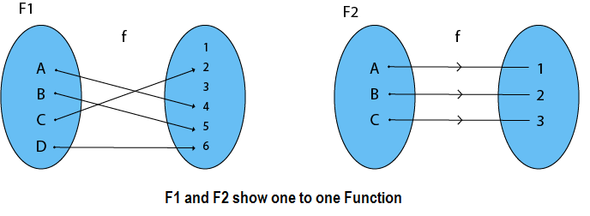

### Example

* f:N→N,f(x)=5x is injective.
* f:N→N,f(x)=x2 is injective.
* f:R→R,f(x)=x2 is not injective as (−x)2=x2

## Surjective / Onto function

A function f:A→B is surjective (onto) if the image of f equals its range. Equivalently, for every b∈B, there exists some a∈A such that f(a)=b. This means that for any y in B, there exists some x in A such that y=f(x).

**Example:** Consider, A = {1, 2, 3, 4}, B = {a, b, c} and f = {(1, b), (2, a), (3, c), (4, c)}.

It is a Surjective Function, as every element of B is the image of some A

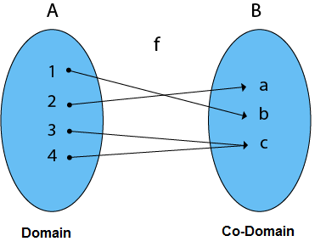

### Example

* f:N→N,f(x)=x+2 is surjective.
* f:R→R,f(x)=x2 is not surjective since we cannot find a real number whose square is negative.

## Bijective / One-to-one Correspondent

A function f:A→B is bijective or one-to-one correspondent if and only if **f** is both injective and surjective.

### Problem

Prove that a function f:R→R defined by f(x)=2x–3 is a bijective function.

**Explanation** − We have to prove this function is both injective and surjective.

If f(x1)=f(x2), then 2x1–3=2x2–3  and it implies that x1=x2.

Hence, f is **injective**.

Here, 2x–3=y

So, x=(y+5)/3 which belongs to R and f(x)=y.

Hence, f is **surjective**.

Since **f** is both **surjective** and **injective**, we can say **f** is **bijective**.

Consider P = {x, y, z}

          Q = {a, b, c}

and f: P → Q such that

         f = {(x, a), (y, b), (z, c)}

The f is a one-to-one function and also it is onto. So it is a bijective function.

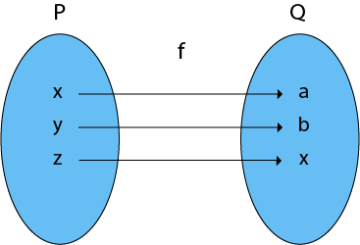

**Graph**

Graph G consists of two things:

1. A set V=V(G) whose elements are called vertices, points or nodes of G.

2. A set E = E(G) of an unordered pair of distinct vertices called edges of G.

3. We denote such a graph by G(V, E) vertices u and v are said to be adjacent if there is an edge e ={u, v}.

4. In such a case u and v are called the endpoint of e={u, v} and e are said to connect u and v.

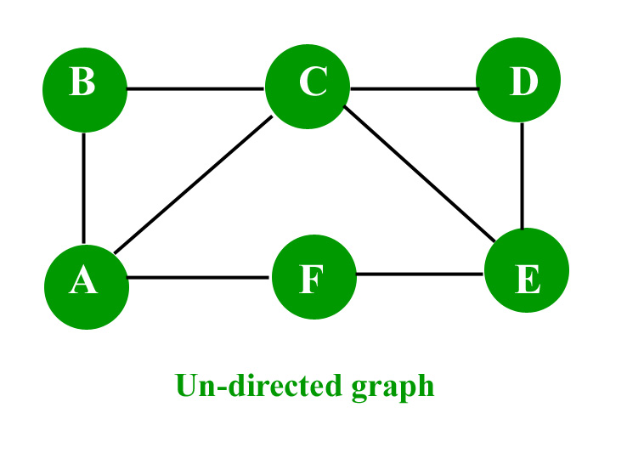

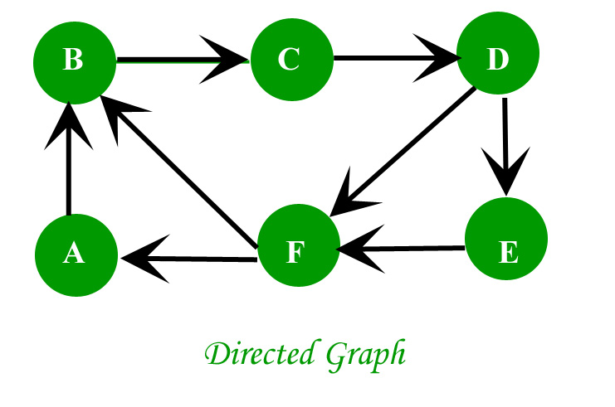

**Characteristics of graphs:**

1. **Adjacent node**: A node ‘v’ is said to be adjacent node of node ‘u’ if and only if there exists an edge between ‘u’ and ‘v’.
2. **Degree of a Vertex**: The degree of a vertex is the number of edges incident on a vertex v. The self-loop is counted twice. The degree of a vertex is denoted by d(v).

In an undirected graph the number of nodes incident on a node is the degree of the node.  
In case of directed graph ,**Indegree** of the node is the **number of arriving edges** to a node.  
**Outdegree** of the node is the **number of departing edges to a node.**

**Example1:** Consider the graph G shown in fig. Determine the degree of each vertex.

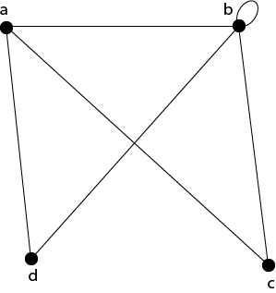

**Solution:** The degree of each vertex is as follows:

                  d(a)=3;       d(b)=5;       d(c) = 2;       d(d)=2.

1. Path: A path of length ‘n’ from node ‘u’ to node ‘v’ is defined as **sequence of n+1 nodes.P(u,v)=(v0,v1,v2,v3…….vn)**

A path is simple if all the nodes are distinct,**exception is source and destination are same.**

1. Isolated node: A node with degree 0 is known as isolated node.

**Types of Graph**

## Null Graph

A **null graph** is a graph in which there are no edges between its vertices. A null graph is also called empty graph.

### Example

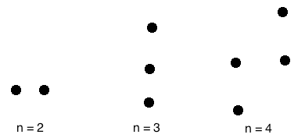

A null graph with n vertices is denoted by Nn.

## Trivial Graph

A **trivial graph** is the graph which has only one vertex

**Example**

Types of Graphs

In the above graph, there is only one vertex 'v' without any edge. Therefore, it is a trivial graph.

## Simple Graph

A **simple graph** is the undirected graph with **no parallel edges** and **no loops**.

A simple graph which has n vertices, the degree of every vertex is at most n -1.

### Example

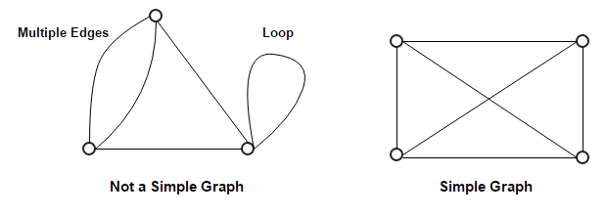

In the above example, First graph is not a simple graph because it has two edges between the vertices A and B and it also has a loop.

Second graph is a simple graph because it does not contain any loop and parallel edges.

### Multi-Graph

If in a graph multiple edges between the same set of vertices are allowed, it is called Multigraph. In other words, it is a graph having at least one loop or multiple edges.

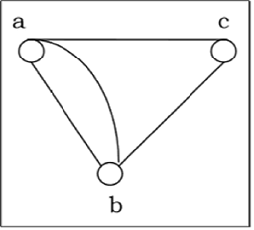

## Complete Graph

A graph in which every pair of vertices is joined by exactly one edge is called **complete graph**. It contains all possible edges.

A complete graph with n vertices contains exactly nC2 edges and is represented by Kn.

### Example

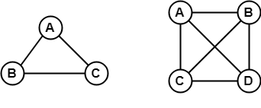

In the above example, since each vertex in the graph is connected with all the remaining vertices through exactly one edge therefore, both graphs are complete graph.

## Connected Graph

A **connected graph** is a graph in which we can visit from any one vertex to any other vertex. In a connected graph, at least one edge or path exists between every pair of vertices.

### Example

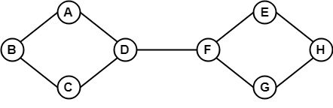

In the above example, we can traverse from any one vertex to any other vertex. It means there exists at least one path between every pair of vertices therefore, it a connected graph.

## Disconnected Graph

A **disconnected graph** is a graph in which any path does not exist between every pair of vertices.

### Example

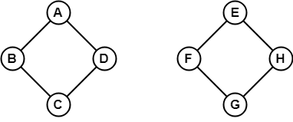

The above graph consists of two independent components which are disconnected. Since it is not possible to visit from the vertices of one component to the vertices of other components therefore, it is a disconnected graph.

## Regular Graph

A **Regular graph** is a graph in which degree of all the vertices is same.

If the degree of all the vertices is k, then it is called k-regular graph.

### Example

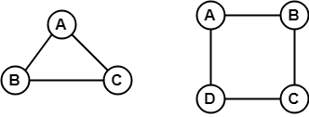

In the above example, all the vertices have degree 2. Therefore they are called 2- **Regular graph**.

**Walk**  
A walk is a sequence of vertices and edges of a graph i.e. if we traverse a graph then we get awalk.   
   
**Note: Vertices and Edges can be repeated.**

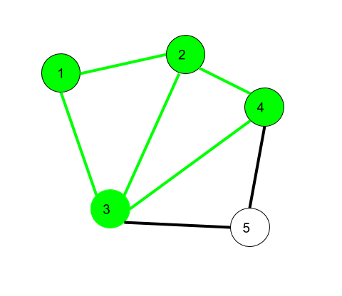

Here, 1->2->3->4->2->1->3 is a walk.

Walk can be open or closed.

**Open walk-**A walk is said to be an open walk if the starting and ending vertices are different i.e. the origin vertex and terminal vertex are different

.   
**Closed walk-**A walk is said to be a closed walk if the starting and ending vertices are identical i.e. if a walk starts and ends at the same vertex, then it is said to be a closed walk.

In the above diagram:   
1->2->3->4->5->3 is an open walk.   
1->2->3->4->5->3->1 is a closed walk.

**Trail**   
Trail is an open walk in which no edge is repeated.

Vertex can be repeated.

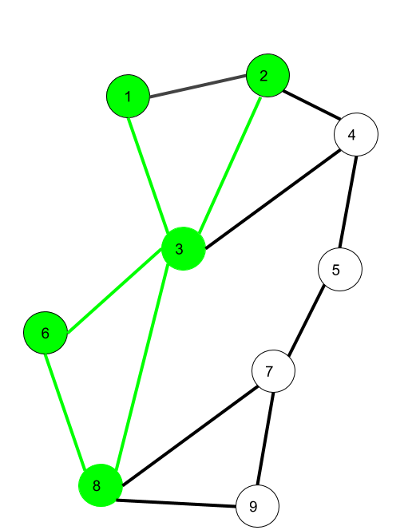

Here1->3->8->6->3->2istrail   
Also 1->3->8->6->3->2->1 will be a closed trail

**Circuit –**   
Traversing a graph such that not an edge is repeated but vertex can be repeated and it is closed also

i.e. it is a closed trail.   
   
Vertex can be repeated.

Edge cannot be repeated.

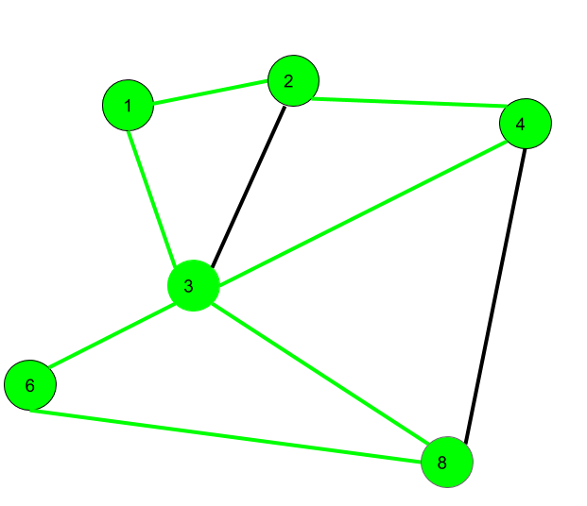

Here 1->2->4->3->6->8->3->1 is a circuit.

Circuit is a closed trail.

These can have repeated vertices only.

**Path –**   
It is a trail in which neither vertices nor edges are repeated i.e. if we traverse a graph such that we do not repeat a vertex and nor we repeat an edge. As path is also a trail, thus it is also an open walk.

Vertex not repeated   
Edge not repeated

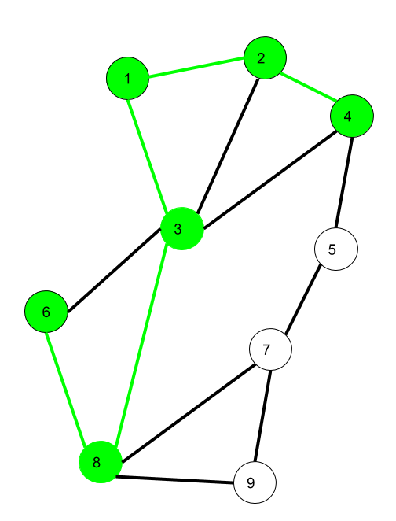

Here 6->8->3->1->2->4 is a Path

**Cycle –**   
Traversing a graph such that we do not repeat a vertex nor we repeat a edge but the starting and ending vertex must be same i.e. we can repeat starting and ending vertex only then we get a cycle.

Vertex not repeated   
Edge not repeated

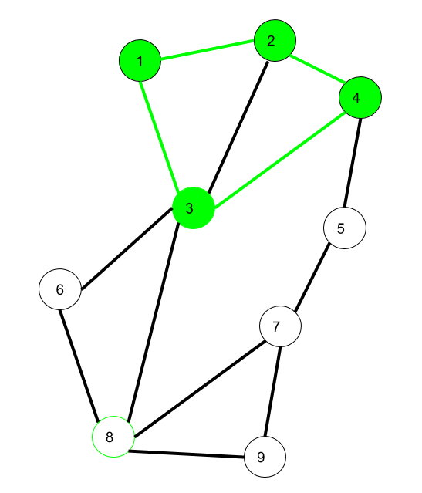

Here 1->2->4->3->1 is a cycle.

Cycle is a closed path.

**Tree**

* A **tree** is an **undirected, connected and acyclic graph**. In other words, a connected graph that does not contain even a single cycle is called a tree.
* A tree represents hierarchical structure in a graphical form.
* The elements of trees are called their nodes and the edges of the tree are called branches.
* A tree with n vertices has (n-1) edges.
* A **leaf** in a tree is a vertex of degree 1 or any vertex having no children is called a leaf.

### Forest

In graph theory, a **forest** is **an undirected, disconnected, acyclic graph**. In other words, a disjoint collection of trees is known as forest. Each component of a forest is tree.

## Properties of Trees

1. Every tree which has at least two vertices should have at least two leaves.
2. Trees have many characterizations:  
   Let T be a graph with n vertices, then the following statements are equivalent:
   * T is a tree.
   * T contains no cycles and has n-1 edges.
   * T is connected and has (n -1) edge.
   * T is connected graph, and every edge is a cut-edge.
   * Any two vertices of graph T are connected by exactly one path.
   * T contains no cycles, and for any new edge e, the graph T+ e has exactly one cycle.
3. Every edge of a tree is cut -edge.
4. Adding one edge to a tree defines exactly one cycle.
5. Every connected graph contains a spanning tree.
6. Every tree has at least two vertices of degree two.