WEATHER ADVISORY SYSTEM
ABSTRACT
The Weather Advisory System for Farmers is a web-based application designed to provide real-time weather information to support agricultural decision-making. Farmers heavily depend on climatic conditions for crop growth, irrigation planning, and harvesting. This system helps them access accurate and timely weather updates using modern web technologies.
The application automatically detects the user’s location using geolocation and fetches weather data from APIs such as Open-Meteo API and location details using OpenStreetMap Nominatim API. It displays important parameters like temperature, wind speed, hourly forecast, and daily forecast in a simple and user-friendly interface.
The system also includes map visualization and graphical representation of weather trends using charts. This helps farmers understand patterns and make better decisions. Overall, the project demonstrates API integration, real-time data handling, and dynamic UI updates.

1. INTRODUCTION
Agriculture is the backbone of many economies, especially in countries like India. Farmers depend on weather conditions such as rainfall, temperature, and wind for successful crop production. However, unpredictable weather can lead to major losses.
Traditional methods of predicting weather are not always reliable. Therefore, there is a need for a digital solution that provides accurate and real-time weather information.
This project aims to solve this problem by providing a simple web application where farmers can view weather details instantly based on their location.

2. PROBLEM STATEMENT
Farmers face the following problems:
- Lack of accurate weather information
- Sudden climate changes
- Difficulty in accessing modern tools
- Crop damage due to poor planning
There is a need for a system that:
- Provides real-time weather updates
- Is easy to use
- Helps in agricultural planning

3. OBJECTIVES
The main objectives of the project are:
- To provide real-time weather information
- To help farmers in irrigation and crop planning
- To build a user-friendly interface
- To integrate APIs for live data
- To visualize weather using charts and maps

4. SCOPE OF THE PROJECT
- Useful for farmers in rural and urban areas
- Can be accessed from any device with internet
- Can be extended with crop recommendation systems
- Can include alerts for extreme weather

5. TECHNOLOGIES USED
Frontend:
- HTML
- CSS
- JavaScript
APIs:
- Open-Meteo API (Weather data)
- OpenStreetMap Nominatim API (Location details)
Libraries:
- Leaflet.js (Map)
- Chart.js (Graphs)

6. SYSTEM ARCHITECTURE
Flow:
User → Browser → API Request → Server → JSON Data → UI Display
Steps:
- User allows location access
- Coordinates are fetched
- API request is sent
- Data is received
- UI is updated

7. PROJECT STRUCTURE
weather-project/
│── index.html
│── style.css
│── script.js

8. WORKING PRINCIPLE
- The browser gets user location
- Latitude and longitude are extracted
- Weather API is called
- Data is processed
- Results displayed on screen
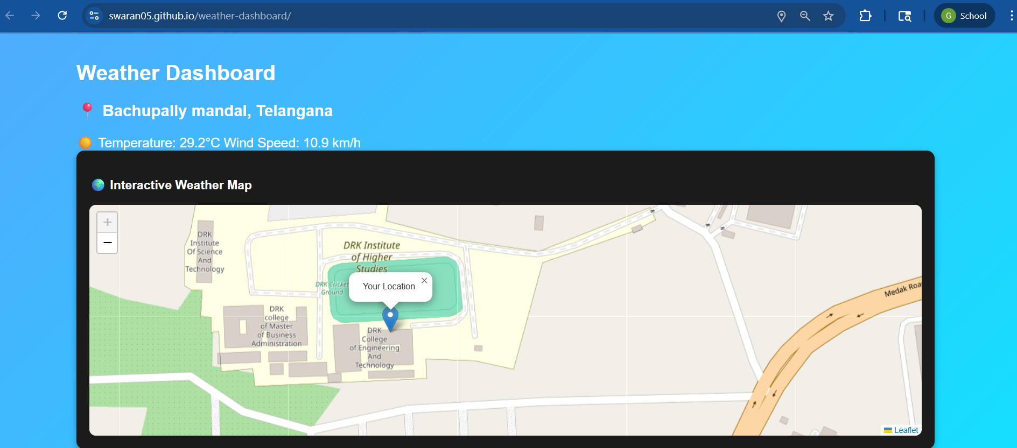
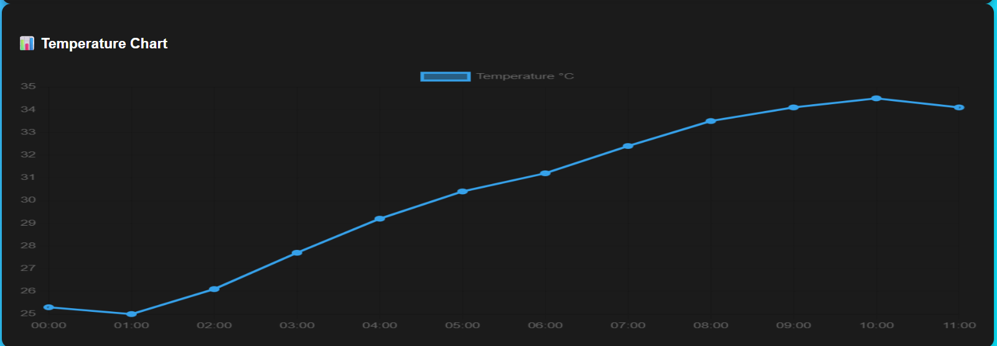
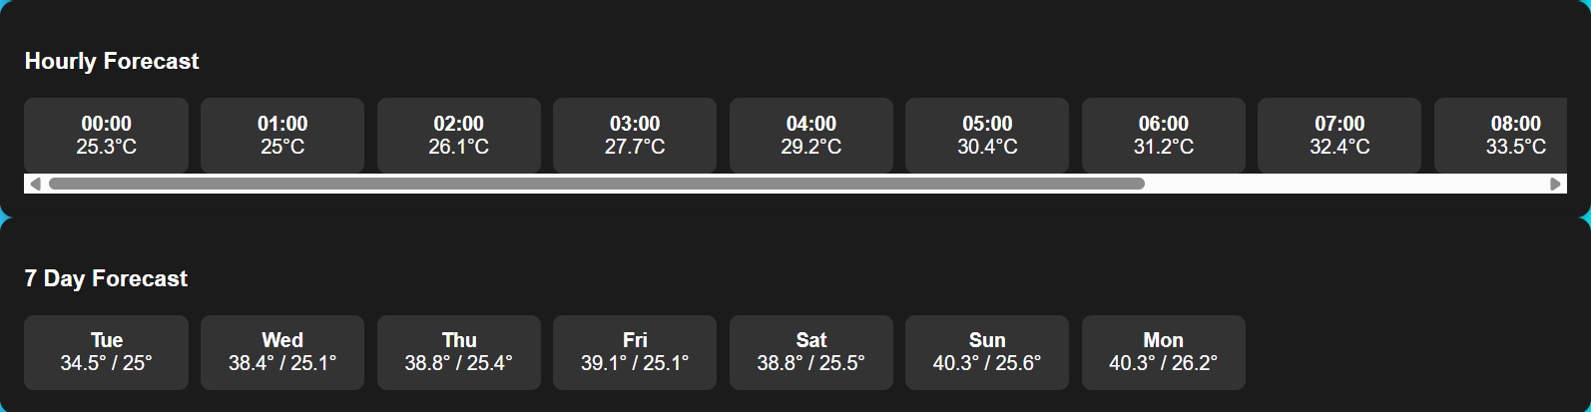

9. IMPLEMENTATION (MAIN CODE)
navigator.geolocation.getCurrentPosition(getWeather);
function getWeather(position){
let lat = position.coords.latitude;
let lon = position.coords.longitude;
getCity(lat,lon);
initMap(lat,lon);
let url =
`https://api.open-meteo.com/v1/forecast?latitude=${lat}&longitude=${lon}&current_weather=true&hourly=temperature_2m&daily=temperature_2m_max,temperature_2m_min`;
fetch(url)
.then(res=>res.json())
.then(data=>{
showCurrent(data);
showHourly(data);
showDaily(data);
createChart(data);
});
}

10. LOCATION FETCHING
function getCity(lat,lon){
fetch(`https://nominatim.openstreetmap.org/reverse?format=json&lat=${lat}&lon=${lon}`)
.then(res=>res.json())
.then(data=>{
let city =
data.address.city ||
data.address.town ||
data.address.village;
let state = data.address.state;
document.getElementById("city").innerText =
"📍 " + city + ", " + state;
});
}

11. CURRENT WEATHER DISPLAY
function showCurrent(data){
let temp=data.current_weather.temperature;
let wind=data.current_weather.windspeed;
document.getElementById("temperature").innerText=
"Temperature: "+temp+"°C";
document.getElementById("wind").innerText=
"Wind Speed: "+wind+" km/h";
}

12. HOURLY FORECAST
function showHourly(data){
let temps=data.hourly.temperature_2m;
let time=data.hourly.time;
for(let i=0;i<12;i++){
// display data
}
}

13. DAILY FORECAST
function showDaily(data){
let max=data.daily.temperature_2m_max;
let min=data.daily.temperature_2m_min;
}

14. MAP INTEGRATION
function initMap(lat,lon){
let map=L.map('map').setView([lat,lon],10);
L.tileLayer('https://{s}.tile.openstreetmap.org/{z}/{x}/{y}.png')
.addTo(map);
L.marker([lat,lon])
.addTo(map)
.bindPopup("Your Location")
.openPopup();
}

15. CHART VISUALIZATION
function createChart(data){
let temps=data.hourly.temperature_2m.slice(0,12);
new Chart(ctx,{
type:'line',
data:{}
});
}

16. FEATURES
- Automatic location detection
- Real-time weather data
- Hourly forecast
- 7-day forecast
- Map display
- Temperature chart

17. ADVANTAGES
- Easy to use
- Accurate data
- Helps farmers plan crops
- Saves time

18. LIMITATIONS
- Requires internet
- API dependency
- Limited offline use

19. FUTURE ENHANCEMENTS
- Crop recommendation system
- Rainfall alerts
- Mobile app version
- AI-based prediction

20. CONCLUSION
The Weather Advisory System is an effective solution for farmers to access real-time weather data. It improves decision-making, reduces risks, and enhances productivity using modern web technologies.

TEAM MEMBERS
- 2320030008 – ERROJU RAJIV RATHAN
- 2320030445 – TADIMARRI SAI JASWANTH
- 2320030337 – GOUTHIREDDY SWARAN CHANDRA REDDY
- 2320030002 – SHANKRI RAHUL

