Course Name: | Web Development Laboratory (316U01L306) | Semester: | III
Date of Performance: | ___ / ___ / ______ | DIV/ Batch No: | B2
Student Name: | Saanvi kulkarni | Roll No: | 16010125118

Experiment No: 3
Title: To implement a Version Control System using Git and GitHub for managing, tracking, and sharing the website files developed in Experiments 1 and 2.

Aim of the Experiment: Implementation of Version Control System (Git & GitHub)

Objectives for the Experiment:
- Understand the concept and importance of version control in web development.
- Install and configure Git and create a local Git repository.
- Track website files using the working directory, staging area, and local repository.
- Use essential Git commands such as init, status, add, commit, log, diff, branch, remote, push, pull, and clone.
- Create and manage a remote repository on GitHub.
- Upload the Experiment 1 and Experiment 2 case-study files to GitHub using meaningful commits.
- Demonstrate synchronization between a local repository and GitHub.

COs to be achieved:
CO1: Developing webpages using HTML and CSS

Books/ Journals/ Websites references:
- Git Documentation: https://git-scm.com/docs
- GitHub Documentation: https://docs.github.com/
- Git Exercises: https://gitexercises.fracz.com/

Theory:

Version Control
Version control is a system used to track and manage changes made to files during the development of a project. It allows developers to maintain different versions of a project and return to an earlier version when required.

Git
Git is a distributed version control system used to track changes in source code and other project files. It maintains a history of changes through commits.

GitHub
GitHub is a cloud-based platform that hosts Git repositories. It allows developers to store projects online, collaborate with others, and manage different versions of a project.

Git Repository
A repository is a location where Git stores the files and the history of changes made to those files.

Basic Git Workflow
The basic Git workflow can be represented as:
Working Directory → Staging Area → Local Repository → Remote Repository (GitHub)

Important Git Commands
Students should explain the purpose and syntax of the following commands:
Command | Purpose
git init | Initializes a new Git repository
git status | Displays the current state of the repository
git add | Adds files to the staging area
git commit | Saves staged changes in the local repository
git log | Displays commit history
git diff | Displays changes made to files
git branch | Displays or manages branches
git remote | Manages connections to remote repositories
git push | Uploads local commits to GitHub
git pull | Retrieves and integrates changes from GitHub
git clone | Creates a local copy of a remote repository

Problem statement:
Upload and maintain the website files developed for Experiments 1 and 2 of the assigned case studies using Git and GitHub. Students must demonstrate a complete version-control workflow by creating meaningful commits, pushing the project to GitHub, cloning the repository, making a change, pushing the change, and retrieving it using git pull. All tasks are compulsory.

Code:

Task 1: Create and Configure a GitHub Account
1. Create/sign in to a GitHub account using the student's own name "Your-Name" and email address "your-email@example.com".
2. Create a repository with a meaningful name related to the assigned case study, for example: smart-agriculture_GrpNo.
3. Add a suitable repository description. Do not upload unrelated files.

Task 2: Install and Configure Git
- Install Git and open Git Bash.
- Verify installation: git --version
- Configure identity: git config --global user.name "Your-Name"
- Configure email: git config --global user.email "your-email@example.com"
- Verify configuration: git config --list

Task 3: Prepare and Initialize the Local Project
- Create/open the folder containing the Experiment 1 and Experiment 2 website files. If required, create a project folder: mkdir smart-agriculture_GrpNo
- Enter the folder: cd smart-agriculture_GrpNo
- Confirm the files are present, such as index.html, style.css, script.js, images, and other files required by the case study.
- Initialize Git: git init
- Check the repository: git status
- Observe the files shown as untracked.

Task 4: Track Files and Create the Initial Commit
- Stage the project files: git add .
- Check staging status: git status
- Create a meaningful first commit: git commit -m "Initial case study website"
- View history: git log

Task 5: Modify the Website and Create a Second Commit
- Modify the website according to the assigned case study, such as changing content, adding a section, updating navigation, or modifying CSS.
- Check changes: git status
- View differences: git diff
- Stage the changes: git add .
- Commit them: git commit -m "Updated homepage and styling"
- View the history again: git log

Task 6: Connect the Local Repository to GitHub
- Copy the URL of the GitHub repository.
- Add the remote: git remote add origin <GitHub-Repository-URL>
- Verify: git remote -v
- Set the primary branch to main if required: git branch -M main

Task 7: Push the Project to GitHub
- Upload the local commits: git push -u origin main
- Open the GitHub repository and verify that the website files, project structure, and commit history are visible.
- Record the GitHub repository URL in the observation/deliverable section.

Task 8: Clone and Synchronize the Repository
- Clone the repository into another folder: git clone <GitHub-Repository-URL>
- Enter the cloned folder and make a small, identifiable website change.
- Stage and commit: git add . ; git commit -m "Updated website content"
- Push the change: git push
- Return to the original project folder and retrieve the latest changes: git pull
- Verify that the change appears in the original local project.

Commands to be used for the above tasks:

Git--version
git config --global user.name "Your-Name"
git config --global user.email "your-email@example.com"
git config --list
mkdir smart-agriculture_GrpNo
cd smart-agriculture_GrpNo
git init
git status
git add .
git commit -m "Initial case study website"
git log
# After making changes
git status
git diff
git add .
git commit -m "Updated homepage and styling"
git log
# Connect to GitHub
git remote add origin <GitHub-Repository-URL>
git remote -v
git branch -M main
git push -u origin main
# Clone and synchronize
git clone <GitHub-Repository-URL>
git add .
git commit -m "Updated website content"
git push
git pull

Expected Output / Screenshots:(Paste here):
Steps are shown below for reference as per the above tasks.

· Git version displayed successfully.
· Git username and email configuration displayed.
· git status showing the project files.
· Successful initial commit and commit history using git log.
· Changes displayed using git diff.
· Remote URL displayed using git remote -v.
· Successful git push to GitHub.
· GitHub repository showing the website files and commit history.
· Successful git clone and git pull demonstrating synchronization.

GitHub Repository URL: https://github.com/saanvikulkarni007/irrigation-advisory-wpl
TASK 1:
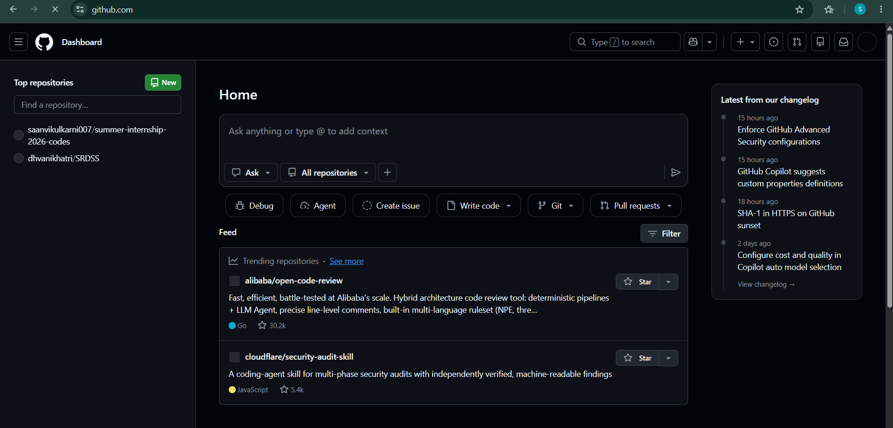
TASK 2:
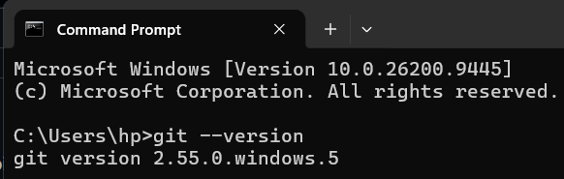
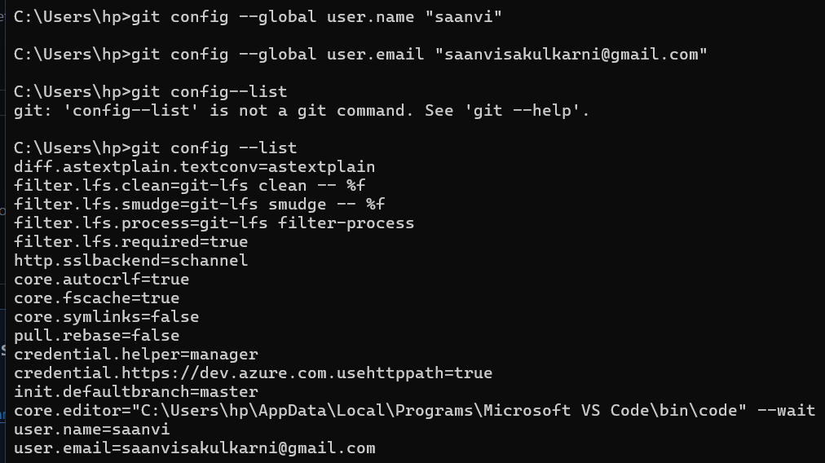
Task 3:
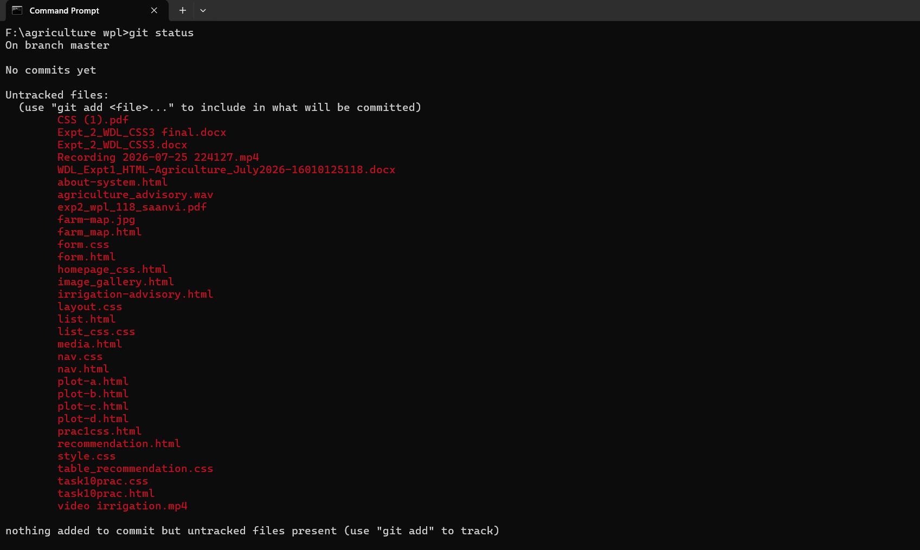
Task 4:
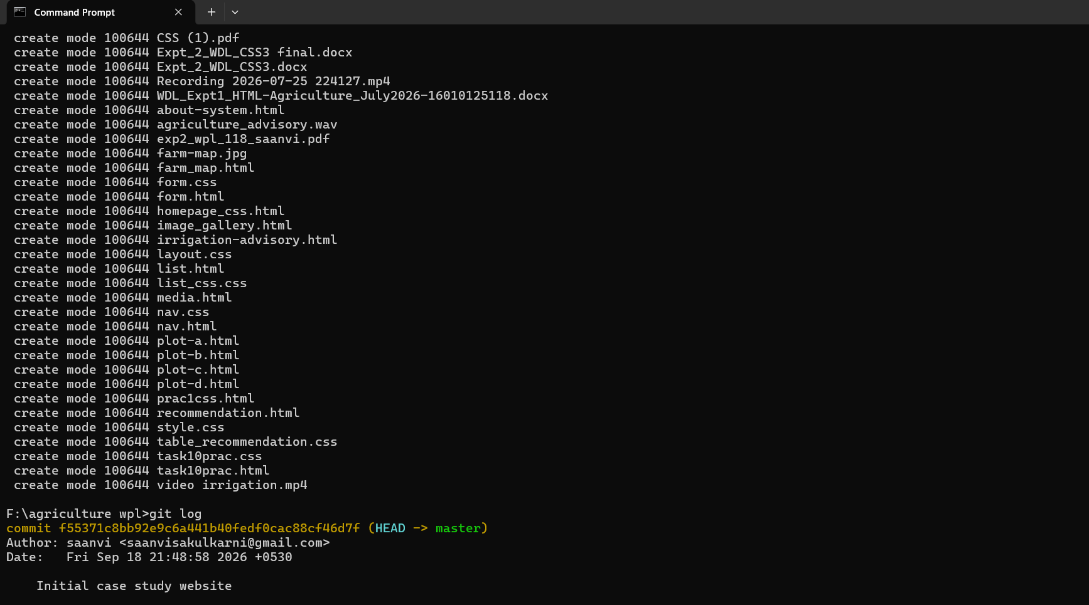
Task 5:
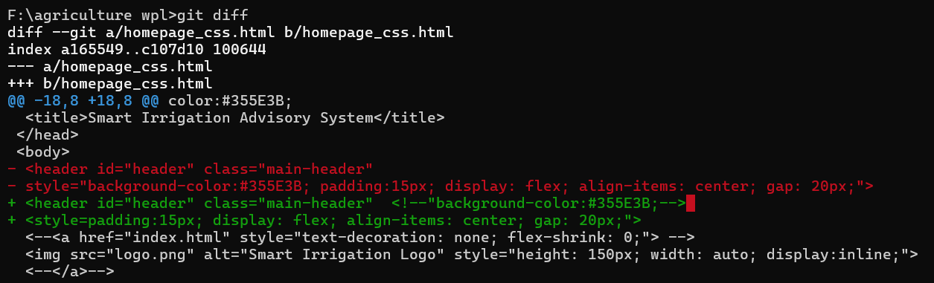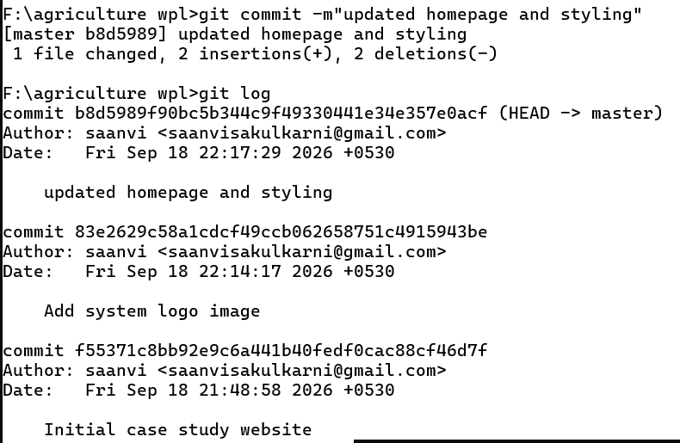
Task 6:
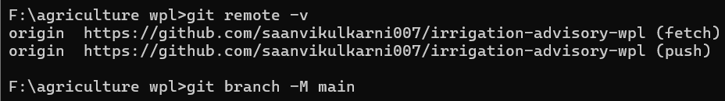

Task 7:
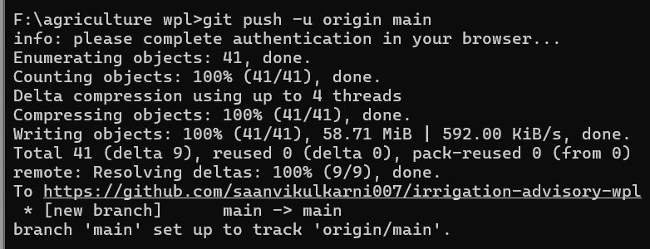
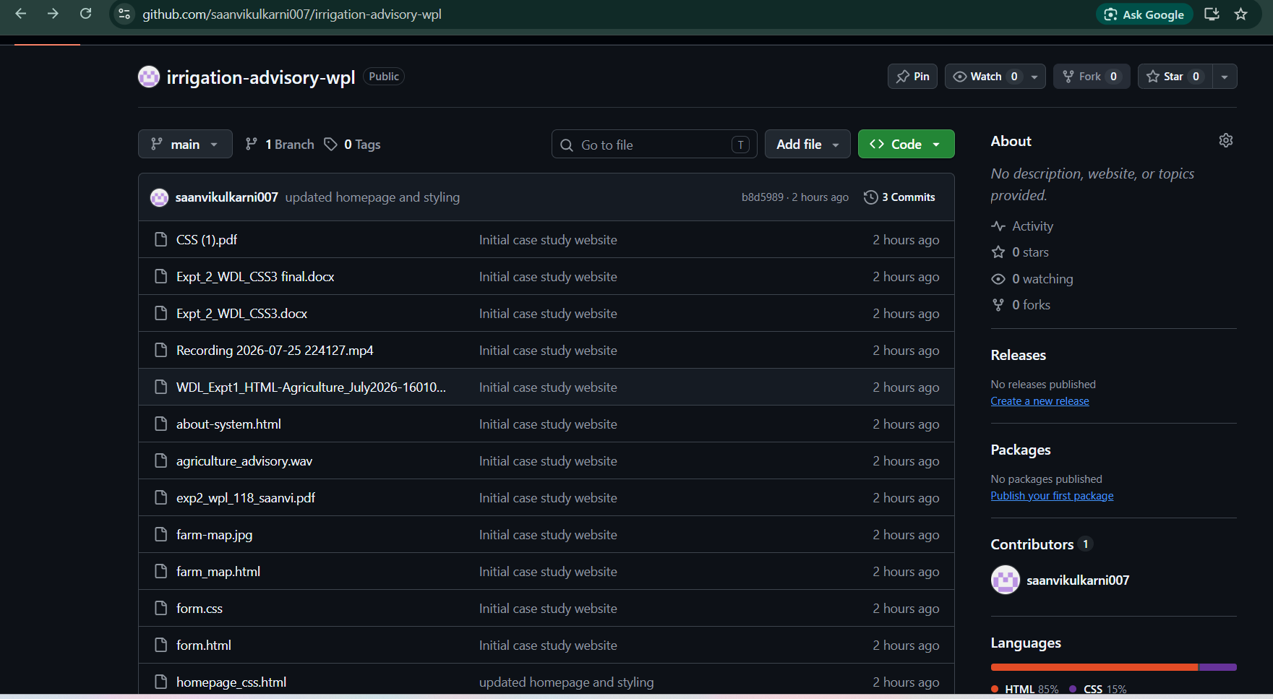
Task 8:

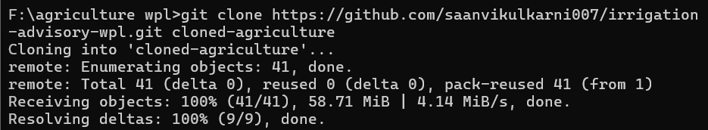

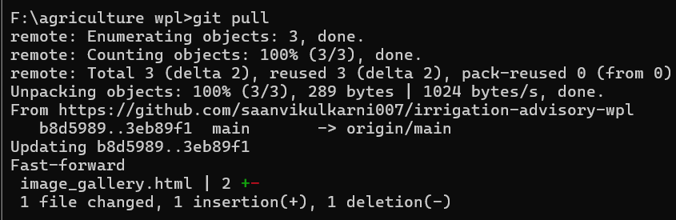

Post Lab Subjective/Objective type Questions:
- What is the purpose of git clone? How is it different from downloading a ZIP file from GitHub?
git clone is a Git command used to create an exact local duplicate of a remote repository on your computer.
- Full Repository Copy: It downloads all project files, subdirectories, and the complete commit history (all past changes, messages, and tags) contained within the repository's .git folder.
- Automatic Remote Linking: It automatically sets up a remote connection called origin pointing back to the source repository URL, allowing you to use git pull and git push immediately.
- Branch Preservation: It copies all branches existing on the remote repository, enabling you to switch between them locally without needing internet access.

Feature / Aspect | git clone | Downloading ZIP File
Git Repository (.git folder) | Included. The folder remains a fully functional Git repository. | Excluded. It extracts as a standard, un-tracked folder.
Version History | Contains full commit history, author logs, and time stamps. | No commit history; contains only the files' current state.
Remote Connection (origin) | Automatically configured to sync (git pull / git push). | No connection to GitHub; cannot push or pull changes.
Branching Support | Copies all branches; switch easily with git checkout. | Downloads only the single selected branch snapshot.
Updates & Synchronization | Fetch changes instantly using git pull. | Requires downloading and unzipping the entire folder again.
Intended Use Case | For developers actively coding, contributing, and tracking changes. | For users who only need to view, run, or inspect the code once.

- Complete at least the relevant interactive exercises from Git Exercises (https://gitexercises.fracz.com/)and demonstrate basic branching, conflict resolution, and remote-repository operations.

Conclusion and Discussion:
Students should write the conclusion in their own words based on the work performed. The discussion should mention what was learned about Git/GitHub, how version history helped in tracking website changes, any difficulties encountered, and how those difficulties were resolved.
Peer feedback (minimum 3 classmates):
1.___Swarangi: The repository structure is very well organized, and the Git commit history shows clear, step-by-step progress rather than just one massive initial commit. The synchronization between the primary folder and the cloned folder worked cleanly. One small suggestion would be to add a short README.md file in the repository root summarizing how to run the project locally.
2.Dhvani: I tested the farmer registration form on form.html. The JavaScript validation works really well—especially the date constraint that blocks future registration dates and the red outline highlighting on invalid fields. It makes the form very user-friendly. Having all the JS logic embedded under <script> tags kept everything self-contained as required by the lab prompt.
3. Siri: The Git workflow setup is solid. Pushing changes from the cloned workspace and pulling them back into the main project directory demonstrated proper remote synchronization. The HTML structure for the smart irrigation advisory interface is clean and easy to navigate. Everything aligns directly with the Task 1 and Task 2 laboratory requirements.

