Course Name: | Web Development Laboratory (316U01L306) | Semester: | III
Date of Performance: | ___ / ___ / ______ | DIV/ Batch No: | B2
Student Name: | SAANVI KULKARNI | Roll No: | 16010125118

Experiment No: 4
Title
Form Validation using JavaScript for an AI-based Smart Irrigation Advisory Web Portal
Aim of the Experiment
To design and implement client-side form validation using JavaScript for the farmer registration form of an AI-based Smart Irrigation Advisory System, ensuring that user-entered data such as name, mobile number, email, plot ID, soil moisture, crop stage, irrigation method, and date is complete, valid, and meaningful before form submission.
Objectives of the Experiment
• To create an interactive HTML form for collecting farmer and farm information.
• To use JavaScript to validate text, numeric, email, date, and selection fields.
• To implement regular expressions for validating mobile numbers, email addresses, and plot IDs.
• To display meaningful error messages and prevent submission when invalid data is entered.
• To apply form validation to a real-world agriculture use case involving farmer and farm registration.
COs to be achieved
CO1: Developing webpages using HTML, CSS and JavaScript.
Books / Journals / Websites references
1. MDN Web Docs – JavaScript Guide and HTML Forms.
2. W3schools.com
3. JavaScript documentation/reference material prescribed by the course instructor.
Theory
Form validation is the process of checking whether the information entered by a user satisfies the required rules before it is submitted or processed. Validation improves data quality, usability, and reliability of web applications.
JavaScript provides client-side validation by accessing form elements through the DOM and checking their values using conditions, string methods, numeric comparisons, regular expressions, and event handlers such as submit and input. If invalid data is detected, JavaScript can display an error message and stop the form from being submitted.
Common validation rules include checking for empty fields, minimum and maximum length, valid email format, valid mobile number, acceptable numeric ranges, selected options, and valid dates. Regular expressions are useful for validating structured values such as mobile numbers and email addresses.
In this experiment, JavaScript validation is applied to a farmer registration form for the AI-based Smart Irrigation Advisory System. The use case calls for farmer-friendly web/mobile platforms and plot-specific advisory and decision support. fileciteturn0file1L41-L46
Problem Statement
"JavaScript Form Validation for Farmer Registration"
Develop a web-based farmer registration form for the Smart Irrigation Advisory System. The form should collect essential farmer and farm information and use JavaScript to validate the entered values before submission. Invalid or incomplete data must be identified and appropriate error messages must be displayed to the user.
Task 1: Create the Farmer Registration Form
Scenario
Design a registration form for farmers who will use the Smart Irrigation Advisory System.
Requirements
• Create fields for Farmer Name, Mobile Number, Email, Plot ID, Village, Crop Stage, Soil Type, Irrigation Method, Soil Moisture (%), Registration Date and Farm Photo.
• Use <form>, <label>, <input>, <select>, <option>, <fieldset> and <legend>.
• Provide Submit and Reset buttons.
• Assign unique id and name attributes to all fields.
Concepts Tested
• HTML Forms
• Form controls
• DOM element identification
Deliverable: registration.html
Task 2: Validate Required Text Fields
Scenario
Ensure that essential farmer and farm information is not left blank.
Requirements
• Check that Farmer Name, Plot ID and Village are not empty.
• Remove leading and trailing spaces using trim().
• Validate that Farmer Name contains alphabetic characters and spaces only.
• Display an error message beside each invalid field.
Concepts Tested
• JavaScript conditions
• String methods
• Required-field validation
Deliverable: registration.html
Task 3: Validate Mobile Number and Email
Scenario
Verify that the farmer's contact information follows the expected format.
Requirements
• Validate a 10-digit Indian mobile number using a suitable regular expression or any other rule.
• Validate the email address.
• Display specific messages for invalid mobile number and email.
• Do not allow the form to submit until both fields are valid.
Concepts Tested
• Regular expressions
• String validation
• Form submit event
Deliverable: registration.html
Task 4: Validate Selection and Date Fields
Scenario
Ensure that the farmer provides valid crop, soil, irrigation and date information.
Requirements
• Ensure that Crop Stage, Soil Type and Irrigation Method are selected.
• Validate that Registration Date is entered.
• Prevent future registration dates if the application rule requires the registration date to be today or earlier.
• Highlight the field when validation fails.
Concepts Tested
• Select validation
• Date validation
• DOM manipulation
Deliverable: registration.html

Code :
Task 1:
<script>
document.addEventListener('DOMContentLoaded', () => {
const farmerForm = document.getElementById('farmerForm');

// DOM Elements
const nameInput = document.getElementById('name');
const mobileInput = document.getElementById('mobile');
const emailInput = document.getElementById('email');
const moistureInput = document.getElementById('soil_moisture');
const photoInput = document.getElementById('farm_photo');

const regDateInput = document.getElementById('reg_date');
if (regDateInput) {
regDateInput.value = new Date().toISOString().split('T')[0];
}
farmerForm.addEventListener('submit', (event) => {
event.preventDefault();

const mobileRegex = /^[6-9]\d{9}$/;
if (!mobileRegex.test(mobileInput.value)) {
alert('Please enter a valid 10-digit mobile number.');
mobileInput.focus();
return;
}
const moistureVal = parseFloat(moistureInput.value);
if (isNaN(moistureVal) || moistureVal < 0 || moistureVal > 100) {
alert('Soil Moisture percentage must be between 0 and 100.');
moistureInput.focus();
return;
}

if (photoInput.files.length === 0) {
alert('Please upload a farm photo.');
photoInput.focus();
return;
}
const formData = new FormData(farmerForm);
const registeredDetails = {};

formData.forEach((value, key) => {
if (key === 'farm_photo') {
registeredDetails[key] = value.name;
} else {
registeredDetails[key] = value;
}
});

console.log('Farmer Registration Data Submitted Successfully:', registeredDetails);
alert(`Registration successful for ${nameInput.value}! Data logged to console.`);
});

farmerForm.addEventListener('reset', () => {
console.log('Form cleared.');
});
});
</script>

Task 2:
<script>
document.addEventListener('DOMContentLoaded', () => {
const farmerForm = document.getElementById('farmerForm');
const nameInput = document.getElementById('name');
const nameError = document.getElementById('nameError');

if (!farmerForm) {
console.error("Error: Could not find <form id='farmerForm'> in HTML.");
return;
}

function validateName() {
if (!nameInput || !nameError) return false;

const nameValue = nameInput.value.trim();

const alphaSpaceRegex = /^[A-Za-z\s]+$/;

if (nameValue === '') {
nameError.textContent = 'Farmer Name is required.';
return false;
} else if (!alphaSpaceRegex.test(nameValue)) {
nameError.textContent = 'Farmer Name must contain alphabetic characters and spaces only.';
return false;
} else {
nameError.textContent = '';
return true;
}
}

if (nameInput) {
nameInput.addEventListener('input', validateName);
nameInput.addEventListener('blur', validateName);
}
farmerForm.addEventListener('submit', (event) => {
const isNameValid = validateName();

if (!isNameValid) {
console.log('Submission blocked: Invalid Farmer Name');
}
});
});
</script>

Task 3:
<script>
// Task 2: Farmer Name Validation
function validateName() {
const nameInput = document.getElementById('name');
const nameError = document.getElementById('nameError');
const nameValue = nameInput.value.trim();
const alphaSpaceRegex = /^[A-Za-z\s]+$/;

if (nameValue === '') {
nameError.textContent = 'Farmer Name is required.';
return false;
} else if (!alphaSpaceRegex.test(nameValue)) {
nameError.textContent = 'Farmer Name must contain alphabetic characters and spaces only.';
return false;
} else {
nameError.textContent = '';
return true;
}
}

// Task 3: Mobile Number Validation
function validateMobile() {
const mobileInput = document.getElementById('mobile');
const mobileError = document.getElementById('mobileError');
const mobileValue = mobileInput.value.trim();
const mobileRegex = /^[6-9]\d{9}$/;

if (mobileValue === '') {
mobileError.textContent = 'Mobile number is required.';
return false;
} else if (!mobileRegex.test(mobileValue)) {
mobileError.textContent = 'Enter a valid 10-digit mobile number (starts with 6-9).';
return false;
} else {
mobileError.textContent = '';
return true;
}
}

// Task 3: Email Validation
function validateEmail() {
const emailInput = document.getElementById('email');
const emailError = document.getElementById('emailError');
const emailValue = emailInput.value.trim();
const emailRegex = /^[a-zA-Z0-9._%+-]+@[a-zA-Z0-9.-]+\.[a-zA-Z]{2,}$/;

if (emailValue === '') {
emailError.textContent = 'Email address is required.';
return false;
} else if (!emailRegex.test(emailValue)) {
emailError.textContent = 'Enter a valid email address (e.g. user@domain.com).';
return false;
} else {
emailError.textContent = '';
return true;
}
}

// Task 2: Village Validation
function validateVillage() {
const villageInput = document.getElementById('village');
const villageError = document.getElementById('villageError');
if (villageInput.value.trim() === '') {
villageError.textContent = 'Village name is required.';
return false;
}
villageError.textContent = '';
return true;
}

// Task 2: Plot ID Validation
function validatePlot() {
const plotInput = document.getElementById('plot');
const plotError = document.getElementById('plotError');
if (plotInput.value.trim() === '') {
plotError.textContent = 'Plot ID is required.';
return false;
}
plotError.textContent = '';
return true;
}

// Additional Field Validations
function validateCrop() {
const cropInput = document.getElementById('crop');
const cropError = document.getElementById('cropError');
if (cropInput.value.trim() === '') {
cropError.textContent = 'Crop variety is required.';
return false;
}
cropError.textContent = '';
return true;
}

function validateCropStage() {
const cropStageInput = document.getElementById('crop_stage');
const cropStageError = document.getElementById('cropStageError');
if (cropStageInput.value === '') {
cropStageError.textContent = 'Please select a crop stage.';
return false;
}
cropStageError.textContent = '';
return true;
}

function validateArea() {
const areaInput = document.getElementById('area');
const areaError = document.getElementById('areaError');
const areaValue = parseFloat(areaInput.value.trim());

if (areaInput.value.trim() === '' || isNaN(areaValue) || areaValue <= 0) {
areaError.textContent = 'Enter a valid farm area greater than 0.';
return false;
}
areaError.textContent = '';
return true;
}

function validateSoilType() {
const soilTypeInput = document.getElementById('soil_type');
const soilTypeError = document.getElementById('soilTypeError');
if (soilTypeInput.value === '') {
soilTypeError.textContent = 'Please select a soil type.';
return false;
}
soilTypeError.textContent = '';
return true;
}

function validateMoisture() {
const moistureInput = document.getElementById('soil_moisture');
const moistureError = document.getElementById('moistureError');
const moistureValue = parseFloat(moistureInput.value.trim());

if (moistureInput.value.trim() === '' || isNaN(moistureValue) || moistureValue < 0 || moistureValue > 100) {
moistureError.textContent = 'Moisture must be a percentage between 0 and 100.';
return false;
}
moistureError.textContent = '';
return true;
}

function validateIrrigation() {
const irrigationInput = document.getElementById('irrigation');
const irrigationError = document.getElementById('irrigationError');
if (irrigationInput.value === '') {
irrigationError.textContent = 'Please select an irrigation method.';
return false;
}
irrigationError.textContent = '';
return true;
}

function validateRegDate() {
const dateInput = document.getElementById('reg_date');
const dateError = document.getElementById('dateError');
if (dateInput.value === '') {
dateError.textContent = 'Registration date is required.';
return false;
}
dateError.textContent = '';
return true;
}

function validatePhoto() {
const photoInput = document.getElementById('farm_photo');
const photoError = document.getElementById('photoError');
if (photoInput.files.length === 0) {
photoError.textContent = 'Please upload a farm photo.';
return false;
}
photoError.textContent = '';
return true;
}

function validateLanguage() {
const languages = document.querySelectorAll('input[name="language"]:checked');
const languageError = document.getElementById('languageError');
if (languages.length === 0) {
languageError.textContent = 'Please select a language.';
return false;
}
languageError.textContent = '';
return true;
}

function validateServices() {
const services = document.querySelectorAll('input[name="services"]:checked');
const servicesError = document.getElementById('servicesError');
if (services.length === 0) {
servicesError.textContent = 'Select at least one advisory service.';
return false;
}
servicesError.textContent = '';
return true;
}

// Master Form Validation Triggered on Submit
function validateForm() {
const isNameValid = validateName();
const isMobileValid = validateMobile();
const isEmailValid = validateEmail();
const isVillageValid = validateVillage();
const isPlotValid = validatePlot();
const isCropValid = validateCrop();
const isCropStageValid = validateCropStage();
const isAreaValid = validateArea();
const isSoilTypeValid = validateSoilType();
const isMoistureValid = validateMoisture();
const isIrrigationValid = validateIrrigation();
const isDateValid = validateRegDate();
const isPhotoValid = validatePhoto();
const isLanguageValid = validateLanguage();
const isServicesValid = validateServices();

return isNameValid && isMobileValid && isEmailValid && isVillageValid &&
isPlotValid && isCropValid && isCropStageValid && isAreaValid &&
isSoilTypeValid && isMoistureValid && isIrrigationValid &&
isDateValid && isPhotoValid && isLanguageValid && isServicesValid;
}

// Clear all Error Spans on Reset
function clearErrors() {
const errorSpans = document.querySelectorAll('span[id$="Error"]');
errorSpans.forEach(span => span.textContent = '');
}
</script>

TASK 4:
<script>
document.addEventListener('DOMContentLoaded', () => {
const farmerForm = document.getElementById('farmerForm');

// DOM Elements
const nameInput = document.getElementById('name');
const mobileInput = document.getElementById('mobile');
const emailInput = document.getElementById('email');
const moistureInput = document.getElementById('soil_moisture');
const photoInput = document.getElementById('farm_photo');

// Task 4 DOM Elements
const cropStageInput = document.getElementById('crop_stage');
const soilTypeInput = document.getElementById('soil_type');
const irrigationInput = document.getElementById('irrigation');
const regDateInput = document.getElementById('reg_date');

if (regDateInput && !regDateInput.value) {
regDateInput.value = new Date().toISOString().split('T')[0];
}

// Helper function to apply/remove visual field highlighting on error
function highlightField(element, isInvalid) {
if (isInvalid) {
element.style.border = '2px solid red';
element.style.backgroundColor = '#ffe6e6';
} else {
element.style.border = '';
element.style.backgroundColor = '';
}
}

// Clear highlight dynamically when user modifies input
const watchedInputs = [cropStageInput, soilTypeInput, irrigationInput, regDateInput, mobileInput, moistureInput, photoInput];
watchedInputs.forEach(input => {
if (input) {
input.addEventListener('change', () => highlightField(input, false));
input.addEventListener('input', () => highlightField(input, false));
}
});
farmerForm.addEventListener('submit', (event) => {
event.preventDefault();

// Clear previous error highlights
watchedInputs.forEach(input => input && highlightField(input, false));

const mobileRegex = /^[6-9]\d{9}$/;
if (!mobileRegex.test(mobileInput.value)) {
alert('Please enter a valid 10-digit mobile number.');
highlightField(mobileInput, true);
mobileInput.focus();
return;
}

// 2. Task 4: Dropdown Selection Validations
if (!cropStageInput.value) {
alert('Please select a Crop Stage.');
highlightField(cropStageInput, true);
cropStageInput.focus();
return;
}

if (!soilTypeInput.value) {
alert('Please select a Soil Type.');
highlightField(soilTypeInput, true);
soilTypeInput.focus();
return;
}

if (!irrigationInput.value) {
alert('Please select an Irrigation Method.');
highlightField(irrigationInput, true);
irrigationInput.focus();
return;
}
const moistureVal = parseFloat(moistureInput.value);
if (isNaN(moistureVal) || moistureVal < 0 || moistureVal > 100) {
alert('Soil Moisture percentage must be between 0 and 100.');
highlightField(moistureInput, true);
moistureInput.focus();
return;
}

// 4. Task 4: Registration Date Validation (Required & No Future Dates)
if (!regDateInput.value) {
alert('Please select a Registration Date.');
highlightField(regDateInput, true);
regDateInput.focus();
return;
}

const selectedDate = new Date(regDateInput.value);
const today = new Date();
today.setHours(23, 59, 59, 999); // Allow all hours of current day

if (selectedDate > today) {
alert('Registration Date cannot be in the future. Please select today or a past date.');
highlightField(regDateInput, true);
regDateInput.focus();
return;
}
if (photoInput.files.length === 0) {
alert('Please upload a farm photo.');
highlightField(photoInput, true);
photoInput.focus();
return;
}

const formData = new FormData(farmerForm);
const registeredDetails = {};

formData.forEach((value, key) => {
if (key === 'farm_photo') {
registeredDetails[key] = value.name;
} else {
registeredDetails[key] = value;
}
});

console.log('Farmer Registration Data Submitted Successfully:', registeredDetails);
alert(`Registration successful for ${nameInput.value}! Data logged to console.`);
});

farmerForm.addEventListener('reset', () => {
watchedInputs.forEach(input => input && highlightField(input, false));
console.log('Form cleared.');
});
});
</script>

Output / Screenshot:
Students should execute registration.html in a web browser and paste screenshots showing: (1) the registration form, (2) validation errors for invalid inputs, and (3) the success message after entering valid data.
Task 1:
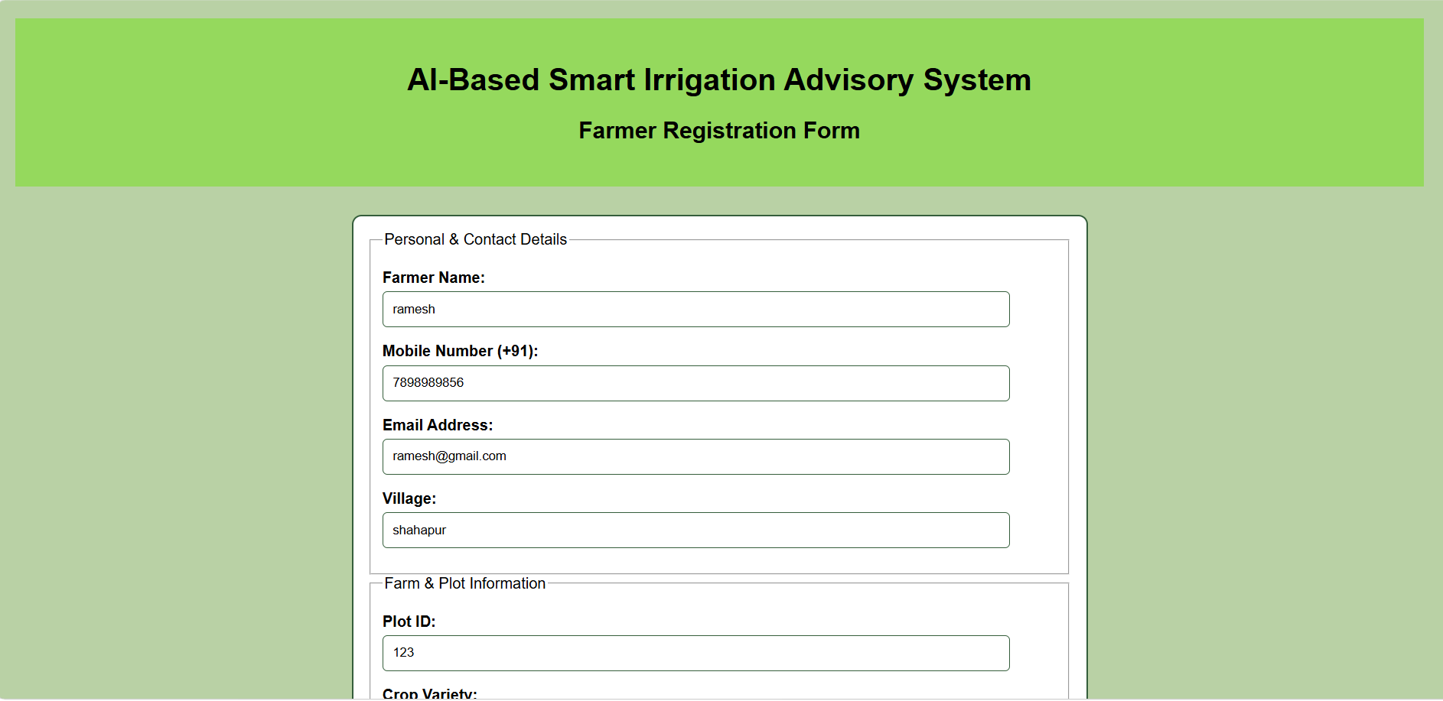
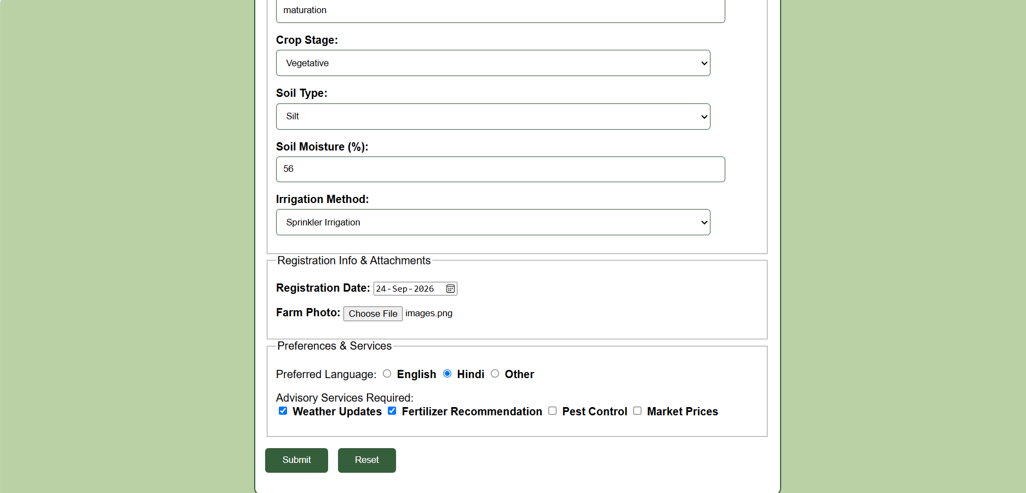
Task 2:

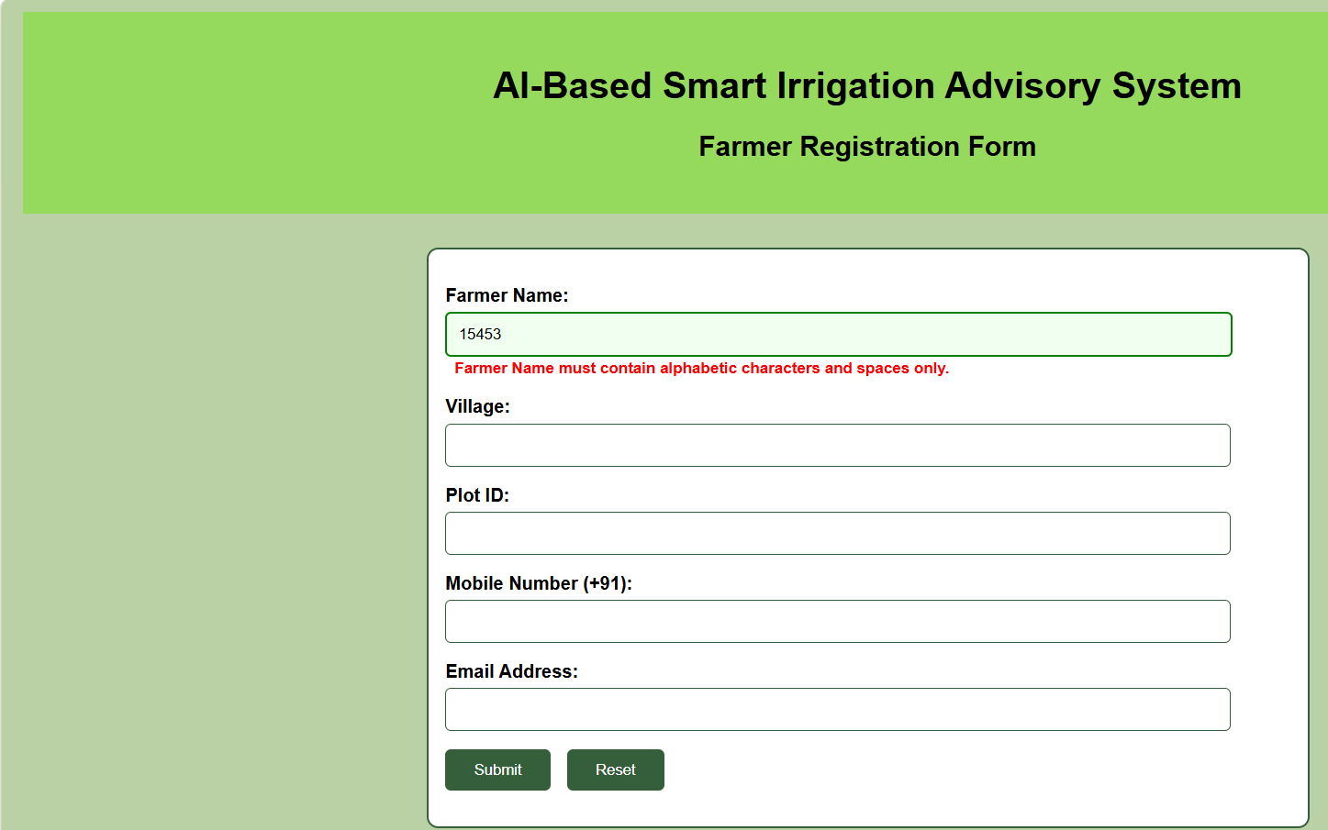

Task 3:
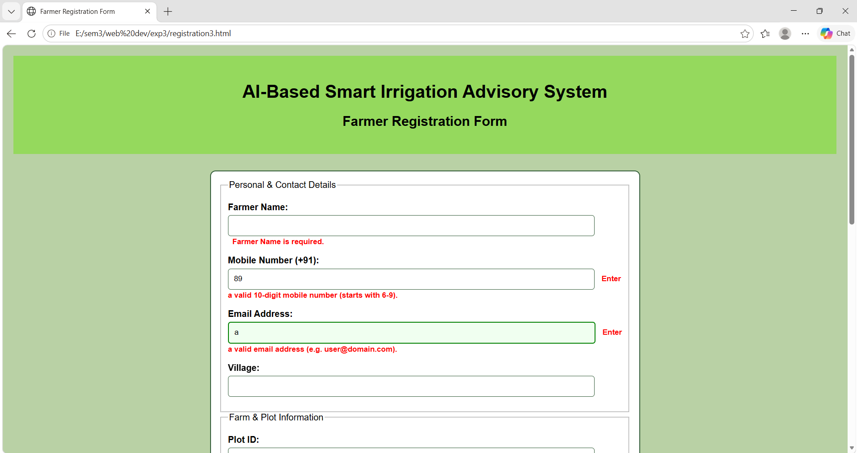
Task 4:
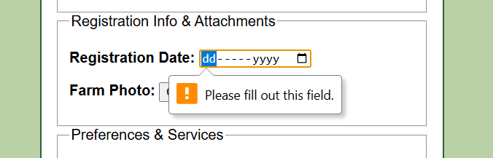
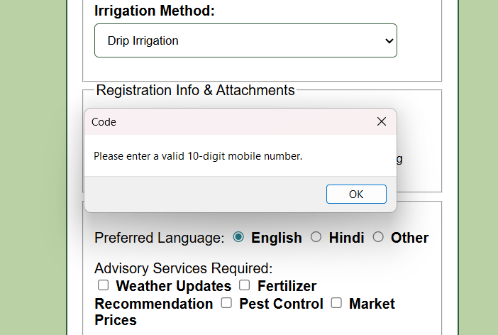
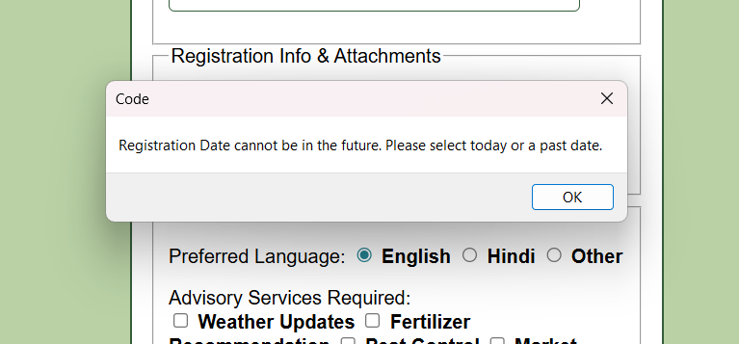
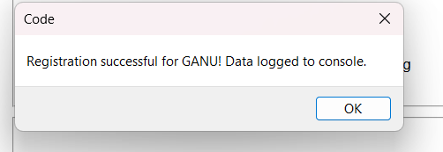
Conclusion and Discussion:
The experiment demonstrates how JavaScript can be used to validate user input on a web form before submission. Validation rules were applied to - - - - in form.html
For fields like farmer name, village, mobile number, email id, registration date
Discussion: Students should test the form with both valid and invalid inputs, record the observed behavior, and take feedback from fellow classmates and faculty.

