Course Name: | Web Development Laboratory (316U01L306) | Semester: | III
Date of Performance: | ___ / ___ / ______ | DIV/ Batch No: | B2
Student Name: | Saanvi Kulkarni | Roll No: | 16010125118

Experiment No: 6
Title
Form Validation using jQuery for an AI-based Smart Irrigation Advisory Web Portal
Aim of the Experiment
To design and implement client-side form validation using jQuery for the farmer registration form of an AI-based Smart Irrigation Advisory System, ensuring that user-entered data such as name, mobile number, email, plot ID, soil moisture, crop stage, irrigation method, and date is complete, valid, and meaningful before form submission.
Objectives of the Experiment
• To create an interactive HTML form for collecting farmer and farm information.
• To use jQuery to validate text, numeric, email, date, and selection fields.
• To use regular expressions with jQuery for validating mobile numbers, email addresses, and plot IDs.
• To display meaningful error messages and prevent submission when invalid data is entered.
• To apply jQuery form validation to a real-world agriculture use case involving farmer and farm registration.
COs to be achieved
CO1: Developing webpages using HTML, CSS, JavaScript and jQuery.
Books / Journals / Websites references
1. jQuery API Documentation – Form events, selectors and DOM manipulation.
2. W3Schools – jQuery and HTML Forms.
3. JavaScript/jQuery documentation/reference material prescribed by the course instructor.
Theory
Form validation is the process of checking whether the information entered by a user satisfies the required rules before it is submitted or processed. Validation improves data quality, usability, and reliability.
jQuery is a JavaScript library that simplifies DOM selection, event handling, and manipulation. For client-side form validation, jQuery can select form elements using selectors, read their values using val(), remove extra spaces using trim(), test patterns using regular expressions, add or remove CSS classes, display error messages, and control form submission through the submit event.
Common validation rules include checking for empty fields, minimum and maximum length, valid email format, valid mobile number, acceptable numeric ranges, selected options, and valid dates. Regular expressions are useful for validating structured values such as mobile numbers, email addresses, and plot IDs.
In this experiment, jQuery validation is applied to a farmer registration form for the AI-based Smart Irrigation Advisory System. The use case calls for farmer-friendly web/mobile platforms and plot-specific advisory and decision support.
Problem Statement
"jQuery Form Validation for Farmer Registration"
Develop a web-based farmer registration form for the Smart Irrigation Advisory System. The form should collect essential farmer and farm information and use jQuery to validate the entered values before submission. Invalid or incomplete data must be identified and appropriate error messages must be displayed to the user.
Task 1: Create the Farmer Registration Form
Scenario
Design a registration form for farmers who will use the AI-based Smart Irrigation Advisory Web Portal.
Requirements
• Create fields for Farmer Name, Mobile Number, Email, Plot ID, Village, Crop Stage, Soil Type, Irrigation Method, Soil Moisture (%), Registration Date and Farm Photo.
• Use <form>, <label>, <input>, <select>, <option>, <fieldset> and <legend>.
• Include the jQuery library and provide Submit and Reset buttons.
• Assign unique id and name attributes to all fields.
Concepts Tested
• HTML Forms
• Form controls and jQuery selectors
• jQuery DOM manipulation
Deliverable: registration.html
Task 2: Validate Required Text Fields using jQuery
Scenario
Ensure that essential farmer and farm information is not left blank.
Requirements
• Check that Farmer Name, Plot ID and Village are not empty using jQuery.
• Remove leading and trailing spaces using $.trim() or JavaScript trim() through jQuery event handling.
• Validate that Farmer Name contains alphabetic characters and spaces only.
• Display an error message beside each invalid field and highlight the invalid field using jQuery.
Concepts Tested
• jQuery selectors and val()
• String validation
• Required-field validation and DOM manipulation
Deliverable: registration.html
Task 3: Validate Mobile Number and Email using jQuery
Scenario
Verify that the farmer's contact information follows the expected format.
Requirements
• Validate a 10-digit Indian mobile number using a suitable regular expression.
• Validate the email address using a regular expression.
• Display specific messages for invalid mobile number and email.
• Do not allow the form to submit until both fields are valid.
Concepts Tested
• jQuery event handling
• Regular expressions
• Form submit event
Deliverable: registration.html
Deliverable: registration.html

Output / Screenshot:
Students should execute registration.html in a web browser and paste screenshots showing: (1) the registration form, (2) validation errors for invalid inputs, and (3) the success message after entering valid data.
[Paste Output / Screenshot Here]
1. Farmer registration form
2. Validation errors for invalid inputs
3. Success message after valid submission

Task 1:
<!-- jQuery Library -->
<script src="https://code.jquery.com/jquery-3.7.1.min.js"></script>

<!-- Message area (filled using jQuery) -->
<div id="form_message"></div>

<script>
$(document).ready(function () {

// jQuery DOM manipulation 1: set today's date as default registration date
var today = new Date().toISOString().split('T')[0];
$('#reg_date').val(today);

// jQuery DOM manipulation 2: auto-calculate Moisture Deficit and Irrigation Status
function calculateMoistureDeficit() {
var current = parseFloat($('#soil_moisture').val());
var required = parseFloat($('#required_moisture').val());
var rain = $('#rain_expected').val();
var $status = $('#irrigation_status');

// Moisture Deficit = Required - Current
if (!isNaN(current) && !isNaN(required)) {
$('#moisture_deficit').val((required - current).toFixed(1) + '%');
} else {
$('#moisture_deficit').val('');
}

// Decision rules (rain is checked first)
if (rain === 'yes') {
$status.val('Postpone Irrigation').css({ color: '#0056b3', fontWeight: 'bold' });
} else if (!isNaN(current)) {
if (current < 30) {
$status.val('Irrigation Required Immediately').css({ color: 'red', fontWeight: 'bold' });
} else if (current <= 50) {
$status.val('Monitor Soil Moisture').css({ color: 'darkorange', fontWeight: 'bold' });
} else {
$status.val('Irrigation Not Required').css({ color: 'green', fontWeight: 'bold' });
}
} else {
$status.val('');
}
}

$('#soil_moisture, #required_moisture').on('input', calculateMoistureDeficit);
$('#rain_expected').on('change', calculateMoistureDeficit);

// jQuery DOM manipulation 3: remove the error highlight when the user edits a field
$('#farmerForm').on('input change', 'input, select', function () {
$(this).removeClass('field-error');
});

// Submit: validation will be added in the next tasks, for now just show a message
$('#farmerForm').on('submit', function (event) {
event.preventDefault();
$('#form_message')
.html('<strong>Form submitted.</strong> Validation will be added in the next task.')
.slideDown();
});

// Reset: clear the auto-calculated fields and message, restore default date
$('#farmerForm').on('reset', function () {
$('#moisture_deficit, #irrigation_status').val('');
$('#farmerForm .field-error').removeClass('field-error');
$('#form_message').hide().empty();
setTimeout(function () { $('#reg_date').val(today); }, 0);
});
});
</script>
Task 2:
/* NEW STYLING ADDED FOR TASK 2: Inline error message styling */
.error-msg { color: red; font-size: 13px; font-weight: bold; margin-left: 10px; }

// MODIFIED: Removes red border AND removes error text span when user types or edits a field
$('#farmerForm').on('input change', 'input, select', function () {
$(this).removeClass('field-error');
$(this).next('.error-msg').remove(); // <-- ADDED: Clears error message beside field
});

// REPLACED SUBMIT HANDLER: Task 2 Text Field Validations ($.trim(), non-empty, & Regex checks)
$('#farmerForm').on('submit', function (event) {
event.preventDefault();

// Clear previous error messages and red highlights
$('.error-msg').remove();
$('.field-error').removeClass('field-error');

var isValid = true;

// Helper function to highlight invalid field and display inline error message beside it
function showError($field, message) {
$field.addClass('field-error');
$field.after('<span class="error-msg">' + message + '</span>');
isValid = false;
}

// 1. Validate Farmer Name (Not empty & Alphabets/Spaces only using $.trim())
var $nameInput = $('#name');
var nameVal = $.trim($nameInput.val()); // Remove leading and trailing spaces
$nameInput.val(nameVal); // Set field value to trimmed version

var namePattern = /^[a-zA-Z\s]+$/;
if (nameVal === '') {
showError($nameInput, 'Farmer Name is required.');
} else if (!namePattern.test(nameVal)) {
showError($nameInput, 'Farmer Name must contain alphabetic characters and spaces only.');
}

// 2. Validate Village (Not empty using $.trim())
var $villageInput = $('#village');
var villageVal = $.trim($villageInput.val());
$villageInput.val(villageVal);

if (villageVal === '') {
showError($villageInput, 'Village is required.');
}

// 3. Validate Plot ID (Not empty using $.trim())
var $plotInput = $('#plot');
var plotVal = $.trim($plotInput.val());
$plotInput.val(plotVal);

if (plotVal === '') {
showError($plotInput, 'Plot ID is required.');
}

// Display form submission status message
if (isValid) {
$('#form_message')
.html('<strong>Success!</strong> Required text fields validated successfully.')
.slideDown();
} else {
$('#form_message').hide().empty();
}
});

// MODIFIED RESET HANDLER: Clears error messages along with form fields
$('#farmerForm').on('reset', function () {
$('.error-msg').remove(); // <-- ADDED: Clears error text spans beside fields
$('#farmerForm .field-error').removeClass('field-error');
$('#moisture_deficit, #irrigation_status').val('');
$('#form_message').hide().empty();
setTimeout(function () { $('#reg_date').val(today); }, 0);
});
output:
task 1:
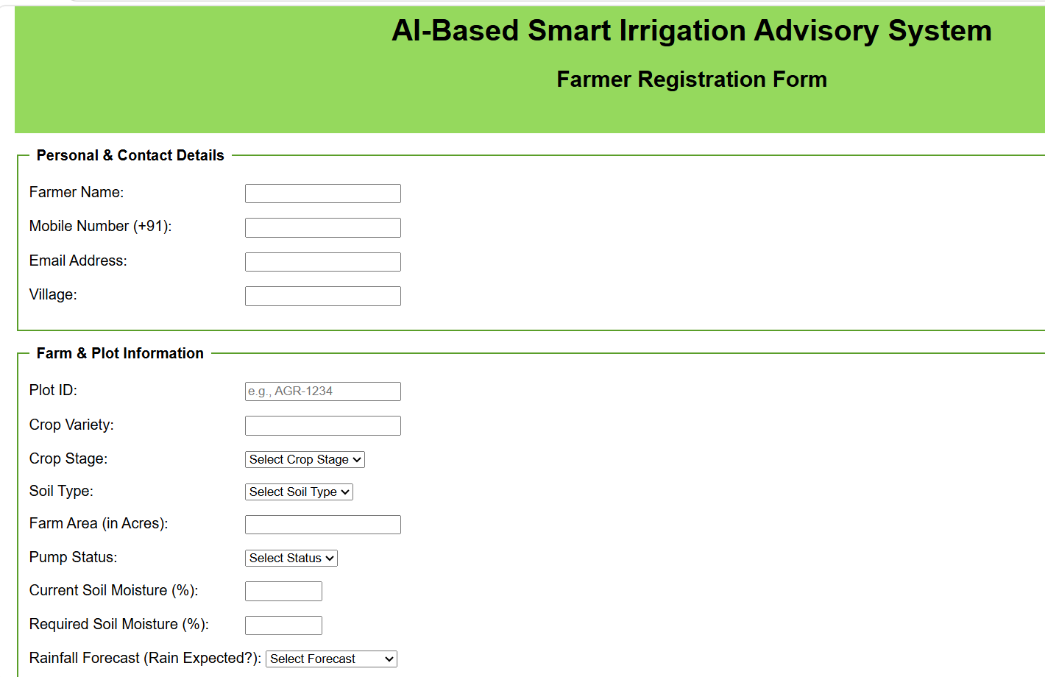

Task 2:
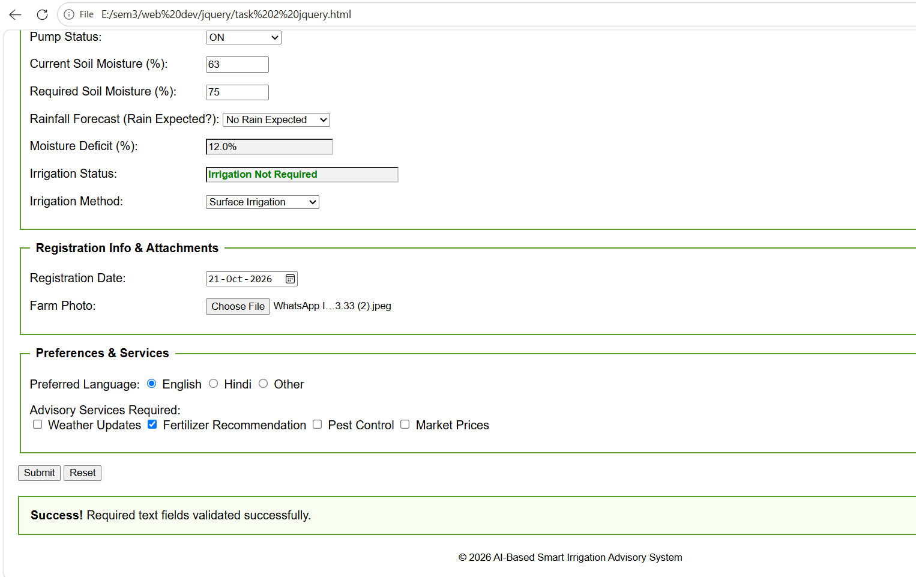
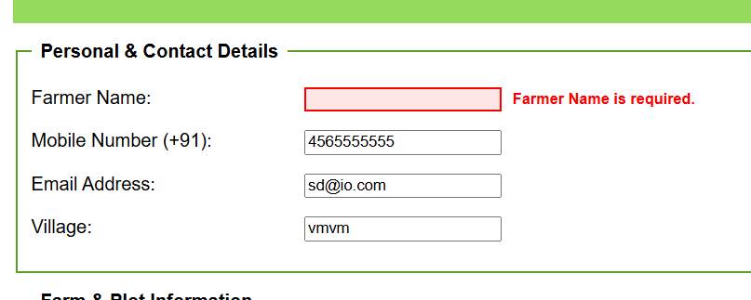
Task 3:
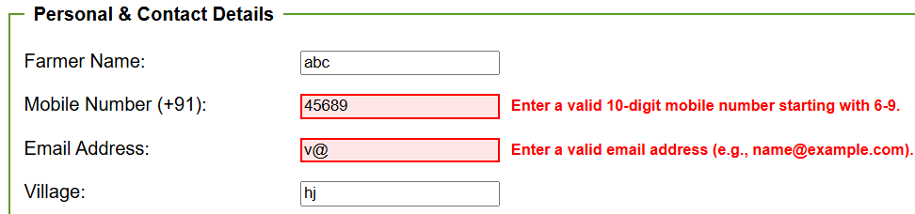
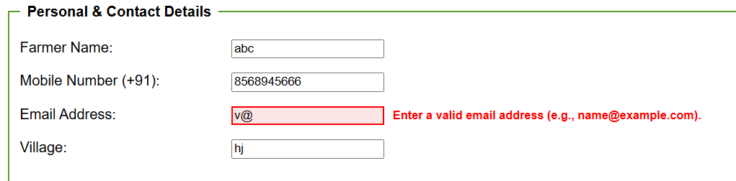
Conclusion and Discussion:
The experiment demonstrates how jQuery can be used to validate user input on a web form before submission. Validation rules were applied to required text fields, mobile number, email, plot ID, selections, soil moisture range, and registration date. jQuery selectors, event handling, regular expressions, DOM manipulation, and error messages were used to improve the reliability and usability of the Smart Irrigation Advisory Web Portal.

Discussion: Students should test the form with both valid and invalid inputs, record the observed behavior, and take feedback from fellow classmates and faculty.

