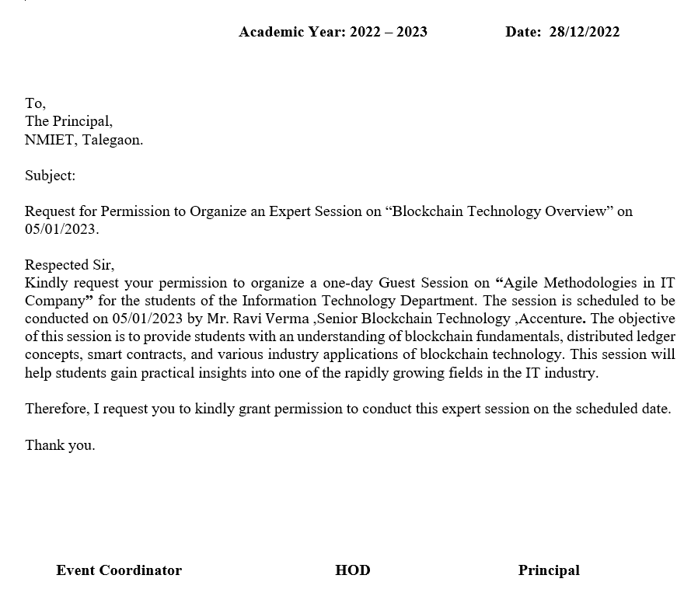
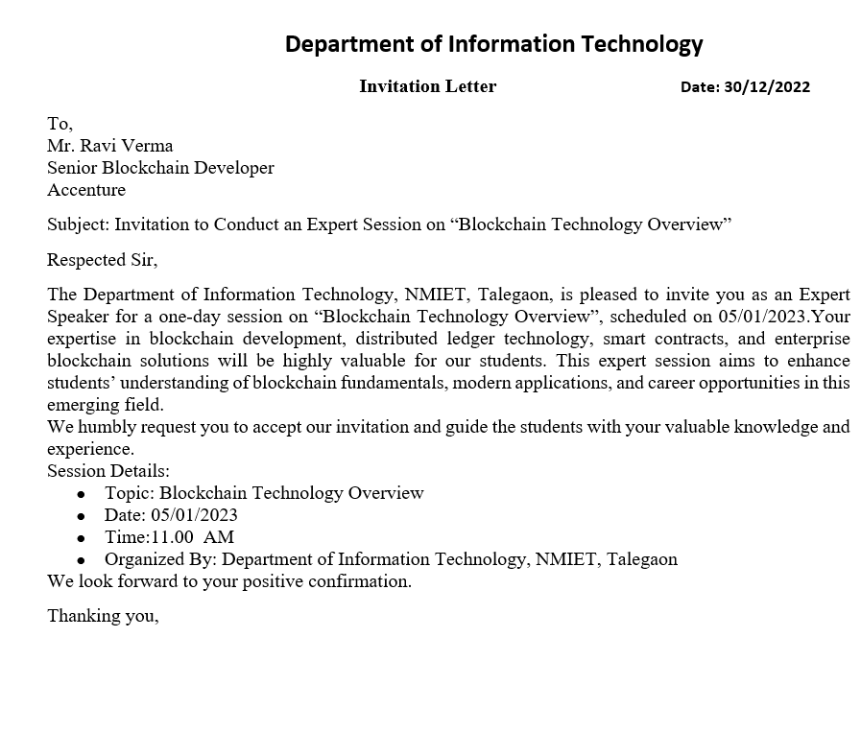
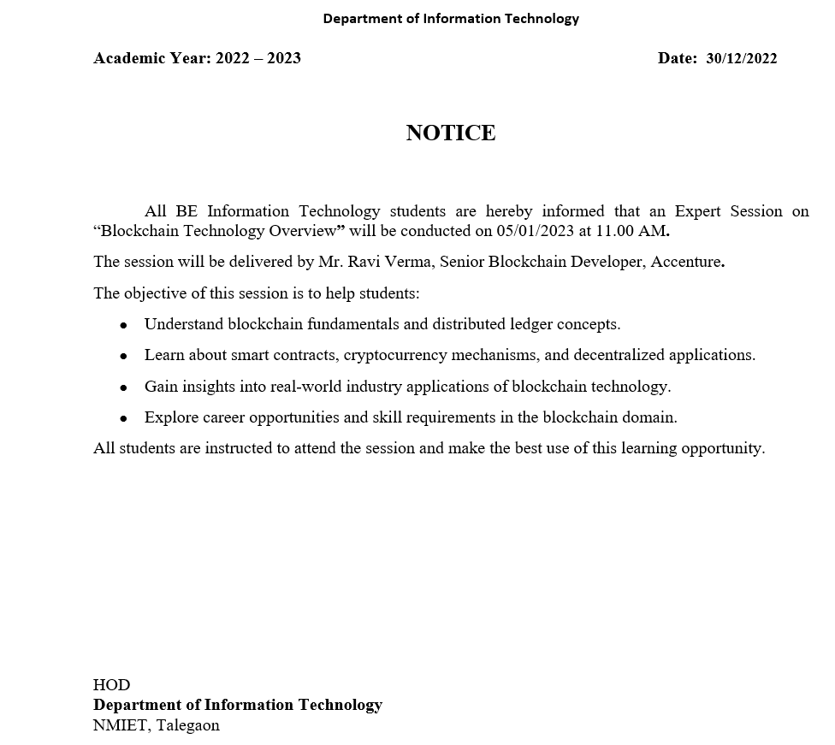

Department of Information Technology

Event Coordinator Prof. Ajay Sonawane
Designation Senior Blockchain Developer, Accenture
Department Information Technology
Venue Seminar Hall
Time 10:00
Date 2025-12-30
Event Type Seminar
Resource Person Mr. Ravi Verma
Name of Event Blockchain Mega Session
Academic Year 2025-26

Brief Description of Activity:
The Department of Information Technology organized a one-day expert session on “Blockchain Technology Overview” on 5th January 2023 for TE Information Technology students. The session was conducted by Mr. Ravi Verma, Senior Blockchain Developer at Accenture, with the objective of familiarizing students with blockchain technology, one of the most transformative innovations in the IT and financial sectors. The session aimed to provide students with a comprehensive understanding of blockchain fundamentals, its working mechanisms, applications in industry, and career opportunities in this rapidly growing field.
Mr. Verma began the session by explaining the history and evolution of blockchain, emphasizing how it emerged as a secure, decentralized solution for digital transactions and data management. He elaborated on the core features of blockchain, including decentralization, immutability, transparency, and cryptographic security, which make it a reliable and tamper-proof system. The students were introduced to the structure of blocks, the concept of hashing, nodes, and the different types of blockchains, such as public, private, and consortium networks, providing a clear understanding of the underlying architecture and how information is securely maintained across distributed ledgers.
The session included a detailed discussion of Bitcoin and Ethereum architectures, illustrating how transactions are validated using consensus mechanisms like Proof of Work (PoW) and Proof of Stake (PoS). Mr. Verma demonstrated, step by step, how a transaction is added to a blockchain and explained the execution of smart contracts in real-time, allowing students to visualize blockchain operations practically. He also introduced students to Decentralized Applications (DApps) and the potential of Ethereum-based solutions for automating agreements and business processes.
Furthermore, the expert highlighted various enterprise blockchain applications, showcasing how multinational companies like Accenture leverage blockchain for supply chain tracking, digital identity management, fraud prevention, healthcare record security, and secure transaction systems. The session helped students understand blockchain’s practical relevance beyond cryptocurrencies and its role in solving real-world industry challenges.
Career guidance was an important component of the session. Mr. Verma explained the programming skills required for blockchain development, such as Solidity, Hyperledger, smart contract development, and auditing, as well as emerging certification courses that can enhance employability in blockchain roles. Students were also informed about the global demand for blockchain professionals and the variety of roles available, including blockchain developer, smart contract engineer, blockchain architect, and consultant.
The session concluded with an interactive question-and-answer segment, where students asked questions about blockchain projects, implementation challenges, cryptocurrencies, and career prospects. Mr. Verma provided practical insights, resources for self-learning, and guidance on industry expectations, motivating students to explore blockchain technology further.
Overall, the expert session on “Blockchain Technology Overview” was highly informative and engaging. It successfully bridged the gap between theoretical concepts and real-world applications, giving students a clear understanding of blockchain architecture, smart contracts, enterprise applications, and career pathways. Students appreciated the detailed explanations, demonstrations, and practical insights, which significantly enhanced their knowledge and interest in pursuing blockchain-related technologies and roles.

Outcomes of the Activity
• Students gained a clear conceptual understanding of blockchain technology and its working process
• Awareness of real-world applications increased, motivating students to consider blockchain-based final year projects
• Students learned about career prospects, required skills, and industry-recognized certifications. ● Participants understood the role of blockchain in enhancing transparency and security across digital systems.

Photographs:
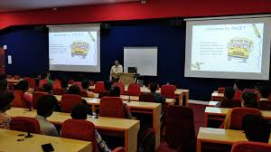

Attendance
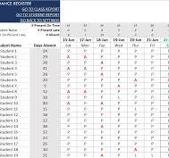

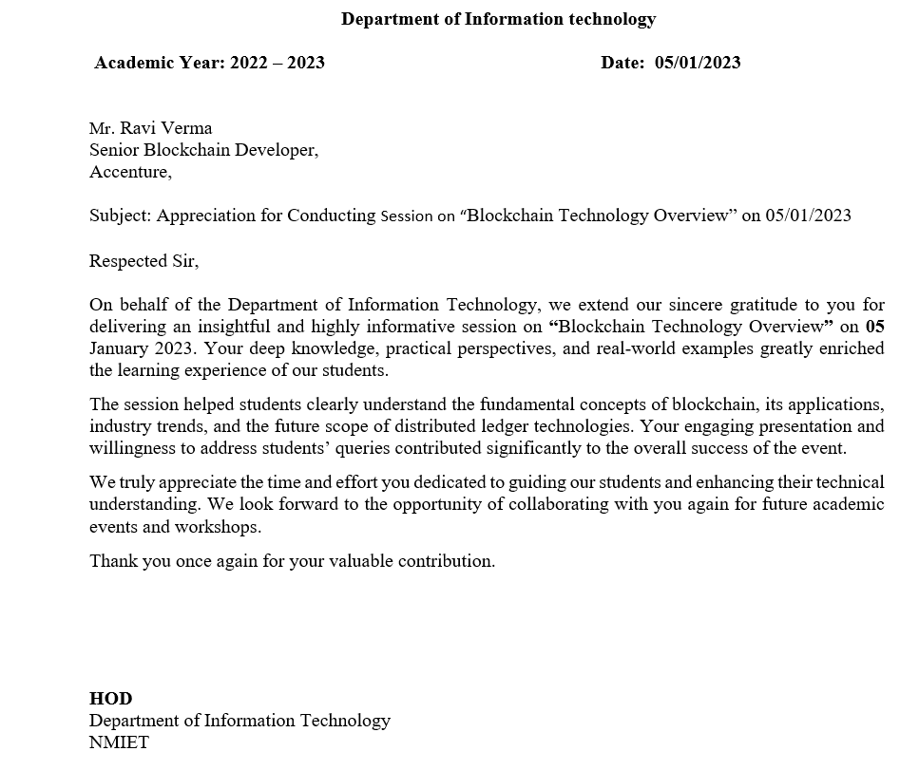

Programme Specific Outcomes (PSO):
PSO1: An ability to apply the theoretical concepts and practical knowledge of Information Technology in the analysis, design, development, and management of information processing systems and applications in the interdisciplinary domain to understand professional, business processes, ethical, legal, security, and social issues and responsibilities.
PSO2: An ability to analyze a problem and identify and define the computing infrastructure and operations requirements appropriate to its solution. IT graduates should be able to work on large-scale computing systems.

Feedback:
Event Name: Blockchain Mega Session
Date: 2025-12-30
Resource Person / Speaker: Mr. Ravi Verma
Department / Organizer: Information Technology

Name | Rating | Comment
student 1 | Very Good | Excellent
student 1 | Excellent | Very Good

