Academic Year: 2025-26 Date: 2026-01-01
Department of Information Technology
Permission Request Letter
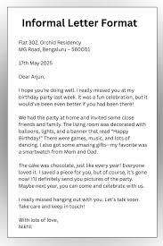
Department of Information Technology
Invitation Letter

Department of Information Technology
Notice

Department of Information Technology

Academic Year: 2025-26 Date: 2026-01-01
Name of Event: FE Induction
Resource Person : Dr. D. B. Sharma
Event Type : Seminar
Date : 2026-01-01
Time : 06:00
Venue : Seminar Hall of Nutan Maharashtra Institude of Engineering and Technology
Department : Information Technology
Designation : HOD of Vit
Organization : fdsfsd

Brief Description of Activity:
First Year Induction Program

Outcomes of the Activity
• First year understood induction
• NA
• NA

Photographs:
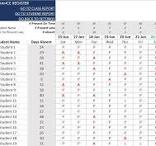

Attendance:


Appreciation Letter


Feedback:

Name | Rating | Comment
student 1 | Very Good | good event
student 2 | Very Good | good good

