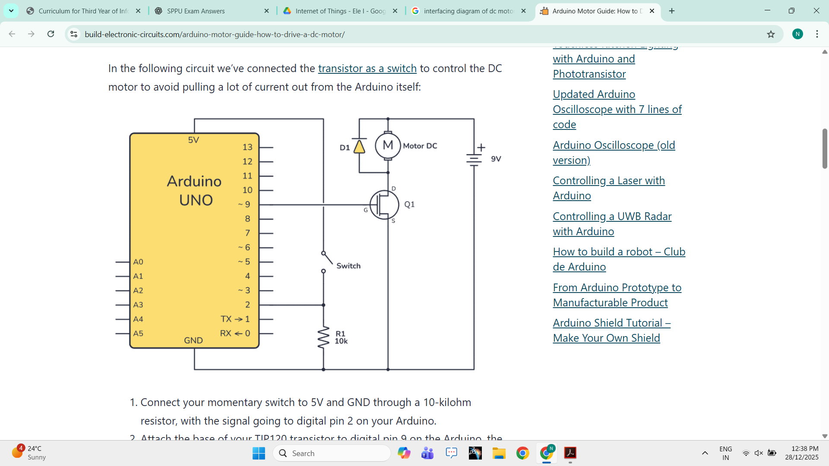



Department of it

Event Coordinator nupoor
Designation student
Department it
Venue school
Time 10:00
Date 2026-03-01
Event Type Cultural Activities
Resource Person nupoor
Name of Event Holi
Academic Year 2026-2027

Brief Description of Activity:
hehe

Outcomes of the Activity
• fun
• fun
• fun

Photographs:


Attendance



Programme Outcome (POs):
• Design / Development of Solutions
• Conduct investigations of complex problems
• Modern Tool Usage

Programme Specific Outcomes (PSO):
PSO1: An ability to apply the theoretical concepts and practical knowledge of Information Technology in the analysis, design, development, and management of information processing systems and applications in the interdisciplinary domain to understand professional, business processes, ethical, legal, security, and social issues and responsibilities.
PSO2: An ability to analyze a problem and identify and define the computing infrastructure and operations requirements appropriate to its solution. IT graduates should be able to work on large-scale computing systems.

Sustainable Development Goals (SDGs):
SDG1: No Poverty
SDG3: Good Health and Well-being
SDG4: Quality Education
SDG5: Gender Equality
SDG17: Partnerships for the Goals

Feedback:
Event Name: Holi
Date: 2026-03-01
Resource Person / Speaker: nupoor
Department / Organizer: it

Name | Rating | Comment
nupoor | Very Good | nice
nice | Excellent

