Permission Letter
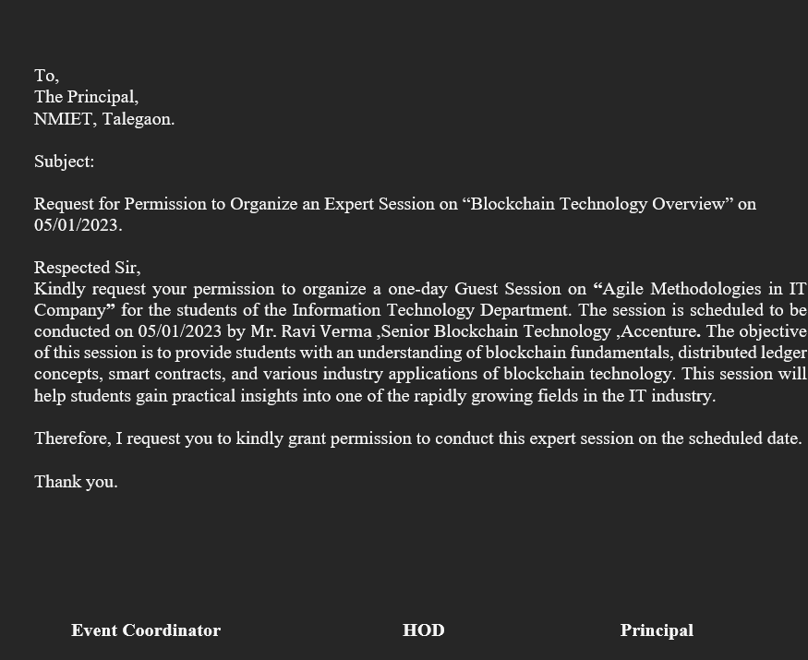
Invitation Letter
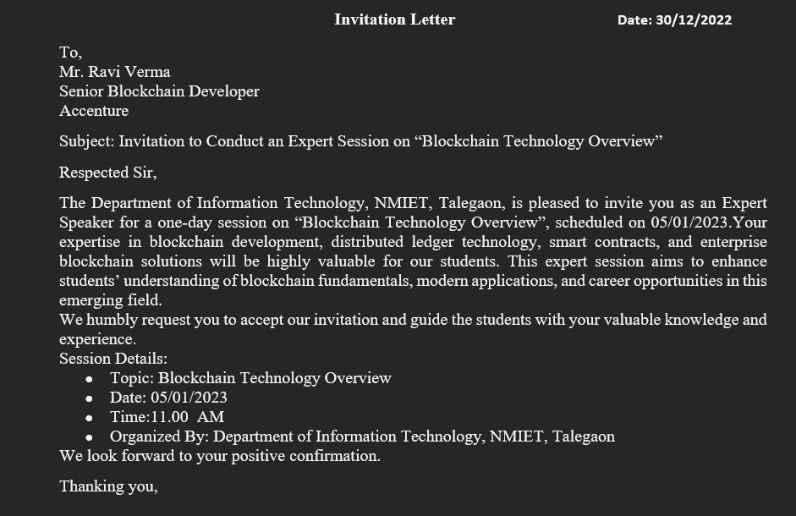
Notice
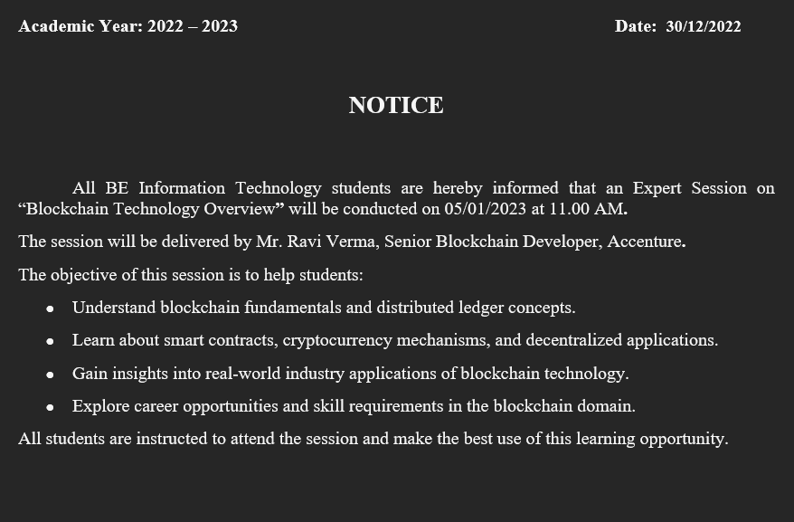

Department of Information Technology

Academic Year: 2025-26 Date: 2025-10-12
Name of the Event: Abc
Resource Person: Dr. D. B. Sharma
Designation: HOD of Vit
Event Type: Webinar
Time: 06:10
Venue: Seminar Hall
Department: Information Technology
Event Coordinator: None

Brief Description of Activity:
The ABC Event is a dynamic and thoughtfully organized program aimed at fostering innovation, creativity, and collaborative learning among participants. Designed to bring together talented individuals from diverse backgrounds, this event serves as a platform to showcase skills, exchange ideas, and gain valuable real-world exposure beyond traditional academic learning.
The event features a wide range of activities, including technical competitions, cultural performances, workshops, guest lectures, panel discussions, and interactive sessions. Each segment of the event is carefully curated to ensure that participants not only compete but also learn and grow through meaningful experiences. Industry experts, faculty members, and professionals are often invited to share their knowledge and insights, helping attendees understand current trends and future opportunities in their respective fields.
One of the key objectives of the ABC Event is to encourage innovation and problem-solving abilities. Participants are motivated to think creatively, work in teams, and develop practical solutions to real-world challenges. The event also emphasizes leadership development, communication skills, time management, and teamwork — qualities that are essential for personal and professional success.
In addition to academic and technical enrichment, the ABC Event promotes cultural exchange and community building. It creates an inclusive environment where participants can connect, network, and form lasting relationships. The vibrant atmosphere, enthusiastic participation, and spirit of healthy competition make the event both educational and enjoyable.
Overall, the ABC Event is more than just a program — it is an opportunity for holistic development. It combines knowledge, experience, and entertainment into a memorable experience that leaves a lasting impact on everyone involved.

Outcomes of the Activity
• First year understood induction
• NA
• srgfrdg

Photographs:
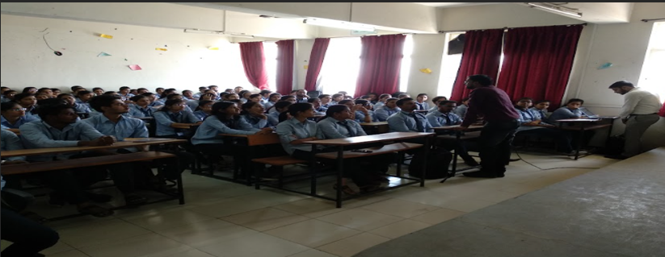
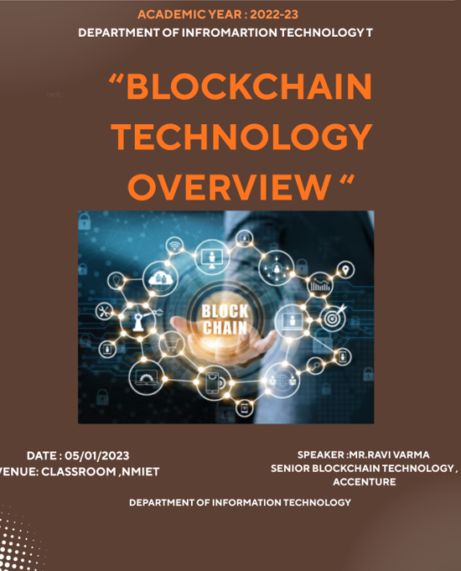

Attendance
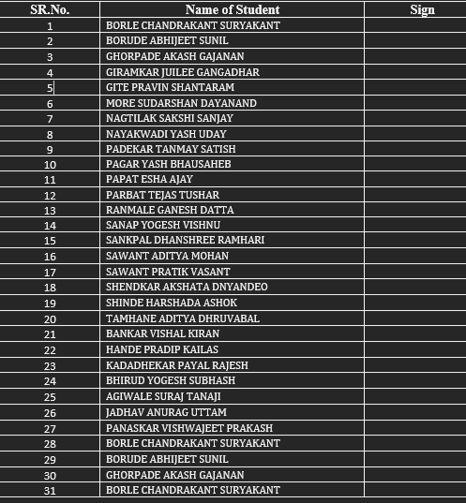

Appreciation Letter
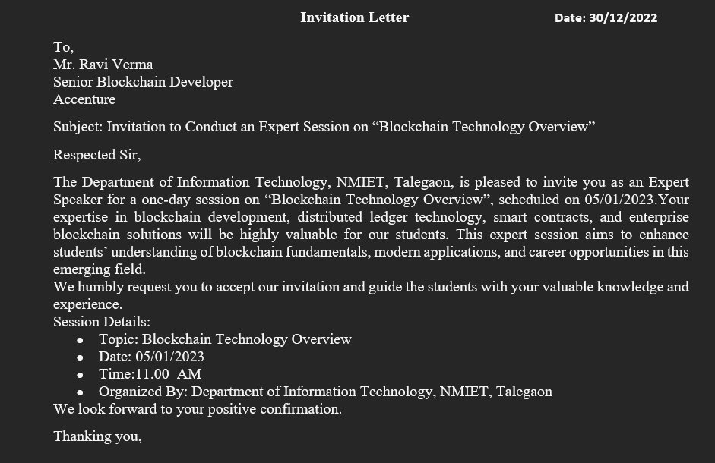
Programme Outcome (POs):
• Engineering Knowledge

Programme Specific Outcomes (PSO):
PSO1: An ability to apply the theoretical concepts and practical knowledge of Information Technology in the analysis, design, development, and management of information processing systems and applications in the interdisciplinary domain to understand professional, business processes, ethical, legal, security, and social issues and responsibilities.

Sustainable Development Goals (SDGs):
SDG3: Good Health and Well-being
SDG5: Gender Equality
SDG6: Clean Water and Sanitation
SDG8: Decent Work and Economic Growth

Feedback:
Event Name: Abc
Date: 2025-10-12
Resource Person / Speaker: Dr. D. B. Sharma
Department / Organizer: Information Technology
Feedback Form: View Feedback Form
Total Responses Received: 8
Analysis generated for 7 question(s).
Branch
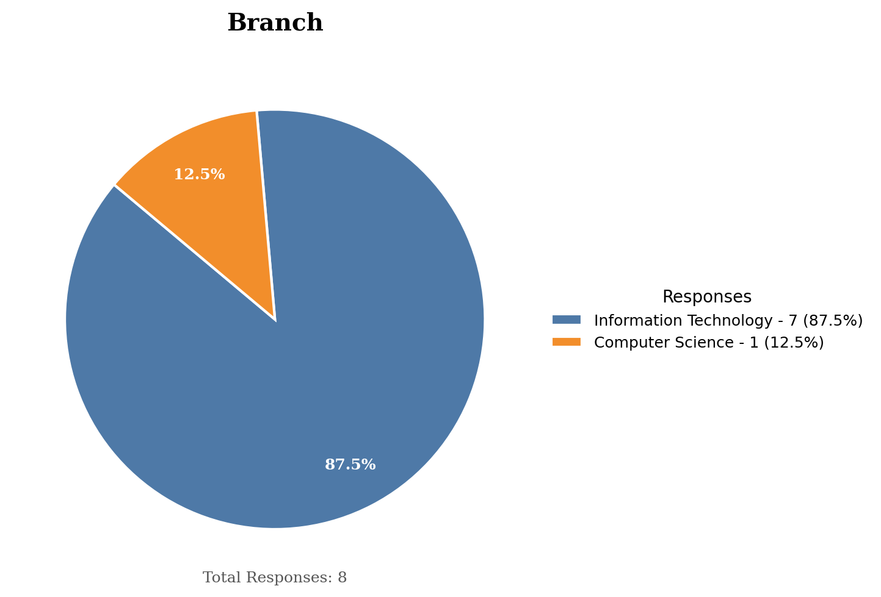
Year
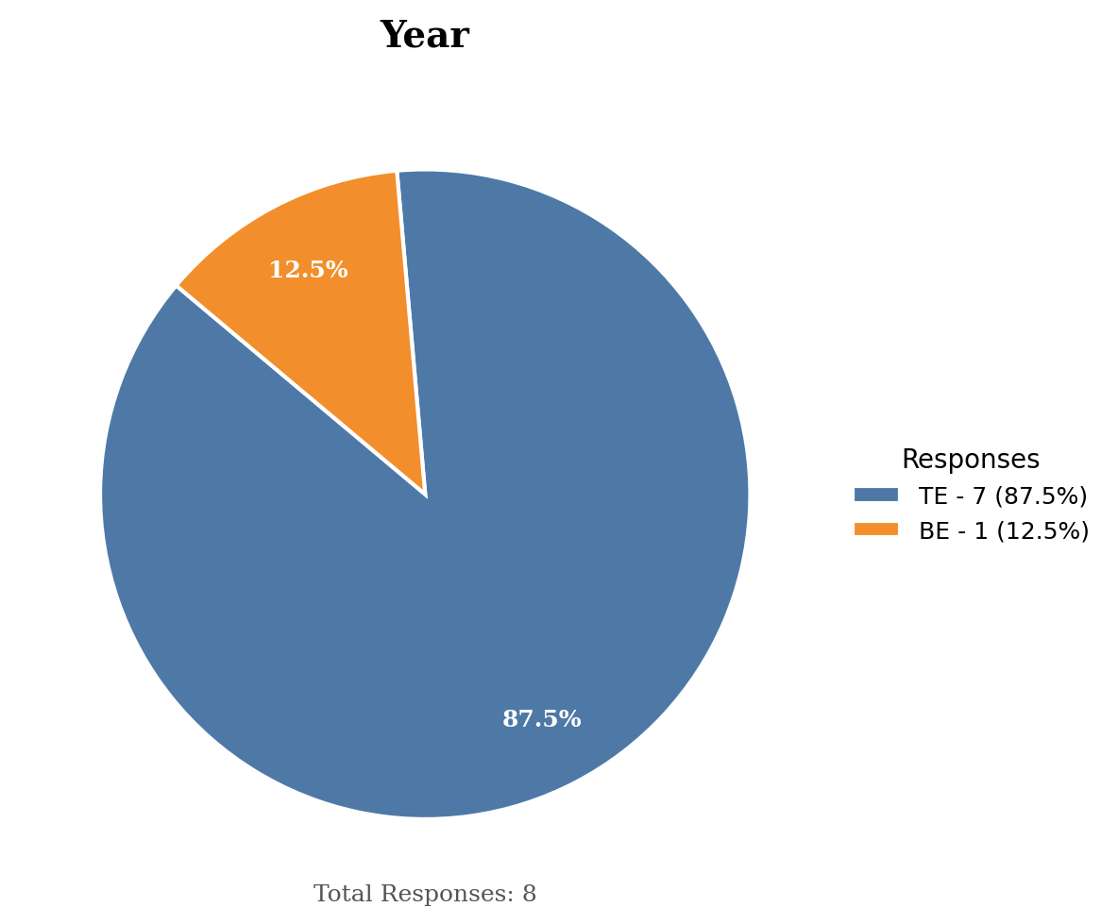
Overall Satisfaction
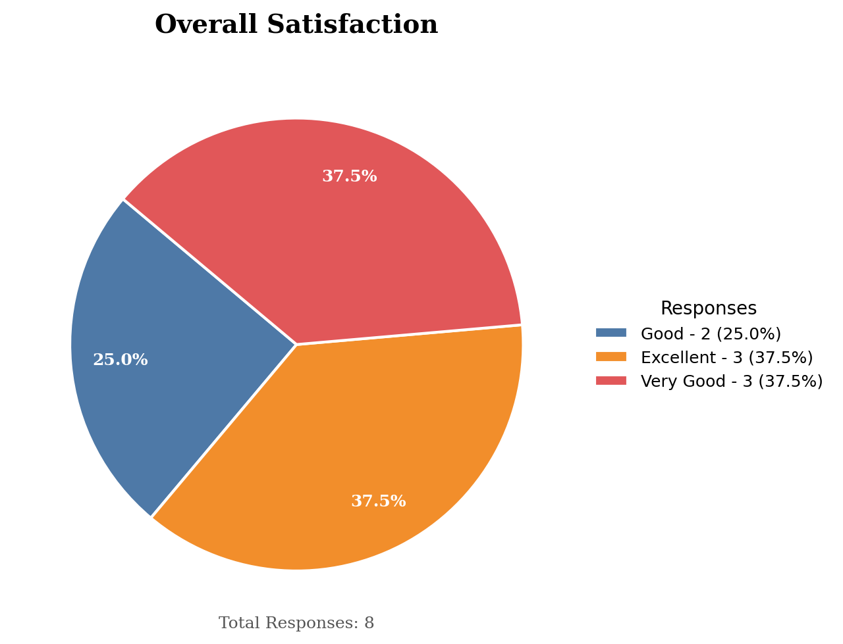
Quality of Resource Person
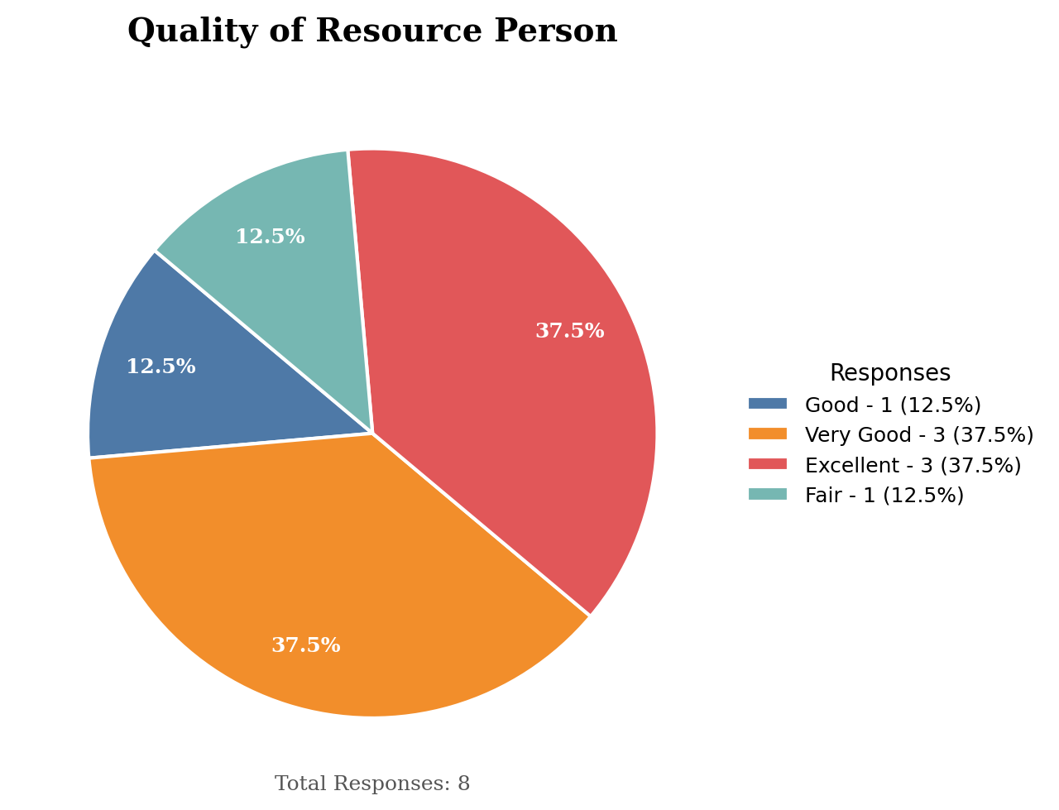
Relevance of Topic
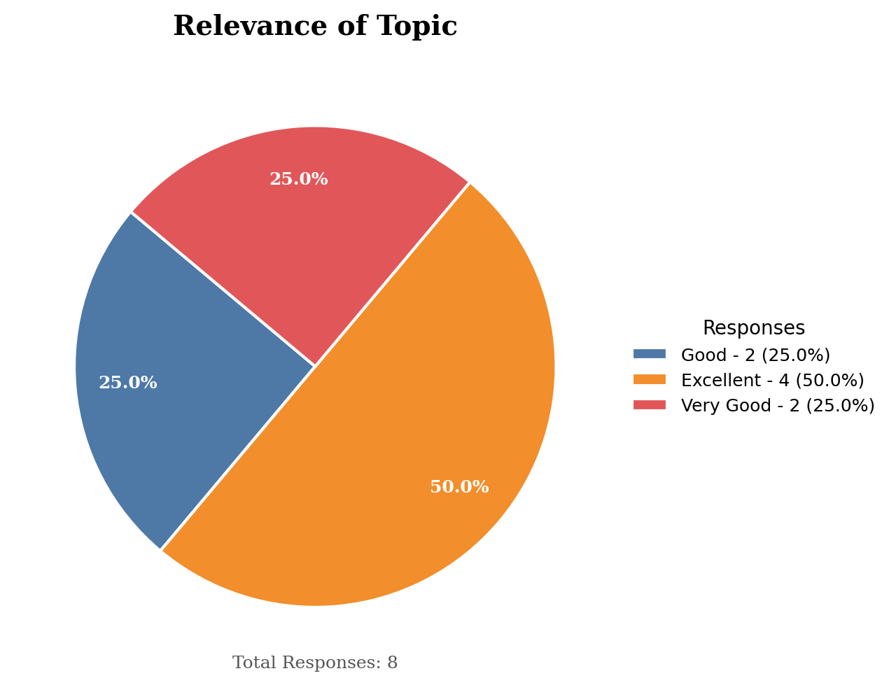
Content and Learning
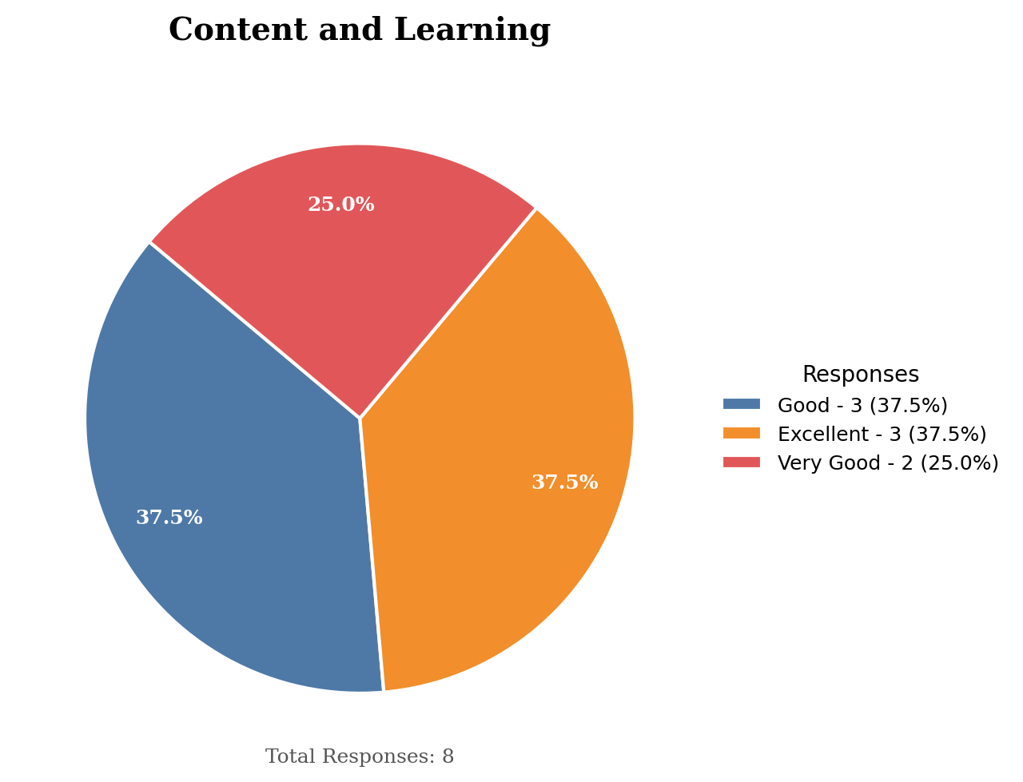
Organization & Coordination
