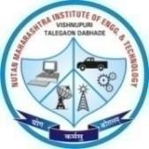 | Nutan Maharashtra Vidya Prasarak Mandal’s (NMVPM’s) |  |  | 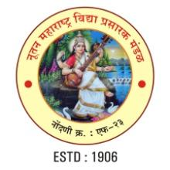
 | NUTAN MAHARASHTRA INSTITUTE OF ENGINEERING AND TECHNOLOGY (NMIET)
 | Under Administrative Support - Pimpri Chinchwad Education Trust (PCET)
Approved by AICTE |  | Accredited by NAAC | Affiliated to SPPU
“Samarth Vidya Sankul”, Vishnupuri, Talegaon Dabhade, Taluka Maval, District Pune - 410507
Tel. No. 02114 - 231666 |  | E-mail : nmiettalegaon@gmail.com | Web : www.nmiet.edu.in
Academic Year: {{academic_year}} Date: 2026-01-15

Permission Request Letter (Scanned Copy)
<<IMAGE_PERMISSION>>

Invitation Letter (Scanned Copy)
<<IMAGE_INVITATION>>

Notice (Scanned Copy)
<<IMAGE_NOTICE>>

Event Details
{{event details table}}

Brief Description of Activity
{{event_description}}

Outcomes of the Activity
•
•
•

Photographs
<<EVENT_PHOTOS>>

Attendance
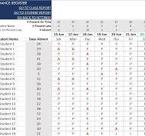

Appreciation Letter (Scanned Copy)
<<IMAGE_APPRECIATION>>

Feedback
<<FEEDBACK_TABLE>>

 | Nutan Maharashtra Vidya Prasarak Mandal’s (NMVPM’s) |  |  | 
 | NUTAN MAHARASHTRA INSTITUTE OF ENGINEERING AND TECHNOLOGY (NMIET)
 | Under Administrative Support - Pimpri Chinchwad Education Trust (PCET)
Approved by AICTE |  | Accredited by NAAC | Affiliated to SPPU
“Samarth Vidya Sankul”, Vishnupuri, Talegaon Dabhade, Taluka Maval, District Pune - 410507
Tel. No. 02114 - 231666 |  | E-mail : nmiettalegaon@gmail.com | Web : www.nmiet.edu.in

