



Department of entc

Event Coordinator Prof. Ajay Sonawane
Designation HOD of Vit
Department entc
Venue abc
Time 06:00
Date 0005-02-04
Event Type Fests
Resource Person Dr. D. B. Sharma
Name of Event asdfg
Academic Year 20

Brief Description of Activity:
fuesgdfibtw9rv39 t9tw9twiutyriu 7yt9 7wbt646t9476r9we y9etb 794t6b46v98t y497T94WT69T698RWT9R7TIUERY9GR

Outcomes of the Activity
• xvx v
• NA
• srgfrdg

Photographs:


Attendance
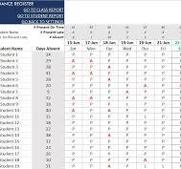



Feedback:
Event Name: asdfg
Date: 0005-02-04
Resource Person / Speaker: Dr. D. B. Sharma
Department / Organizer: entc

Name | Rating | Comment
student 1 | Excellent | SCFdFsdEASFD
student 1 | Very Good | ESGDSGDG

