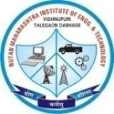
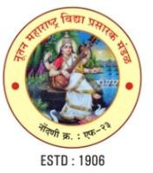
Nutan Maharashtra Vidya Prasarak Mandal’s (NMVPM’s) NUTAN MAHARASHTRA INSTITUTE OF ENGINEERING AND TECHNOLOGY (NMIET)
(An Autonomous Institute)
Under Administrative Support - Pimpri Chinchwad Education Trust (PCET)

AICTE
Approved
C.E./E.T./M.E.
NBA Accredited
NAAC
Accredited
2(f) UGC
Recognised
Govt. of Maharashtra Recognised
SPPU
Affiliated

“Samarth Vidya Sankul”, Vishnupuri, Talegaon Dabhade, Taluka Maval, District Pune - 410507

Tel. No. 02114 - 231666 | E-mail : nmiettalegaon@gmail.com | Web : www.nmiet.edu.in
AICTE ID - 1-8618657 | AISHE ID - C-41640 DTE ID - 6310 | UNIVERSITY ID - CEGP013890

Department of Information Technology

Ref No.: Date: / / 2025

Event Report

Event Details
Event Title: F.E. Induction Program
Date: 2026-01-07
Venue: Seminar Hall of Nutan Maharashtra Institude of Engineering and Technology
Department: Information Technology
Description: Induction program of F.E.

Event Photo
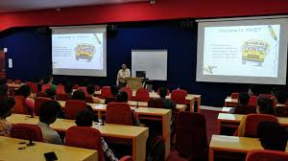

Attendance Sheet


