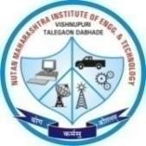 | Nutan Maharashtra Vidya Prasarak Mandal’s (NMVPM’s) |  |  | 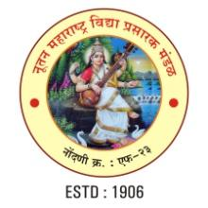
 | NUTAN MAHARASHTRA INSTITUTE OF ENGINEERING AND TECHNOLOGY (NMIET)
 | Under Administrative Support - Pimpri Chinchwad Education Trust (PCET)
Approved by AICTE |  | Accredited by NAAC | Affiliated to SPPU
“Samarth Vidya Sankul”, Vishnupuri, Talegaon Dabhade, Taluka Maval, District Pune - 410507
Tel. No. 02114 - 231666 |  | E-mail : nmiettalegaon@gmail.com | Web : www.nmiet.edu.in

 | Nutan Maharashtra Vidya Prasarak Mandal’s (NMVPM’s) |  |  | 
 | NUTAN MAHARASHTRA INSTITUTE OF ENGINEERING AND TECHNOLOGY (NMIET)
 | Under Administrative Support - Pimpri Chinchwad Education Trust (PCET)
Approved by AICTE |  | Accredited by NAAC | Affiliated to SPPU
“Samarth Vidya Sankul”, Vishnupuri, Talegaon Dabhade, Taluka Maval, District Pune - 410507
Tel. No. 02114 - 231666 |  | E-mail : nmiettalegaon@gmail.com | Web : www.nmiet.edu.in

Event Report

Event Details
Event Title: Content Verse
Date: 2026-01-10
Venue: Seminar Hall
Department: Information Technology
Description: Turning thoughts into powerful content
Organized by:
SAIT (Student Association of Information Technology)
Department of Information Technology
NMIET

Event Photo
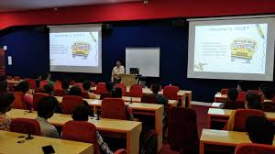

Attendance Sheet
