**Aim:** Implement a program that demonstrates the concepts of class and objects

**Objective:** To develop the ability of converting real time entity into objects and create their classes.

## **Theory:**

A class is a user defined blueprint or prototype from which objects are created. It represents the set of properties i.e., members and methods that are common to all objects of one type. In general, class declarations can include these components, in order:

1. Modifiers: A class can be public or has default access.

2. class keyword: class keyword is used to create a class.

3. Class name: The name should begin with a initial letter (capitalized by convention).

4. Superclass (if any): The name of the class’s parent (superclass), if any, preceded by the keyword extends. A class can only extend (subclass) one parent.

5. Interfaces (if any): A comma-separated list of interfaces implemented by the class, if any, preceded by the keyword implements. A class can implement more than one interface.

6. Body: The class body surrounded by braces, {}.

An OBJECT is a basic unit of Object-Oriented Programming and represents the real-life entities. A typical Java program creates many objects, which interact by invoking methods. An object consists of:

1. State: It is represented by attributes of an object. It also reflects the properties of an object.

2. Behavior: It is represented by methods of an object. It also reflects the response of an object with other objects.

3. Identity: It gives a unique name to an object and enables one object to interact with other objects.

**Code:**

**1}**

class Lamp {

boolean isOn;

void turnOn() {

isOn = true;

System.out.println("Light on? " + isOn);

}

void turnOff() {

isOn = false;

System.out.println("Light on? " + isOn);

}

}

class Main {

public static void main(String[] args) {

Lamp led = new Lamp();

Lamp halogen = new Lamp();

led.turnOn();

halogen.turnOff();

}

}

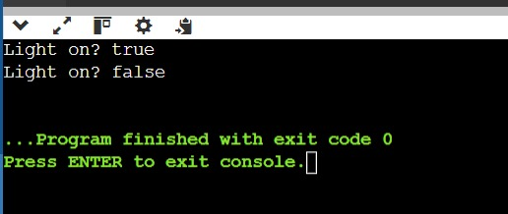

## **Conclusion:**

1) Comment on how you create a class template and their objects.

Define a Class Template:

Use the class keyword followed by the class name to define a class template.

Inside the class, declare fields (attributes) to represent the state of objects.

Define constructors to initialize the object's state.

Add methods to define the behavior and actions of the objects.

Create Objects from the Class:

To create objects, use the new keyword followed by the class constructor.

Assign the created objects to variables.

Access Fields and Methods:

Use the dot notation to access fields and call methods of the objects.