**Aim:** To use packages in java.

**Objective:** To use packages in java to use readymade classes available in them using square root method in math class.

## Theory:

A java package is a group of similar types of classes, interfaces and sub-packages. Packages are used in Java in order to prevent naming conflicts, to control access, to make searching/locating and usage of classes, interfaces, enumerations and annotations easier, etc.

There are two types of packages-

1. Built-in package: The already defined package like java.io.*, java.lang.* etc are known as built-in packages.
2. User defined package: The package we create for is called user-defined package.

Programmers can define their own packages to bundle group of classes/interfaces, etc. While creating a package, the user should choose a name for the package and include a package statement along with that name at the top of every source file that contains the classes, interfaces, enumerations, and annotation types that you want to include in the package. If a package statement is not used then the class, interfaces, enumerations, and annotation types will be placed in the current default package.

**Code:**

import java.math.*;

class inbuilt {

public static void main(String[] args) {

int a = 100, b = 200, maxi;

maxi = Math.max(a, b);

System.out.printf("Maximum is = " + maxi);

}

}

**Output**:

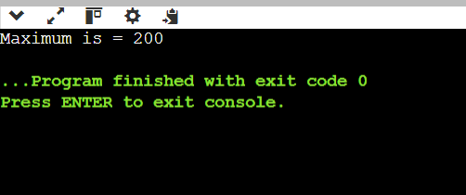

## Conclusion:

Comment on the autoencoder architecture and the Image compression results.

Autoencoders are neural networks used for data compression. They consist of an encoder to reduce data dimensions and a decoder to reconstruct the data. In Java, you can build an autoencoder for image compression. Results will include smaller-sized images that maintain essential features, useful for storage and transmission, but with some loss of detail due to the compression.