Generating Synthetic Images from Text using RNN & CNN
In this paper author is using fully trained RNN (generative adversarial networks) algorithm to convert TEXT to Face. RNN algorithms is a deep learning algorithm which was introduced to generate Fake images by getting trained on sample images. RNN can be used to train on sample images and after training it can predict related fake images from given input images.
Later RNN was used to convert TEXT to FACES but this existing RNN model was training separately with images and pre-trained TEXT encoder and due to separate training, face generated from pre-trained TEXT model was not accurate and to overcome from this problem, author of this paper is simultaneously training TEXT encoder and image decoder.
RNN algorithm was used to decode images and BI-LSTM (Bidirectional-Long Short Term Memory) was used to encode TEXT. Both models will be combine to decode image based on input text sentences. BI-LSTM will map each input sentence to related image and then get trained to generate image decoding model. Input TEXT will be converted into VECTOR and this vector will be input to BI-LSTM model to encode vector and this vector will be input to RNN to decode image.
In this paper author propose a fully trained generative adversarial network to generate realistic and natural images. The proposed work trained the text encoder as well as the image decoder at the same time to generate more accurate and efficient results.
To trained RNN and BI-LSTM model author has used CELEBA dataset which consists of DESCRIPTION and IMAGES. RNN get trained on IMAGES and BI-LSTM get trained on DESCRIPTION.
Below screen showing description file which is available in JSON format
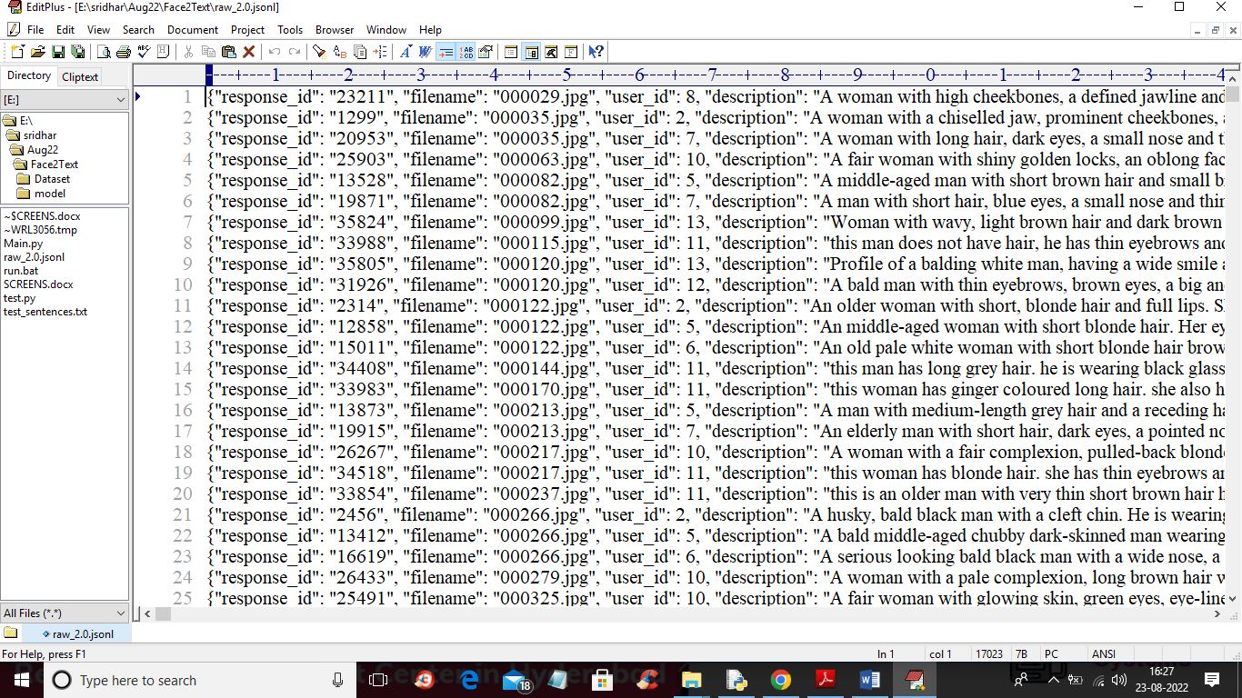
In above JSON file we can see IMAGE NAME and Description and this images we can find inside ‘Dataset/img_align_celeba’ folder and I am showing those images in below screen.
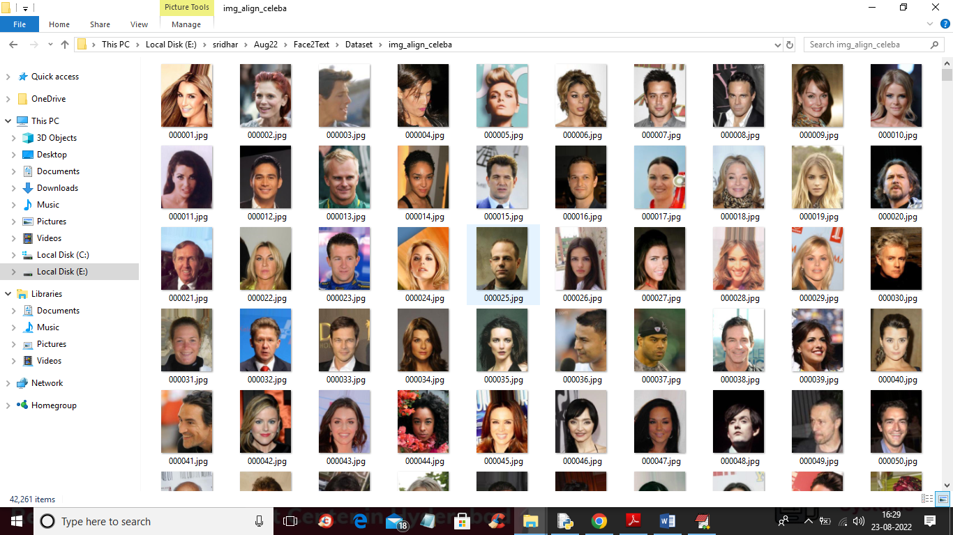
So by using above description and images we will train RNN and BI-LSTM model. RNN model consists of Discriminator which will take REAL dataset images and Generator will generate fake or alternate images by taking trained features from Discriminator.
In below screen I am showing code with comments for Generator and discriminator
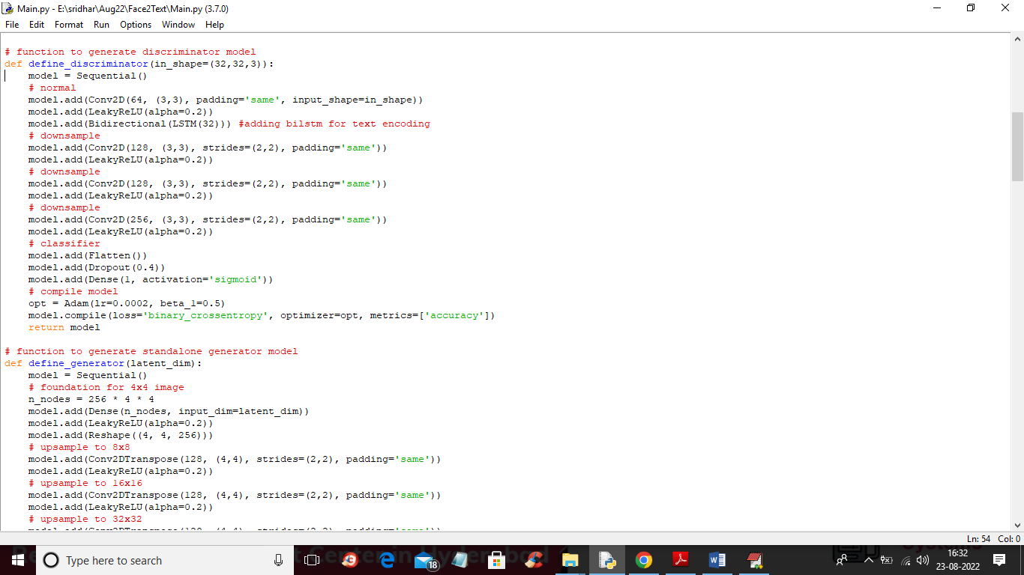
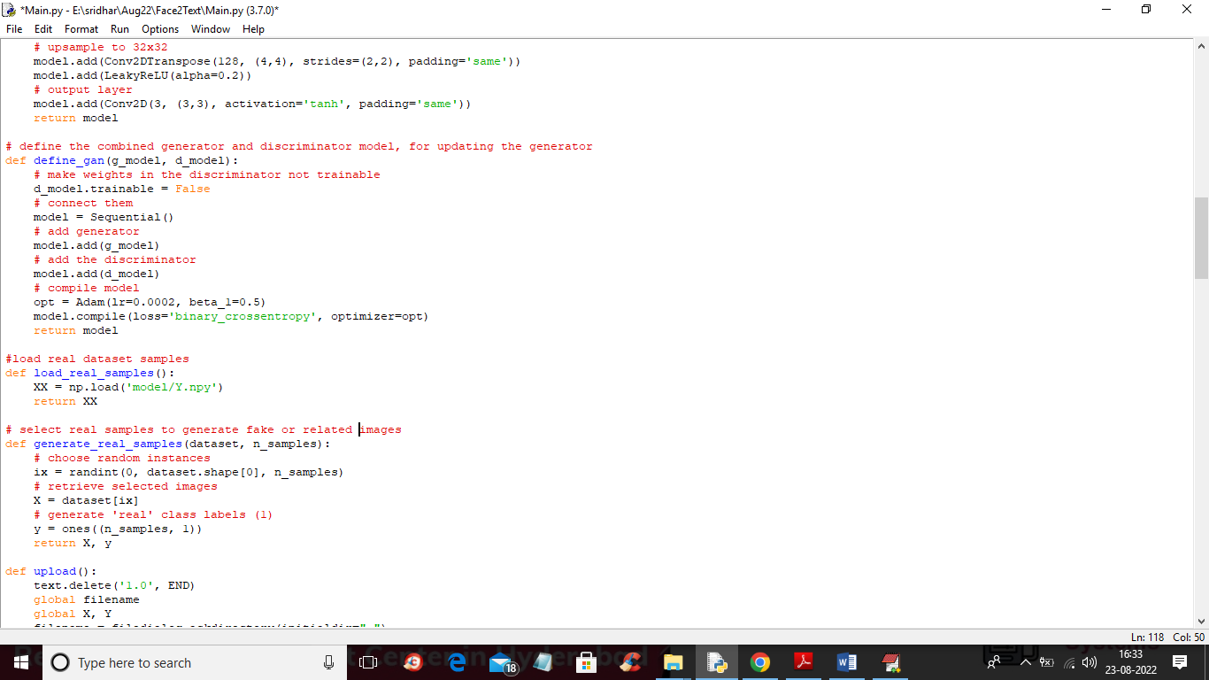
In above screen read red colour comments to know about RNN training with Discriminator, Generator and BI-LSTM.
To implement this project we have designed following modules
- Upload CelebA Dataset: using this module we will upload dataset images to application and this module we will read all images and description and then saved it as array
- Generate Fully Trained RNN Model: images and description array will be input to Proposed Fully Trained RNN to generate TEXT to Face conversion model. This model will differentiate gender using MALE and FEMALE and age will be differentiate using YOUNG and OLD words.
- Generate Face from Text: this module will take sentences as TEXT and then input to RNN model which will covert TEXT into vector and then input this vector to RNN to decode vector to faces.
SCREEN SHOTS
To run project double click on ‘run.bat’ file to get below screen
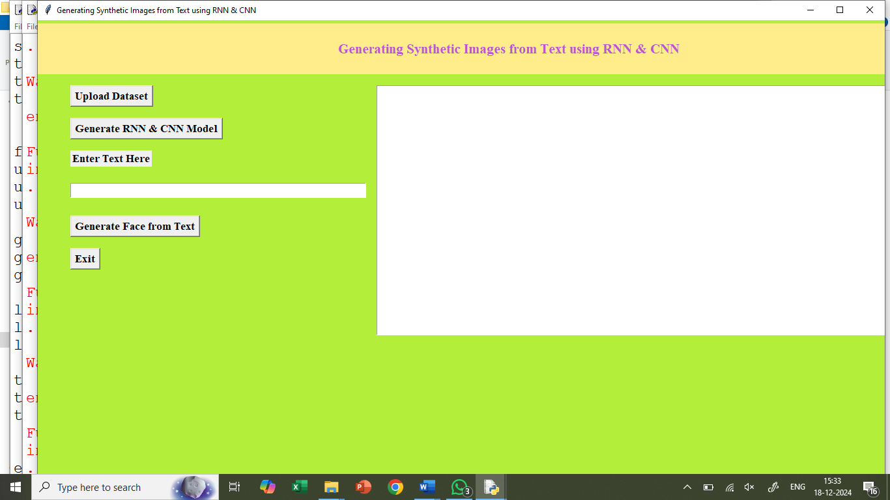
In above screen click on ‘Upload CelebA Dataset’ button to upload dataset and get below screen
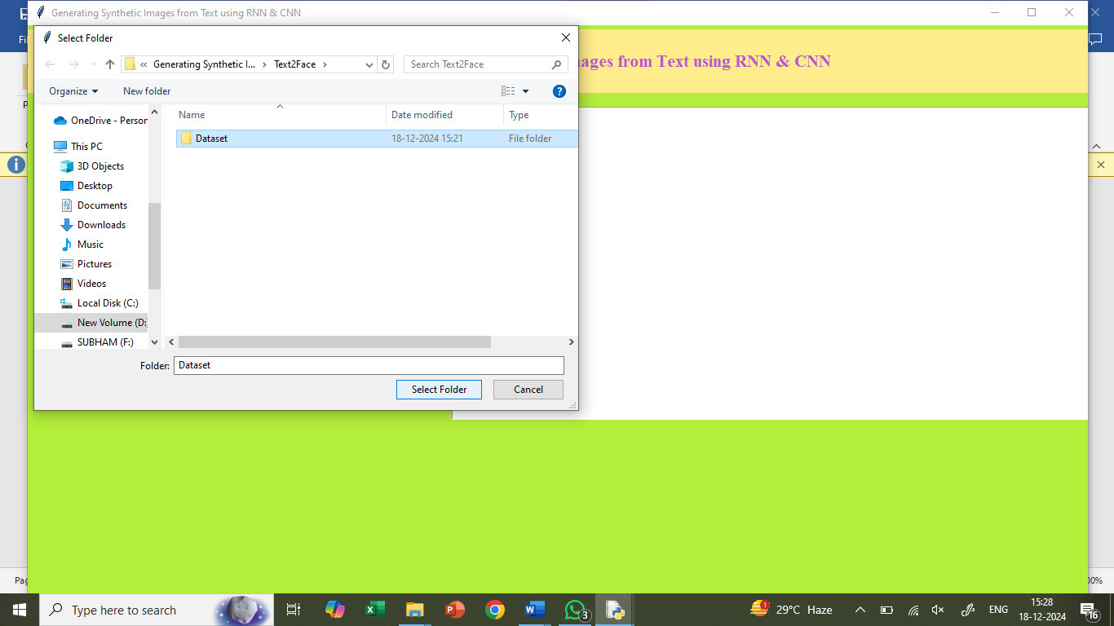
In above screen selecting and uploading ‘Dataset’ folder and then click on ‘Select Folder’ button to load dataset and get below output
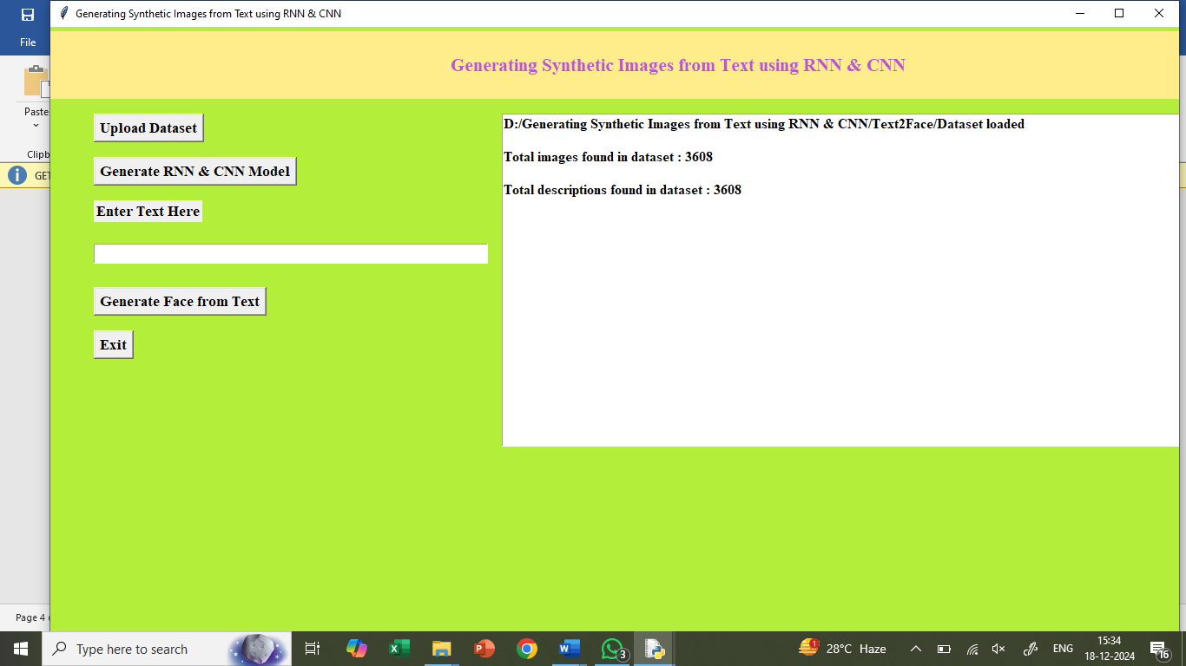
In above screen dataset loaded and application read 3608 images and description from dataset and now click on ‘Generate Fully Trained RNN Model’ button to train RNN with above images and description to get below output
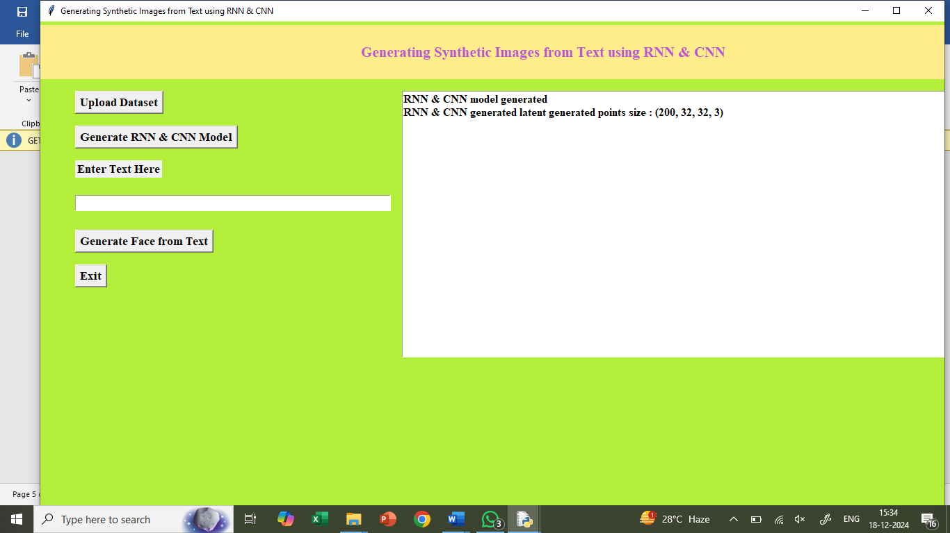
In above screen RNN model generated and this model can generated 200 faces with 32 X 32 dimension with 3 as RGB colour images from TEXT sentences and then extract face with maximum similarity from input encoded text. Now enter some TEXT inside text box and then click on ‘Generate Image from Text’ button to get below output
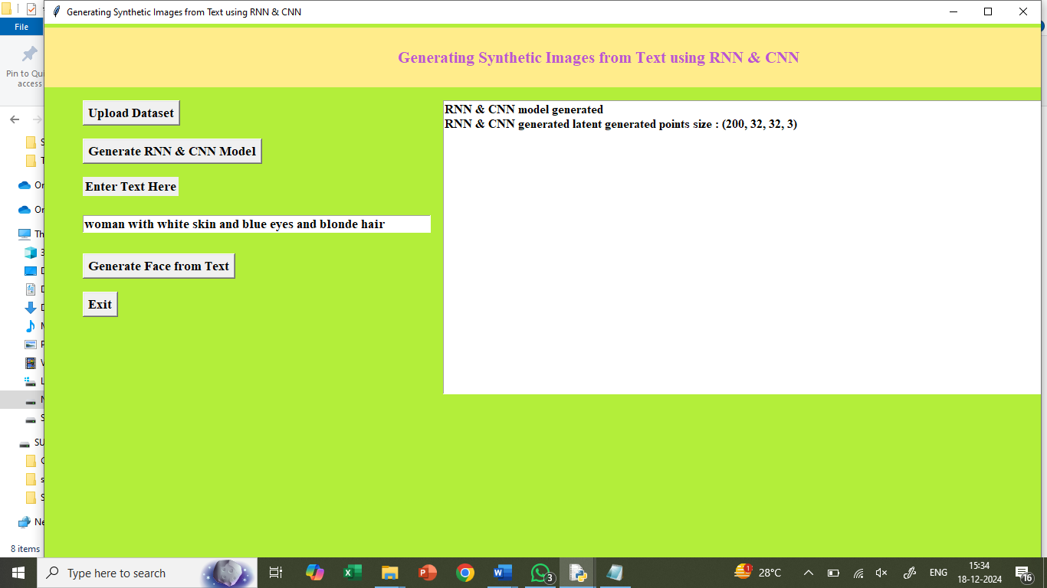
In above screen I entered some message in the TEXT BOX and then click on ‘Generate Image from Text’ button to get below output
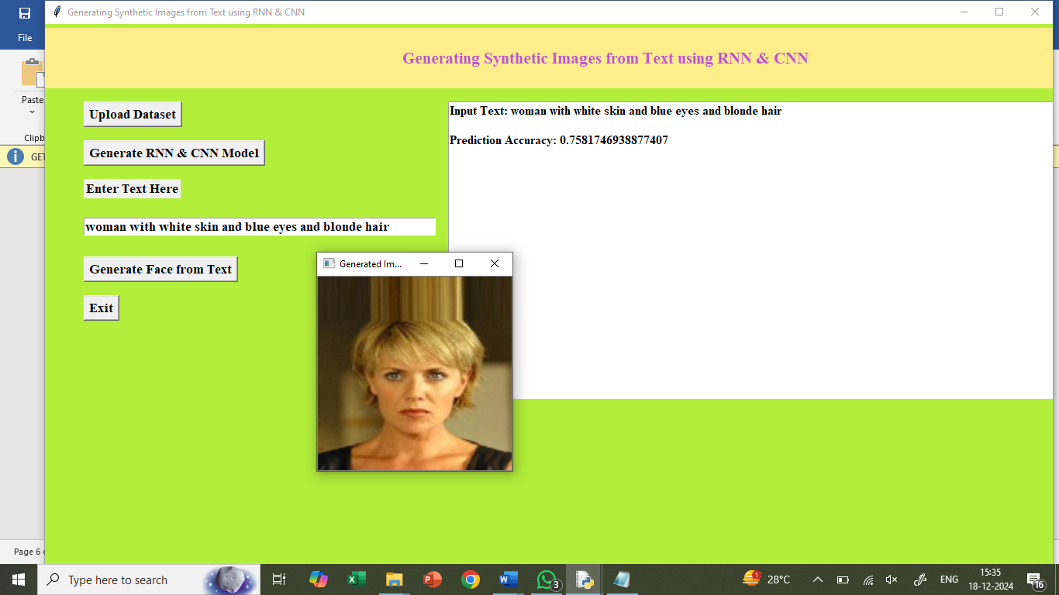
In above screen we can see face generated from given text and now try another TEXT sentences
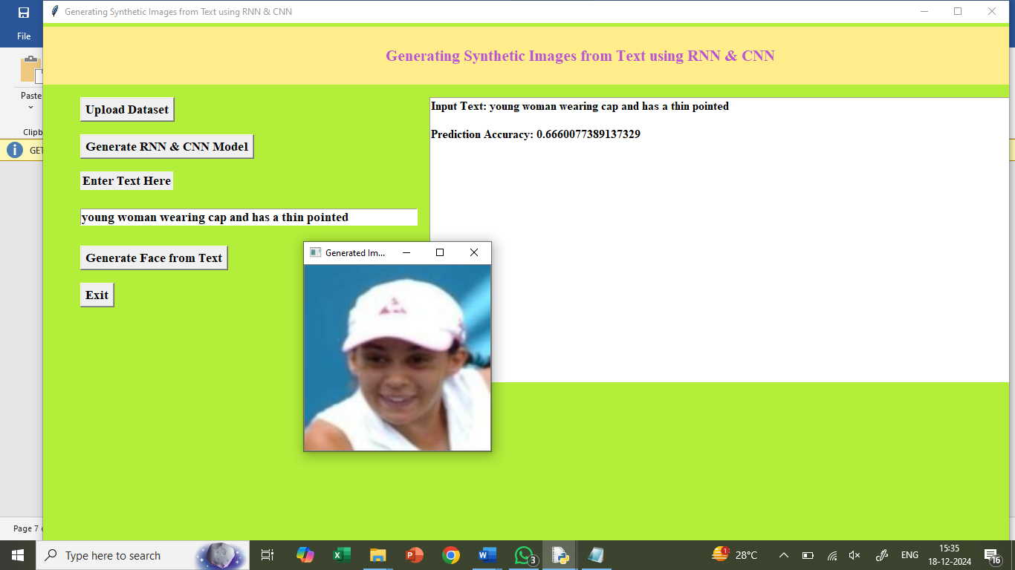
In above screen you can read sentence from TEXT AREA and then can see generated image
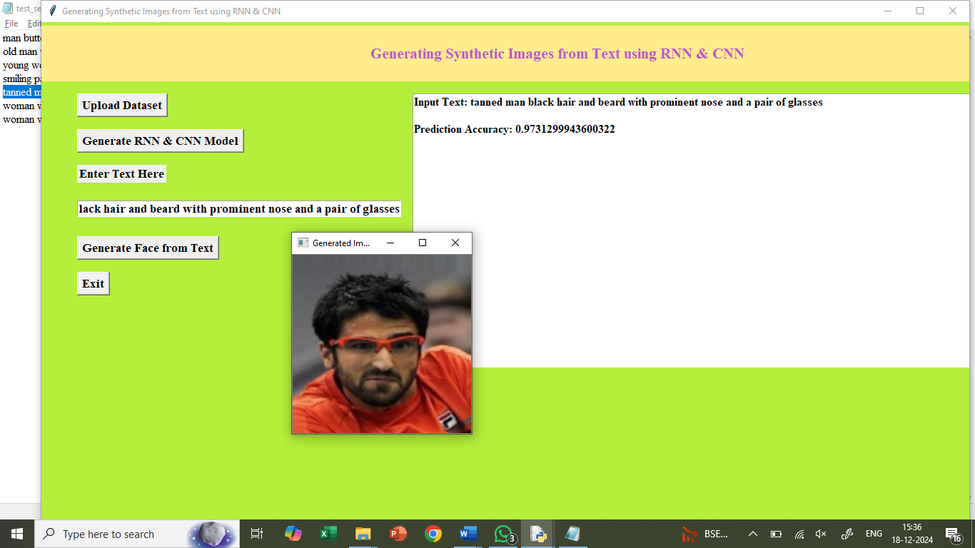
In above screen you can see given TEXT sentence and generated image and we can see prediction accuracy also. This accuracy refers to MAX matching similarity between RNN predicted image and input TEXT sentence vector.

Similarly you can input any text to generate faces

