ODT Summative 2
Idea Brief :
The Last Transmission is a miniature, interactive escape-room experience. It combines physical puzzles, embedded electronics, and a digital interface to create an immersive, story-driven gameplay experience.
The player steps into the role of an assistant to a missing scientist, Dr Benedict Rememberton, who has left behind a fragmented system to prevent the misuse of a powerful memory-manipulation device. Through a series of interconnected modules, the player must uncover hidden information, reconstruct the system, and ultimately decide the fate of the experiment.

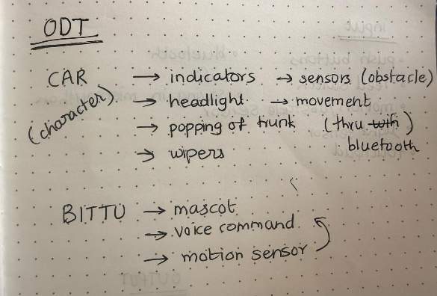
Basic Idea Sketch : Final Idea Basic Ideation Sketch
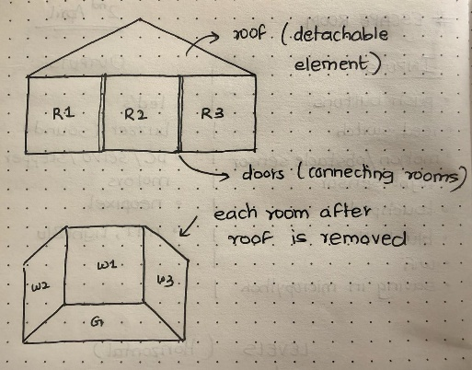
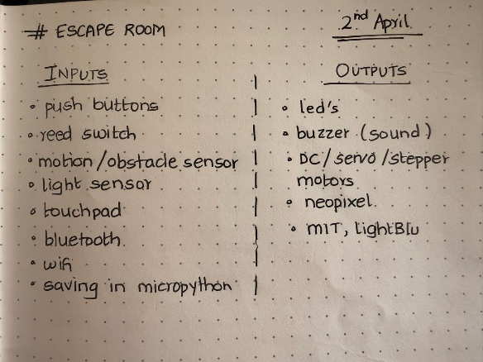

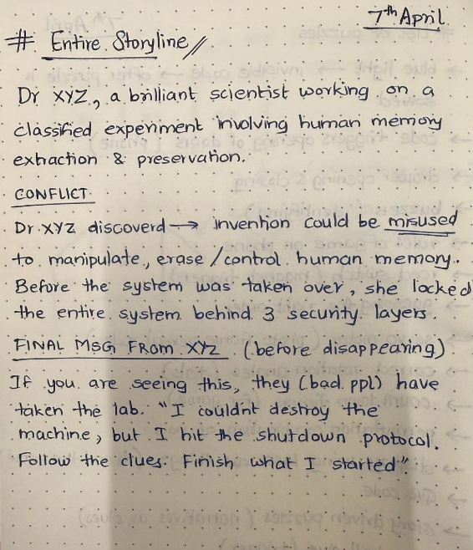
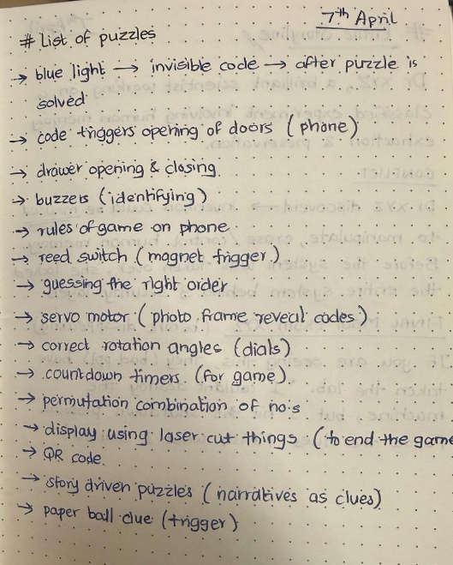
Initial Ideas

