#hw1 question 6 - sarah ward

times <- 1:5

N <- log(c(100, 158, 315, 398, 794))

lm(y ~ x, data = z)$coefficients

y <- N

x <- times

lm(y ~ x)$coefficients

# evaluating lm(y ~ x)$coefficients returns:

#(Intercept) = 4.0964696

# x = 0.5067684

# X = r = 0.506784

plot (x,y)

?abline

abline (4.0964696, 0.5067684)

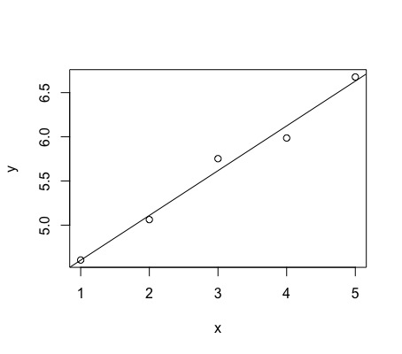#hw1-7 sarah ward

exp.growth <- function (t, y, p) {

N <- y[1]

with(as.list(p), {

dN.dt <- r * N

return(list(dN.dt))

})

}

p <- c('r' = 0.25)

y0 <- c('N' = 1)

t <- 1:100

install.packages ('deSolve')

library (deSolve)

?ode

#creating data using dN/dt formula and then making data frames for differnet r variables

sim <- ode(y = y0, times = t, func = exp.growth, parms = p, method = 'lsoda')

head(sim)

class(sim)

sim.frame <- as.data.frame(sim)

p <- c('r' = 0.33)

sim2 <- ode(y = y0, times = t, func = exp.growth, parms = p, method = 'lsoda')

head(sim2)

class(sim2)

sim2.frame <- as.data.frame(sim2)

p <- c('r'= .02)

sim3 <- ode(y = y0, times= t, func = exp.growth, parms = p, method = 'lsoda')

head(sim3)

class(sim3)

sim3.frame <- as.data.frame(sim3)

#naming variables/vectors for each data frame

names(sim.frame)

names(sim.frame) <- c('t', 'abundance')

sim.frame$t

sim.frame$abundance

names(sim2.frame)

names(sim2.frame) <- c('t', 'abundance')

sim2.frame$t

sim2.frame$abundance

names(sim3.frame)

names(sim3.frame) <- c('t', 'abundance1')

sim3.frame$t

sim3.frame$abundance1

#attempt to plot...

install.packages ('ggplot2')

?plot

time <- sim.frame$t

abundance1 <- sim.frame$abundance

abundance2 <- sim2.frame$abundance

abundance3 <- sim3.frame$abundance

?points

points (t ~ abundance, data = totalsim,)

#I've been trying to get this data plotted for hours with no avail.