Homework 2 – SARAH WARD

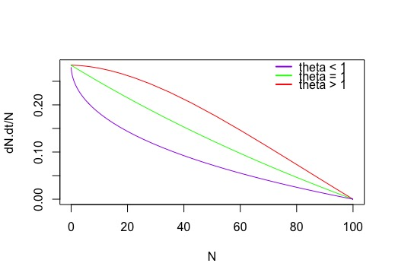

**Graph for problem 4.1 c**

**Problem 2**

**#WRITE A LOGISTIC GROWTH FUNCTION**

log.growth <- function (t, y, p) {

N <- y[1]

with (as.list (p), {

dN.dt <- r *N * (1- (N/K))

return (list(dN.dt))

})

}

**#set parameters rate of growth r, and carrying capacity k**

p <- c('r' = 0.25, 'K' = 100)

**#set initial conditions, runif selects a random number within a uniform range**

**# in this example, between min of 0.01 and max of 0.1**

y0 <- c('N' = runif (1, min = 0.01, max = 0.1))

t <- 1:100

install.packages ('deSolve')

library(deSolve)

sim <- ode(y = y0, times =t, func = log.growth, parms = p, method = 'lsoda')

sim <- as.data.frame(sim)

p2 <- c('r' = 0.25, 'K' = 50)

sim2 <- ode(y = y0, times = t, func = log.growth, parms = p2, method = 'lsoda')

sim2 <- as.data.frame(sim2)

p3 <- c('r' = 0.25, 'K' = 25)

sim3 <- ode(y = y0, times = t, func = log.growth, parms = p3, method = 'lsoda')

sim3 <- as.data.frame(sim3)

**#in order to process diff, you have to add a dummy value**

**#(NA in this case) for the diff function to work**

head(sim)

sim$deriv <- c(diff(sim$N), NA)

sim2$deriv <- c(diff(sim2$N), NA)

sim3$deriv <- c(diff(sim3$N), NA)

**#plot it!**

plot(deriv ~ N, data = sim, type = 'l', col = 'red',

xlab = 'N', ylab = 'dN/dt')

points (deriv ~ N, data = sim2, type = 'l', col = 'green')

points (deriv ~ N, data = sim3, type = 'l', col = 'purple')

legend (75, 6, c ('K = 100', 'K = 50', 'K = 25'),

lty=c(1,1, 1), lwd=c(2.5,2.5),

col = c('red', 'green', 'purple'), bty = 'n')

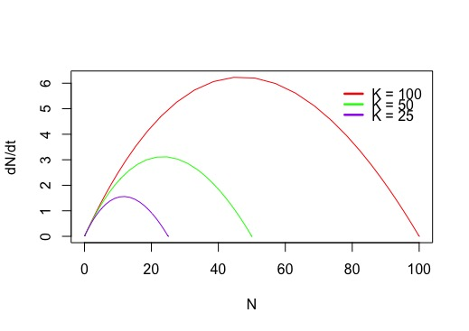

**# find abundance with the highest growth rate**

max (sim$deriv, na.rm = TRUE) #gives me 6.229076

which (sim$deriv == max (sim$deriv, na.rm = TRUE)) #gives me 35

sim$N[which(sim$deriv == max(sim$deriv, na.rm = TRUE))] #gives me 44.62426

**# so in row 35 of sim (k=100), N = 44.62426 and deriv is 6.229076 which is**

**# the maximum growth rate (deriv) at abundance N**

max (sim2$deriv, na.rm = TRUE) ##3.112799

which (sim2$deriv == max (sim2$deriv, na.rm = TRUE)) ## 33

sim2$N [which(sim2$deriv == max (sim2$deriv, na.rm = TRUE))] #24.7185

**#so in row 33 of sim2 (k=50) , N = 24.7185, and deriv is 3.112799**

max (sim3$deriv, na.rm = TRUE) #1.559653

which (sim3$deriv == max (sim3$deriv, na.rm = TRUE)) #30

sim3$N [which(sim3$deriv == max (sim3$deriv, na.rm = TRUE))] # 12.006

**# in row 33 of sim 3 (k = 25), N = 12.006, and deriv is 1.559653**

k.vec <- c(k, k2, k3)

n.vec <- c(n1, n2, n3)

plot(n.vec ~ k.vec, bty = 'l', pch = 21, bg = 'red', xlab = 'Carrying Capacity (K)', ylab = 'N')

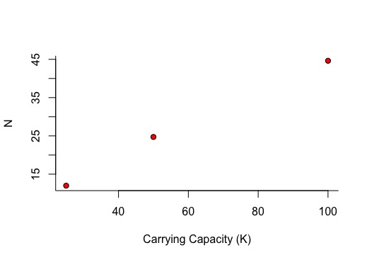

**PROBLEM 3**

**# A scientist visited the fishery and determined the theta**

**#value for each fish: 0.5 for species A, 1 for species B and 1.8 for**

**#species C. Which species will be maintained at the highest**

**#population abundance in your fishery? Include any code and figures.**

**#WRITE A theta LOGISTIC GROWTH FUNCTION**

theta.log.growth <- function (t, y, p) {

N <- y[1]

with (as.list (p), {

dN.dt <- r *N * (1- ((N/K)^theta))

return (list(dN.dt))

})

}

**#lets make K = 100, r = 0.25**

p.A <- c('r' = 0.25, 'K' = 100, 'theta' = 0.5)

p.B <- c('r' = 0.25, 'K' = 100, 'theta' = 1)

p.C <- c('r' = 0.25, 'K' = 100, 'theta' = 1.8)

sim.A <- ode(y = y0, times =t, func = theta.log.growth,

parms = p.A, method = 'lsoda')

sim.B <- ode(y = y0, times =t, func = theta.log.growth,

parms = p.B, method = 'lsoda')

sim.C <- ode(y = y0, times =t, func = theta.log.growth,

parms = p.C, method = 'lsoda')

**#make simulations into data frames**

sim.A <- as.data.frame(sim.A)

sim.B <- as.data.frame(sim.B)

sim.C <- as.data.frame(sim.C)

**#take derivative and add dummy value so we can plot**

sim.A$deriv <- c(diff(sim.A$N), NA)

sim.B$deriv <- c(diff(sim.B$N), NA)

sim.C$deriv <- c(diff(sim.C$N), NA)

plot(deriv ~ N, data = sim.C, type = 'l', col = 'red',

xlab = 'N', ylab = 'dN/dt')

points (deriv ~ N, data = sim.B, type = 'l', col = 'green')

points (deriv ~ N, data = sim.A, type = 'l', col = 'purple')

legend (70, 9, c ('theta = 1.8', 'theta = 1', 'theta = 0.5'),

lty=c(1,1, 1), lwd=c(2.5,2.5),

col = c('red', 'green', 'purple'), bty = 'n')

**##### Species C will be maintained at the highest abundance ######**

