Given an array of size n, find the majority element. The majority element is the element that appears more than floor(n/2) times.
The majority element always exist! Means there is a number occurred more than floor(n/2) times and there will be one and only one such number

public static int majorityElement(final List<Integer> A) {

HashMap<Integer, Integer> hashMap = new HashMap<Integer, Integer>();
for(int index = 0; index < A.size(); index++){
int key = A.get(index);
hashMap.put(key, hashMap.getOrDefault(key, 0)+1);
}

for(Map.Entry<Integer, Integer> entry : hashMap.entrySet()){
if(entry.getValue() >= Math.floor(A.size()/2))
return entry.getKey();
}
return -1;
}

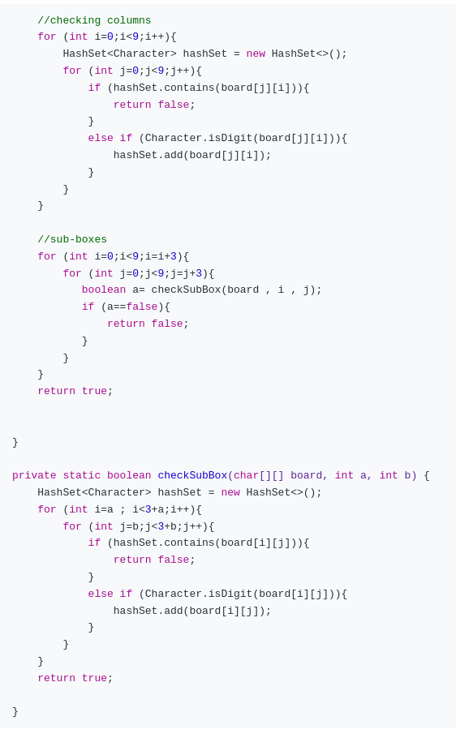
sudoku is valid

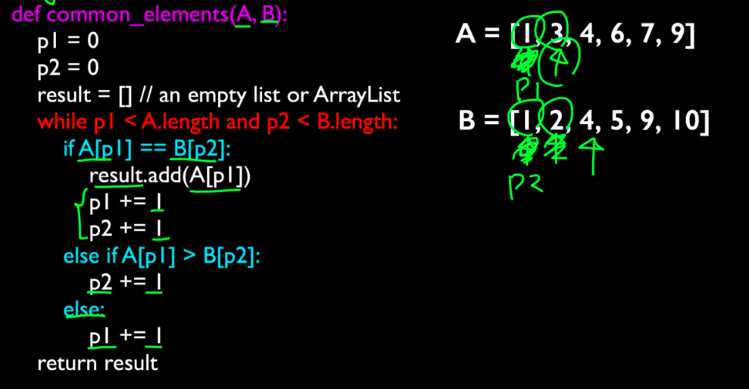
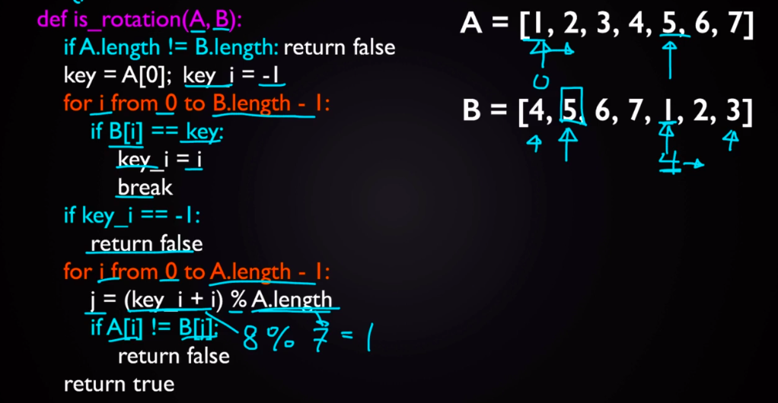
PRINT Common elements in two Sorted arrays. ^^^^

Check if two arrays are rotational

Two Inorder trees are same or not

