Started SpringWebfluxPocApplicationTests in 1.392 seconds (JVM running for 2.471)

2022-03-16 18:35:47.106 INFO 5482 --- [ main] reactor.Flux.Array.1 : | onSubscribe([Synchronous Fuseable] FluxArray.ArraySubscription)

2022-03-16 18:35:47.107 INFO 5482 --- [ main] reactor.Flux.Array.1 : | request(unbounded)

2022-03-16 18:35:47.108 INFO 5482 --- [ main] reactor.Flux.Array.1 : | onNext(spring)

spring

2022-03-16 18:35:47.108 INFO 5482 --- [ main] reactor.Flux.Array.1 : | onNext(springboot)

springboot

2022-03-16 18:35:47.108 INFO 5482 --- [ main] reactor.Flux.Array.1 : | onNext(springwebflux)

springwebflux

2022-03-16 18:35:47.108 INFO 5482 --- [ main] reactor.Flux.Array.1 : | onComplete()

@Test  
public void testFlux(){  
 Flux<String> fluxS = Flux.*just*("spring","springboot","springwebflux").log();  
 fluxS.subscribe(System.*out*:: println);  
}

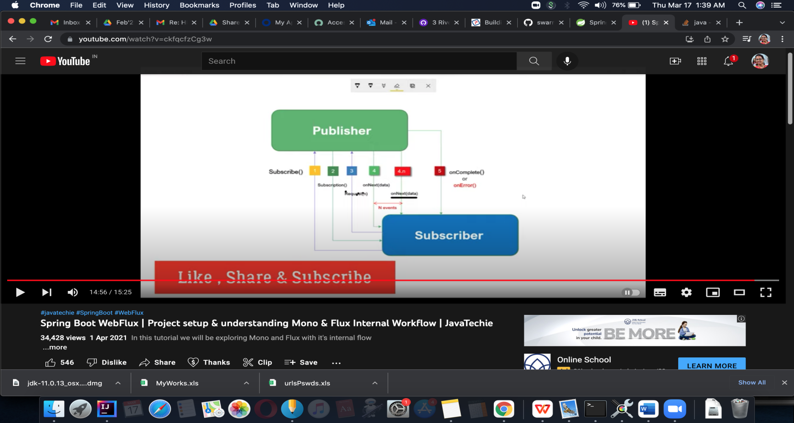

-------------SPring REactive with Mongo

https://github.com/Java-Techie-jt/spring-reactive-mongo-crud/blob/main/pom.xml

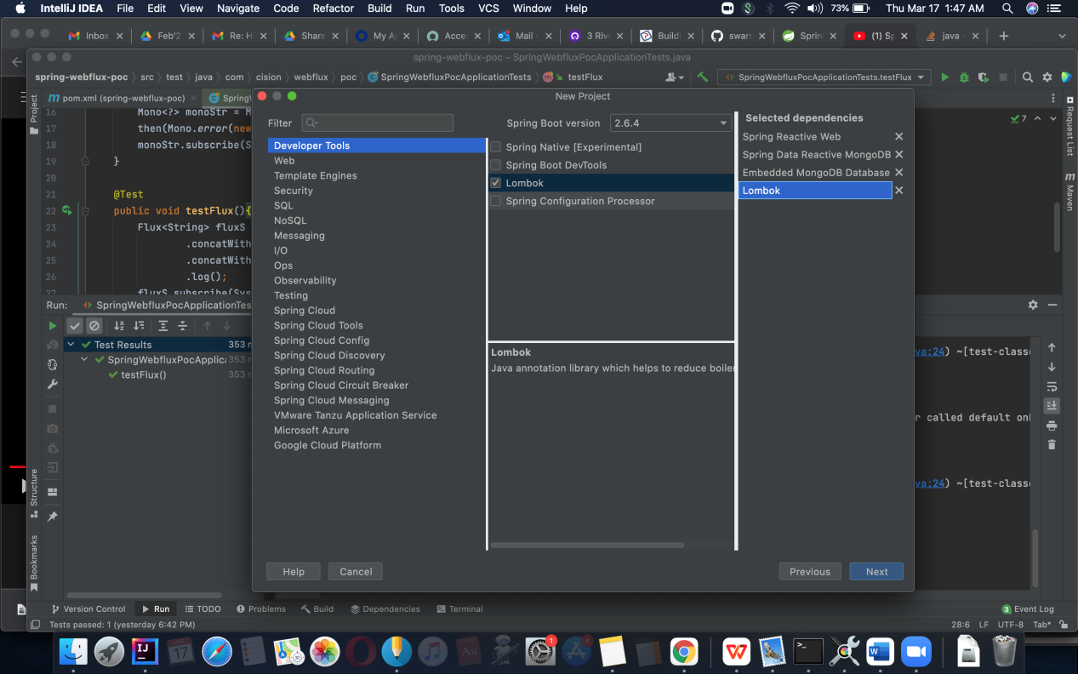

docker pull mongo:latest

docker images

docker run -d -p 27017:27017 --name pslmongodb mongo:latest

So shall use container image of this mongo.

Create your service..

Dockerize by adding Dockerfile ,

add mongo details in applicaion.yml.

Maven install to get app jar in target floder. . - fails becoz mongo is not in host system .

_ Build a docker image Containerize the app now::

docker build -t sb-reactive-mongo:1.0 .

- Docker images

See both mongo n reactive srvc

Create docker -compose file in resources.

GO to resourcepath onterminal > run docker-compose up

- Link the two

docker run -d -p 9090:9090 --name reactive-mongo-poc reactive-mongo-poc:1.0

docker images

VIA Compose :

Docker-compose.yml

