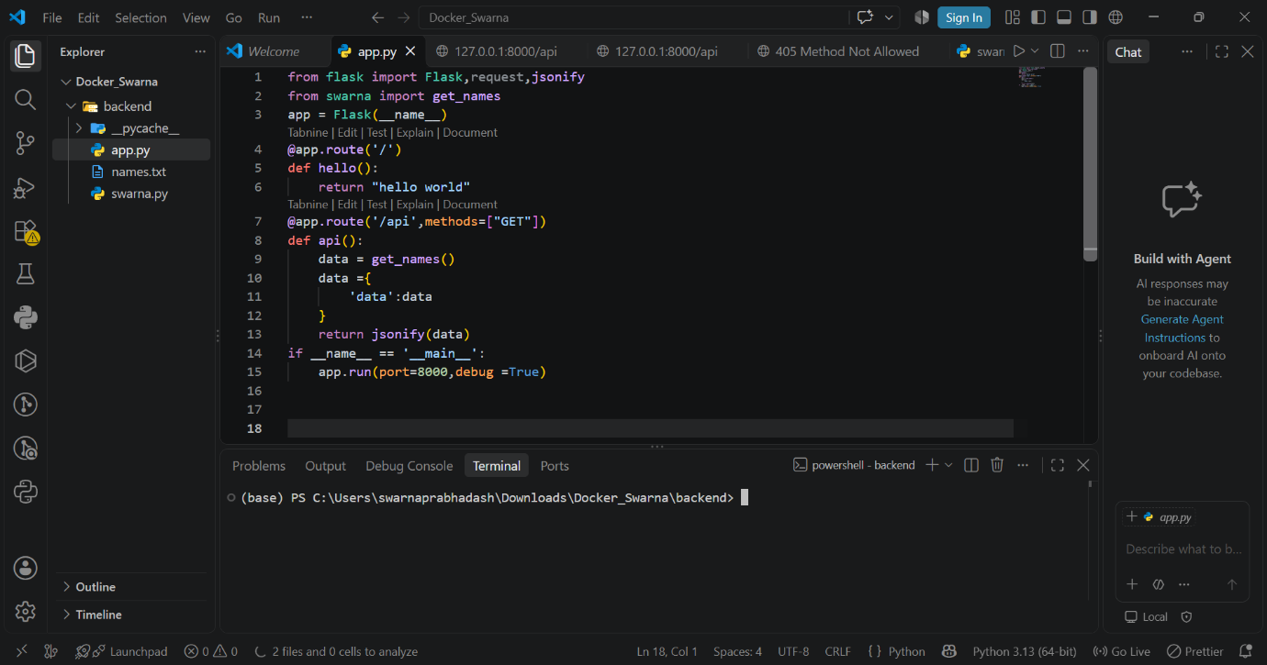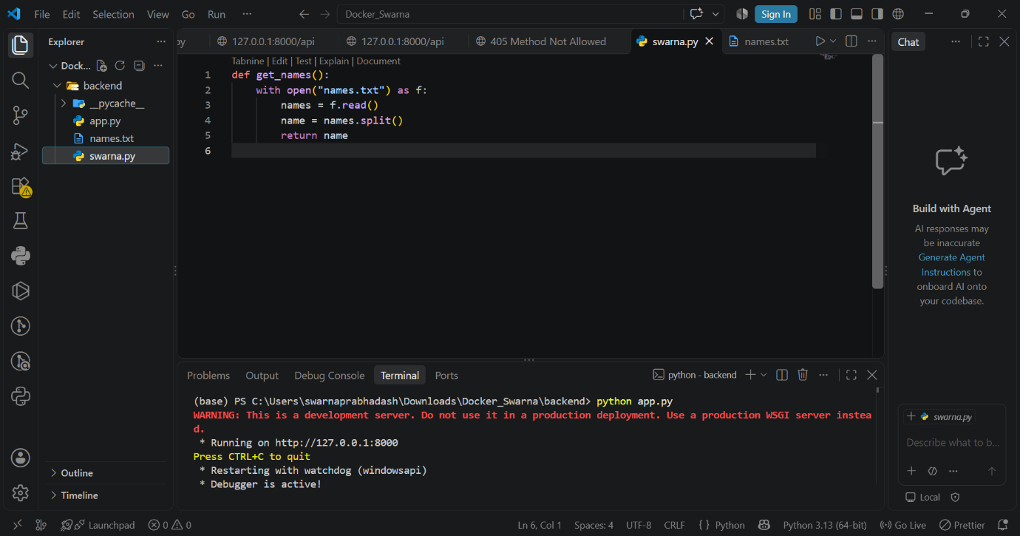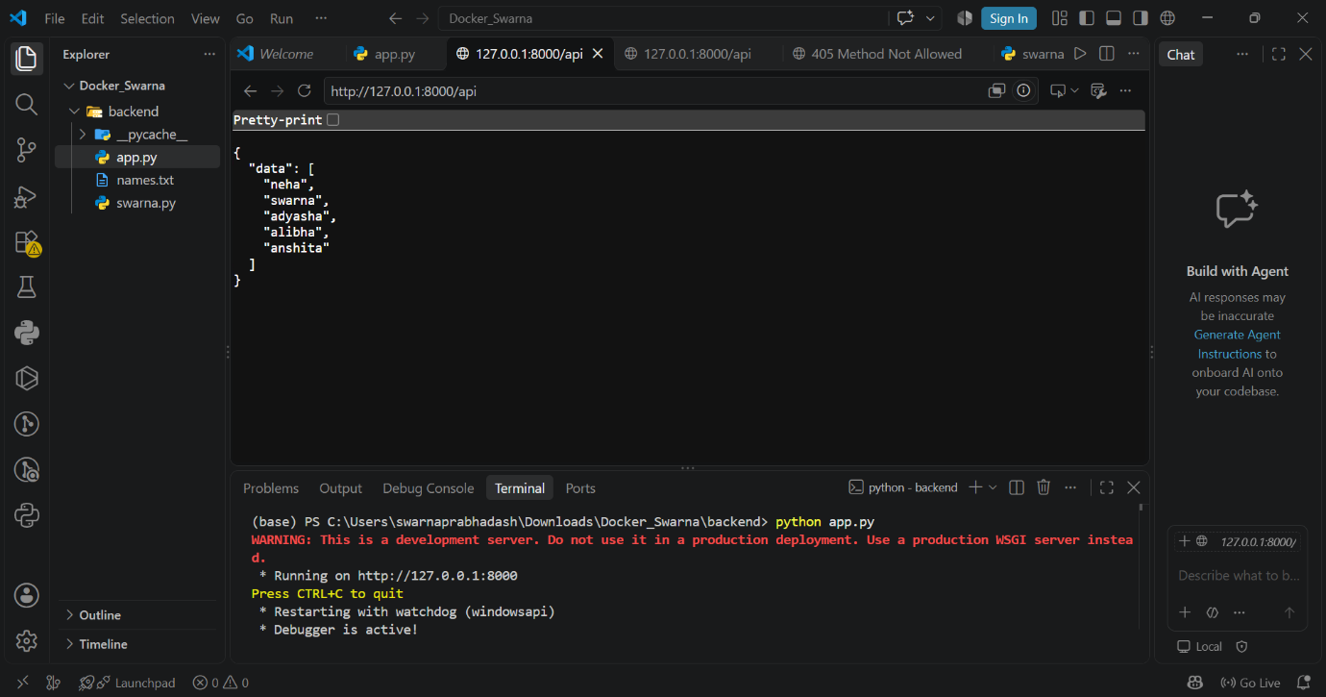
Source code of backend:
App.py:
from flask import Flask,request,jsonify
from swarna import get_names
app = Flask(__name__)
@app.route('/')
def hello():
return "hello world"
@app.route('/api',methods=["GET"])
def api():
data = get_names()
data ={
'data':data
}
return jsonify(data)
if __name__ == '__main__':
app.run(port=8000,host='0.0.0.0',debug =True)

Swarna.py
def get_names():
with open("names.txt") as f:
names = f.read()
name = names.split()
return name

names.txt
neha
swarna
adyasha
alibha
Anshita

Frontend:
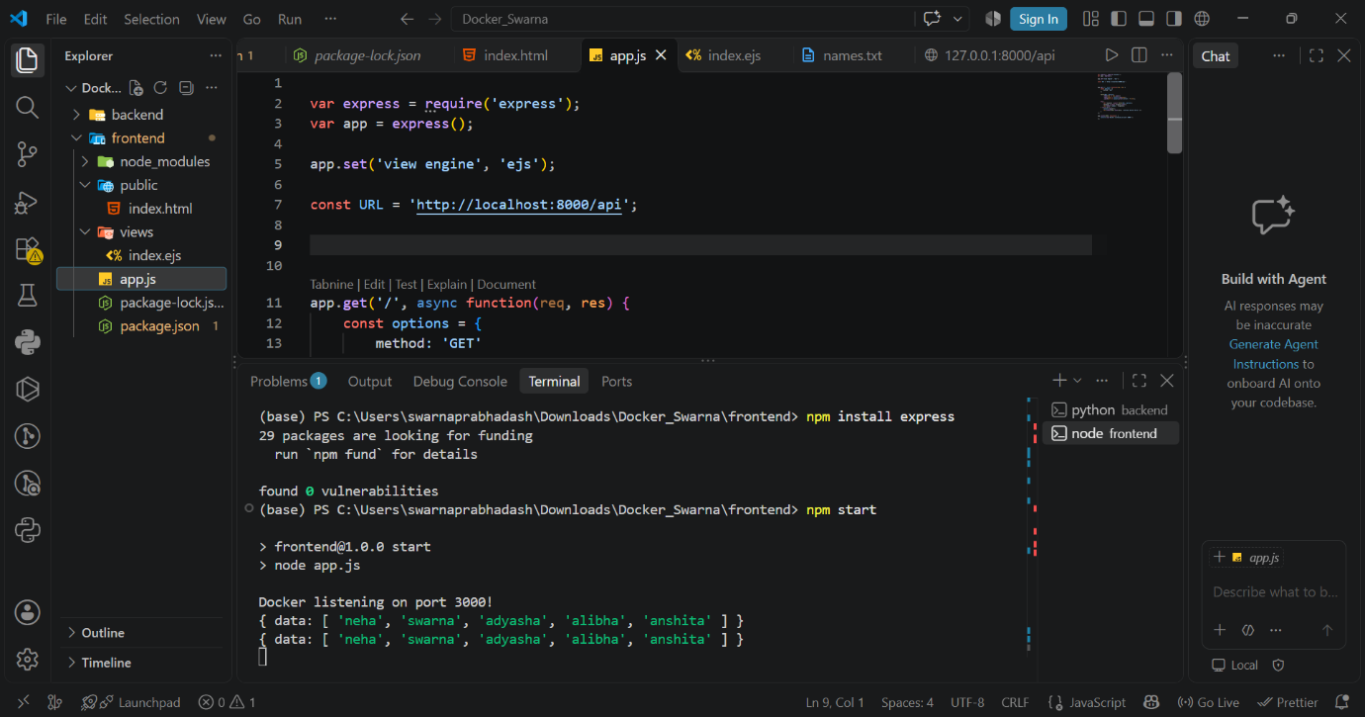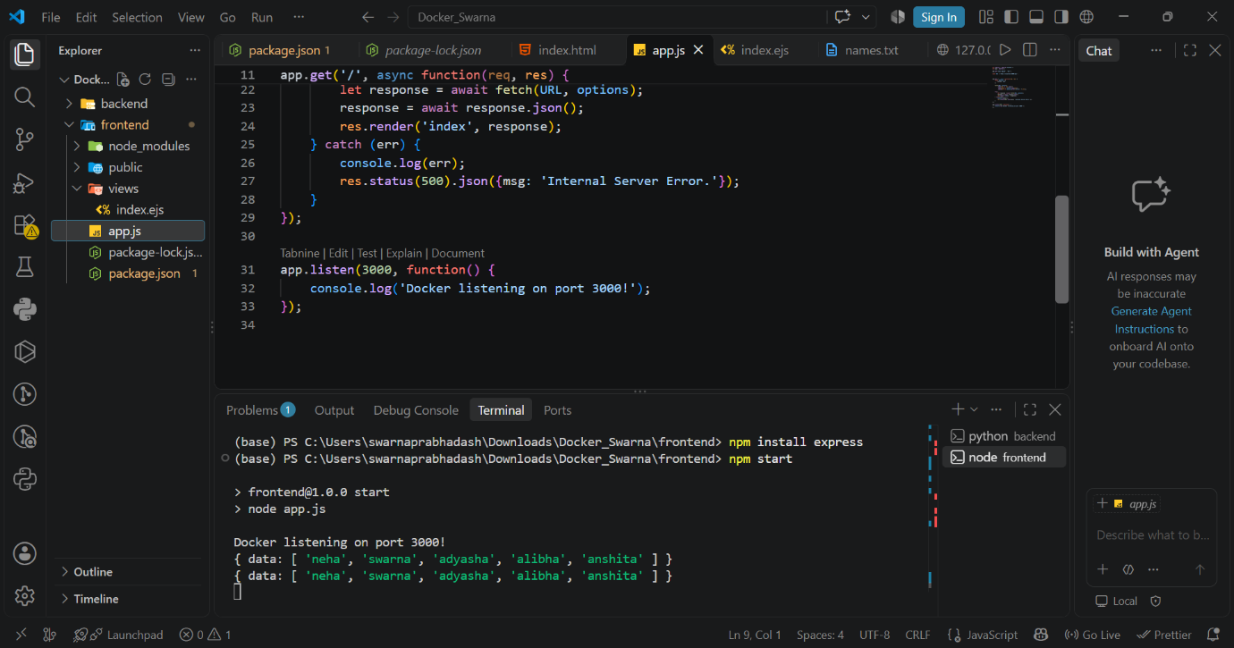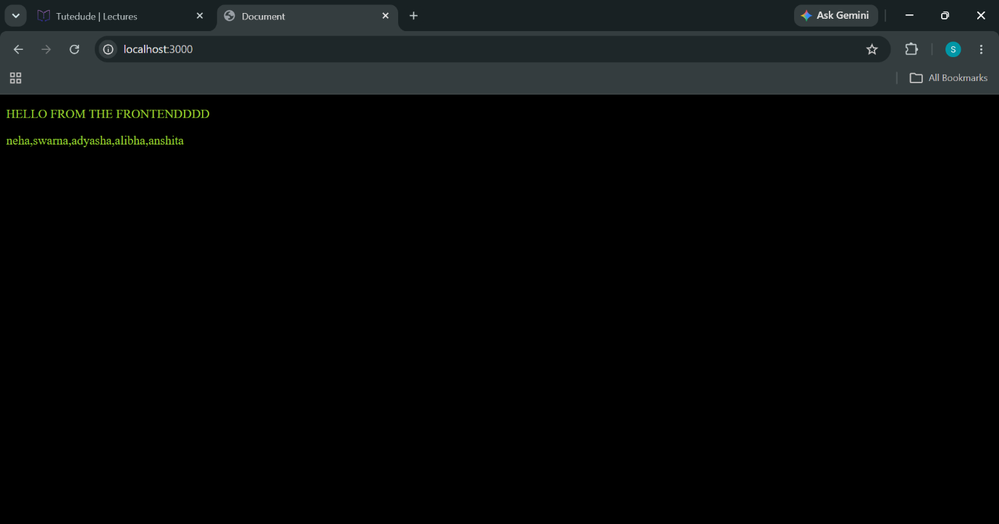
Source code :
App.js
const express = require('express');
const app = express();

app.set('view engine', 'ejs');

const URL = process.env.API_URL || 'http://localhost:8000/api';

app.get('/', async (req, res) => {
try {
const response = await fetch(URL);
const result = await response.json();

console.log(result);
res.render('index', result);
} catch (err) {
console.error(err);
res.status(500).send('Internal Server Error');
}
});

app.listen(3000, '0.0.0.0', () => {
console.log('Docker listening on port 3000!');
});

Index.ejs

<!DOCTYPE html>
<html lang="en">
<head>
<meta charset="UTF-8">
<meta http-equiv="X-UA-Compatible" content="IE=edge">
<meta name="viewport" content="width=device-width, initial-scale=1.0">
<title>Document</title>
</head>
<body>
<p>HELLO FROM THE FRONTENDDDD</p>
<p><%= data %></p>
</body>
<style>
body {
background-color: #000;
color: yellowgreen;
}
</style>
</html>

Package.json
{
"name": "frontend",
"version": "1.0.0",
"description": "",
"main": "index.js",
"scripts": {
"test": "echo \"Error: no test specified\" && exit 1",
"start": "node app.js"
},
"keywords": [],
"author": "",
"license": "ISC",
"type": "commonjs",
"dependencies": {
"ejs": "^7.0.2",
"express": "^5.3.0"
}
}

Dockerfile backend

FROM python:3.12-slim

WORKDIR /app

COPY backend/requirements.txt /app/requirements.txt

RUN pip install --no-cache-dir -r /app/requirements.txt

COPY backend/ /app/

EXPOSE 8000

CMD ["python", "app.py"]

Dockerfile-frontend

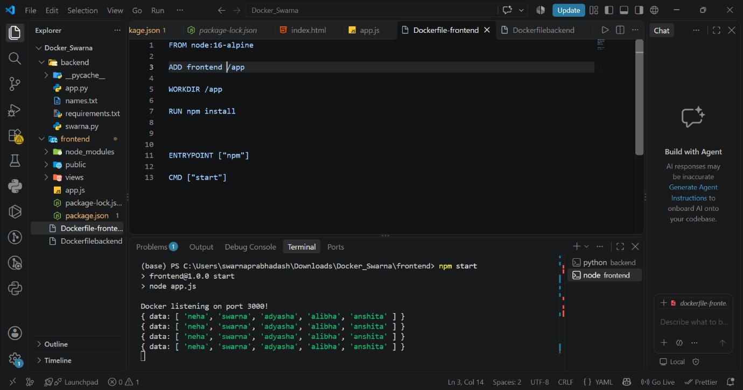
FROM node:22-alpine

ENV API_URL='http://localhost:5000'

ADD frontend /app

WORKDIR /app

RUN npm install

ENTRYPOINT ["npm"]

CMD ["start"]
Building docker backend image:
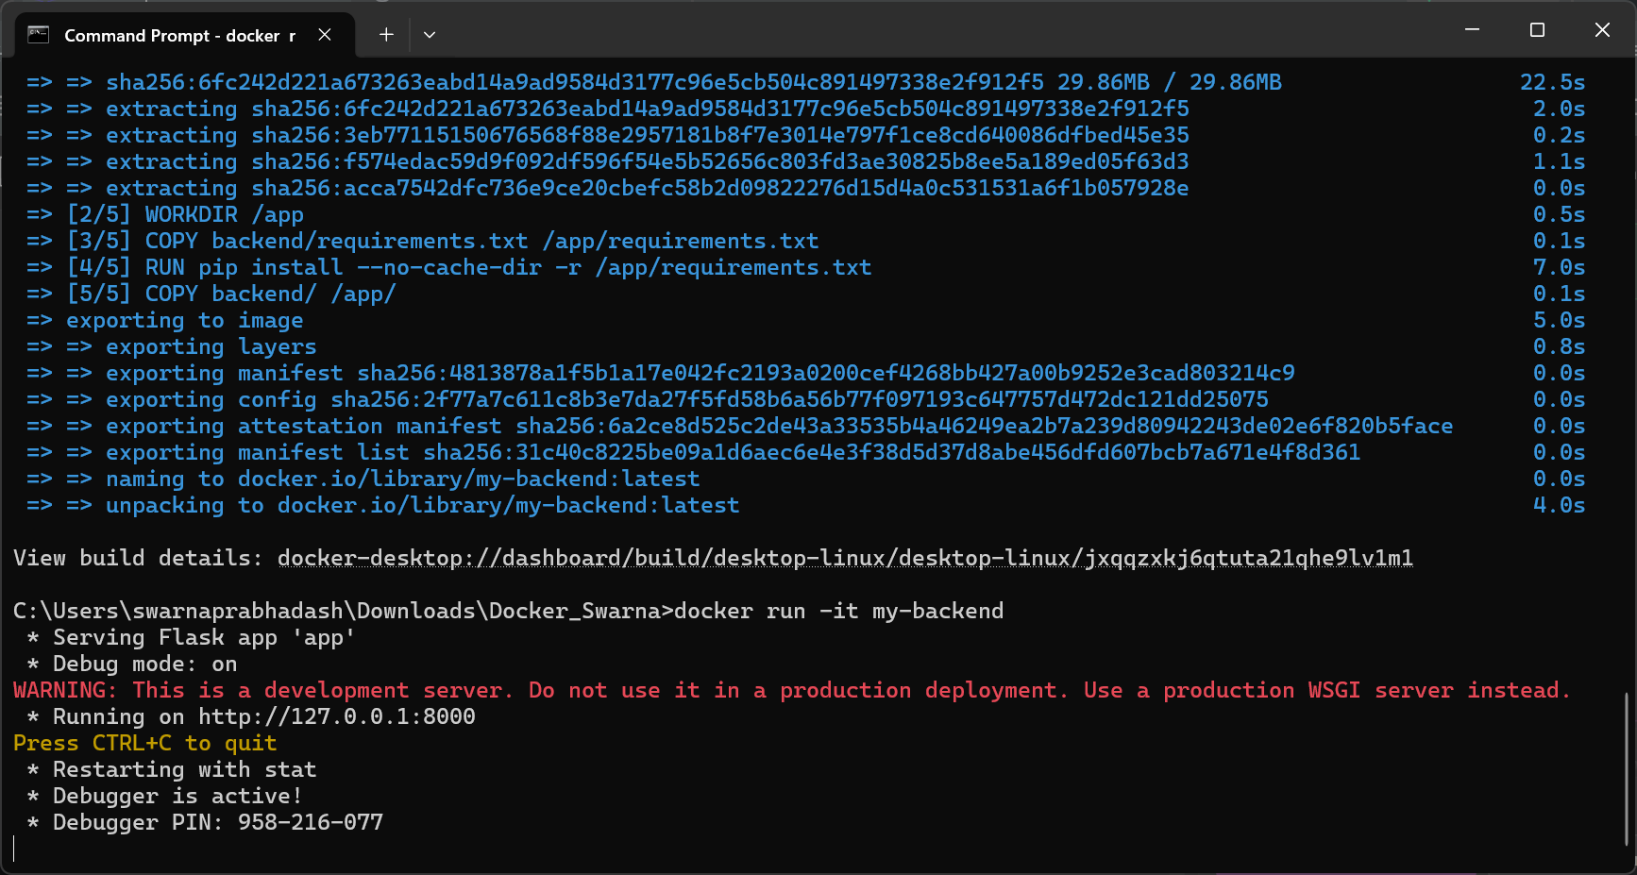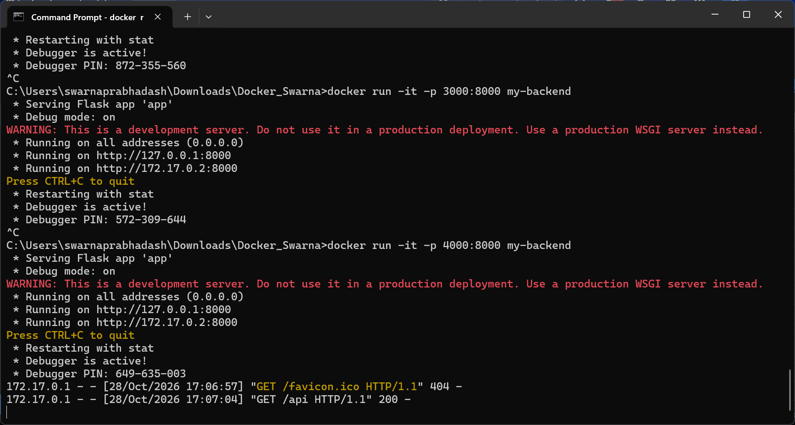
Docker frontend image:
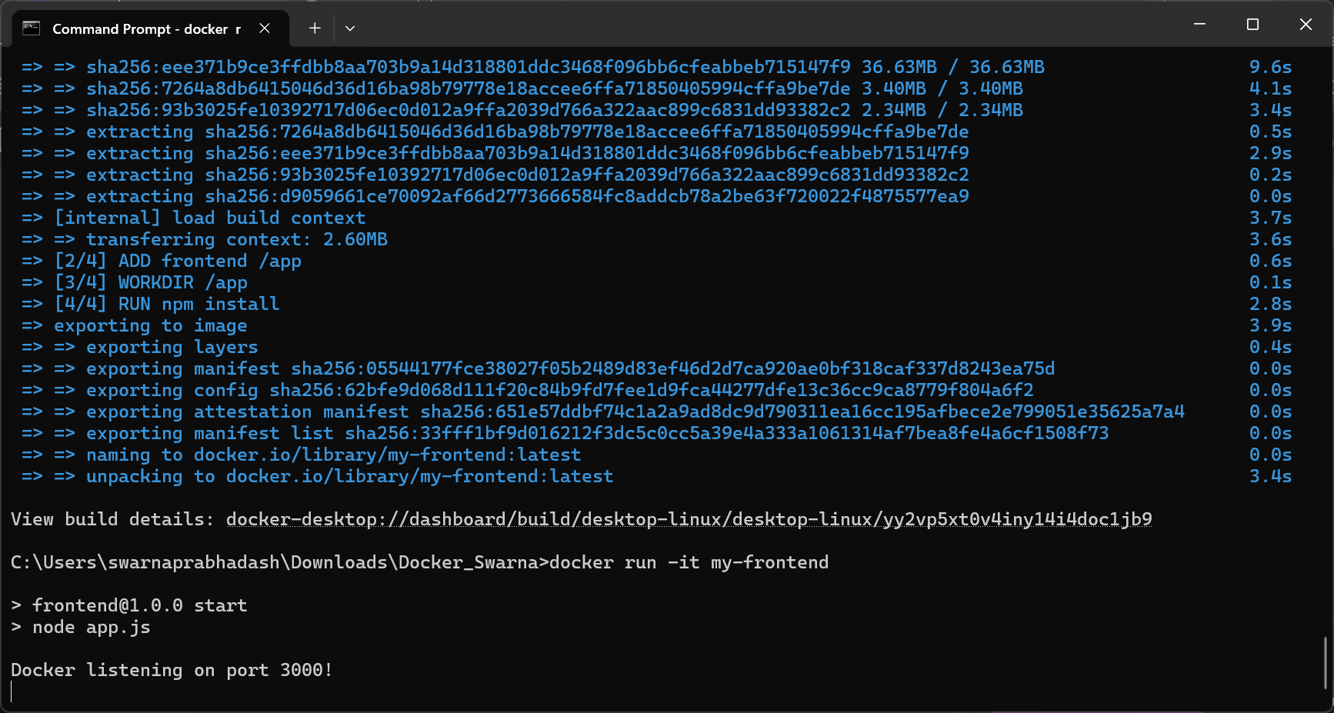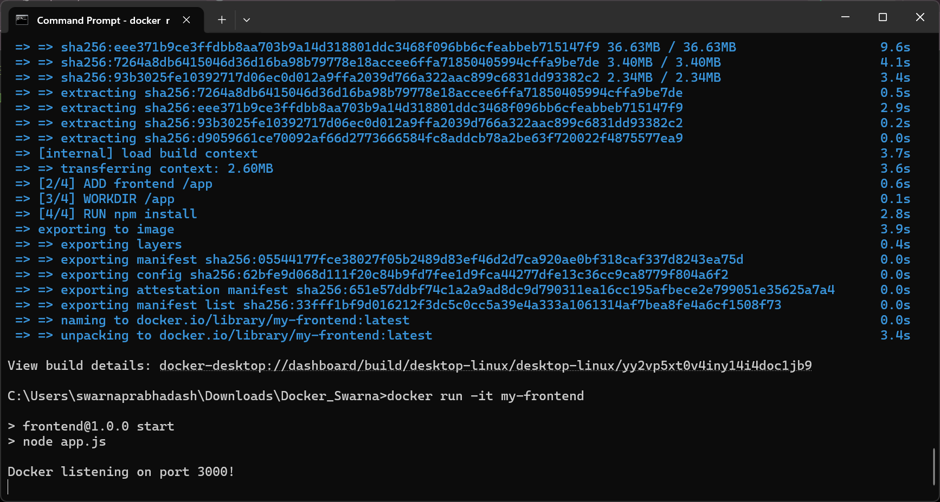
Docker compose
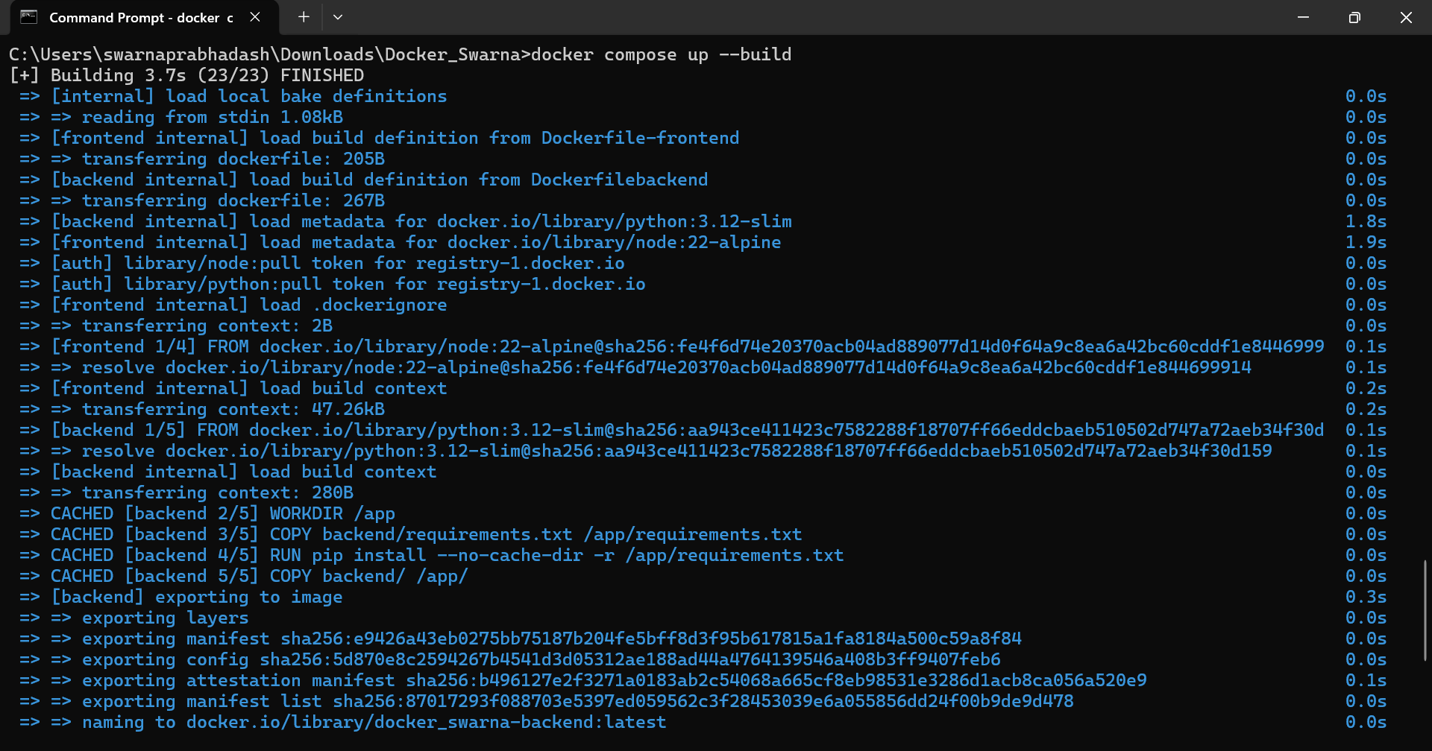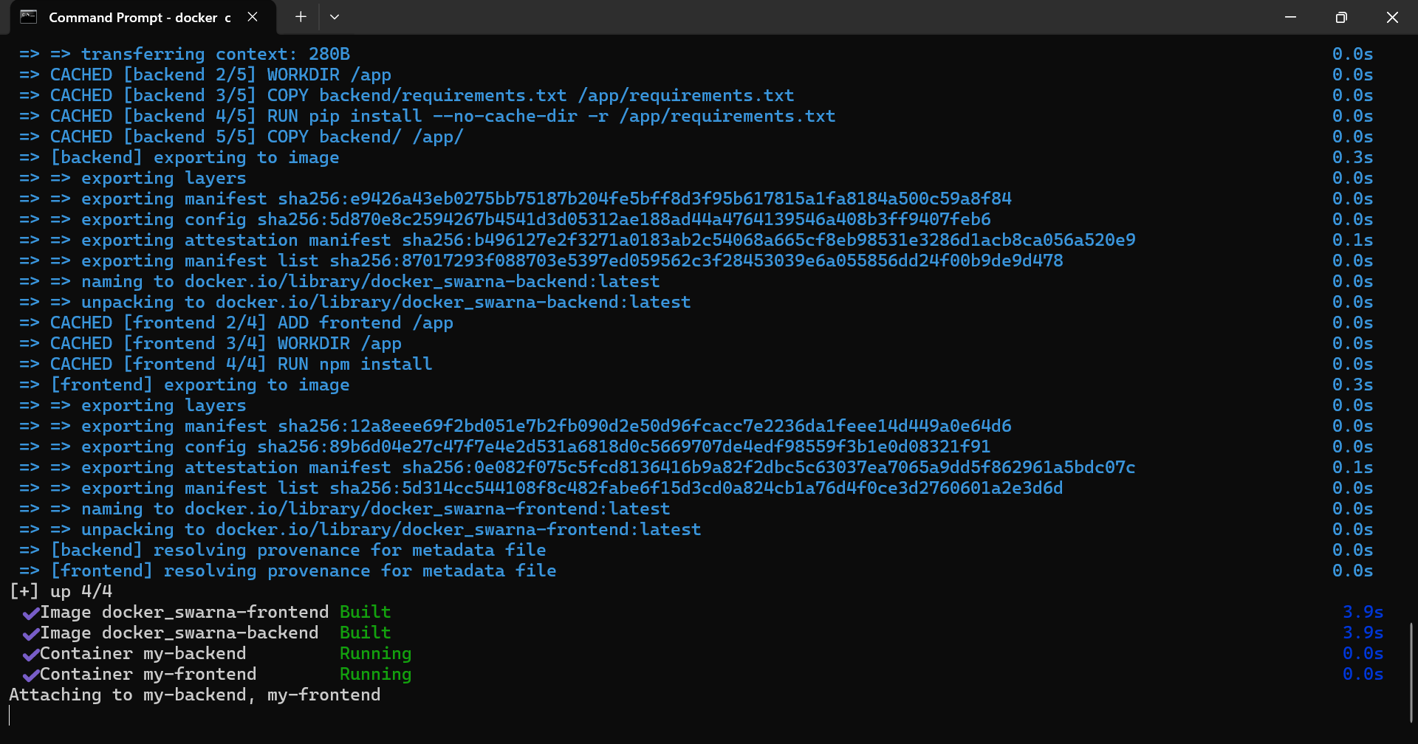
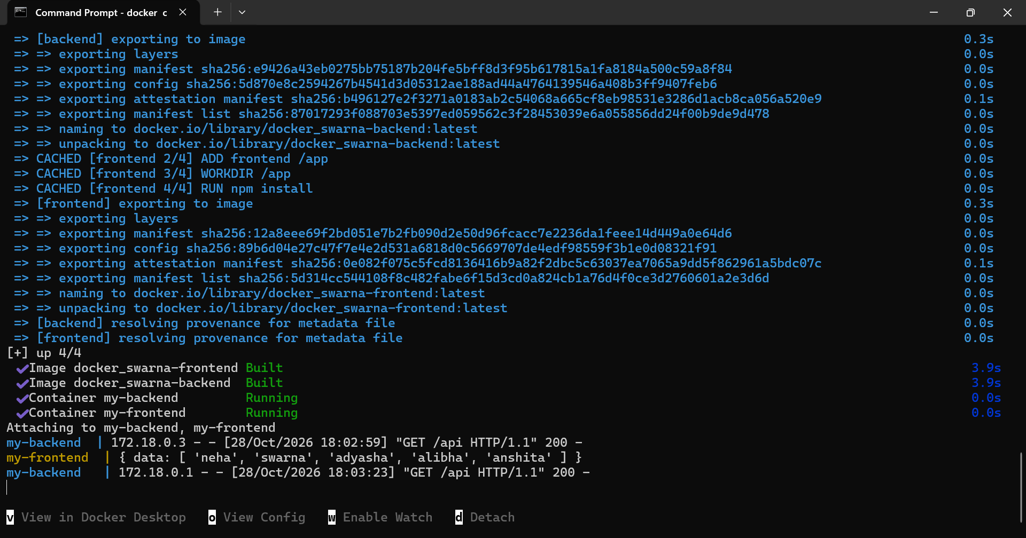
Creating repositories in docker hub:
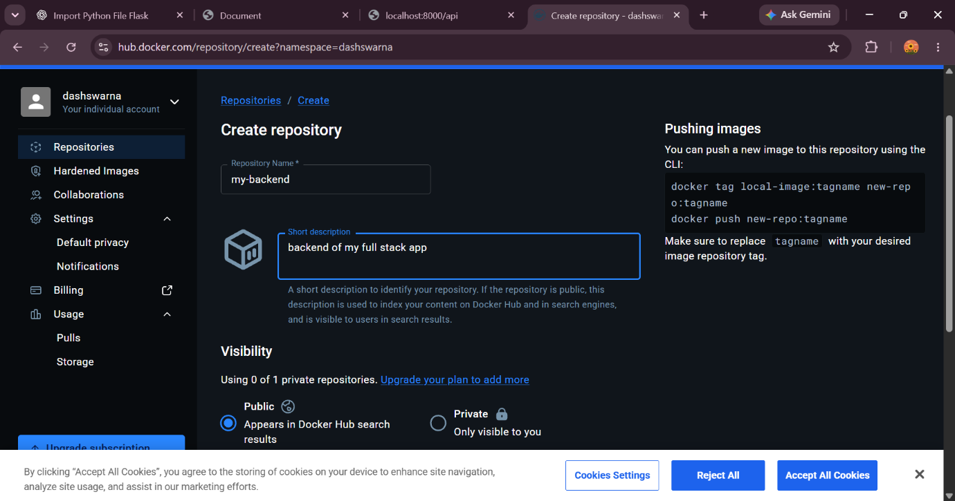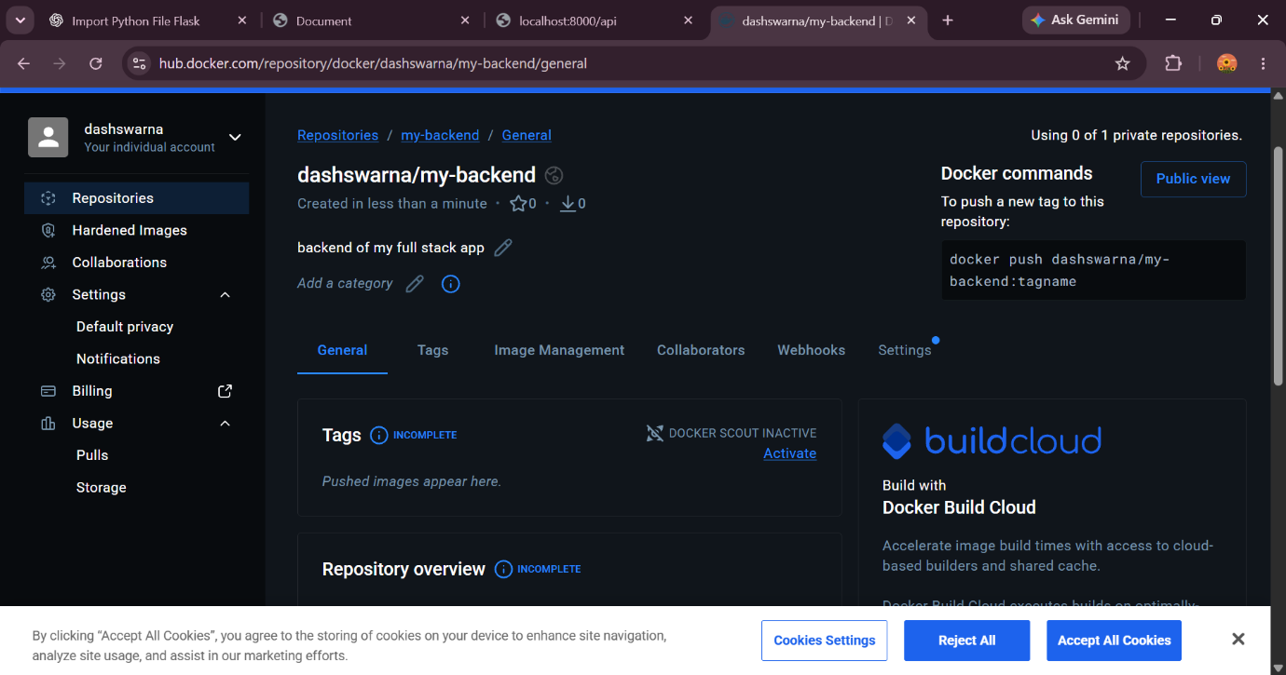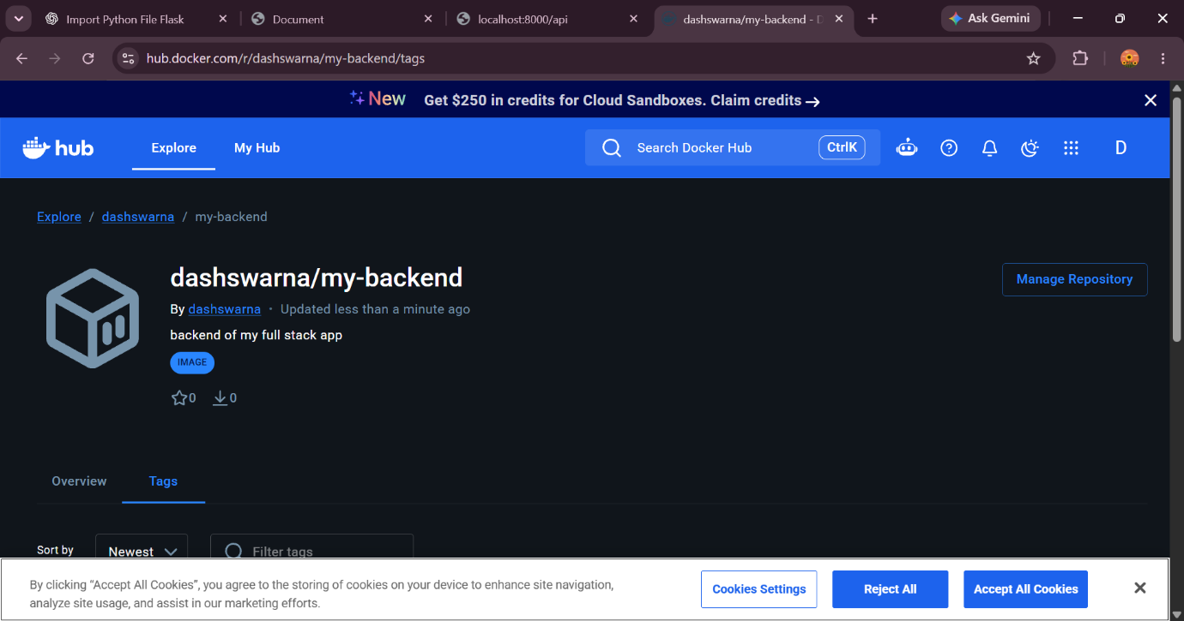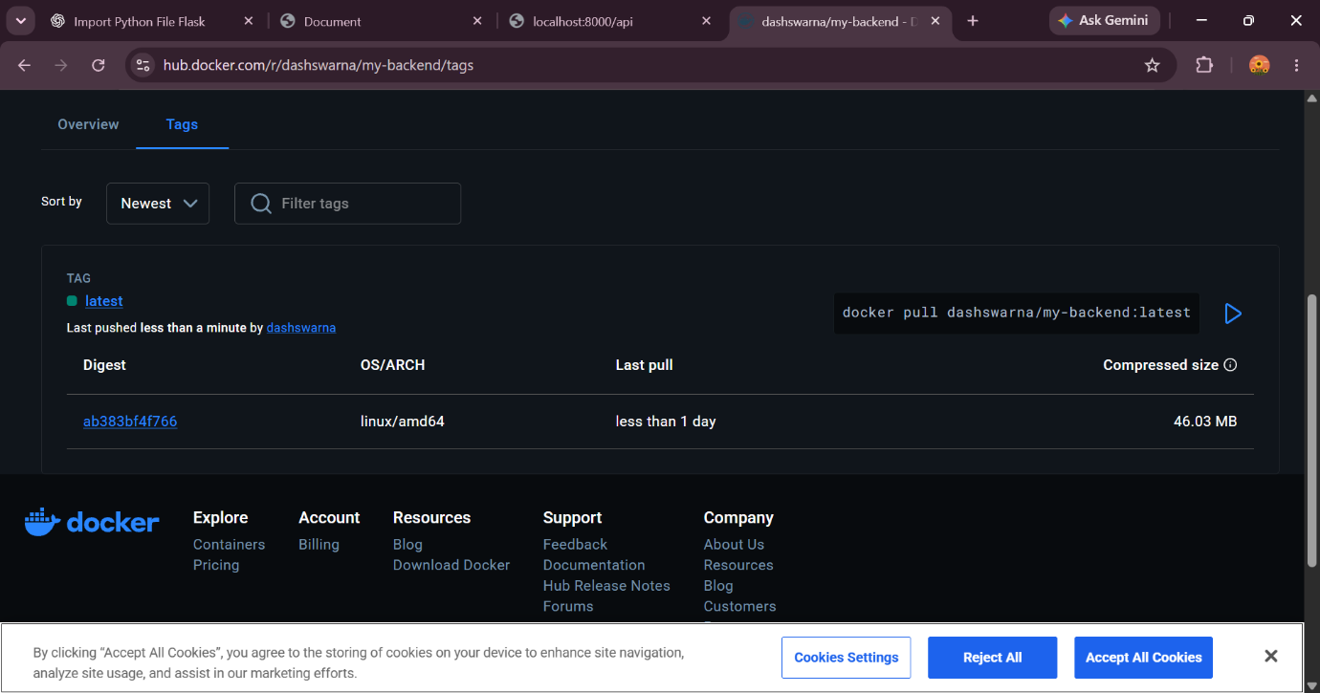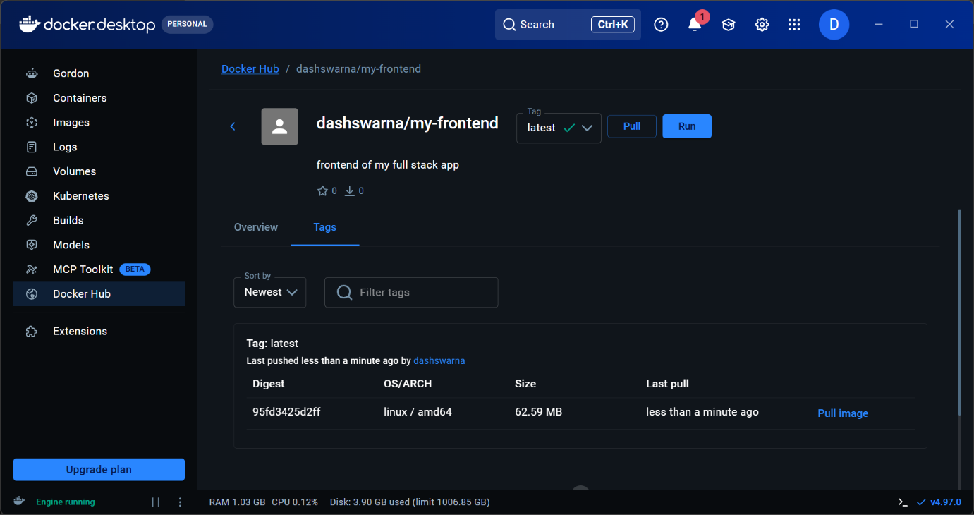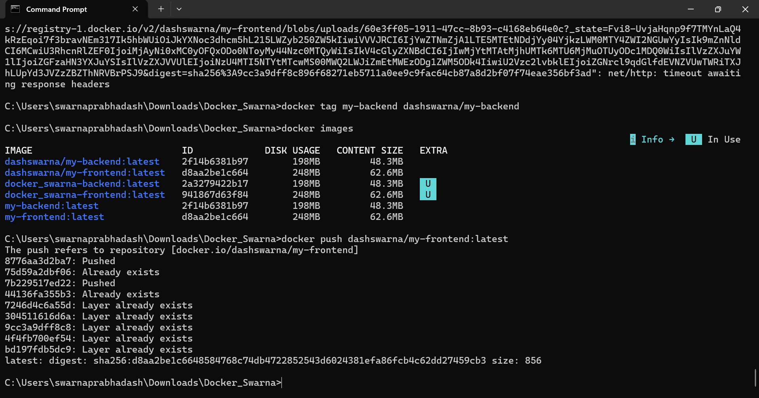
Adding .gitignore file:
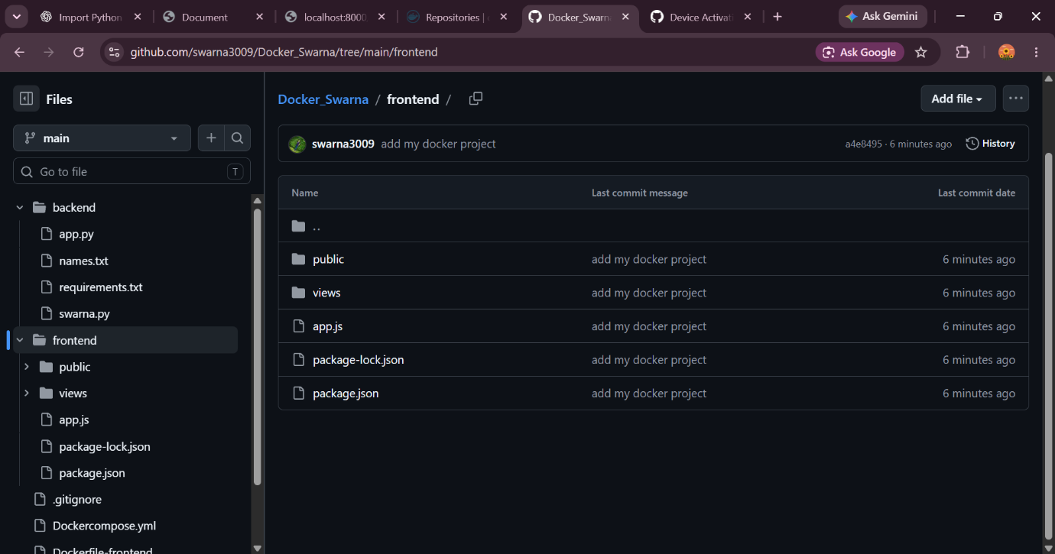node_modules/
venv/
.venv/
__pycache__/
.env
*.pyc
Github repository: https://github.com/swarna3009/Docker_Swarna.gits

