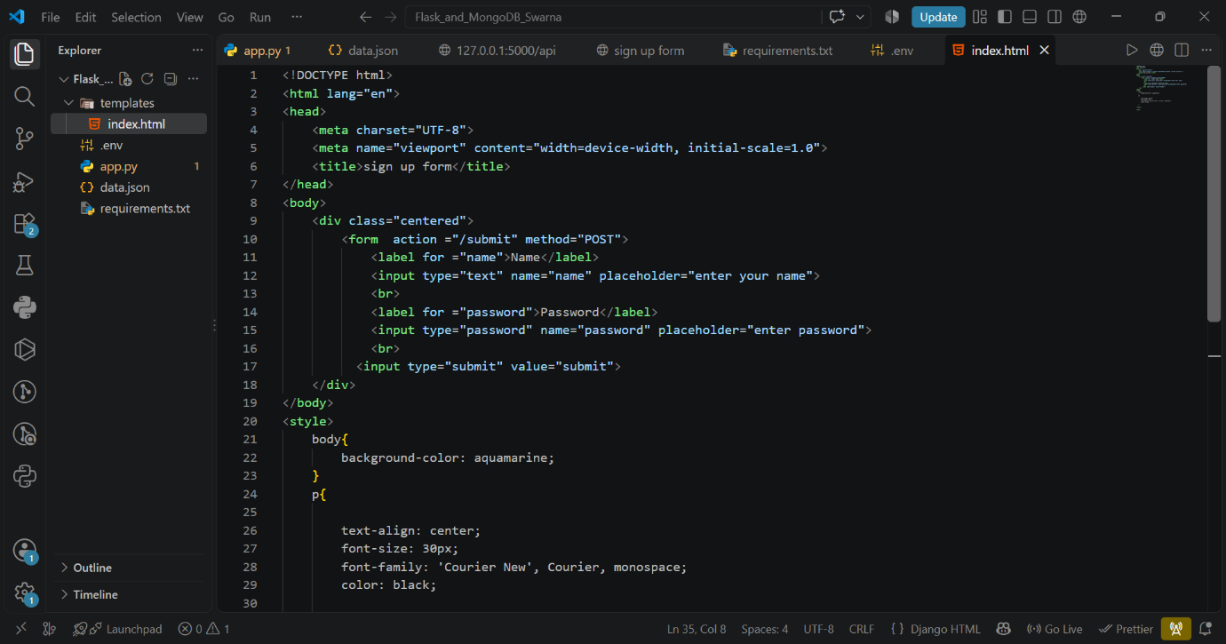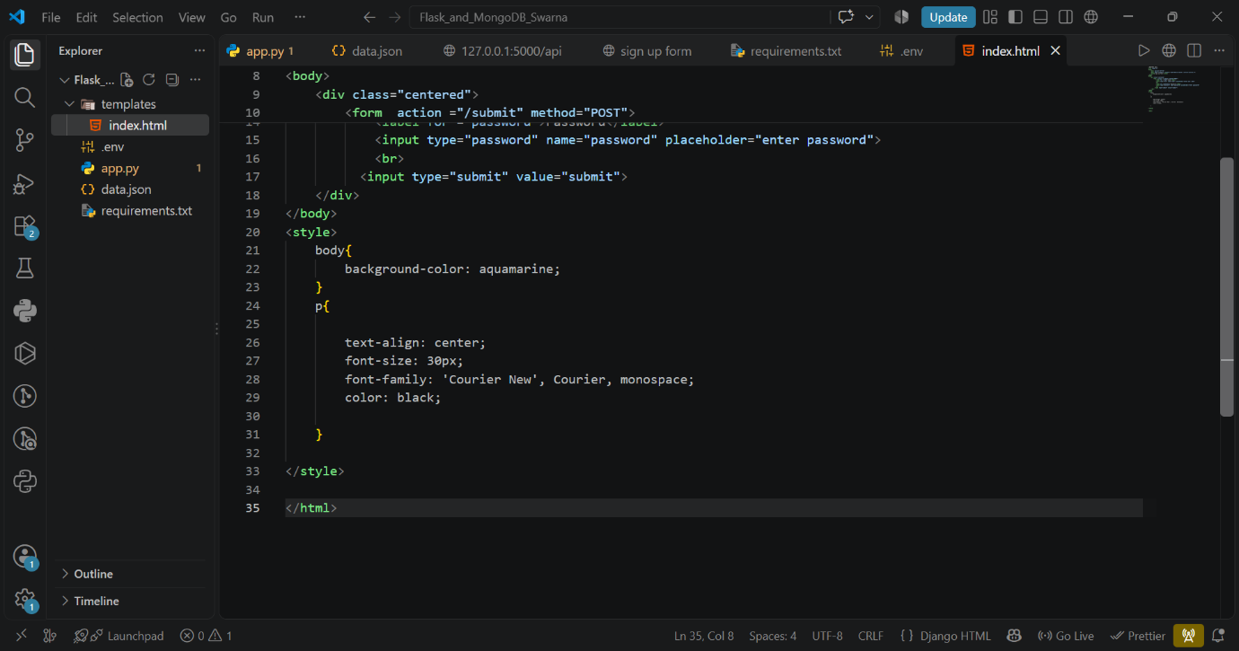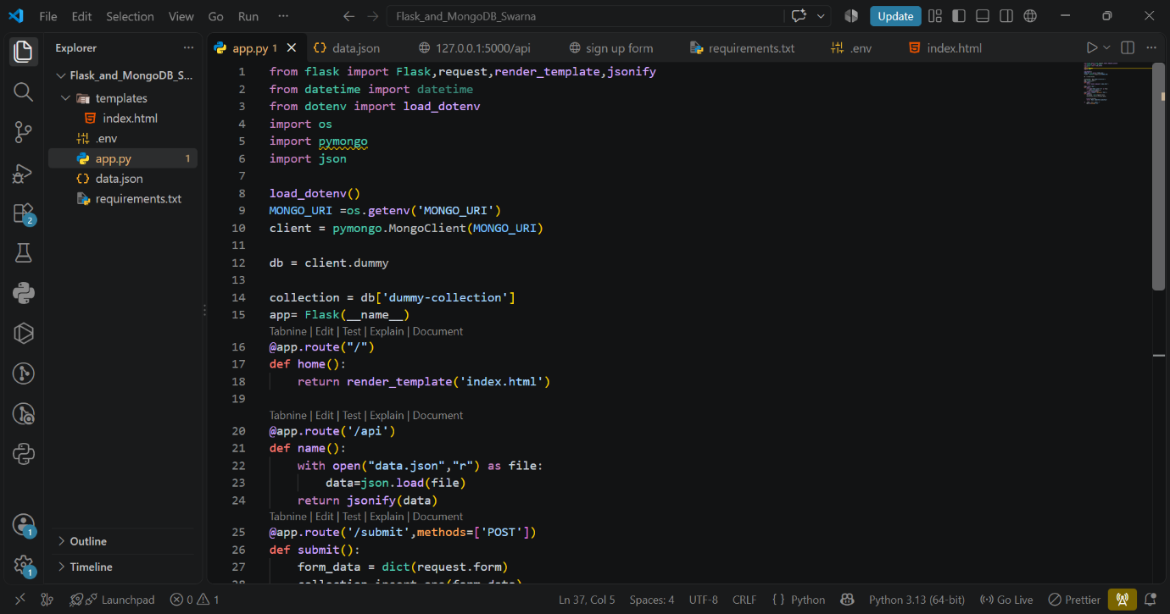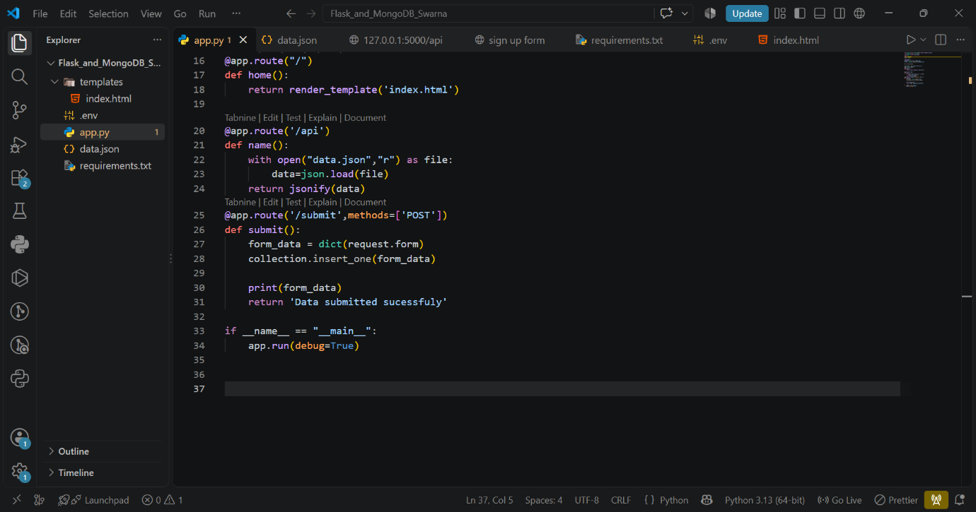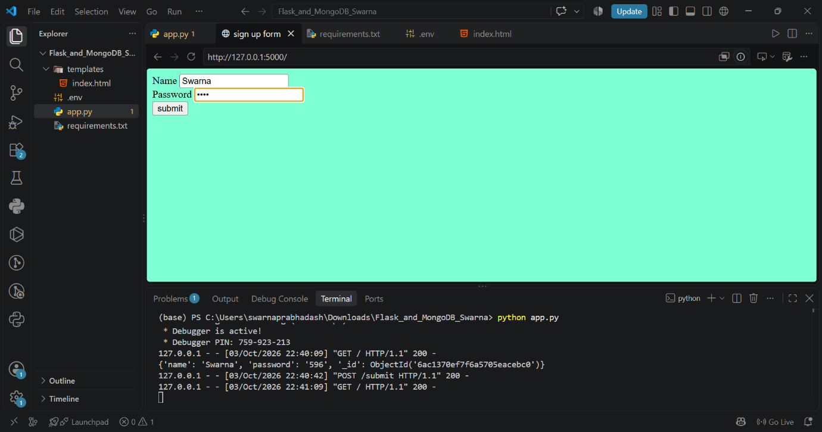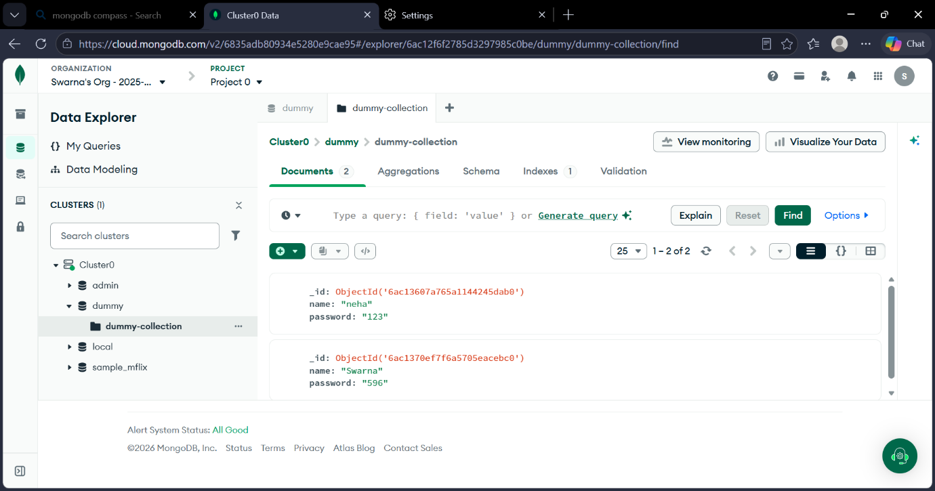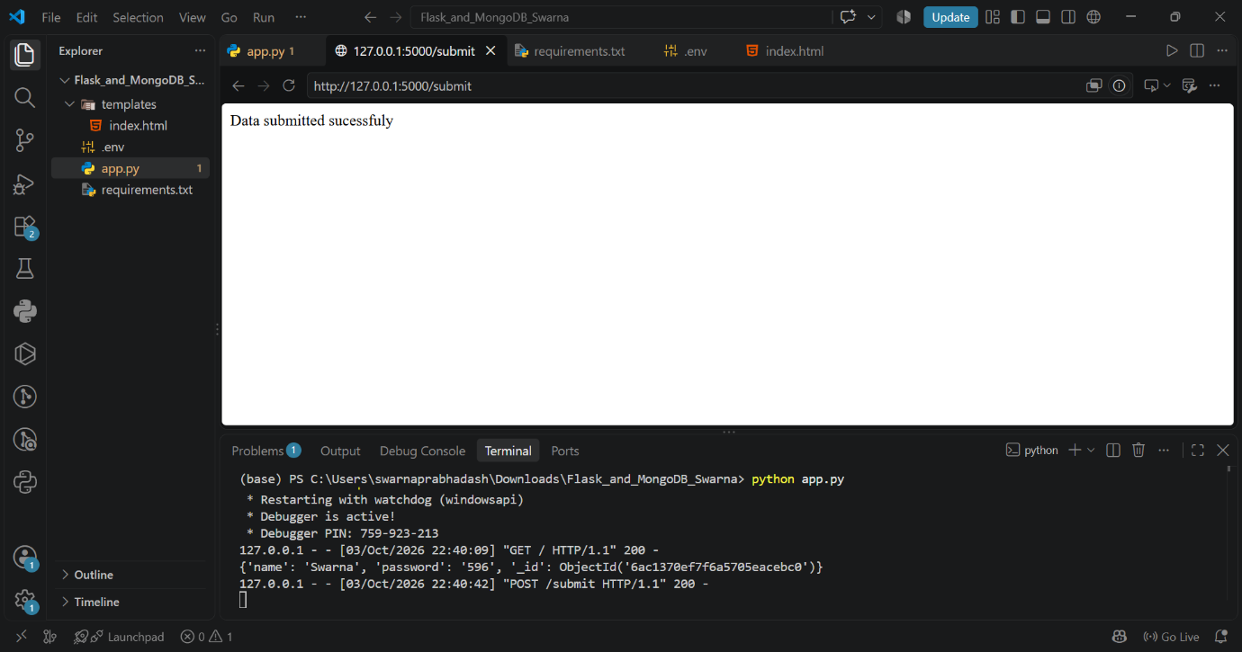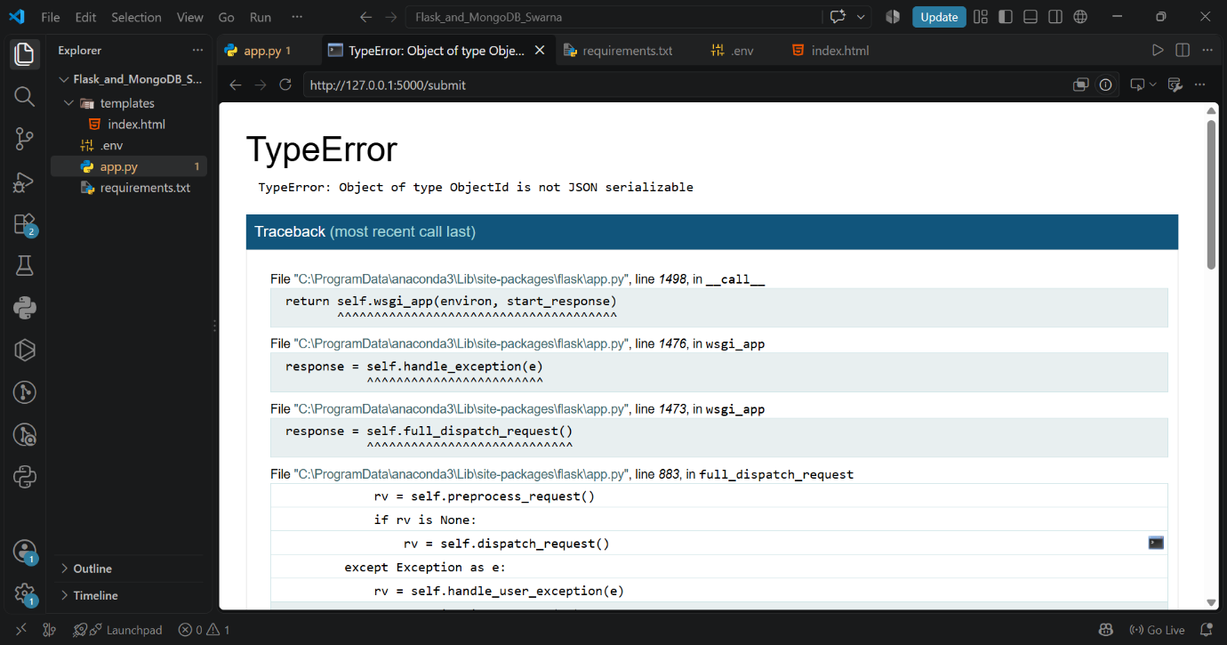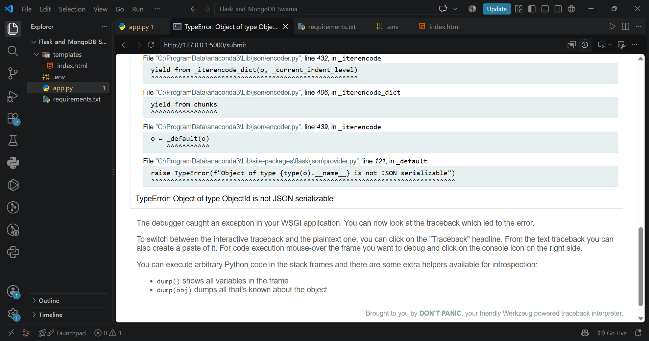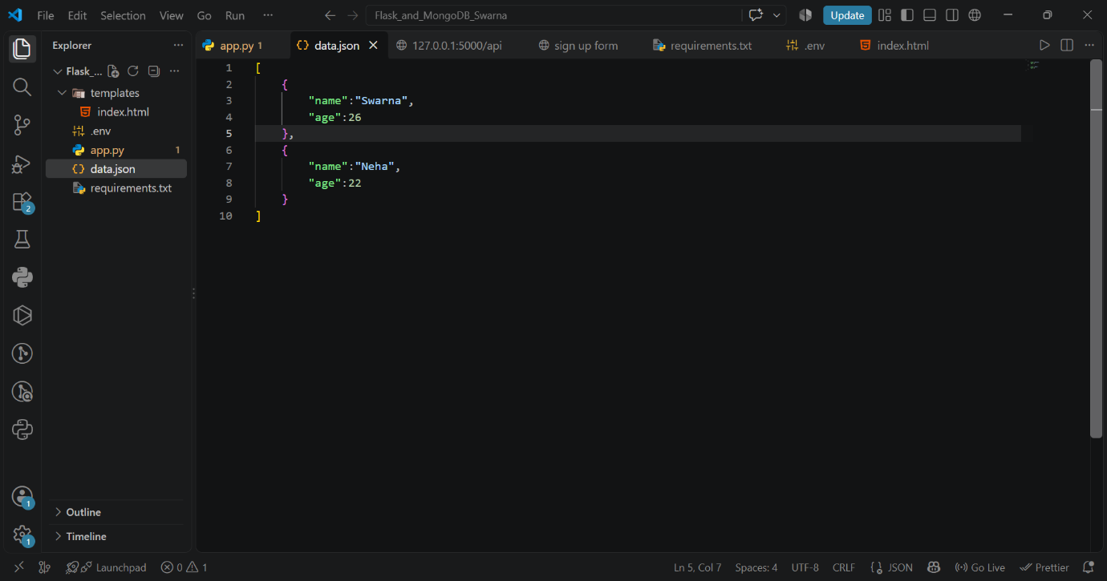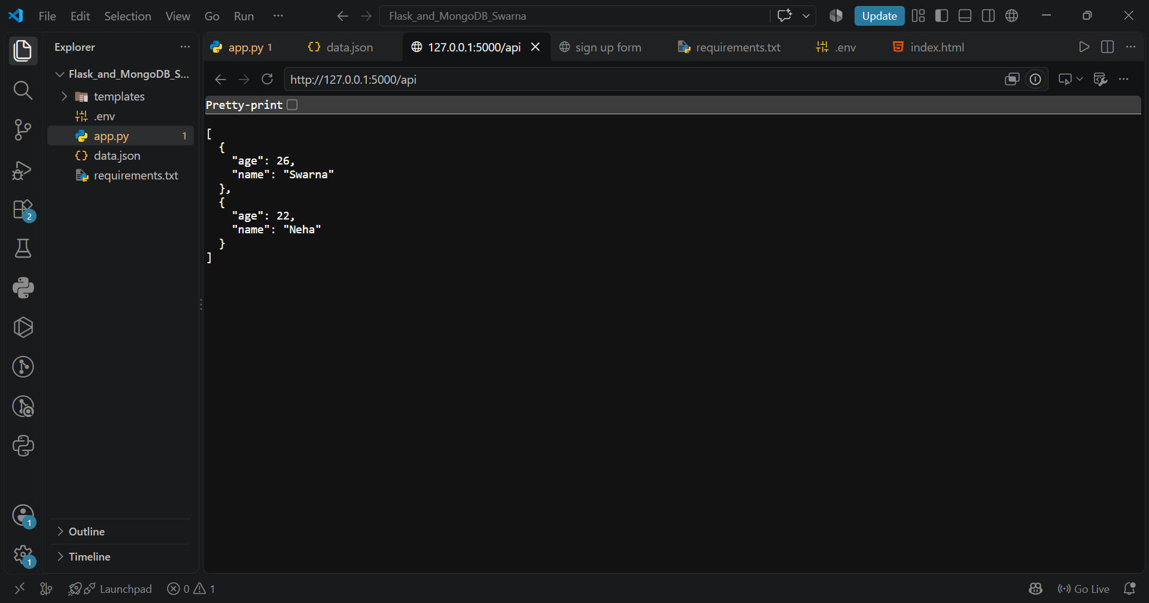
Source code –
App.py of both task
from flask import Flask,request,render_template,jsonify
from datetime import datetime
from dotenv import load_dotenv
import os
import pymongo
import json

load_dotenv()
MONGO_URI =os.getenv('MONGO_URI')
client = pymongo.MongoClient(MONGO_URI)

db = client.dummy

collection = db['dummy-collection']
app= Flask(__name__)
@app.route("/")
def home():
return render_template('index.html')

@app.route('/api')
def name():
with open("data.json","r") as file:
data=json.load(file)
return jsonify(data)
@app.route('/submit',methods=['POST'])
def submit():
form_data = dict(request.form)
collection.insert_one(form_data)

print(form_data)
return 'Data submitted sucessfuly'

if __name__ == "__main__":
app.run(debug=True)

Index.html:
<!DOCTYPE html>
<html lang="en">
<head>
<meta charset="UTF-8">
<meta name="viewport" content="width=device-width, initial-scale=1.0">
<title>sign up form</title>
</head>
<body>
<div class="centered">
<form action ="/submit" method="POST">
<label for ="name">Name</label>
<input type="text" name="name" placeholder="enter your name">
<br>
<label for ="password">Password</label>
<input type="password" name="password" placeholder="enter password">
<br>
<input type="submit" value="submit">
</div>
</body>
<style>
body{
background-color: aquamarine;
}
p{

text-align: center;
font-size: 30px;
font-family: 'Courier New', Courier, monospace;
color: black;

}

</style>

</html>
Requirements.txt
flask
pymongo
dnspython
python-dotenv
data.json:
[
{
"name":"Swarna",
"age":26
},
{
"name":"Neha",
"age":22
}
]

Github repo-https://github.com/swarna3009/Flask_and_MongoDB_Swarna.git

