FITZONE

*Project Report Submitted By*

# SWARNA MOL K K

**Reg.No: AJC20MCA-2074**

*In Partial fulfillment for the Award of the Degree Of*

**MASTER OF COMPUTER APPLICATIONS**

# (MCA)

**APJ ABDUL KALAM TECHNOLOGICAL UNIVERSITY**



# AMAL JYOTHI COLLEGE OF ENGINEERING KANJIRAPPALLY

[Affiliated to APJ Abdul Kalam Technological University, Kerala. Approved by AICTE, Accredited by NAAC with ‘A’ grade. Koovappally, Kanjirappally, Kottayam, Kerala – 686518]

# 2021-2022

**DEPARTMENT OF COMPUTER APPLICATIONS AMAL JYOTHI COLLEGE OF ENGINEERING KANJIRAPPALLY**



**CERTIFICATE**

This is to certify that the Project report, “**FITZONE”** is the bonafide work of **SWARNA MOL K K(Reg.No:AJC20MCA-2074)** in partial fulfillment of the requirements for the award of the Degree of Master of Computer Applications under APJ Abdul Kalam Technological University during the year 2021-22.

### Ms. Shelly Shiju George Ms. Grace Joseph Internal Guide Coordinator

**Rev.Fr.Dr.Rubin Thottupurathu Jose Head of the Department**

**DECLARATION**

I hereby declare that the project report **“FITZONE”** is a bonafided work done at Amal Jyothi College of Engineering, towards the partial fulfilment of the requirements for the award of the Degree of Master of Computer Applications (MCA) from APJ Abdul Kalam Technological University, during the academic year 2021-2022.

**Date: SWARNA MOL K K**

**KANJIRAPPALLY Reg. No: AJC20MCA-2074**

**ACKNOWLEDGEMENT**

First and foremost, I thank God almighty for his eternal love and protection throughout the project. I take this opportunity to express my gratitude to all who helped me in completing this project successfully. It has been said that gratitude is the memory of the heart. I wish to express my sincere gratitude to our manager **Rev. Fr. Dr. Mathew Paikatt** and Principal **Dr. Lillykutty Jacob** for providing good faculty for guidance.

I owe a great depth of gratitude towards our Head of the Department **Rev.Fr. Rubin Thottupurathu Jose** for helping us. I extend my whole hearted thanks to the project coordinators **Rev.Fr. Rubin Thottupurathu Jose** and **Ms**. **Grace Joseph** for their valuable suggestions and for overwhelming concern and guidance from the beginning to the end of the project. I would also like to express sincere gratitude to my guide**, Ms. Shelly Shiju George** for her inspiration and helping hand.

I thank our beloved teachers for their cooperation and suggestions that helped me throughout the project. I express my thanks to all my friends and classmates for their interest, dedication, and encouragement shown towards the project. I convey my hearty thanks to my family for the moral support, suggestions, and encouragement to make this venture a success.

SWARNA MOL K K

**ABSTRACT**

**FitZone** is an automated system for gym. FitZone make it easier to manage a fitness center or gym.it helps the users to get a quick access to the overall events in a gym. The main objective of this project for the better performance of gym and to manage that services through computerized system. The purpose of this system is to digitalize and create an automated system. The system will perform the task like adding the new member to the gym, Removing the member or keeping the payments records and other stuff required in managing the gym properly. The present scenario in the gyms is that the records are kept by writing in a file on paper. Every management task is done manually. This creates a system unreliable and confusing to keep the correct track of the records. The maintenance of a system like this is hardly required until it needs to change any part of the system. The information about the various things contained in the system are like members, trainers, the equipment can get by just a few clicks unlike the paper documents required the serious reading for such information.It helps in creating the various batch according to their preference or if they want a particular trainer. It made it easy to generate the reports of various operations performed in the gym are like paying the fee it can be stored and later evaluated and get the list of members who did not pay the fee. It also helps the users in reducing the carbon footprint as the amount of paper used in the company reduces.

This also helps in keeping the standard width of the management system as if there is a case where the administration involves more than one person to manage the gym. This system does not only limit itself to the administration and but also helps the members of the gym. The members can have options like attendance and fee payment change batch request etc. This will improve the transparency between the members which is always a good quality in the system. It will also give a layer of security to the administration and the users that only authorized users can access by their credentials.

**CONTENT**

|  |  |  |
| --- | --- | --- |
| **Sl.**  **No** | **Topic** | **Page**  **No** |
| **1** | **INTRODUCTION** | **1** |
| **1.1** | **PROJECT OVERVIEW** | **2** |
| **1.2** | **PROJECT SPECIFICATION** | **2** |
| **2** | **SYSTEM STUDY** | **4** |
| **2.1** | **INTRODUCTION** | **5** |
| **2.2** | **EXISTING SYSTEM** | **6** |
| **2.3** | **DRAWBACKS OF EXISTING**  **SYSTEM** | **6** |
| **2.4** | **PROPOSED SYSTEM** | **6** |
| **2.5** | **ADVANTAGES OF PROPOSED**  **SYSTEM** | **8** |
| **3** | **REQUIREMENT ANALYSIS** | **9** |
| **3.1** | **FEASIBILITY STUDY** | **10** |
| **3.1.1** | **ECONOMICAL FEASIBILITY** | **10** |
| **3.1.2** | **TECHNICAL FEASIBILITY** | **11** |
| **3.1.3** | **BEHAVIORAL FEASIBILITY** | **11** |
| **3.2** | **SYSTEM SPECIFICATION** | **12** |
| **3.2.1** | **HARDWARE SPECIFICATION** | **12** |
| **3.2.2** | **SOFTWARE SPECIFICATION** | **12** |
| **3.3** | **SOFTWARE DESCRIPTION** | **12** |
| **3.3.1** | **PHP** | **12** |
| **3.3.2** | **MYSQL** | **13** |
| **4** | **SYSTEM DESIGN** | **15** |
| **4.1** | **INTRODUCTION** | **16** |
| **4.2** | **UML DIAGRAM** | **16** |
| **4.2.1** | **USE CASE DIAGRAM** | **17** |
| **4.2.2** | **SEQUENCE DIAGRAM** | **20** |
| **4.3** | **USER INTERFACE DESIGN** | **22** |
| **4.4** | **DATA BASE DESIGN** | **29** |
| **5** | **SYSTEM TESTING** | **40** |
| **5.1** | **INTRODUCTION** | **41** |
| **5.2** | **TEST PLAN** | **42** |

|  |  |  |
| --- | --- | --- |
| **5.2.1** | **UNIT TESTING** | **42** |
| **5.2.2** | **INTEGRATION TESTING** | **43** |
| **5.2.3** | **VALIDATION TESTING** | **43** |
| **5.2.4** | **USER ACCEPTANCE TESTING** | **44** |
| **6** | **IMPLEMENTATION** | **45** |
| **6.1** | **INTRODUCTION** | **46** |
| **6.2** | **IMPLEMENTATION**  **PROCEDURE** | **46** |
| **6.2.1** | **USER TRAINING** | **47** |
| **6.2.2** | **TRAINING ON APPLICATION**  **SOFTWARE** | **47** |
| **6.2.3** | **SYSTEM MAINTENANCE** | **47** |
| **7** | **CONCLUSION & FUTURE SCOPE** | **48** |
| **7.1** | **CONCLUSION** | **49** |
| **7.2** | **FUTURE SCOPE** | **49** |
| **8** | **BIBLIOGRAPHY** | **50** |
| **9** | **APPENDIX** | **52** |
| **9.1** | **SAMPLE CODE** | **53** |
| **9.2** | **SCREEN SHOTS** | **60** |

**List of Abbreviation**

IDE - Integrated Development Environment HTML - Hyper Text Markup Language.

CSS - Cascading Style Sheet

SQL - Structured Query Language UML - Unified Modeling Language

# CHAPTER 1 INTRODUCTION

### PROJECT OVERVIEW

### We all know health is a wealth. We do not need a fancy car, big apartment, a doctor

### degree without a health. Being healthy is a first thing we need to keep in mind.

### Because most of time our attitude depends on how we feel. Being healthy and fit gives

### us energy to do anything. Physical fitness is very necessary for a healthy and tension

### free life. Physical fitness includes diet, exercise and sleep. These three basic things have

### their own importance in each individual's life and everyone should be sensible with regard

### to these for a healthy life. Our proposed “FitZone” system is for those who run a gym

### business. Before doing anything we did a decent research on major difficulties for gym

### owners. We examined carefully about how to make a huge registering system without

### failure as well as different functions for different kind of user depending on their privilege.

### The Gym Management requires a system that will handle all the necessary and minute

### details easily and proper database security accordingly to the user.

### PROJECT SPECIFICATION

The proposed system is made it easier to manage a fitness center or gym.it helps the users to get a quick access to the overall events in a gym. The main objective of this project for the better performance of gym and to manage that services through computerized system.

The system includes 5 modules. They are:

### Admin Module

Admin must have a login into this system. He has the overall control of the system. Admin can add or update user, staff. Admin can able to view all registered user details and their profiles . And he can add/delete events, add trainer schedules.

### User Module

User can register and they can upload details, join under a selected trainer and do secure online payment. User can view trainer’s schedule and can view/book for events. User can take appointments for physician and can view diet chart.

### Staff Module

Staffs can register and they can see all the gym timings, add/delete trainer ,physician add competition details, view participants list for each users.

### Trainer Module

Trainers can login in this site and they can see all the gym details by searching them. He can also see their own training schedules. And can view the users under his/her training schedules

### Physician Module

Physician can login in this site and can add/update diet planning. They can also see their own schedules. And can see the appointments from users

# CHAPTER 2 SYSTEM STUDY

### INTRODUCTION

System analysis is a process of gathering and interpreting facts, diagnosing problems and the information to recommend improvements on the system. It is a problem solving activity that requires intensive communication between the system users and system developers. System analysis or study is an important phase of any system development process. The system is studied to the minute’s detail and analyzed. The system analyst plays the role of the interrogator and dwells deep into the working of the present system. The system is viewed as a whole and the input to the system are identified. The outputs from the organizations are traced to the various processes. System analysis is concerned with becoming aware of the problem, identifying the relevant and decisional variables, analyzing and synthesizing the various factors and determining an optimal or at least a satisfactory solution or program of action.

A detailed study of the process must be made by various techniques like interviews, questionnaires etc. The data collected by these sources must be scrutinized to arrive to a conclusion. The conclusion is an understanding of how the system functions. This system is called the existing system. Now the existing system is subjected to close study and problem areas are identified. The designer now functions as a problem solver and tries to sort out the difficulties that the enterprise faces. The solutions are given as proposals. The proposal is then weighed with the existing system analytically and the best one is selected. The proposal is presented to the user for an endorsement by the user. The proposal is reviewed on user request and suitable changes are made. This is loop that ends as soon as the user is satisfied with proposal.

Preliminary study is the process of gathering and interpreting facts, using the information for further studies on the system. Preliminary study is problem solving activity that requires intensive communication between the system users and system developers. It does various feasibility studies. In these studies, a rough figure of the system activities can be obtained, from which the decision about the strategies to be followed for effective system study and analysis can be taken.

### EXISTING SYSTEM

Existing system is not a fully automated system. An Existing system refers to the system that is being followed till now. The gym is working manually. The current system is time consuming and also it is very costly, because it involves a lot of paperwork. To manually handle the system was very difficult task. But now-a-days computerization made easy to work. It is necessary to modify the existing system in order to include additional information and make the system efficient, flexible and secure.

### DRAWBACKS OF EXISTING SYSTEM

* + - Less convenient in managing project details including plan approval, less transparency, no standardized packages.
    - Project often delayed with no progress visibility.
    - Required a lot of paperwork and the process takes time.
    - Everything is done on paper and these are highly prone to damages and require

a good amount of security and space to store.

* + - Required Buying of goods more frequently as compared to the online system

e.g.: paper, pen.

* + - Likely to have an error.
    - Lack of storage space for handwritten documents.
    - Require more physical work and manpower.
    - Information is not available globally to both clients and employees hence

location restriction

* + - Human effort is needed.

### PROPOSED SYSTEM

The proposed system is defined to meets all the disadvantages of the existing system.

In the gym management system, after the planning and analysis phase of the system gets completed. Then the next phase required to transform the collected required system information into a structural blueprint which will serve as a reference while constructing the working system. It is a phase when most of the risks and errors unveiled so it’s is good practice to take care of this thing from the start.

This is a fully-fledged system that will be the backbone of the whole management of the gym so ignoring the risk or error is not an option as later it can make a greater form of itself. So, it is better to minimize the problems faced by both staff and the manager in the Organization.

### ADVANTAGES OF PROPOSED SYSTEM

* The proposed system is highly secured, because for login the system it requires

the username and password which is different for each department therefore

providing each department a different view of the customer information.

* It provides wide range of certain criteria in each window the client is working for

better and quicker solution.

* It maintains report for all criteria and transactions.
* Manages member information separately for all bill information separately for

considering the requirement of gym.

* Stores information about regular products.
* Diet recommendation

# CHAPTER 3 REQUIREMENT ANALYSIS

## FEASIBILITY STUDY

Feasibility study is made to see if the project on completion will serve the purpose of the organization for the amount of work, effort and the time that spend on it. Feasibility study lets the developer foresee the future of the project and the usefulness. A feasibility study of a system proposal is according to its workability, which is the impact on the organization, ability to meet their user needs and effective use of resources. Thus, when a new application is proposed it normally goes through a feasibility study before it is approved for development.

The document provides the feasibility of the project that is being designed and lists various areas that were considered very carefully during the feasibility study of this project such as Technical, Economic and Operational feasibilities. The following are its features: -

### Economical Feasibility

The developing system must be justified by cost and benefit. Criteria to ensure that effort is concentrated on project, which will give best, return at the earliest. One of the factors, which affect the development of a new system, is the cost it would require.

The following are some of the important financial questions asked during preliminary investigation:

* + - * The costs conduct a full system investigation.
      * The cost of the hardware and software.
      * The benefits in the form of reduced costs or fewer costly errors.

The proposed system is developed as part of project work, there is no manual cost to spend for the proposed system. Also all the resources are already available, it give an indication of the system is economically possible for development.

The cost of project, FITZONE was divided according to the system used, its development cost and cost for hosting the project. According to all the calculations the project was developed in a low cost. As it is completely developed using open source software.

### Technical Feasibility

The system must be evaluated from the technical point of view first. The assessment of this feasibility must be based on an outline design of the system requirement in the terms of input, output, programs and procedures. Having identified an outline system, the investigation must go on to suggest the type of equipment, required method developing the system, of running the system once it has been designed.

Technical issues raised during the investigation are:

* + - * Does the existing technology sufficient for the suggested one?
      * Can the system expand if developed?

The project should be developed such that the necessary functions and performance are achieved within the constraints. The project requires High Resolution Scanning device and utilizes Cryptographic techniques. Through the technology may become obsolete after some period of time, due to the fact that newer version of same software supports older versions, the system may still be used. So there are minimal constraints involved with this project. The system has been developed using PHP in front end and MySQL in server in back end, the project is technically feasible for development. The system has been developed using PHP in front end and MySQL in server in back end, the project is technically feasible for development. The System used was also of good performance of Processor Intel i3 core; RAM 4GB and, Hard disk 1TB

### Behavioral Feasibility

The proposed system includes the following questions:

* + - * Is there sufficient support for the users?
      * Will the proposed system cause harm?

The project would be beneficial because it satisfies the objectives when developed and installed. All behavioral aspects are considered carefully and conclude that the project is behaviorally feasible.

FITZONE, GUI is simple so that

users can easily use it. FITZONE is simple enough so that no training is needed.

## SYSTEM SPECIFICATION

### Hardware Specification

Processor - Intel core i3 RAM - 4 GB

Hard disk - 1 TB

### Software Specification

Front End - HTML, CSS Backend - MYSQL

Client on PC - Windows 7 and above.

Technologies used - JS, HTML5, AJAX, J Query, PHP, CSS

## SOFTWARE DESCRIPTION

### PHP

PHP is a server side scripting language designed for web development but also used as a general purpose programming language. PHP is now installed on more than 244 million websites and 2.1 million web servers. Originally created by Rasmus Ledorf in 1995, the reference implementation of PHP is now produced by the PHP group. While PHP originally stood for personal Home page ,it now stands for PHP:HypertextPreprocessor, a recursive acronym.PHP code is interpreted by a web server with a PHP processor module which generates the resulting web page.PHP commands can be embedded directly into a HTML source document rather than calling an external file to process data. It has also evolved to include a command-line interface capability and can be used in standalone incompatible with the GNU General Public License (GPL) due to restrictions on the usage of the term PHP.PHP can be deployed on most web servers and also as a standalone shell on almost every operating system and platform, free of charge.

### MySQL

MySQL, the most popular Open Source SQL database management system, is developed, distributed, and supported by Oracle Corporation. The MySQL Web site provides the latest information about MySQL software.

### MySQL is a database management system.

A database is a structured collection of data. It may be anything from a simple shopping list to a picture gallery or the vast amounts of information in a corporate network. To add, access, and process data stored in a computer database, youneed a database management system such as MySQL Server. Since computers are very good at handling large amounts of data, database management systems play a central role in computing, as standalone utilities, or as parts of other applications.

### MySQL databases are relational.

A relational database stores data in separate tables rather than putting all the data in one big storeroom. The database structures are organized into physical files optimized for speed. The logical model, with objects such as databases, tables, views, rows, and columns, offers a flexible programming environment. You set up rules governing the relationships between different data fields, such as one-to-one, one-to-many, unique, required or optional, and “pointers” between different tables. The database enforces these rules, so that with a well-designed database, your application never sees inconsistent, duplicate, orphan, out-of-date, or missing data. The SQL part of “MySQL” stands for “Structured Query Language”. SQL is the most common standardized language used to access databases. Depending on your programming environment, you might enter SQL directly (for example, to generate reports), embed SQL statements into code written in another language, or use a language-specific API that hides the SQL syntax. SQL is defined by the ANSI/ISO SQL Standard. The SQL standard has been evolving since 1986 and several versions exist. In this manual, “SQL92” refers to the standard released in 1992, “SQL: 1999” refers to the standard released in 1999, and “SQL: 2003” refers to the current version of the standard. We use the phrase “the SQL standard” to mean the current version of the SQL Standard at any time.

### MySQL software is Open Source*.*

Open Source means that it is possible for anyone to use and modify the software. Anybody can download the MySQL software from the Internet and use it without paying anything. If you wish, you may study the source code and change it to suit your needs. The MySQL software uses the GPL (GNU General Public License), to define what you may and may not do with the software in different situations. If you feel uncomfortable with the GPL or need to embed MySQL code into a commercial application, you can buy a commercially licensed version from us. See the MySQL Licensing Overview for more information.

### The MySQL Database Server is very fast, reliable, scalable, and easy to use.

If that is what you are looking for, you should give it a try. MySQL Server can run comfortably on a desktop or laptop, alongside your other applications, web servers, and so on, requiring little or no attention. If you dedicate an entire machine to MySQL, you can adjust the settings to take advantage of all the memory, CPU power, and I/O capacity available.

### MySQL Server works in client/server or embedded systems*.*

The MySQL Database Software is a client/server system that consists of a multi- threaded SQL server that supports different backends, several different client programs and libraries, administrative tools, and a wide range of application programming interfaces (APIs). We also provide MySQL Server as an embedded multi-threaded library that you can link into your application to get a smaller, faster, easier-to-manage standalone product.

# CHAPTER 4 SYSTEM DESIGN

* 1. **INTRODUCTION**

Design is the first step into the development phase for any engineered product or system. Design is a creative process. A good design is the key to effective system. The term “design” is defined as “the process of applying various techniques and principles for the purpose of defining a process or a system in sufficient detail to permit its physical realization”. It may be defined as a process of applying various techniques and principles for the purpose of defining a device, a process or a system in sufficient detail to permit its physical realization. Software design sits at the technical kernel of the software engineering process and is applied regardless of the development paradigm that is used. The system design develops the architectural detail required to build a system or product. As in the case of any systematic approach, this software too has undergone the best possible design phase fine tuning all efficiency, performance and accuracy levels. The design phase is a transition from a user oriented document to a document to the programmers or database personnel. System design goes through two phases of development: Logical and Physical Design.

## UML DIAGRAM

UML is a standard language for specifying, visualizing, constructing, and documenting the artifacts of software systems. UML was created by the Object Management Group (OMG) and UML 1.0 specification draft was proposed to the OMG in January 1997.

UML stands for **Unified Modeling Language**. UML is different from the other common programming languages such as C++, Java, COBOL, etc. UML is a pictorial language used to make software blueprints. UML can be described as a general purpose visual modeling language to visualize, specify, construct, and document software system. Although UML is generally used to model software systems, it is not limited within this boundary. It is also used to model non-software systems as well. For example, the process flow in a manufacturing unit, etc. UML is not a programming language but tools can be used to generate code in various languages using UML diagrams. UML has a direct relation with object oriented analysis and design. After

some standardization, UML has become an OMG standard. All the elements, relationships are used to make a complete UML diagram and the diagram represents a system. The visual effect of the UML diagram is the most important part of the entire process. All the other elements are used to make it complete. UML includes the following nine diagrams.

* Class diagram
* Object diagram
* Use case diagram
* Sequence diagram
* Collaboration diagram
* Activity diagram
* Statechart diagram
* Deployment diagram
* Component diagram

## USE CASE DIAGRAM

A use case diagram is a graphic depiction of the interactions among the elements of a system. A use case is a methodology used in system analysis to identify, clarify, and organize system requirements. In this context, the term "system" refers to something being developed or operated, such as a mail-order product sales and service Web site. Use case diagrams are employed in UML (Unified Modeling Language), a standard notation forthe modeling of real-world objects and systems.

System objectives can include planning overall requirements, validating a hardware design, testing and debugging a software product under development, creating an online help reference, or performing a consumer-service- oriented task. For example, use cases in a product sales environment would include item ordering, catalog updating, payment processing, and customer relations. A use case diagram contains four components.

* + - * The boundary, which defines the system of interest in relation to the world around it.
      * The actors, usually individuals involved with the system defined according to their

roles.

* + - * The use cases, which are the specific roles are played by the actors within and around the system.
      * The relationships between and among the actors and the use cases.

Use case diagrams are drawn to capture the functional requirements of a system. After identifying the above items, we have to use the following guidelines to draw an efficient use case diagram

* + - * The name of a use case is very important. The name should be chosen in such a way so that it can identify the functionalities performed.
      * Give a suitable name for actors.
      * Show relationships and dependencies clearly in the diagram.
      * Do not try to include all types of relationships, as the main purpose of the diagram is to identify the requirements.
      * Use notes whenever required to clarify some important points.

Fig 1 : Use case diagram for FitZone

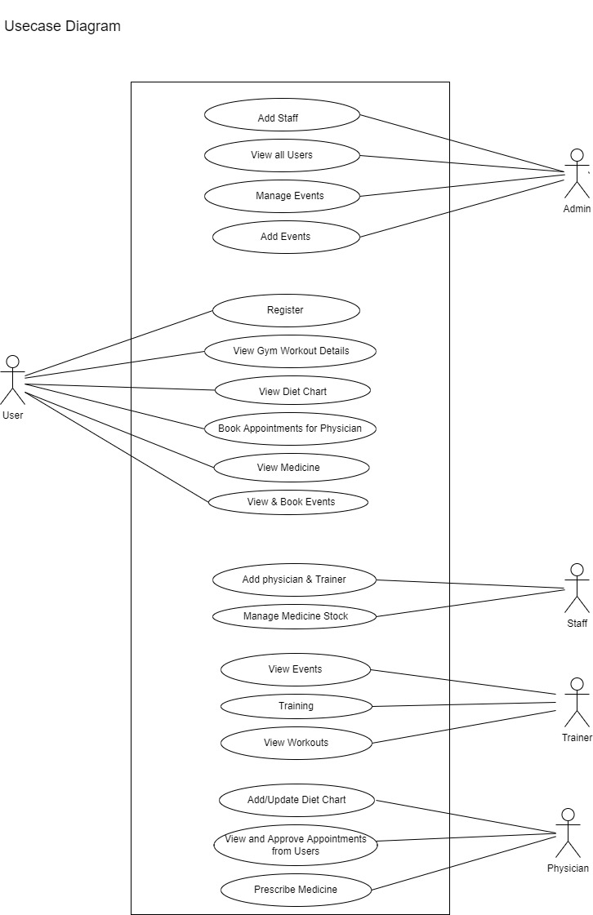

## SEQUENCE DIAGRAM

A sequence diagram simply depicts interaction between objects in a sequential order

i.e. the order in which these interactions take place. We can also use the terms event diagrams or event scenarios to refer to a sequence diagram. Sequence diagrams describe how and in what order the objects in a system function. These diagrams are widely used by businessmen and software developers to document and understand requirements for new and existing systems.

### Sequence Diagram Notations –

1. **Actors –** An actor in a UML diagram represents a type of role where it interacts with the system and its objects. It is important to note here that an actor is always outside the scope of the system we aim to model using the UML diagram. We use actors to depict various roles including human users and other external subjects. We represent an actor in a UML diagram using a stick person notation. We can have multiple actors in a sequence diagram.
2. **Lifelines –** A lifeline is a named element which depicts an individual participant in a sequence diagram. So basically each instance in a sequence diagram is represented by a lifeline. Lifeline elements are located at the top in a sequence diagram.
3. **Messages –** Communication between objects is depicted using messages. The messages appear in a sequential order on the lifeline. We represent messages using arrows. Lifelines and messages form the core of a sequence diagram.

Messages can be broadly classified into the following categories:

* + Synchronous messages
  + Asynchronous Messages
  + Create message
  + Delete Message
  + Self-Message
  + Reply Message
  + Found Message
  + Lost Message

1. **Guards –** To model conditions we use guards in UML. They are used when we need to restrict the flow of messages on the pretext of a condition being met. Guards play an important role in letting software developers know the constraints attached to a system or a particular process.

### Uses of sequence diagrams –

* Used to model and visualize the logic behind a sophisticated function, operation or procedure.
* They are also used to show details of UML use case diagrams.
* Used to understand the detailed functionality of current or future systems.
* Visualise how messages and tasks move between objects or components in a system.

Fig 1 : Sequence diagram for BuildTech Construction Management System

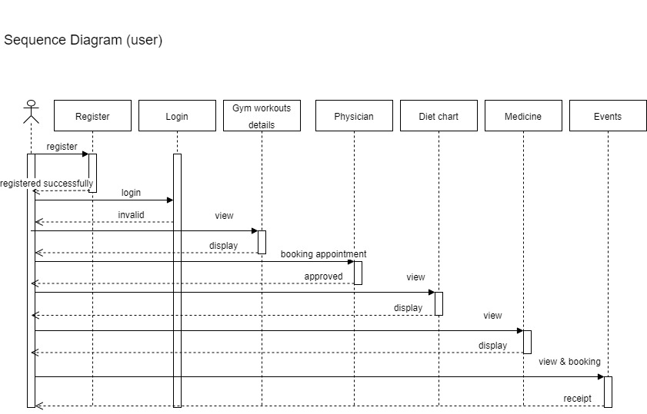

### USER INTERFACE DESIGN

**4.3.1-INPUT DESIGN**

Form Name : User Registration

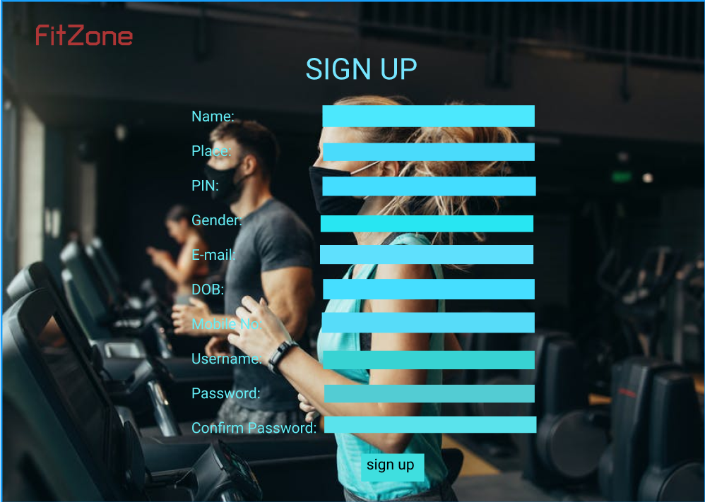

Form Name : User Login

### 4.3.2 OUTPUT DESIGN

**User Login**

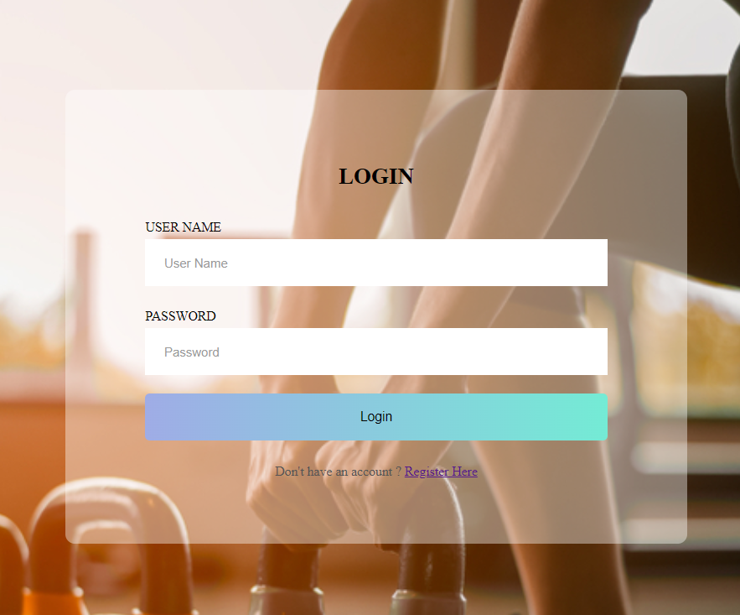

**User Registration**

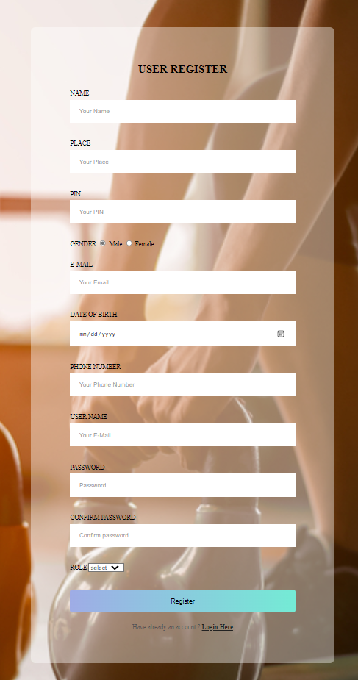

**Admin-View all Users**

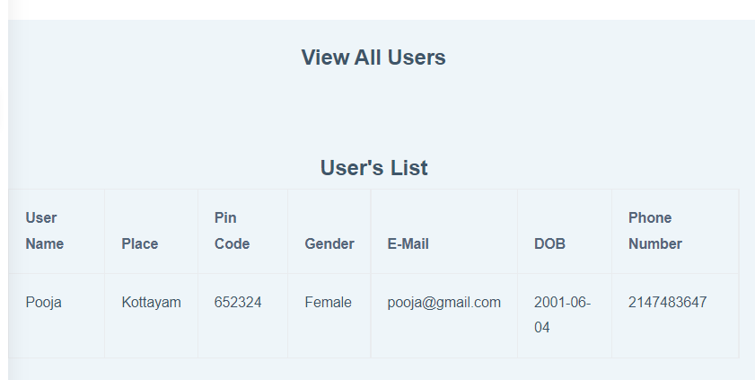

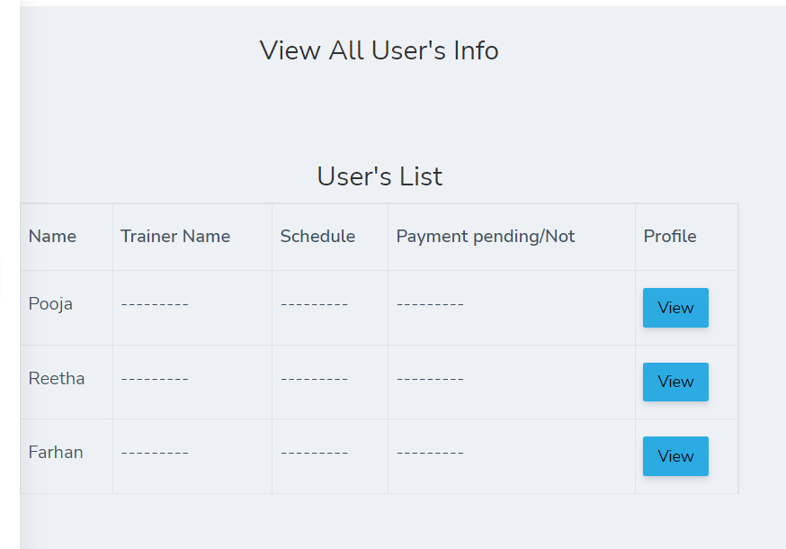

**Admin-Add Trainer Schedule**

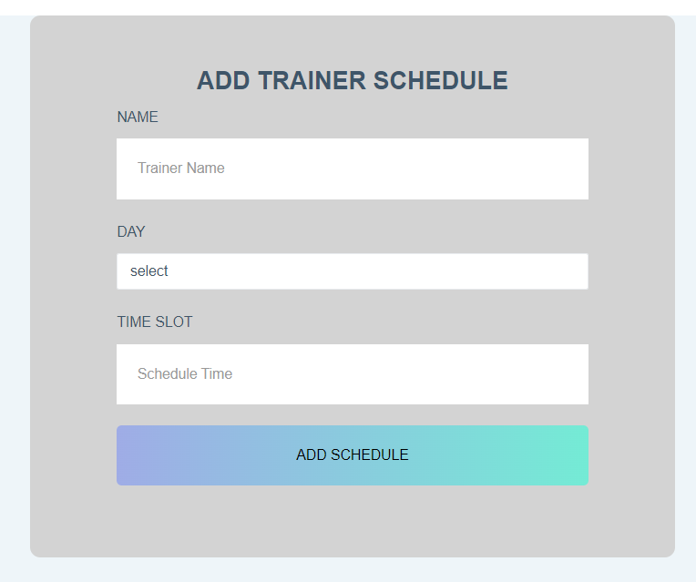

**User &Trainer-View Trainer Schedule**

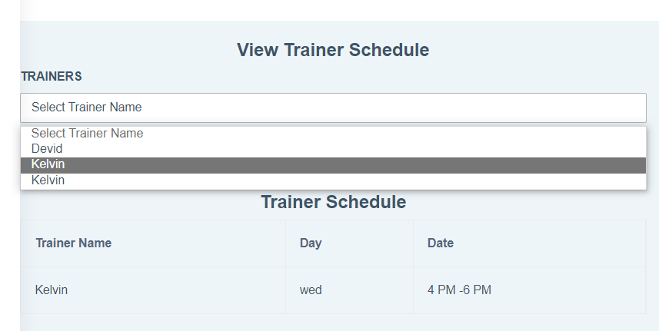

**Admin -Add Staff**

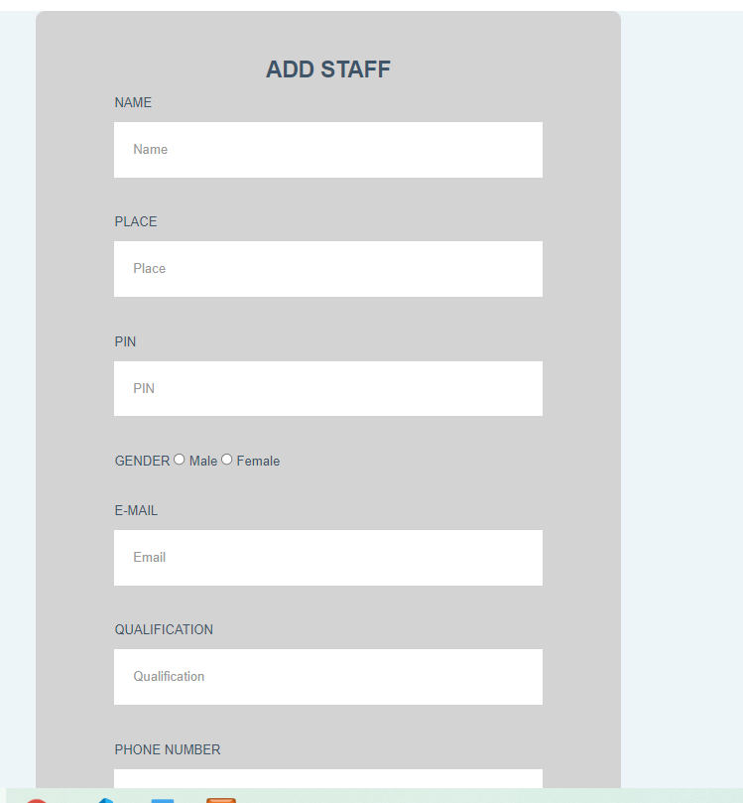

**Staff -Add Trainer**

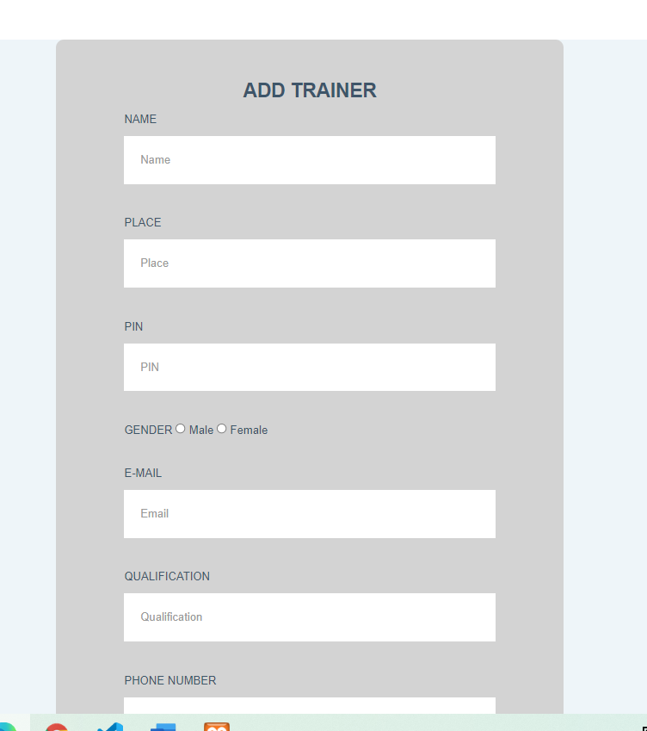

**Staff -Add Physician**

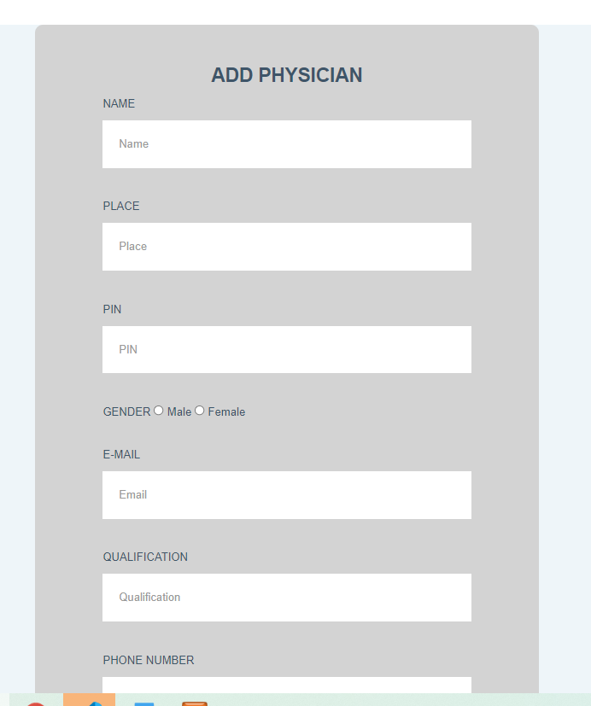

## DATABASE DESIGN

A database is an organized mechanism that has the capability of storing information through which a user can retrieve stored information in an effective and efficient manner. The data is the purpose of any database and must be protected.

The database design is a two level process. In the first step, user requirements are gathered together and a database is designed which will meet these requirements as clearly as possible. This step is called Information Level Design and it is taken independent of any individual DBMS.

In the second step, this Information level design is transferred into a design for the specific DBMS that will be used to implement the system in question. This step is called Physical Level Design, concerned with the characteristics of the specific DBMS that will be used. A database design runs parallel with the system design. The organization of the data in the database is aimed to achieve the following two major objectives.

* + - Data Integrity
    - Data independence

### Relational Database Management System (RDBMS)

A relational model represents the database as a collection of relations. Each relation resembles a table of values or file of records. In formal relational model terminology, a row is called a tuple, a column header is called an attribute and the table is called a relation. A relational database consists of a collection of tables, each of which is assigned a unique name. A row in a tale represents a set of related values.

### Relations, Domains & Attributes

A table is a relation. The rows in a table are called tuples. A tuple is an ordered set of n elements. Columns are referred to as attributes. Relationships have been set between every table in the database. This ensures both Referential and Entity Relationship Integrity. A domain D is a set of atomic values. A common method of specifying a domain is to specify a data type from which the data values forming the domain are drawn. It is also useful to specify a name for the domain to help in interpreting its values.

Every value in a relation is atomic, that is not decomposable.

### Relationships

* + - * Table relationships are established using Key. The two main keys of prime importance are Primary Key & Foreign Key. Entity Integrity and Referential Integrity Relationships can be established with these keys.
      * Entity Integrity enforces that no Primary Key can have null values.
      * Referential Integrity enforces that no Primary Key can have null values.
      * Referential Integrity for each distinct Foreign Key value, there must exist a matching Primary Key value in the same domain. Other key are Super Key and Candidate Keys.

### Normalization

Data are grouped together in the simplest way so that later changes can be made with minimum impact on data structures. Normalization is formal process of data structures in manners that eliminates redundancy and promotes integrity. Normalization is a technique of separating redundant fields and breaking up a large table into a smaller one. It is also used to avoid insertion, deletion, and updating anomalies. Normal form in data modelling use two concepts, keys and relationships. A key uniquely identifies a row in a table. There are two types of keys, primary key and foreign key. A primary key is an element or a combination of elements in a table whose purpose is to identify records from the same table. A foreign key is a column in a table that uniquely identifies record from a different table. All the tables have been normalized up to the third normal form.

As the name implies, it denotes putting things in the normal form. The application developer via normalization tries to achieve a sensible organization of data into proper tables and columns and where names can be easily correlated to the data by the user. Normalization eliminates repeating groups at data and thereby avoids data redundancy which proves to be a great burden on the computer resources. These include:

* Normalize the data.
* Choose proper names for the tables and columns.
* Choose the proper name for the data.

### First Normal Form

The First Normal Form states that the domain of an attribute must include only atomic values and that the value of any attribute in a tuple must be a single value from the domain of that attribute. In other words 1NF disallows “relations within relations” or “relations as attribute values within tuples”. The only attribute values permitted by 1NF are single atomic or indivisible values. The first step is to put the data into First Normal Form. This can be donor by moving data into separate tables where the data is of similar type in each table. Each table is given a Primary Key or Foreign Key as per requirement of the project. In this we form new relations for each non-atomic attribute or nested relation. This eliminated repeating groups of data. A relation is said to be in first normal form if only if it satisfies the constraints that contain the primary key only.

### Second Normal Form

According to Second Normal Form, for relations where primary key contains multiple attributes, no non-key attribute should be functionally dependent on a part of the primary key. In this we decompose and setup a new relation for each partial key with its dependent attributes. Make sure to keep a relation with the original primary key and any attributes that are fully functionally dependent on it. This step helps in taking out data that is only dependent on a part of the key. A relation is said to be in second normal form if and only if it satisfies all the first normal form conditions for the primary key and every non-primary key attributes of the relation is fully dependent on its primary key alone.

### Third Normal Form

According to Third Normal Form, Relation should not have a non-key attribute functionally determined by another non-key attribute or by a set of non-key attributes. That is, there should be no transitive dependency on the primary key. In this we decompose and set up relation that includes the non-key attributes that functionally determines other non-key attributes. This step is taken to get rid of anything that does not depend entirely on the Primary Key. A relation is said to be in third normal form if only if it is in second normal form and more over the non key attributes of the relation should not be depend on other non-key attribute.

### TABLE DESIGN

**Table No 01**

### Table Name : tbl_login Primary Key : login_id Foreign Key :

**Table Description : To store user Login information**

|  |  |  |  |  |
| --- | --- | --- | --- | --- |
| **Sl.no** | **Field name** | **Data type** | **Size** | **Constraints** |
| 1 | login_id | int |  | P.K |
| 2 | uname | varchar | 50 | Not null |
| 3 | pwd | varchar | 50 | Not null |
| 4 | role | varchar | 15 | Not null |

### Table No 02

**Table Name : add_staff**

**Primary Key : s_id**

### Foreign Key : login_id

**Table Description: To store staff information**

|  |  |  |  |  |
| --- | --- | --- | --- | --- |
| **Sl.no** | **Field name** | **Data type** | **Size** | **Constraints** |
| 1 | s_id | int |  | P.K |
| 2 | login_id | int |  | F.K |
| 3 | s_name | varchar | 50 | Not null |
| 4 | s_place | varchar | 50 | Not null |
| 5 | s_pin | int |  |  |
| 6 | s_gender | varchar | 10 | Not null |
| 7 | s_email | varchar | 50 | Not null |
| 8 | s_qualification | varchar | 50 | Not null |
| 9 | s_phone | int |  | Not null |
| 10 | s_experience | varchar | 50 | Not null |
| 11 | s_aadhar | int |  | Not null |
| 12 | s_upaadhar | varchar | 50 | Not null |

### Table No 03

**Table Name : user_reg Primary Key : u_id**

### Foreign Key : login_id

### Table Description: To store user registration information

|  |  |  |  |  |
| --- | --- | --- | --- | --- |
| **Sl.no** | **Field name** | **Data type** | **Size** | **Constraints** |
| 1 | u_id | int |  | P.K |
| 2 | login_id | int |  | F.K |
| 3 | name | varchar | 50 | Not null |
| 4 | place | varchar | 50 | Not null |
| 5 | pin | int |  |  |
| 6 | gender | varchar | 10 | Not null |
| 7 | email | varchar | 50 | Not null |
| 8 | dob | date |  |  |
| 9 | phone | int |  | Not null |

**Table No 04**

### Table Name : add_trainer Primary Key : t_id

**Foreign Key : login_id**

### Table Description: To store trainer information

|  |  |  |  |  |
| --- | --- | --- | --- | --- |
| **Sl.no** | **Field name** | **Data type** | **Size** | **Constraints** |
| 1 | t_id | int |  | P.K |
| 2 | login_id | int |  | F.K |
| 3 | t_name | varchar | 50 | Not null |
| 4 | t_place | varchar | 50 | Not null |
| 5 | t_pin | int |  |  |
| 6 | t_gender | varchar | 10 | Not null |
| 7 | t_email | varchar | 50 | Not null |
| 8 | certification | varchar | 50 | Not null |
| 9 | t_phone | int |  | Not null |
| 10 | t_experience | varchar | 50 | Not null |
| 11 | t_aadhar | int | 50 | Not null |
| 12 | t_upaadhar | varchar | 50 | Not null |

**Table No 05**

### Table Name :add_physician Primary Key : p_id

**Foreign Key : login_id**

### Table Description: To store physician details

|  |  |  |  |  |
| --- | --- | --- | --- | --- |
| **Sl.no** | **Field name** | **Data type** | **Size** | **Constraints** |
| 1 | p_id | int |  | P.K |
| 2 | login_id | int |  | F.K |
| 3 | p_name | varchar | 50 | Not null |
| 4 | p_place | varchar | 50 | Not null |
| 5 | p_pin | int |  |  |
| 6 | p_gender | varchar | 10 | Not null |
| 7 | p_email | varchar | 50 | Not null |
| 8 | p_qualification | varchar | 50 | Not null |
| 9 | p_phone | int |  | Not null |
| 10 | p_experience | varchar | 50 | Not null |
| 11 | license_no | int |  | Not null |
| 12 | up_license | varchar | 50 | Not null |

**Table No 06**

### Table Name : t_schedule

### Primary Key : ts_id

**Foreign Key :**

### Table Description: To store schedules of trainer

|  |  |  |  |  |
| --- | --- | --- | --- | --- |
| **Sl.no** | **Field name** | **Data type** | **Size** | **Constraints** |
| 1 | ts_id | int |  | P.K |
| 2 | ts_name | varchar | 50 | Not null |
| 3 | ts_day | varchar | 100 | Not null |
| 4 | ts_time | varchar | 50 | Not null |

**Table No 07**

### Table Name : add_events

### Primary Key : e_id

**Foreign Key :**

### Table Description: To store event details

|  |  |  |  |  |
| --- | --- | --- | --- | --- |
| **Sl.no** | **Field name** | **Data type** | **Size** | **Constraints** |
| 1 | e_id | int |  | P.K |
| 2 | e_name | varchar | 50 | Not null |
| 3 | e_description | varchar | 100 | Not null |
| 4 | venue | varchar | 50 | Not null |
| 5 | eligibility | varchar | 100 | Not null |
| 6 | date | date |  |  |
| 7 | time | time |  |  |

**Table No 08**

### Table Name : medical_history Primary Key : h_id

**Foreign Key :**

### Table Description: To store medical history details of user

|  |  |  |  |  |
| --- | --- | --- | --- | --- |
| **Sl.no** | **Field name** | **Data type** | **Size** | **Constraints** |
| 1 | h_id | int |  | P.K |
| 2 | u_id | int |  | F.K |
| 3 | height | varchar | 10 | Not null |
| 4 | weight | varchar | 10 | Not null |
| 5 | blood_grp | varchar | 10 | Not null |
| 6 | allergies | varchar | 50 | Not null |

**Table No 09**

### Table Name : event_booking Primary Key :b_id

**Foreign Key :**

### Table Description: To store booking details of events

|  |  |  |  |  |
| --- | --- | --- | --- | --- |
| **Sl.no** | **Field name** | **Data type** | **Size** | **Constraints** |
| 1 | b_id | int |  | P.K |
| 2 | u_id | int |  | F.K |
| 3 | e_id | int |  | F.K |
| 4 | b_date | date |  |  |

**Table No 10**

### Table Name : appointment_booking

### Primary Key : a_id Foreign Key :

**Table Description: To store appointment booking for physician details**

|  |  |  |  |  |
| --- | --- | --- | --- | --- |
| **Sl.no** | **Field name** | **Data type** | **Size** | **Constraints** |
| 1 | a_id | int |  | P.K |
| 2 | u_id | int |  | F.K |
| 3 | p_id | int |  | F.K |
| 4 | a_date | date |  |  |

### Table No 11

**Table Name: medicine_info**

**Primary Key : did Foreign Key : sid**

### Table Description: To store medicine details

|  |  |  |  |  |
| --- | --- | --- | --- | --- |
| **Sl.no** | **Field name** | **Data type** | **Size** | **Constraints** |
| 1 | m_id | int |  | P.K |
| 2 | m_name | varchar | 50 | Not null |
| 3 | quantity | float |  |  |
| 4 | mfg_date | date |  |  |
| 5 | exp_date | date |  |  |
| 6 | price/unit | float |  |  |

**Table No 12**

### Table Name : diet_ chart

### Primary Key : d_id

**Foreign Key :** Table Description: To store customer complaints

|  |  |  |  |  |
| --- | --- | --- | --- | --- |
| **Sl.no** | **Field name** | **Data type** | **Size** | **Constraints** |
| 1 | d_id | int |  | P.K |
| 2 | plan | varchar | 100 | Not null |
| 3 | description | varchar | 100 | Not null |

# CHAPTER 5 SYSTEM TESTING

## INTRODUCTION

Software Testing is the process of executing software in a controlled manner, in order to answer the question - Does the software behave as specified? Software testing is often used in association with the terms verification and validation. Validation is the checking or testing of items, includes software, for conformance and consistency with an associated specification. Software testing is just one kind of verification, which also uses techniques such as reviews, analysis, inspections, and walkthroughs. Validation is the process of checking that what has been specified is what the user actually wanted.

Other activities which are often associated with software testing are static analysis and dynamic analysis. Static analysis investigates the source code of software, looking for problems and gathering metrics without actually executing the code. Dynamic analysis looks at the behavior of software while it is executing, to provide information such as execution traces, timing profiles, and test coverage information.

Testing is a set of activity that can be planned in advanced and conducted systematically. Testing begins at the module level and work towards the integration of entire computers based system. Nothing is complete without testing, as it vital success of the system testing objectives, there are several rules that can serve as testing objectives. They are:

Testing is a process of executing a program with the intent of finding an error.

* + - A good test case is one that has high possibility of finding an undiscovered error.
    - A successful test is one that uncovers an undiscovered error.

If a testing is conducted successfully according to the objectives as stated above, it would uncover errors in the software. Also testing demonstrate that the software function appear to be working according to the specification, that performance requirement appear to have been met.

There are three ways to test program.

* + - For correctness
    - For implementation efficiency
    - For computational complexity

Test for correctness are supposed to verify that a program does exactly what it was designed to do. This is much more difficult than it may at first appear, especially for large programs.

## TEST PLAN

A test plan implies a series of desired course of action to be followed in accomplishing various testing methods. The Test Plan acts as a blue print for the action that is to be followed. The software engineers create a computer program, its documentation and related data structures. The software developers is always responsible for testing the individual units of the programs, ensuring that each performs the function for which it was designed. There is an independent test group (ITG) which is to remove the inherent problems associated with letting the builder to test the thing that has been built. The specific objectives of testing should be stated in measurable terms. So that the mean time to failure, the cost to find and fix the defects, remaining defect density or frequency of occurrence and test work-hours per regression test all should be stated within the test plan.

The levels of testing include:

* Unit testing
* Integration Testing
* Data validation Testing
* Output Testing

### Unit Testing

Unit testing focuses verification effort on the smallest unit of software design – the software component or module. Using the component level design description as a guide, important control paths are tested to uncover errors within the boundary of the module. The relative complexity of tests and uncovered scope established for unit testing. The unit testing is white-box oriented, and step can be conducted in parallel for multiple components. The modular interface is tested to ensure that information properly flows into and out of the program unit under test. The local data structure is examined to ensure that data stored temporarily maintains its integrity during all steps in an algorithm’s execution. Boundary conditions are tested to ensure that all statements in a module have been executed at least once. Finally, all error handling paths are tested.

Tests of data flow across a module interface are required before any other test is initiated. If data do not enter and exit properly, all other tests are moot. Selective testing of execution paths is an essential task during the unit test. Good design dictates that error conditions be anticipated and error handling paths set up to reroute or cleanly terminate processing when an error does occur. Boundary testing is the last task of unit testing step. Software often fails at its boundaries.

Unit testing was done in Sell-Soft System by treating each module as separate entity and testing each one of them with a wide spectrum of test inputs. Some flaws in the internal logic of the modules were found and were rectified. After coding each module is tested and run individually. All unnecessary code where removed and ensured that all modules are working, and gives the expected result.

### Integration Testing

Integration testing is systematic technique for constructing the program structure while at the same time conducting tests to uncover errors associated with interfacing. The objective is to take unit tested components and build a program structure that has been dictated by design. The entire program is tested as whole. Correction is difficult because isolation of causes is complicated by vast expanse of entire program. Once these errors are corrected, new ones appear and the process continues in a seemingly endless loop. After performing unit testing in the System all the modules were integrated to test for any inconsistencies in the interfaces. Moreover differences in program structures were removed and a unique program structure was evolved.

### Validation Testing or System Testing

This is the final step in testing. In this the entire system was tested as a whole with all forms, code, modules and class modules. This form of testing is popularly known as Black Box testing or System tests.

Black Box testing method focuses on the functional requirements of the software. That is, Black Box testing enables the software engineer to derive sets of input conditions thatwill fully exercise all functional requirements for a program.

Black Box testing attempts to find errors in the following categories; incorrect or missing functions, interface errors, errors in data structures or external data access, performance errors and initialization errors and termination errors.

### Output Testing or User Acceptance Testing

The system considered is tested for user acceptance; here it should satisfy the firm’s need. The software should keep in touch with perspective system; user at the time of developing and making changes whenever required. This done with respect to the following points:

* + - * Input Screen Designs,
      * Output Screen Designs,

The above testing is done taking various kinds of test data. Preparation of test data plays a vital role in the system testing. After preparing the test data, the system under study is tested using that test data. While testing the system by which test data errors are again uncovered and corrected by using above testing steps and corrections are also noted for future use.

# CHAPTER 6 IMPLEMENTATION

## INTRODUCTION

Implementation is the stage of the project where the theoretical design is turned into a working system. It can be considered to be the most crucial stage in achieving a successful new system gaining the users confidence that the new system will work and will be effective and accurate. It is primarily concerned with user training and documentation. Conversion usually takes place about the same time the user is being trained or later. Implementation simply means convening a new system design into operation, which is the process of converting a new revised system design into an operational one.

At this stage the main work load, the greatest upheaval and the major impact on the existing system shifts to the user department. If the implementation is not carefully planned or controlled, it can create chaos and confusion.

Implementation includes all those activities that take place to convert from the existing system to the new system. The new system may be a totally new, replacing an existing manual or automated system or it may be a modification to an existing system. Proper implementation is essential to provide a reliable system to meet organization requirements. The process of putting the developed system in actual use is called system implementation. This includes all those activities that take place to convert from the old system to the new system. The system can be implemented only after through testing is done and if it is found to be working according to the specifications. The system personnel check the feasibility of the system. The more complex the system being implemented, the more involved will be the system analysis and design effort required to implement the three main aspects: education and training, system testing and changeover.

The implementation state involves the following tasks:

Careful planning.

Investigation of system and constraints. Design of methods to achieve the changeover.

## IMPLEMENTATION PROCEDURES

Implementation of software refers to the final installation of the package in its real environment, to the satisfaction of the intended uses and the operation of the system. In many organizations someone who will not be operating it, will commission the software development project. In the initial stage people doubt about the software but we have to

ensure that the resistance does not build up, as one has to make sure that:

The active user must be aware of the benefits of using the new system. Their confidence in the software is built up.

Proper guidance is imparted to the user so that he is comfortable in using the application.

Before going ahead and viewing the system, the user must know that for viewing the result, the server program should be running in the server. If the server object is not up running on the server, the actual process won’t take place.

### User Training

User training is designed to prepare the user for testing and converting the system. To achieve the objective and benefits expected from computer based system, it is essential for the people who will be involved to be confident of theirrole in the new system. As system becomes more complex, the need for training is more important. By user training the user comes to know how to enter data, respond to error messages, interrogate the database and call up routine that will produce reports and perform other necessary functions.

### Training on the Application Software

After providing the necessary basic training on computer awareness the user will have to be trained on the new application software. This will give the underlying philosophy of the use of the new system such as the screen flow, screen design type of help on the screen, type of errors while entering the data, the corresponding validation check at each entry and the ways to correct the date entered. It should then cover information needed by the specific user/ group to use the system or part of the system while imparting the training of the program on the application. This training may be different across different user groups and across different levels of hierarchy

### System Maintenance

Maintenance is the enigma of system development. The maintenance phase of the software cycle is the time in which a software product performs useful work. After a system is successfully implemented, it should be maintained in a proper manner. System maintenance is an important aspect in the software development life cycle. The need for system maintenance is for it to make adaptable to the changes in the system environment. Software maintenance is of course, far more than "Finding Mistakes".

# CHAPTER 7 CONCLUSION AND FUTURE SCOPE

## CONCLUSION

The current system working technology is old fashioned and there is no usage of commonly used technologies like internet, digital money. The proposed system introduces facility for fully-fledged system that will be the backbone of the whole management of the gym so ignoring the risk or error is not an option as later it can make a greater form of itself. So, it is better to minimize the problems faced by both staff and the manager in the Organization.

### FUTURE SCOPE

* + - The proposed system is designed in such a way that the payment should be done in online mode.
    - Users can able to add complaints and feedbacks etc.
    - Data security can be enhanced.
    - It provides wide range of certain criteria in each window the client is working for better and quicker solution.
    - It maintains report for all criteria and transactions.
    - Manages member information separately for all bill information separately for considering the requirement of gym.
    - Stores information about regular products.
    - Diet recommendation

# CHAPTER 8 BIBLIOGRAPHY

### REFERENCES:

* + - Gary B. Shelly, Harry J. Rosenblatt, “*System Analysis and Design*”, 2009.
    - Roger S Pressman, “*Software Engineering*”, 1994.
    - PankajJalote, “So*ftware engineering*: a precise approach”, 2006.
    - James lee and Brent ware Addison, “Open source web development with LAMP”, 2003
    - IEEE Std 1016 Recommended Practice for Software Design Descriptions.

### WEBSITES:

* + - [www.w3schools.com](http://www.w3schools.com/)
    - [www.jquery.com](http://www.jquery.com/)
    - <https://www.lovelycoding.org/construction-work-management-system/>
    - [https://www.slideshare.net/chiragbarasiya/construction-management-system-final-year-](https://www.slideshare.net/chiragbarasiya/construction-management-system-final-year-report) [report](https://www.slideshare.net/chiragbarasiya/construction-management-system-final-year-report)
    - https://app.diagrams.net
    - <http://homepages.dcc.ufmg.br/~rodolfo/es-1-03/IEEE-Std-830-1998.pdf>
    - [www.agilemodeling.com/artifacts/useCaseDiagram.html](http://www.agilemodeling.com/artifacts/useCaseDiagram.html)

# CHAPTER 9 APPENDIX

* 1. **Sample Code User**

**view_ts.php** <!DOCTYPE html>

<html dir="ltr" lang="en">

<head>

    <meta charset="utf-8">

    <meta http-equiv="X-UA-Compatible" content="IE=edge">

    <!-- Tell the browser to be responsive to screen width -->

    <meta name="viewport" content="width=device-width, initial-scale=1">

    <meta name="keywords"

        content="wrappixel, admin dashboard, html css dashboard, web dashboard, bootstrap 5 admin, bootstrap 5, css3 dashboard, bootstrap 5 dashboard, Ample lite admin bootstrap 5 dashboard, frontend, responsive bootstrap 5 admin template, Ample admin lite dashboard bootstrap 5 dashboard template">

    <meta name="description"

        content="Ample Admin Lite is powerful and clean admin dashboard template, inpired from Bootstrap Framework">

    <meta name="robots" content="noindex,nofollow">

    <title>Trainer Home</title>

    <link rel="canonical" href="https://www.wrappixel.com/templates/ample-admin-lite/" />

    <!-- Favicon icon -->

    <link rel="icon" type="image/png" sizes="16x16" href="assets/plugins/images/favicon.png">

    <!-- Custom CSS -->

    <link href="assets/plugins/bower_components/chartist/dist/chartist.min.css" rel="stylesheet">

    <link rel="stylesheet" href="assets/plugins/bower_components/chartist-plugin-tooltips/dist/chartist-plugin-tooltip.css">

    <!-- Custom CSS -->

    <link href="assets/css/style.min.css" rel="stylesheet">

</head>

<body>

    <div class="preloader">

        <div class="lds-ripple">

            <div class="lds-pos"></div>

            <div class="lds-pos"></div>

        </div>

    </div>

    <div id="main-wrapper" data-layout="vertical" data-navbarbg="skin5" data-sidebartype="full"

        data-sidebar-position="absolute" data-header-position="absolute" data-boxed-layout="full">

        <header class="topbar" data-navbarbg="skin5">

            <nav class="navbar top-navbar navbar-expand-md navbar-dark">

                <div class="navbar-header" data-logobg="skin6">

                    <a class="navbar-brand" href="trainer.php">

                        <!-- Logo icon -->

                        <b class="logo-icon">

                            <!-- Dark Logo icon -->

                         <img src="assets/plugins/images/favicon.png" alt="homepage" />

                        </b>

                        <!--End Logo icon -->

                        <!-- Logo text -->

                        <span class="logo-text">

                            <p><b><h3>TRAINER HOME</h3></B></p>

                            <!-- dark Logo text -->

                            <!-- <img src="assets/plugins/images/logo-text.png" alt="homepage" /> -->

                        </span>

                    </a>

                    <a class="nav-toggler waves-effect waves-light text-dark d-block d-md-none"

                        href="javascript:void(0)"><i class="ti-menu ti-close"></i></a>

                </div>

                <div class="navbar-collapse collapse" id="navbarSupportedContent" data-navbarbg="skin5">

                    <ul class="navbar-nav ms-auto d-flex align-items-center">

                        <li class=" in">

                            <form role="search" class="app-search d-none d-md-block me-3">

                                <input type="text" placeholder="Search..." class="form-control mt-0">

                                <a href="" class="active">

                                    <i class="fa fa-search"></i>

                                </a>

                            </form>

                        </li>

                        <li>

                            <a class="profile-pic" href="#">

                                <img src="assets/plugins/images/users/varun.jpg" alt="user-img" width="36"

                                    class="img-circle"><span class="text-white font-medium">Steave</span></a>

                        </li>

                    </ul>

                </div>

            </nav>

        </header>

        <aside class="left-sidebar" data-sidebarbg="skin6">

            <!-- Sidebar scroll-->

            <div class="scroll-sidebar">

                <!-- Sidebar navigation-->

                <nav class="sidebar-nav">

                    <ul id="sidebarnav">

                        <!-- User Profile-->

                        <li class="sidebar-item pt-2">

                            <a class="sidebar-link waves-effect waves-dark sidebar-link" href="trainer.php"

                                aria-expanded="false">

                                <i class="far fa-clock" aria-hidden="true"></i>

                                <span class="hide-menu">Dashboard</span>

                            </a>

                        </li>

                        <li class="sidebar-item">

                            <a class="sidebar-link waves-effect waves-dark sidebar-link" href="view_ts.php">

                                <i class="fa fa-user" aria-hidden="true"></i>

                                <span class="hide-menu">View Own Schedule</span>

                            </a>

                        </li>

                        <li class="sidebar-item">

                            <a class="sidebar-link waves-effect waves-dark sidebar-link" href="login.php"

                                aria-expanded="false">

                                <i class="fa fa-info-circle" aria-hidden="true"></i>

                                <span class="hide-menu">Logout</span>

                            </a>

                        </li>

                        <li class="text-center p-20 upgrade-btn">

                            <a href="https://www.wrappixel.com/templates/ampleadmin/"

                                class="btn d-grid btn-danger text-white" target="_blank">

                                Upgrade to Pro</a>

                        </li>

                    </ul>

                </nav>

                <!-- End Sidebar navigation -->

            </div>

            <!-- End Sidebar scroll-->

        </aside>

        <div class="page-wrapper">

            <div class="page-breadcrumb bg-white">

                <div class="row align-items-center">

                    <div class="col-lg-3 col-md-4 col-sm-4 col-xs-12">

                        <h4 class="page-title">Dashboard</h4>

                    </div>

                    <div class="col-lg-9 col-sm-8 col-md-8 col-xs-12">

                        <div class="d-md-flex">

                            <ol class="breadcrumb ms-auto">

                                <li><a href="#" class="fw-normal">Dashboard</a></li>

                            </ol>

                            <a href="https://www.wrappixel.com/templates/ampleadmin/" target="_blank"

                                class="btn btn-danger  d-none d-md-block pull-right ms-3 hidden-xs hidden-sm waves-effect waves-light text-white">Upgrade

                                to Pro</a>

                        </div>

                    </div>

                </div>

                <!-- /.col-lg-12 -->

            </div>

<div class="col-md-6">

          <div class="tile">

              <br>

            <center><h3 class="tile-title">View Trainer Schedule</h3></center>

            <div class="form-group">

        <label><b>TRAINERS</b></label>

        <select id="trainer" name="trainer" class="form-control" onchange="location = this.value;" required>

          <option value="select" selected disabled>Select Trainer Name</option>

          <?php

             $sql = mysqli_query($connection,"SELECT * FROM `t_schedule` where ts_id !=1");

             while($row = mysqli_fetch_assoc($sql)){

          ?>

         <option value="view_ts.php?sid=<?php echo $row['ts_id']; ?>"><?php echo $row['ts_name']; ?></option>

          <?php } ?>

          </select>

      </div>

                      </div>

        </div>

        <br>

        <br>

        <div class="col-md-6">

          <div class="tile">

              <br>

           <center> <h3 class="tile-title">Trainer Schedule</h3></center>

            <table class="table table-bordered"align="center" border="1px">

              <thead>

                <tr>

                  <th>Trainer Name</th>

                  <th>Day</th>

                  <th>Date</th>

                </tr>

              </thead>

              <tbody>

                <?php

                $ts=mysqli_query($connection,"SELECT * FROM `t_schedule` where ts_id='$tsid'");

                while($t = mysqli_fetch_array($ts)){

                ?>

                <tr>

                  <td><?php echo $t['ts_name'] ;?></td>

                  <td><?php echo $t['ts_day'] ;?></td>

                  <td><?php echo $t['ts_time'] ;?></td>

                </tr>

                <?php

               }

               ?>

              </tbody>

            </table>

          </div>

        </div>

<br>

            <footer class="footer text-center"> 2021 © Ample Admin brought to you by <a

                    href="https://www.wrappixel.com/">wrappixel.com</a>

            </footer>

        </div>

          </div>

    <script src="assets/plugins/bower_components/jquery/dist/jquery.min.js"></script>

    <!-- Bootstrap tether Core JavaScript -->

    <script src="assets/bootstrap/dist/js/bootstrap.bundle.min.js"></script>

    <script src="assets/js/app-style-switcher.js"></script>

    <script src="assets/plugins/bower_components/jquery-sparkline/jquery.sparkline.min.js"></script>

    <!--Wave Effects -->

    <script src="assets/js/waves.js"></script>

    <!--Menu sidebar -->

    <script src="assets/js/sidebarmenu.js"></script>

    <!--Custom JavaScript -->

    <script src="assets/js/custom.js"></script>

    <!--This page JavaScript -->

    <!--chartis chart-->

    <script src="assets/plugins/bower_components/chartist/dist/chartist.min.js"></script>

    <script src="assets/plugins/bower_components/chartist-plugin-tooltips/dist/chartist-plugin-tooltip.min.js"></script>

    <script src="assets/js/pages/dashboards/dashboard1.js"></script>

</body>

</html>

* 1. **Screen Shots**

1. **USER PAGES**

**User Home page**

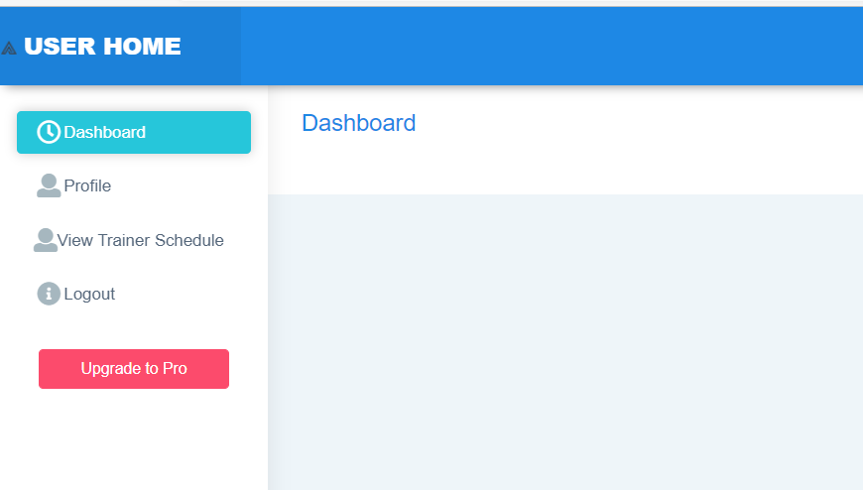

**View Trainer Schedules page**

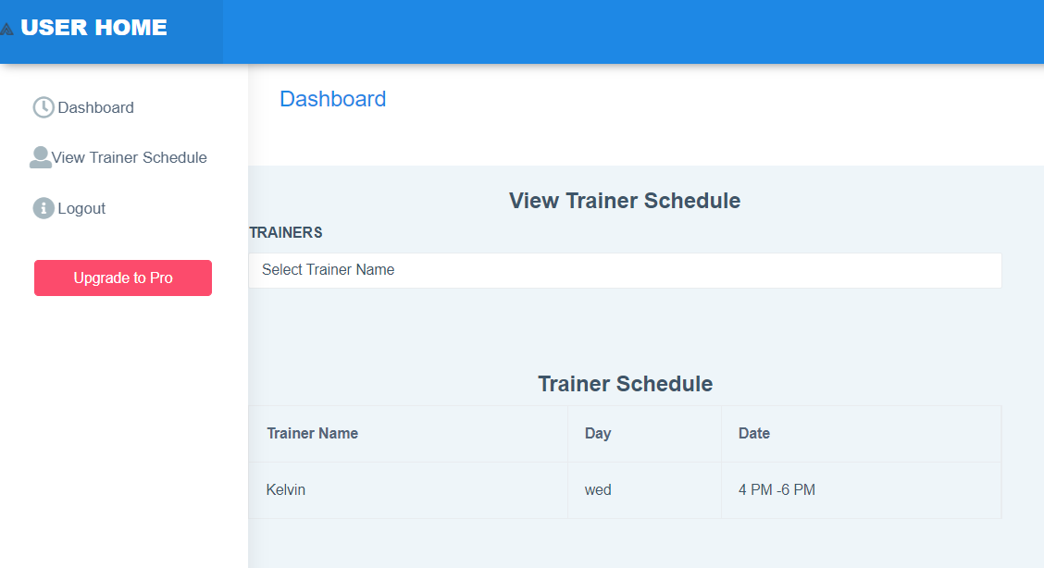

**ADMIN PAGES Admin Home page**

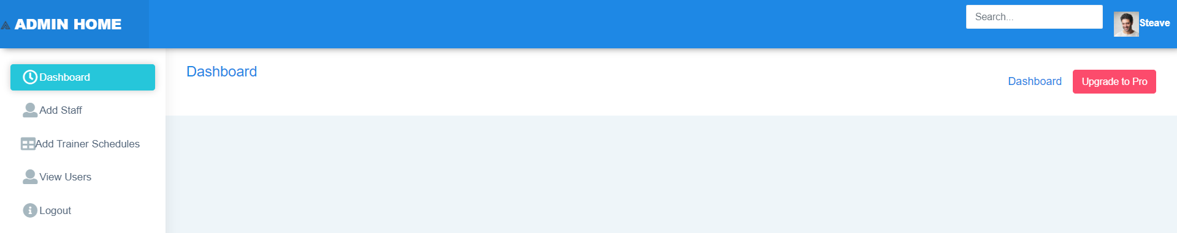

**STAFF PAGES**

**Staff Home page**

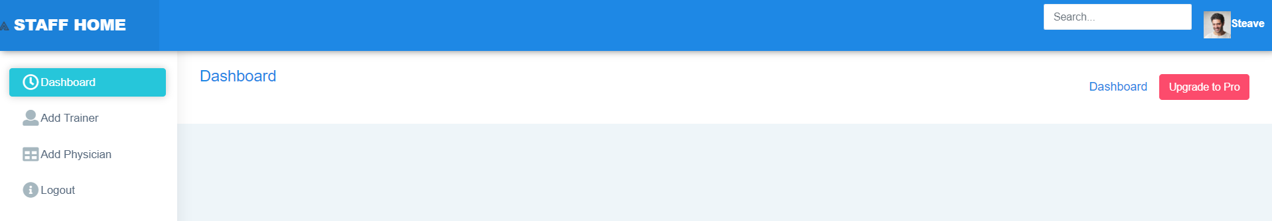

**TRAINER PAGES**

**Trainer Home page**

