**EXPERIENCE-10**

**SWARNA MOL K K**

**RMCA- B**

**Roll No:29**

1. create view view1 as selct order_no,order_date FROM salesorder;

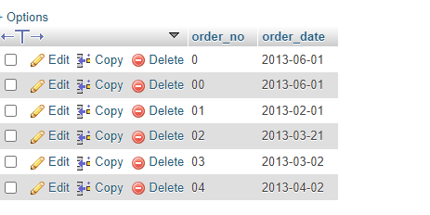

1. desc view1;

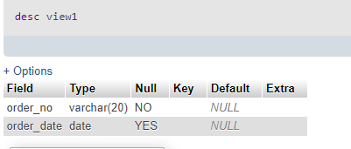

1. SELECT * from view1;

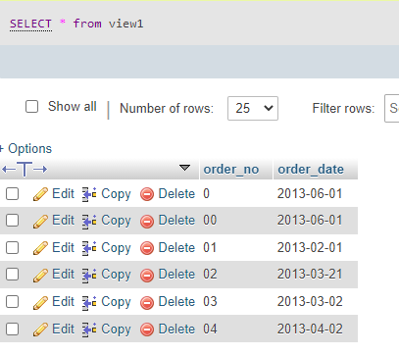

4. insert into view1 values('05','2013-08-08');

5.create view view2 as select client_no,cname from clientmaster;

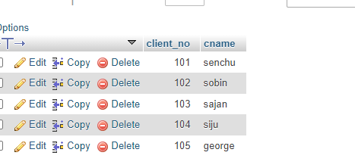

6. INSERT INTO view2 VALUES(106,'vidhya');

7. create view view3 as select salesman_number,sname,city FROM salesmaster WHERE city="mumbai";

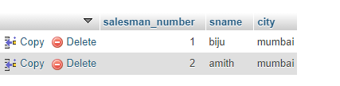

8. create view view4 as SELECT cname,clientmaster.city as ccity,sname,salesmaster.city from salesmaster,clientmaster;

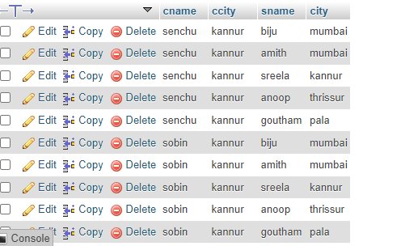

9. desc view4;

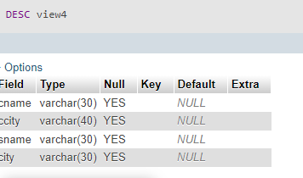

10. insert into view4 values('vidhya','idukki','prasad','idukki');

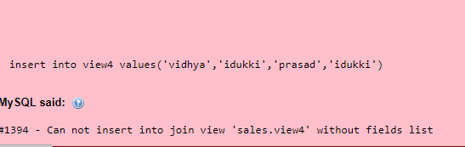

11. create view view5 as select cname,sname from view4;

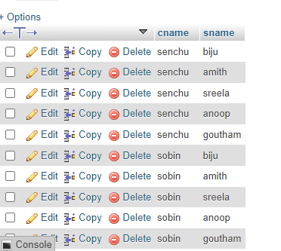

12. desc view5;

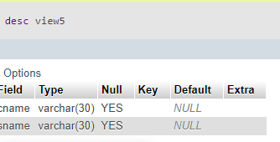

13. insert into view5 values('vidhya','prasad');

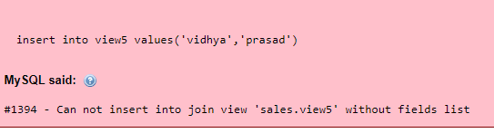

14. drop view view4;

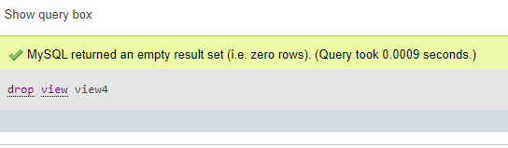

15. drop view view5;

