**EXPERIMENT-6**

SWARNA MOL K K

RMCA –B

Roll No:29

1. SELECT cname FROM deposite UNION (SELECT cname FROM borrow);

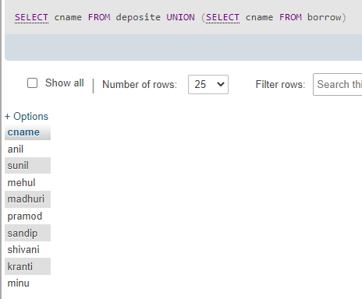

1. SELECT D1.cname FROM deposite D1 WHERE D1.bname IN (SELECT D2.bname FROM deposite D2 WHERE D2.cname = 'sunil');

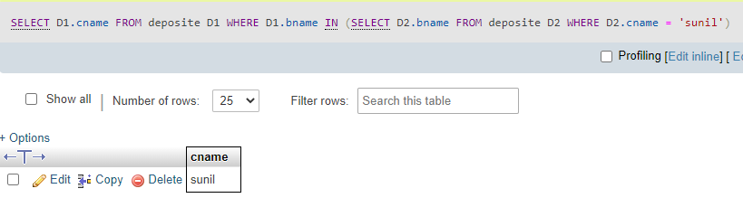

1. SELECT C1.cname FROM customer C1,deposite D1, branch B1 WHERE C1.city = 'nagpur' and C1.cname = D1.cname AND D1.bname = B1.bname AND B1.city IN ('bombay','delhi');

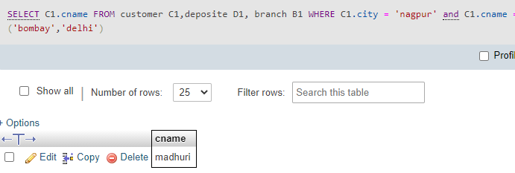

1. SELECT Distinct(customer.cname) from customer,deposite WHERE city='nagpur';

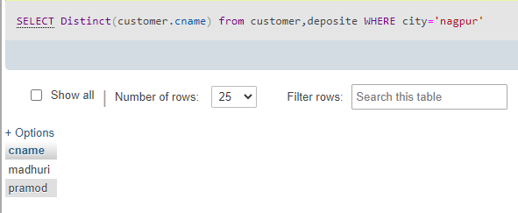

1. SELECT B1.city FROM deposite D1, branch B1 WHERE D1.bname = B1.bname AND D1.cname IN ('sunil' ,'anil');

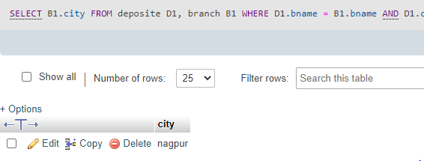

1. SELECT B1.city FROM branch B1 WHERE B1.bname IN (SELECT D1.bname FROM deposite D1 WHERE D1.cname IN ('anil','sunil'));

