**EXPERIENCE-7**

**SWARNA MOL K K**

**RMCA-B**

**Roll No:29**

1. SELECT D1.cname,D1.bname,C1.cname,C1.city,B1.city,B1.bname FROM deposite D1,customer C1,branch B1 WHERE C1.city = 'bombay' AND B1.city = 'nagpur' AND D1.cname = C1.cname AND D1.bname = B1.bname;
2. SELECT distinct(customer.cname), branch.city FROM branch, customer WHERE branch.city = customer.city;

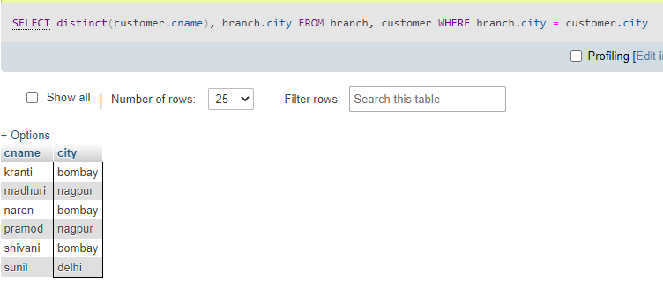

1. SELECT C1.cname FROM customer C1,deposite D1,borrow B1 WHERE C1.city='nagpur' AND C1.cname=D1.cname AND D1.cname = B1.cname;

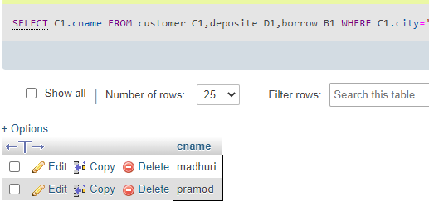

1. SELECT b1.cname, b1.amount, D1.cname, D1.amount FROM borrow b1,deposite D1 WHERE D1.cname = b1.cname AND D1.amount > 1000 AND b1.amount>2000;

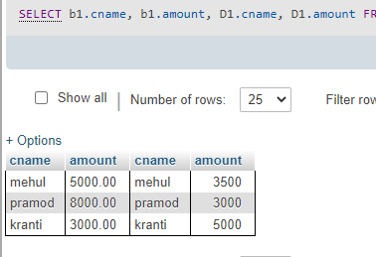

1. SELECT D1.cname FROM deposite D1 WHERE D1.bname IN (SELECT D2.bname FROM deposite D2 WHERE D2.cname = 'sunil');

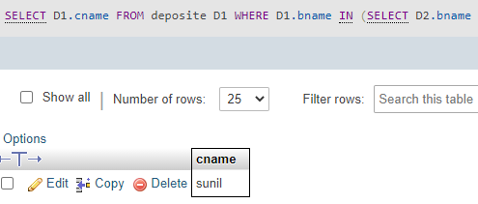

1. SELECT b1.cname,b1.amount FROM borrow b1 WHERE b1.amount > ALL (SELECT b2.amount FROM borrow b2 WHERE b2.cname = 'pramod');
2. SELECT C.cname FROM customer C WHERE C.city IN (SELECT B.city FROM branch B WHERE B.bname IN (SELECT D.bname FROM deposite D WHERE D.cname='sunil'));
3. SELECT B1.city , C1.city FROM branch B1,customer C1, deposite D1 WHERE C1.cname = 'pramod' AND C1.cname = D1.cname AND D1.bname = B1.bname;

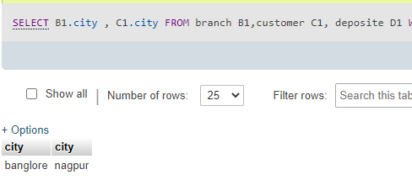

1. SELECT B1.city FROM deposite D1, branch B1 WHERE D1.bname = B1.bname AND D1.cname IN ('sunil' ,'anil');

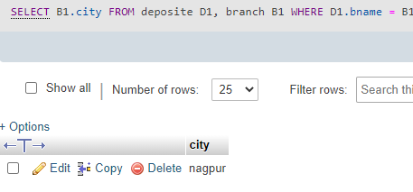

1. SELECT C1.cname, C1.city FROM customer C1 WHERE C1.cname = 'anil' OR C1.cname = 'sunil';

