**EXPERIMENT-8**

SWARNA MOL K K

RMCA-B

Roll No:29

1. create table department (department_id int(4), department_name varchar(30), manager_id int(6), location_id int(4));

* insert into department (department_id , department_name, manager_id, location_id) values (10, 'administration', 200, 1700);
* insert into department (department_id , department_name, manager_id, location_id) values (20, 'marketing', 201, 1800);
* insert into department (department_id , department_name, manager_id, location_id) values (50, 'shipping', 124, 1500);
* insert into department (department_id , department_name, manager_id, location_id) values (60, 'it', 103, 1400);
* insert into department (department_id , department_name, manager_id, location_id) values (80, 'sales', 149, 2500);
* insert into department (department_id , department_name, manager_id, location_id) values (90, 'executive', 100, 1700);
* insert into department (department_id , department_name, manager_id, location_id) values (110, 'accountig', 205, 1700);
* insert into department (department_id , department_name, manager_id, location_id) values (190, 'contacting', 1700);

select * from department;

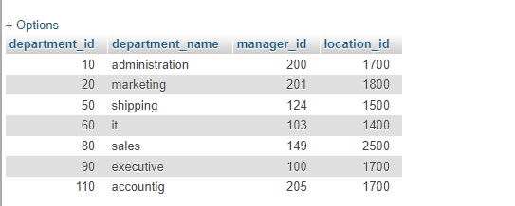

1. CREATE table employee(empid int PRIMARY KEY ,empname varchar (100),department varchar(50),contactno bigint,emailid varchar(100),empheadid int)

* INSERT INTO `employee` (`employee_id`, `first_name`, `last_name`, `email`, `phone_number`, `hire_date`, `job_id`, `salary`, `commission_pct`, `manager_id`, `department_id`) VALUES ('100', 'steven', 'king', 'sking', '5151234567', '17-jun-87', 'ad_pres', '2400', NULL, NULL, '90');
* INSERT INTO `employee` (`employee_id`, `first_name`, `last_name`, `email`, `phone_number`, `hire_date`, `job_id`, `salary`, `commission_pct`, `manager_id`, `department_id`) VALUES ('101', 'neena', 'kochhar', 'nkochhar', '5151234568', '1989-10-21', 'ad_vp', '1700', NULL, 100, '90');
* INSERT INTO `employee` (`employee_id`, `first_name`, `last_name`, `email`, `phone_number`, `hire_date`, `job_id`, `salary`, `commission_pct`, `manager_id`, `department_id`) VALUES ('102', 'lex', 'de haan', 'ldehaan', '5151234569', '1993-01-13', 'ad_vp', '1700', NULL, 100, '90');
* INSERT INTO `employee` (`employee_id`, `first_name`, `last_name`, `email`, `phone_number`, `hire_date`, `job_id`, `salary`, `commission_pct`, `manager_id`, `department_id`) VALUES ('103', 'alexander', 'hunold', 'ahunold', '5904234567', '1990-01-03', 'it_prog', '9000', NULL, 102, '60');
* INSERT INTO `employee` (`employee_id`, `first_name`, `last_name`, `email`, `phone_number`, `hire_date`, `job_id`, `salary`, `commission_pct`, `manager_id`, `department_id`) VALUES ('107', 'diana', 'lorentz', 'dlorentz', '5904234567', '1999-02-07', 'it_prog', '4200', NULL, 103, '60');

Select * form employee;

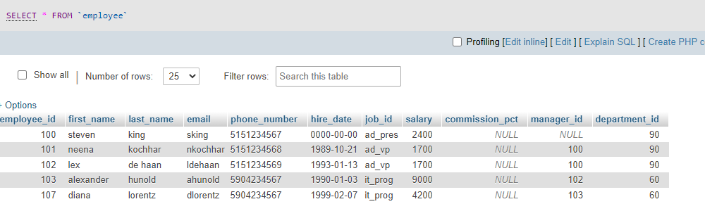

1. CREATE TABLE country ( country_id varchar(2) NOT NULL ,countryname varchar(40) DEFAULT NULL,region_id decimal(10,0) NOT NULL,PRIMARY KEY (country_id));

* insert into country values('CA','Canada',2);
* insert into country values('DE','Germany',1);
* insert into country values('UK','United Kingdom',1);
* select * from country

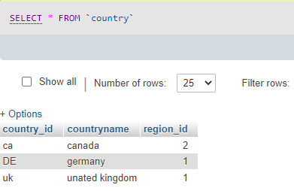

1. create table jobs (JOB_ID varchar(10) NOT NULL, JOB_TITLE varchar(35) NOT NULL, MIN_SALARY decimal(6), MAX_SALARY decimal(6),PRIMARY KEY (JOB_ID));

* insert into job values('AD_VP','Adminstartion vice presedant',15000,30000);
* insert into job values('AD_PRES','presedant',20000,40000);
* insert into job values('AD_ASST','Adminstartion assistant',3000,6000);
* insert into job values('AC_MGR','accounting manager',20000,40000);
* insert into job values('AC_ACCOUNT','public account',15000,30000);

Select * from jobs;

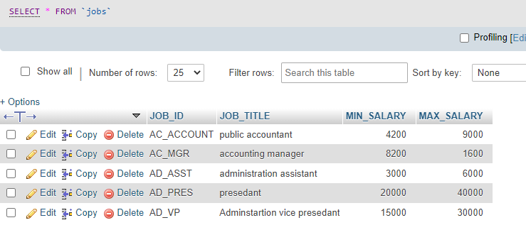

1. CREATE TABLE job_grades (gradelevel varchar(3),lowest_sal decimal,highest_sal decimal(8,2));

* insert into job_gradesvalues('A',1000,2999);
* insert into job_grades values('B',3000,5999);
* insert into job_gradesvalues('c',6000,9999);
* insert into job_grades values('d',10000,14999);

select * from job_grades;

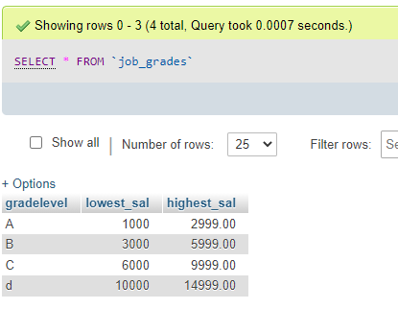

1. CREATE TABLE job_history ( EMPLOYEE_ID decimal(6,0) NOT NULL PRIMARY KEY, START_DATE date NOT NULL, END_DATE date NOT NULL, JOB_ID varchar(10) NOT NULL, DEPARTMENT_ID decimal(4,0) DEFAULT NULL, FOREIGN KEY (job_id) REFERENCES jobs(job_id));

* insert into jobhistory values(102,19930213,19980724,'IT_PROG',60);
* INSERT INTO jobhistory VALUES (101,19890921,19931027,"ac_account",110);
* INSERT INTO jobhistory VALUES (101,19931028,19970315,"ac_mgr",110);
* INSERT INTO jobhistory VALUES (201,19960217,19991219,"mk_rep",20);

Select * from jobhistory;

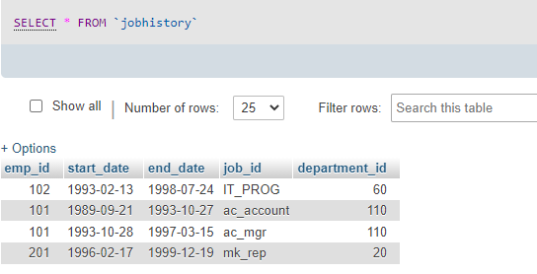

1. create table locations(LOCATION_ID decimal(4) NOT NULL, STREET_ADDRESS varchar(40), POSTAL_CODE varchar(12), CITY varchar(30), STATE_PROVINCE varchar(25) NOT NULL, COUNTRY_ID char(2), PRIMARY KEY (LOCATION_ID));

* insert into locations values(1700,'2004charadeRd',98199,'seattle','washington','US');
* insert into locations values(1500,'2011inteririosRd',99236,'south san franscisco','california','US');
* insert into locations values(1400,'2014jabberwocky rd',26192,'southlake','texas','US');
* insert into locations values(1800,'460 bloor st.w',on m5s 1xb,'toronto','ontario','ca');

Select * from locations;

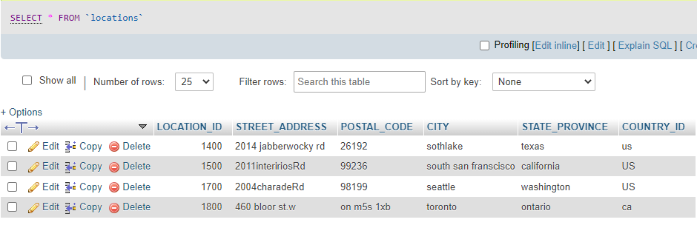

1. CREATE TABLE regions (region_id DECIMAL,region_name VARCHAR(25));

* insert into regions(region_id,region_name)values(1,'Europe');
* insert into regions(region_id,region_name)values(2,'amerians');
* insert into regions(region_id,region_name)values(3,'asia');
* insert into regions(region_id,region_name)values(4,'middle east and africa');

Select * from regions;

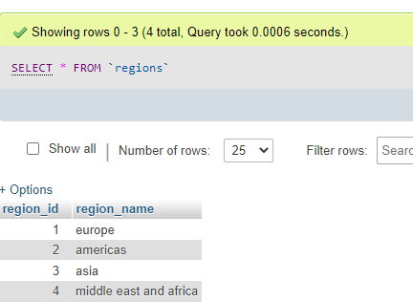

* SELECT * FROM `employee` WHERE (hire_date>'1997-05-02')and(job_id='it_prog');

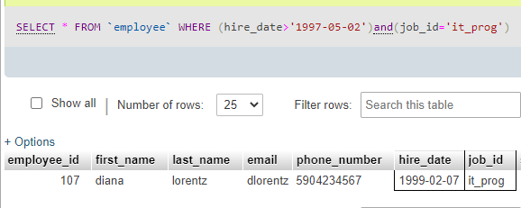

* SELECT last_name, job_id, salary, commission_pct FROM employee WHERE commission_pct IS NULL ORDER BY salary DESC;

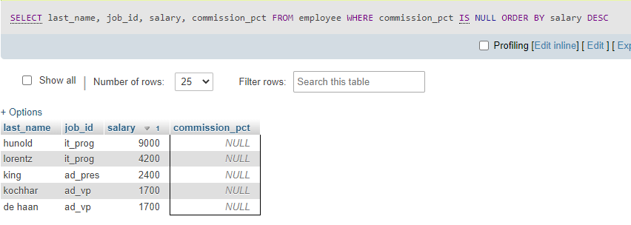

* SELECT first_name,salary,commission_pct,round(salary*(10/100)) AS newsalary FROM employee WHERE commission_pct IS NULL;

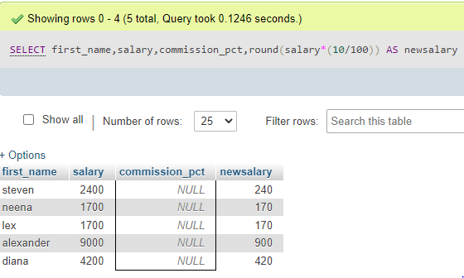

* SELECT last_name,timestampdiff (year,hire_date,sysdate()) AS years, timestampdiff(month,hire_date,sysdate()) AS months from employee ORDER BY years DESC,months DESC;

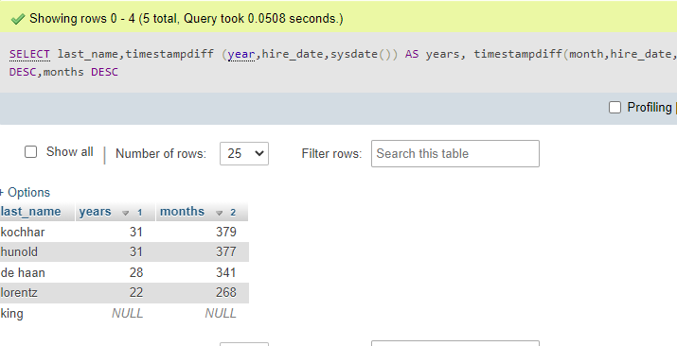

* SELECT last_name FROM employee WHERE SUBSTR(last_name, 1,1) IN ('J', 'K', 'L', 'M');

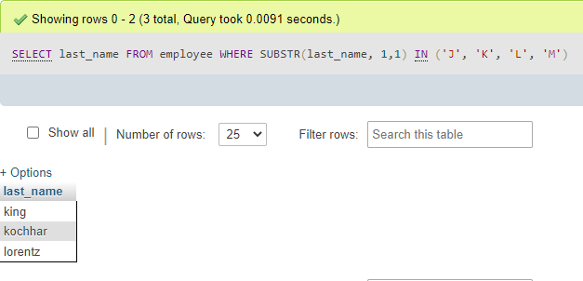

* SELECT LAST_name,job_id,salary from employee WHERE job_id=

(SELECT job_id FROM employee where employee_id=141);

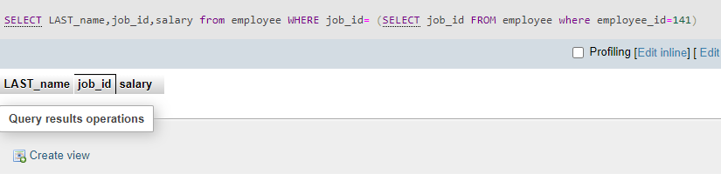

* SELECT LAST_name,job_id,salary from employee WHERE salary=

(SELECT min(salary)FROM employee);

