

**IBM NAAN MUDHALVAN PROJECT**

**PROJECT NAME :-FAKE NEWS DETECTION USING NLP**

**TEAM MEMBERS:-**

|  |  |  |
| --- | --- | --- |
| **Serial no:** | **Team members name** | **Team members email id** |
| 1. | P.Udhaiyalakshmi | udayalaxmi2002@gmail.com |
| 2. | V.Swarnalakshmi | swarnalakshmi065@gmail.com |
| 3. | M.Sneha | keccse21097@kingsedu.ac.in |
| 4. | K.Srivarthini | srivaruthik007@gmail.com |
| 5. | H.Stephy graph | graphstephy171@gmail.com |

# ProblemStatement:

Beginbuildingthefakenewsdetectionmodelbyloadingand preprocessing the dataset. Load the fake news dataset and

preprocessthetextualdata.

# DataCleaning:



Datacleaningisaprocessofremovinginconsistenciesinthedataset and incorrect values .It also in involves handling missing values

eitherbyremovingthemorassigningthemaveragevalues.Ithelps to improve the efficiency of the model.

Inthefirststep,wewillonlyremovetheunnecessarydatapoints from the dataset which does not helps in improving the model

performance.

Initiallyweimportthenecessarypackagesforourdatacleaning process and also in the future purposes,

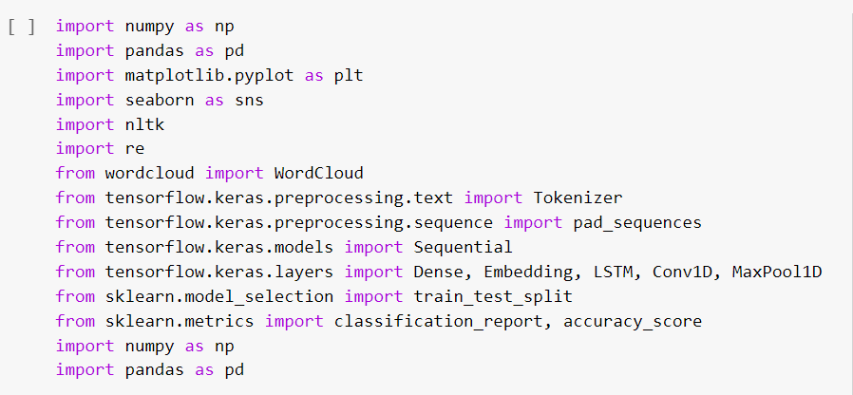

weusethesepackagesinvariousstagesofourcleaningprocessand also in the future in which we need to build models.

Here,wereadthe.csvfilesoftrueandfakenewsandthenexplore the count values of their subjects

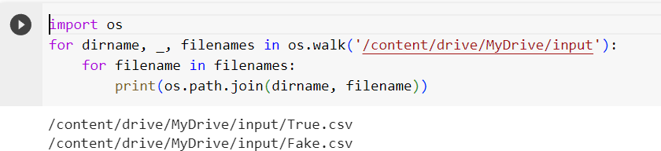

[]fake_news=pd.read_csv('/content/drive/MyDrive/input/Fake.csv') fake_news.head()

**title textsubject date**

**0** DonaldTrumpSends OutEmbarrassingNew Year'... DonaldTrumpjustcouldnt wishallAmericans... NewsDecember31,2017DrunkBraggingTrumpStafferStartedRussian...HouseIntelligenceCommitteeChairmanDevinNu... NewsDecember31,2017

1. SheriffDavidClarkeBecomesAnInternetJoke... OnFriday,itwasrevealedthatformerMilwauk... NewsDecember30,2017
2. TrumpIsSoObsessedHeEvenHasObama'sName...OnChristmasday,DonaldTrumpannouncedthat... NewsDecember29,2017
3. PopeFrancisJustCalledOutDonaldTrumpDur...PopeFrancisusedhisannualChristmasDaymes... NewsDecember25,2017

[] fakenews.columns

Index(['title','text",'subject",'date'],dtype='object')

[]fake_news['subject'].value_counts()

|  |  |
| --- | --- |
| News | 9050 |
| politics | 6841 |
| left-news | 4459 |
| GovernmentNews | 1570 |
| USNews | 783 |
| Middle-east | 778 |

Name:subject,dtype:int64

**0**plt.figure(figsize=(10,6)) sns.countplot(x='subject',data=fake_ne1 s)

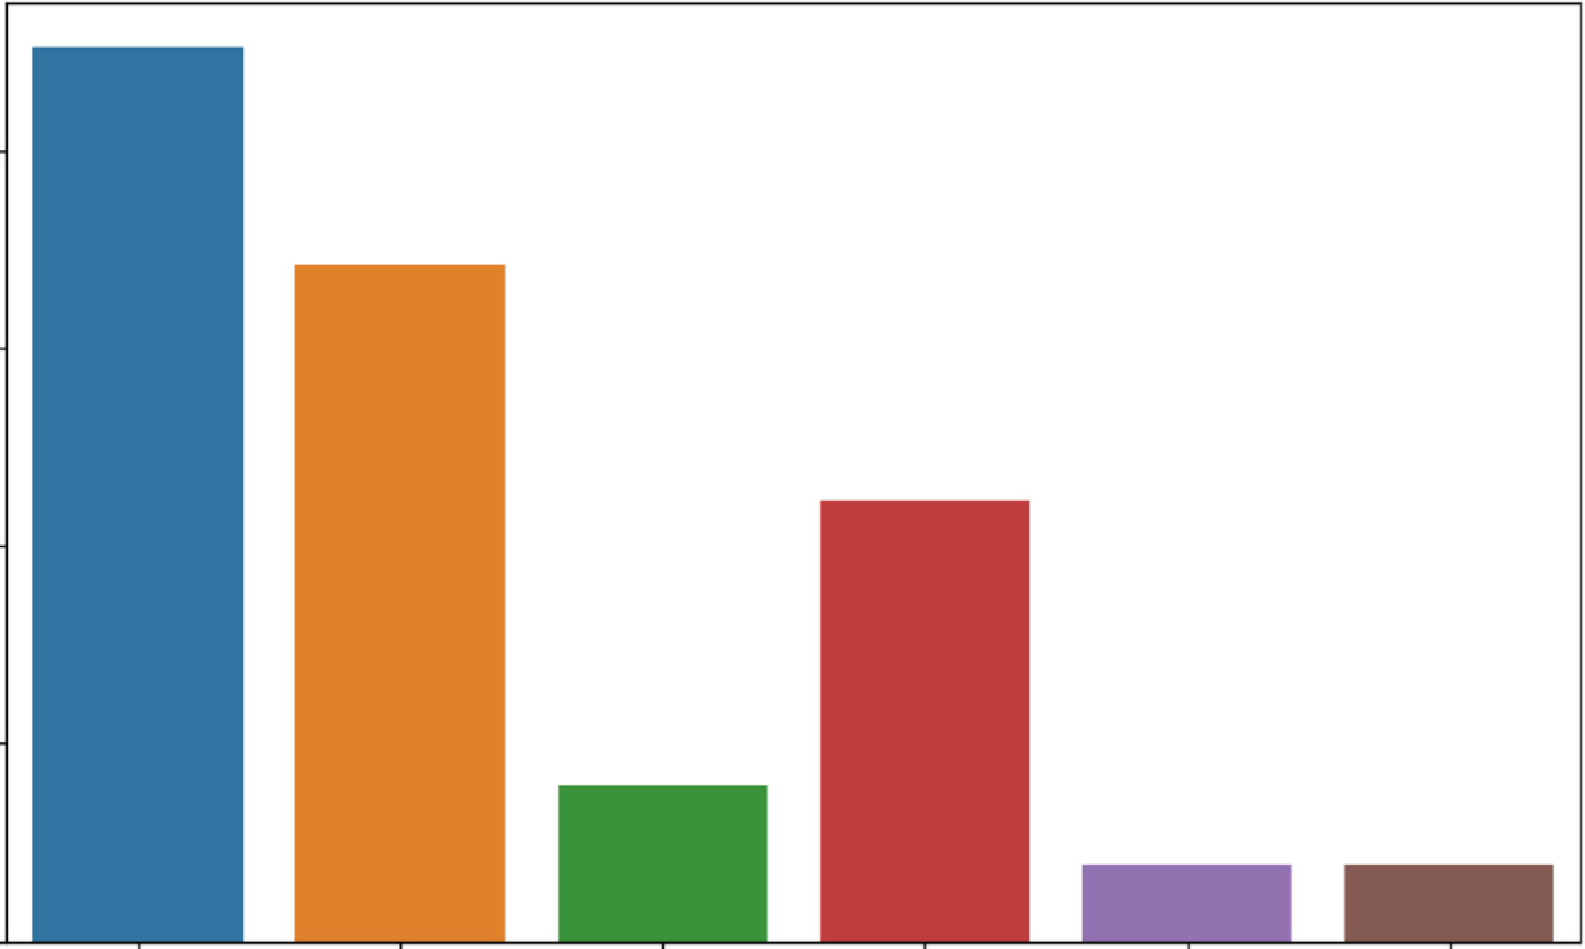**e**<Axes:xlabel='subject',ylabel='count'>

**8000**

**6000**

......

**C**

:,

8

**4000**

**2000**

**0**

**News politics GovernmentNews left-news**

**subject**

**US_News Middle-east**

Here,wehaveusedwordcloudtoseethatwhichwordhasmostly used for the fake news. By seeing that we can make a conclusion

thatwhichtopic(aboutaperson,eventoranything)ismostly contains fake news).We also do the same for true news.

# WordCloudforFakeNews:

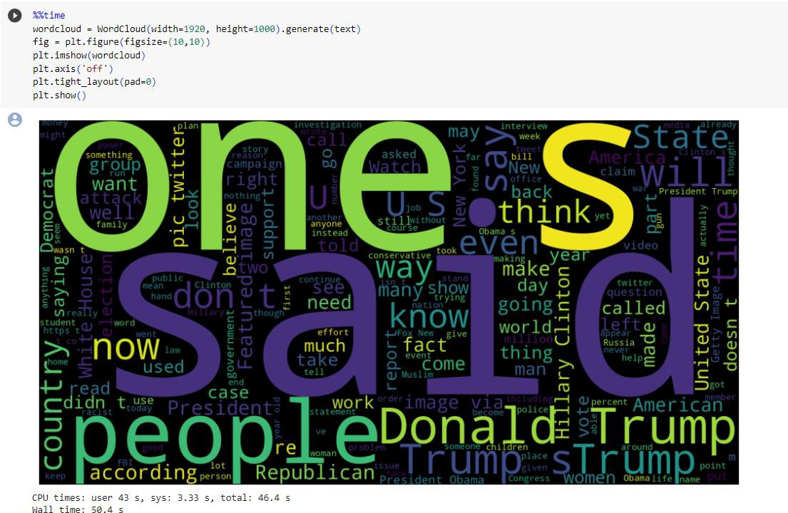

WordcloudforTrueNews:

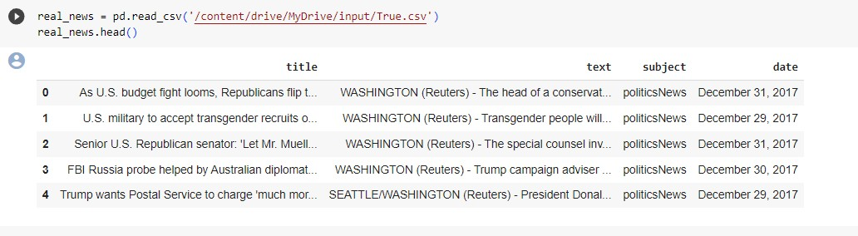

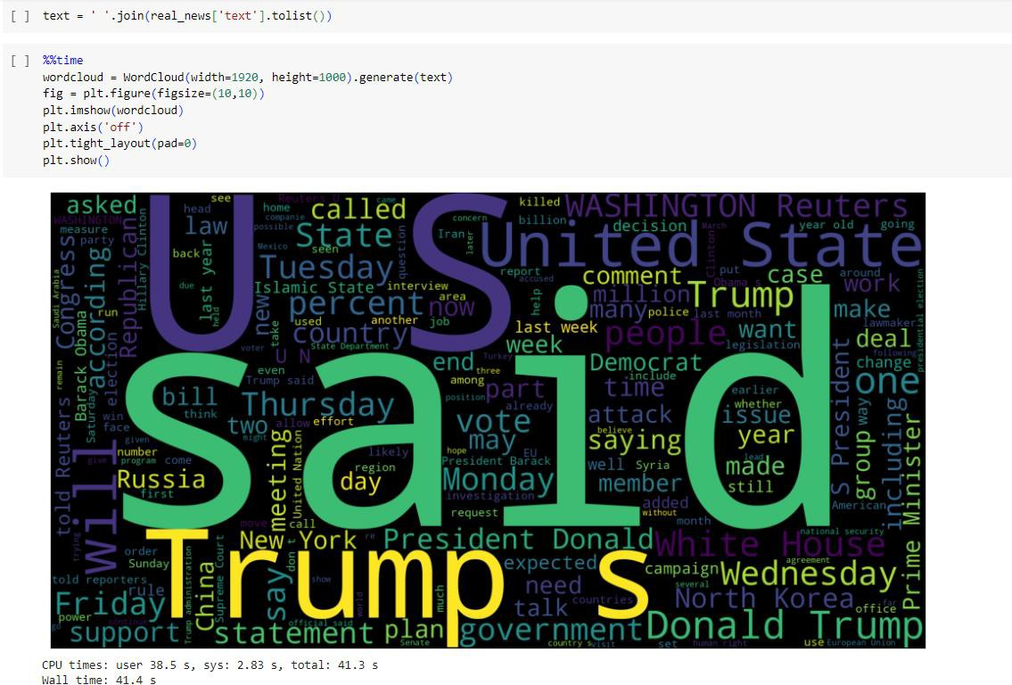

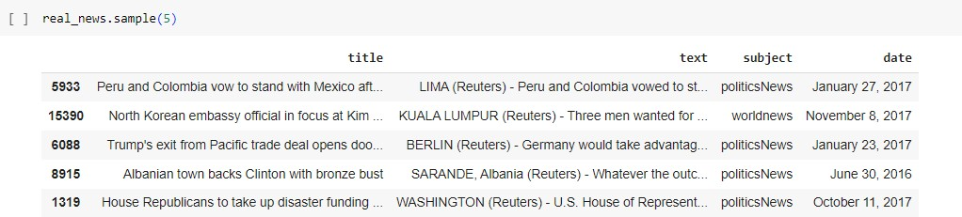

Let’screatealistofnewslistsinreal_news.csvwithunknown publishers by using the following code snippets

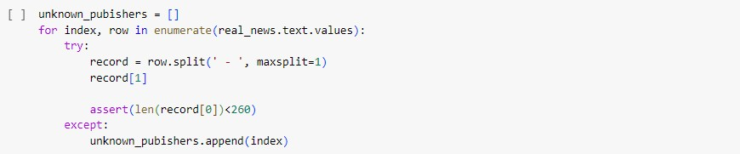

[] len(unkn01n_pub.ishers)

35

0 real_news.iloc[unknown_pub.ishers].t:ext

e

|  |  |  |  |  |  |  |  |
| --- | --- | --- | --- | --- | --- | --- | --- |
| 2922 | Thefo1lowingstatementswerepostedtotheve... | | | | | | |
| 3488 | Thel·lh.it:eHouseori ednesdayd.is,closedagroup... | | | | | | |
| 3782 | Thefo1lowingstatementswerepostedtotheve... | | | | | | |
| 4358 | NeilGorsuch,Pr,esidentDoria1dTrump'sappoint... | | | | | | |
| 4465 | l•IASHINGTQNTheclockbeganrunningoutthis\.re... | | | | | | |
| 5290 | The | fo1lowing | statementswere | posted | to | the | ve... |
| 5379 | The | fo1lowing | statementswere | posted | to | the | ve... |
| 5412 | The | fo1lowing | statementswere | posted | to | the | ve... |
| 5504 | The | fo1lowing | statementswere | posted | to | the | ve... |
| 5538 | The | following | statementswere | posted | to | the | ve... |
| 5588 | The | fo1lowing | statementswere | posted | to | the | ve... |
| 5593 | The | fo1lowing | statementswere | posted | to | the | ve... |

5761 Thefo11owingbulletpointsarefrom theU.S. 5784 FederalappealsrnurtjudgeNeilGorsuc.h,the 6026 ThefollowingbulletpointsarefromtheU.s.

61.84 Thefo1lowingbulletpointsarefromtheU.S.6660 RepublicanmembersofCongr,essar<ecomp1aining... 6823 OverthecourseoftheU.S.presidentia1,carnpa... 7922 Aftergo.ingthroughaweekreminiscentoifNapo... 8194 Thefollowingtimelinechartstheoriginands...

81.95 Globalhealthofif.icialsareracingtobetteru... 8247 U.,S.,Pr,esidentBarackObamavisitedastreetm... 8465 ALGONAC,MICH.-Parlk:erFoxdr.iiftedout:oftheD... 8481 Globalhealthofif.icialsareracingtobetteru... 8482 Thefo1lowingtimelinechartstheoriginands... 8505 Globalhealthofif.icialsareracingtobetteru... 8506 Thefo11owingtimelinechartstheoriginands... 8771 Inaspeech1,1eightedi..ithAmer.ica'scomplicate... 8970

9008

9009

9307

9618

9737

10479

Name:

Thefo1lowingtimeline chartstheoriginands... Globalhealthofficialsareracingtobetteru... It'sthene,arfuture,andNorthKor<ea''sre,gime... GOPleadershaveun1eashed a stunninglevelof... CaitlynJennerpostedavideoonl-lednesday (Ap... TheDemocraticandRepublicannomineesforthe...

text,dtype:object

0 publisher=[]

tmp_text=[]

forindex,ro1,1 inenumerate(real_11e1s.,text.values):: ifindexinunkno in_pubishers:

tmp_text.append(roi)

publisher.append{'Unknoin')

else:

record=ro,i.split{·-·,rnaxsplit=1) publisher.append{record[0].strip()) tmp_text.append(record[1].strip())

[]re,al_news['publisher·]=publisher real_news['text"]=trnp_text

[]real_news.head()

[Ireal_nei<s.head()

title

text

subject date publisher

AsU.S.budgetfigMlooms.RepublicansmpI...

U.S.militarytoaccept transgenderrecruitso...SeniorU.S.Republicansenator:'LetMr.Muell...

TheheadofaconservativeRepublicanfaction.polrticsNewsDecember31,2017Transgenderpeoplewillbeallowedforthefir...polrticsNewsDecember29,2017Thespecialcounselinvestigationoflinksbet...polrticsNewsDecember31,2017

WASHINGTON(Reuters)WASHINGTON(Reuters)WASHINGTON(Reuters)

1. FBIRussiaprobehelpedbyAustraliandiplomat...TrumpcampaignadviserGeorgePapadopoulostol..polrticsNewsDecember 30,2017 WASHINGTON(Reuters)
2. TrumpwantsPostalServicetocharge'muchmar... PresidentDonaldTrumpcalledontlleU.S.Post...polrt1csNewsDecember29,2017SEATTLE/WASHINGTON(Reuters)

[]real_nei>Js.shape

(21417,5)

[]ernpty_fake_index=[indexforindex,textinenumerate{f.ake_ne,s.text.tolist())ifstr(text).strip()=='"'][]fake_ne1vs.iloc[empty_fake_index]

|  |  |  |  |  |
| --- | --- | --- | --- | --- |
|  | title | text | subject | date |
| **10923** | TAKEOURPOLL:WhoDoYouThinkPresidentTrum... |  | politics | May10,2017 |
| **11041** | JoeScarboroughBERATESMikaBrzezinskiOver·... |  | politics | Apr26,2017 |
| **11190** | WATCHTUCKERCARLSONScorchSanctuaryCityMay... |  | politics | Apr6, 2017 |
| **11225** | MAYOROFSANCTUARYCITY:TrumpTryingToMake.. |  | politics | Apr2,2017 |
| **11236** | SHOCKERPublicSchoolTumsComputerLabInto... |  | polltlCS | Apr1,2017 |
| **21816** | BALTIMOREBURNS:MARYLANDGOVERNORBRINGSINN.. |  | len-news | Apr27,2015 |
| **21826** | FULLVIDEO:THEBLOCKBUSTERINVESTIGATIONINTO... |  | len-news | Apr25,2015 |
| **21827** | (VIDEO)HILLARYCLINTONRELIGIOUSBELIEFSMUS |  | left-news | Apr25,2015 |
| **21857** | (VIDEO)ICEPROTECTINGOBAMAWON'TRELEASENAM.. |  | left-news | Apr14,2015 |
| **21873** | (VIDEO)HYSTERICALSNLTAKEONHILLARY'SANNOU.. |  | left-news | Apr12,2015 |

630rawsx4columns

{]real_news['text']=real_news['title']+""+real_news['text'][]fake_news['text']..fake_news['title']+""+fake_news['text']

[]real_news('text']=real_nei,s('text'].apply(lambdax:str(x).lmoer())fake_news('text']=fake_nei,s('text'].apply(lambdax:str(x).lmoer())

[]real_news('class']=1fake_news['class']=0

[]real_news.columns

Index(['title','text','subject','date·'publisher·'class'],dtype-'oDject')

0real=real_ne\ s[['text', 'class']]fake=fake_ne\s[['text','class']]

0data=real. append(fake,ignore_index=True)data.head()

e<ipython-input-33-8770c2a2a545>:1:FutureWarning:Theframe.appendmethodisdeprecatedandwillberemovedfrompandasinafutureversion.Usepandas.concatinstead.

data=real.append(fake,ignore_index=True)

textclass

**o** asu.s.budgetfightlooms.republicansmpt...

u.s.militarytoaccepttransgenderrecruitsa

senioru.s.republicansenator'letmr.muell...

1. fbirussiaprobehelpedbyaustraliandiplomat...
2. trumpwantspostalservicetocharge'muchmar...

0!pipinstallspacy==2.2.3

!python-mspacydownloaden_rnre_web_sm

!pipinstallbeautifulsoup4=4.9.l!

!pipinstalltextblob==0.15.3

!pip installgit+https://github.com/laxmimerit/preprocesskgptalkie.git--upgrade--force-reinstall

enote:Thiserrororiginatesfromasubprocess,andislikelynotaproblemwithpip.

2.023-10-1616:41:23.058566:Wtensorflow/cornpiler/tf2tensorrt/utils/py_utils.cc:38)TF-TRT\•larning:CouldnotfindTensorRT

Collectingen-rnre-web-sm.,..3,6.0

Downloadingm!p..i,;,LL.github.com/exf!losion/sP.acy-models/releases/download/encorewebsm-3.6.e/encorewebsm-3.6.0-oy3-none-an'i..Jill!(12.8MB)

12.8/12.8MB21.6MB/seta0:00:00

Requirementalreadysatisfied:spacy<3.7.0,>=3.6.0*in*/usr/local/lib/python3.10/dist-packages(fromen-core-web-sm==3.6.0}(3.6.1)

Requirementalreadysatisfied:spacy-legacy0.1.0,>=3.0.11in/usr/local/lib/python3.10/dist-packages(fromspacy<3.7.0,>=3.6.0->en-core-web-sm=3.6.0)(3.0.12)Requirementalreadysatisfied:spacy-loggers<2.0.0,>=1.0.0in/usr/local/lib/python3.10/dist-packages(fromspacy<3.7.0,>=3.6.0->en-core-web-sm==3.6.0)(1.0.5)

Requirementalreadysatisfied:murmurhash<l.1.0,>=0.28.6in/usr/local/lib/python3.10/dist-packages(fromspacy<3.7.0,>=3.6.0->en-core-web-sm==3.6.0)(1.0.10)

Requirementalready satisfied:cymem<2.1.0,>=2.0.2in /usr/local/lib/python3.10/dist-packages(fromspacy<3.7.0, >=3.6.0->en-rnre-web-sm==3.6.0)(2.0.8)Requirementalready satisfied:preshed<3.1.0,>=3.0.2 in/Lisr/local/lib/python3.10/dist-packages(fromspacy<3.7.0, >=3.6.0->en-core-web-sm==3.6.0)(3.0.9}Requirementalreadysatisfied:thinc<8.2.0, )..8.1.8*in*/usr/local/lib/python3.10/dist-packages(fromspacy<3.7.0,)..3.6.0->en-core-web-sm....3.6.0)(8.1.12)Requirement.already s.atisfied:w.asabi<1.2.e,>..0.9.1in/usr/loc.al/lib/python3.10/dist-packages(fromspacy<3.7.e,>"3.6.0->en-core-web-sm,...3.6.0)(1.1.2)Requirement.alreadysatisfied:srsly<3.0.0,)..2.4.3*in*/usr/local/lib/python3.10/dist-packages(fromspacy<3.7.0,)..3.6.0->en-rnre-web-sm....3.6.6)(2.4.8)Requirementalready satisfied:catalogue<2.1.0,>=2.8.6in /usr/local/lib/python3.10/dis.t-packages(fromspacy<3.7.0, >=3.6.0->en-core-web-sm==3.6.0)(2.0.19)Requirementalready satisfied:typer<0.10.8,>=0.3.0in/usr/local/lib/python3.10/dist-packages(fromspacyG.7.0,>=3.6.6->en-core-web-sm==3.6.0} (0.9.0)Requirementalready satisfied:pathy>=0.10.0in/usr/local/lib/pyttion3.10/dist-packages. (fromspacy<3.7.0,>=3.6.0->en-core-web-srn==3.6.0)(0.10.2)Requirementalready satisfied:smart-open<7.0.0,>=5.2.1in/usr/local/lib/python3.10/dist-packages(fromspacy<3.7.0, >=3.6.0->en-rnre-1-1eb-sm==3.6.0} (6.4.0)

Requirementalready satisfied:tqdm<S.0.0,>=4.38.0 *in* /usr/local/lib/python3.10/dist-packages(fromspacy<3.7.0, >=3.6.0->en-core-web-srn==3.6.0)(4.66.1)Requirement.already satisfied:numpy>..1.15.0in/usr/local/lib/python3.10/dist-packages(fromspacy<3.7.0,>•3.6.0-)en-core-web-srn.,..3.6.0)(1.23.S)Requirement.alreadysatisfied:requests<3.B.0,>•2.13.0in/usr/local/lib/python3.10/dist-packages(fromspacy<3.7.0, )..3.6.0->en-core-web-sm....3.6.0)(2.31.0)

Requirement.alreadysatisfied:pydantic!=1.8,l=l.8.1,<3.0.0,>=1.7.4in/usr/loc.al/lib/python3.10/dis.t-packages(froms.pacy<3.7.0,>=3.6.0->en-core-web-s.m==3.6.0)(1.10.13}

Requirementalready satisfied:jinja2in /usr/local/lib/python3.10/dist-packages(fromspacy<3.7.0,>=L6.0->en-cori:-web-srn==3.6.6)(3.1.2)Requirementalreadysatisfied:setuptoolsin/usr/local/lib/pythonJ.10/dist-packages(fromspacy<3.7.0,)=3.6.0->en-core-web-srn==3.6.0)(67.7.2)Requirementalready satisfied:packaging>=20.0in/us.r/local/lib/python3.10/dist-packages(fromspacy<3.7.0,>=3.6.0->en-core-web-sm==3.6.0} (23.2)

Requirementalreadysatisfied:langcodes.<4.0.0,>=3.2.0in/usr/local/lib/python3.10/dis.t-packages(fromspacy<3.7.0,>=3.6.0->en-core-web-sm==3.6.0)(3.3.0)

Requirement.already satisfied:typing-extensions>..4.2.0in/usr/local/lib/python3.10/dist-packages(frompydantic!..1.s,!..1.8.1,<3.0.0,)..1.7.4->sp.acy<3.7.0, )..3.6.0-)en-core-web-sm....3.6.e)(4.5.0)Requirement.already satisfied:ctiarset-normalizer<4,)..2in/usr/local/lib/python3.10/dist-packages(framrequests<3.0.0,)..2.13.0->sp.acy<3.7.0, )..J.6.0->en-rnre-web-sm,...3.6.0)(3.3.e)

Requirement.already satisfied:idna<4,)..2.5in/usr/local/lib/python3.10/dist-packages(fromrequests0.0.6,>..2.13.8->spacyG.7.6,>..3.6.0->en-core-web-sm...3.6.0}(3.4)Requirementalready satisfied:urllib3<3,>=1.21.1in /usr/local/lib/python3.10/dist-pack.ages(fromrequests<3.0.0,>=2.13.0->spacy<J.7.0, >=3.6.0->en-core-web-sm==3.6.0)(2.0.6)

Requirementalready satisfied:certifi>=2017.4.17 in /usr/local/lib/python3.10/dist-pack.ages(fromrequests<3.0.0,>=2.13.0->spacy<J.7.0, >=3.6.0->en-core-web-sm==3.6.0)(2023.7.22)Requirementalreadysatisfied:blis<0.8.0,>=0.7.8in/usr/local/lib/pyttion3.10/dist-packages(fromthinc<8.2.0,>=8.1.8->spacyo.7.0,>=3.6.0->en-core-l-Jeb-sm==3.6.0)(0.7.11)

Requirementalreadysatisfied:confection<!.0.0,>=0.0.1in/usr/local/lib/python3.10/dist-packages(fromthinc<B.2.0,>=8.1.8->spacy<:3.7.0,>=3.6.0->en-core-web-sm==3.6.0)(0.1.3}

Requirementalreadysatisfied:click<9.0.0,)..7.1.1*in*/usr/local/lib/python3.10/dist-packages(fromtyper<0.10.0,)..0.3.0->spacy<3.7.0,)..3.6.0->en-core-web-sm....3.6.0)(8.1.7)

Requirement.alreadysatisfied:MarkupSafe>..2.0*in*/usr/local/lib/python3.10/dist-packages(fromjinja2->spacy<3.7.0,)..3.6.0->en-core-web-sffic..3.6.0)(2.1.3)

[]importpreprocess_kgptalkieasps

[]data['text')data['text'].apply(lamodax:ps.remove_special_chars(x))

[]fr<Jmgooglae.colabimportdrivedrive.mount('/co11tE!nt/(trive')

Dri11ealreadymountedat/content/drive;toattenpttoforciblyreroount,calldrive.mou11tC/content/dri11e",force_re11ount-True).

0i11:portgaenlm

I]y-data["class·].values

I]X-[d.split()fordindata['text'].tolist()]

I]type(X)list

I]type(X(0])list

I]print(X[0)}

{'as',·us',"budget','fight",'looms','republicans','flip',"their','fiscal','script·,'the','head·,'of",'a','conser..ati11e',"republican','faction·,'in','the','us','congress','who',·voted",'this·,'month','for',·a·,'hl

[]DIM•100

w2v_model=gensim.models.t•Jord2Vec(sentences=X,vector_siz:e=DIM,windarJ=10,min_caunt=l)

[lw2v_model.wv['india']

|  |  |  |  |  |
| --- | --- | --- | --- | --- |
| array([-1.717186 | 0.09980671, | -0.54519814, | 2.873516 | 1.1529748, |
| -1.612415 | -0.4013639 | 1.5510874, | -1.9637966, | 1.7516707, |
| 2,3293521 | 1.0115958, | -1.7413545, | 2.1367438, | 0.30087247, |
| 2.0449893 | 0.7790712, | 3.5431712, | -3.617873.2, | -2.512199 |
| 1.1306514 | 1.4577612, | 1.4371244, | -2.7274785, | 0.8482319, |
| -0.56985384, | 0.39158794, | -0.17285948, | -1.384397 | -0.29015785, |
| 3.9670284, | -0.66227573, | -0.49190876, | 1. 5287828, | -0.3802559, |
| 4.286491 | -1.8598944 | 0.12558945, | 2.3769717, | 2.274344 |
| -0.06563634, | -2.254771 | 2.0082936, | -0.8159753, | -2.254789 |
| -0.83319783, | 1.6255909 | 0.84546375, | -2.1749024, | -0.4050095, |
| -0.20788828, | 1.3658859 | 3.4065766, | -0.53475 | 0.80121416, |
| 0.32413623, | 1.7693163 | 0.5977933, | 0.2685584, | -1.3846186, |
| 0.9586846, | 1.2754706 | -2.076492 | 0.3734416, | 1.1651148, |
| 2.8482974, | 0.03156389, | 0.2842725, | 2.050075 | 0.03186256, |
| -0.09902999, | -3.034646 | 1.9252772, | 1.1805288, | 2.0976923, |
| 0.19032483, | -0.4042304 | 0.23345727, | 0.96000504, | -1.2318734, |
| -0.84461105, | 1.195374 | -0.26830855, | -0.28300276, | 1.791177 |
| -1.8392042, | 0.61264 | 0.73491406, | -1.7531322 | 1.2770014, |
| 3.557539 | 2.2037764, | -0.4719132, | 1.6767381 | 2.088745 |
| 0.7665555,  dtype=float32) | 0.39926797, | -2.281819 | -1.1530005, | 1.843919], |

[]ia2v_model.wv.most_similar('india')

[(•pakistan·,0.7414124011993408),

(•malaysia·,0.6891069412231445),

("china·,0.6626362204551697),

("australia',0.645916759967804),

("beijings·,0.6376063227653503),

(•nor,iay·,0.6274385452270508),

("japan·,0.611946702003479),

(•controlchina•,0.6110749244689941),

("indian·,0.6049240827560425),

(•indias·,0.5988717079162598)]

[Iia2v_model.,iv.most_similar("china')[("beij ing',0.8647976517677307),

("tah1an·,0.8008958101272583),

(·chinas·,0.7648460268974304),

("pyongyang',0.6972832679748535),

(•chinese',0.6958582401275635),

("india·,0.6626362204551697),

("japan·,0.6597095131874084),

("beijings·,0.6444934010505676),

("xi",0.6359792947769165),

(01<ater,1ay·,0.6162828803062439)]

## []w2v_model.1t1V.most_similar('usa')

[("mcculloughthis",0.5617169141769409),

(01<irecom',0.5184991955757141),

(•nl2nlgc0il·,0.510539710521698),

("pacsharyl',0.4913540482521057),

(•pictwittercomsfe6zfdoli·,0.48563042283058167),

("orgs·,0.4720892906188965),

("pictwittercomzkutv76j11·,0.4677456021308899),

("biz",0.4658149182796478),

("flopped',0.4636586606502533),

(·gospel·,0.4619619846343994)]

[]ia2v_model.,iv.most_similar('gandhi")[('rahul',0.7698065638542175),

('75yearold·,0.6625608801841736),

('cristina',0.6558746099472046),

('oza'1a',0.6513022184371948),

('tounes',0.641105592250824),

('sobotka',0.6337205171585083),

(•grillo·,**0.**6289705038070679),

('loyalist',0.6274853944778442),

('mediashy',0.6266793012619019),

('pastrana',0.6204155683517456)]

[]tokenizer•Tokenizer()tokenizer.**f**it_on_texts(X)

## []X tokenizer.texts_to_sequences(X)

**0** plt.hist([len(x)forxinX],binsa700)plt.shm;()

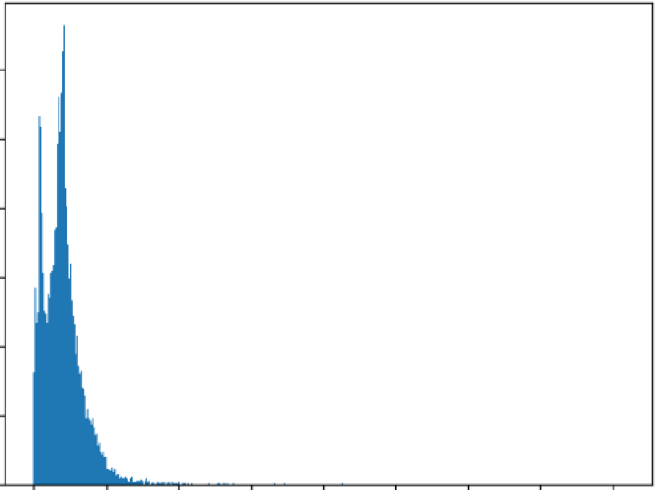**e**

|  |  |  |  |
| --- | --- | --- | --- |
| **1200** |  | | |
| **1000** |  |  |  |
| **800** |  |  |  |
| **600** |  |  |  |
| **400** |  |  |  |
| 200 |  |  |  |
| 0 | 0 | 1000 2000300040005000 | 600070008000 |

[]nos "np.array([len(x)forxinX])len(nos[nos>1000])

1580

[]maxlen•1000

X=pad_sequences(X,maxlen=rnaxlen)

[]len(X[101])1000

(]vocab_size=len(tokenizer.word_index)+l

voeab=tokenizer.1,ror-d_index

[]defget_weight_matrix(rnodel)::

weight_matrix=np.zeros{(vocab_size,DIM))

for1tJOrdiinvocab.items{):1,,1eight_matrix[i]=model.i..N{word}

returnweight_matrix

(]embedding_vectors=get_weight_111atrix(w2v_model)

[]embedding_vectors.shape

(231850,100)

[]model=Sequential()

model.add(Embedding{vocab_size,output_dim=OIM,,eights=[embedding_vectors],input_length=maxlen,trainable=Fals.e))model.add(LSTM(units,.128))

model.add(Dense(1,activation..'sigmoid'))

model.compile(optimizer='adam',loss='binary_crossentropy',metrics=['ace'])

[]model.summary()

|  |  |  |
| --- | --- | --- |
| Model:··sequential" |  | |
| Layer(type) | OutputShape | Param#" |
| embedding(Embedding) | (None,1000,100) | 23185000 |
| lstm(LSTM) | (None,128) | 117248 |
| dense(Dense) | (None,1) | 129 |

Totalparams:23302377(88.89MB)

Trainableparams:117377(458.50KB)

Non-trainableparams:23185000(88.44MB)

[]X_train,:X_test,y_tr.:iin,y_test..train_test_split(X,y)

0model.fit(X_train,y_train,validation_split,..0.2,epochs=-1)

842/841:[..........................................]42s41ms/step-loss:0.1594-ace:0.9393-val_loss:0.0484-val_acc:0.9841

<keras.src.callbacks.Historyat0x7afc6234f5e0>

[]y_pred"**(model.**predict(X_test)>"**0.**5).astype(int)351/351[ ]-8s23ms/step

[]accuracy_score(y_test,y_pred)

0.9824498886414254

[]print (f"accuracy_score:{accuracy_score(y_test,*y*_pred).round(4)*100}%")accuracy_score:98.24000000000001%

0 pr-int(classification_report(y_test,y_pred))

e

|  |  |  |  |  |
| --- | --- | --- | --- | --- |
|  | precision | recall | ft-score | support |
| 0 | 0.99 | 0.98 | 0.98 | 5966 |
|  | 0.97 | 0.99 | 0.98 | 5259 |
| accuracy |  |  | 0.98 | 11225 |
| macroavg | 0.98 | 0.98 | 0.98 | 11225 |
| weightedavg | 0.98 | 0.98 | 8.98 | 11225 |

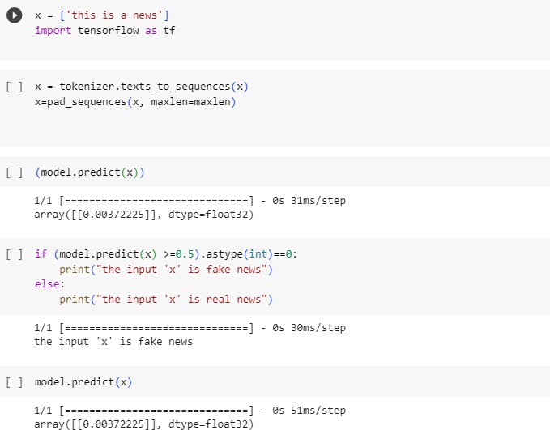

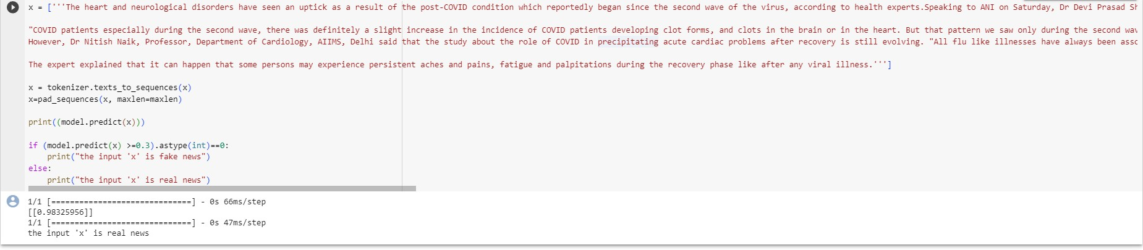

# Conclusion:

Inconclusion,utilizingNaturalLanguageProcessing(NLP)techniquesforfakenewsdetection has proven to be a significant advancement in combating misinformation. The model developed

demonstratesthepotentialofmachinelearninginidentifyingdeceptivecontent,contributingtothe ongoing efforts to maintain the integrity of information online. By leveraging NLP algorithms, the

accuracy and efficiency of fake news detection have been greatly enhanced, empowering users to makeinformeddecisionsandfosteringamorereliabledigitalinformationecosystem.Aswemove forward, continued research and development in this field will play a pivotal role in ensuring the

authenticityandtrustworthinessofonlinecontent,therebypromotingahealthierandmoreinformed society.

