ELEVATE LABS CYBER SECURITY INTERNSHIP
TASK 1: Scan Your Local Network for Open Ports
Objective: Learn to discover open ports on devices in your local network to understand network exposure.
Tools: Nmap (free), Wireshark (optional).
Finding the ip range
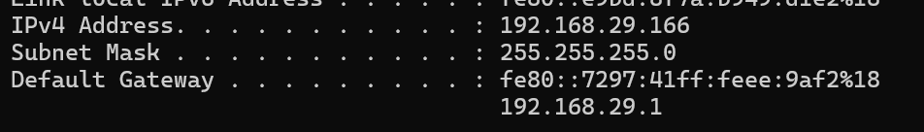
Ip address== 192.168.29.166
Thus local ip range 192.168.29.0/24

command used in nmap
nmap -sn 192.168.29.0/24
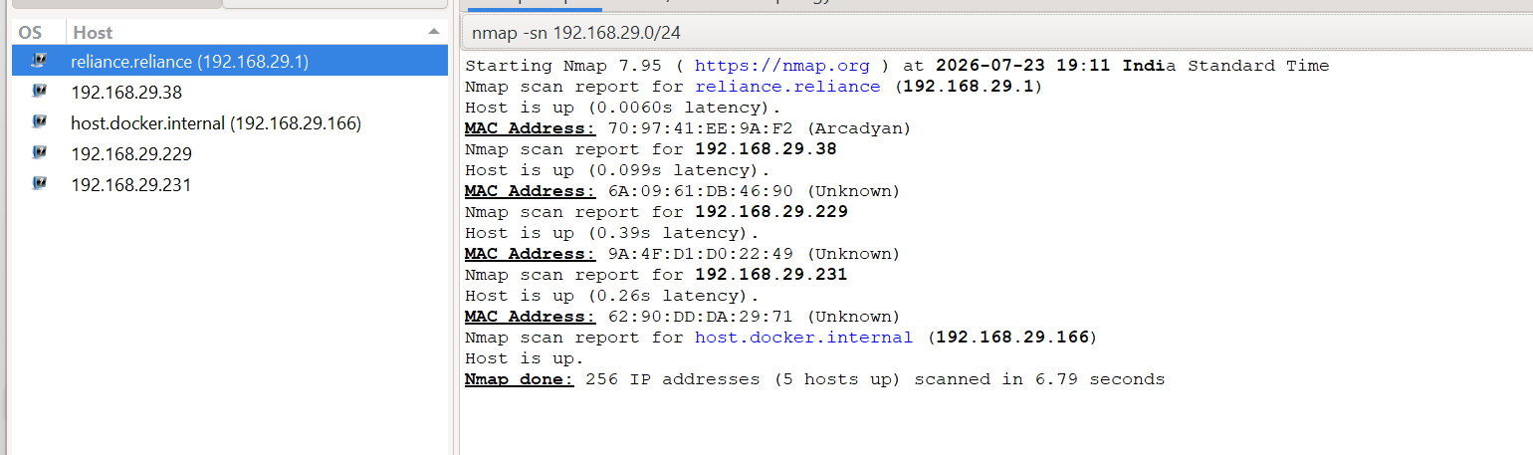
The scan identified five active hosts present on the local network.
IP Address | Observation
192.168.29.1 | Reliance Router
192.168.29.38 | Active Device
192.168.29.166 | Local Machine
192.168.29.229 | Active Device
192.168.29.231 | Active Device
The network discovery scan successfully demonstrated how Nmap can be used to identify active hosts connected to the same network segment.
Open ports discovered
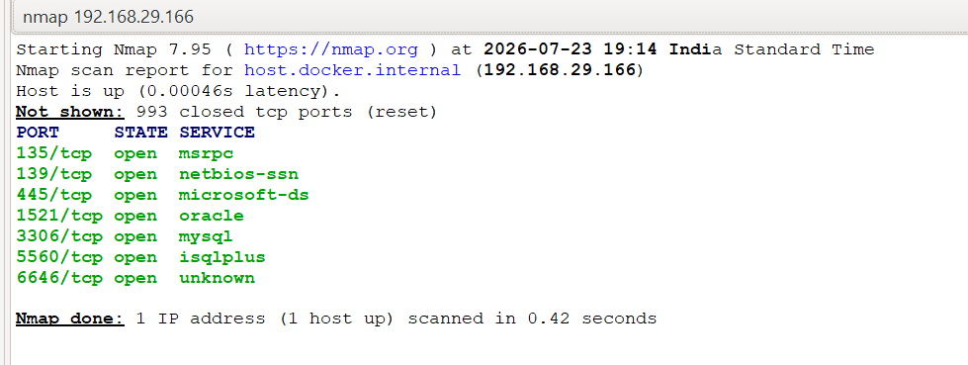
Service Analysis
Port 135 – MSRPC
Microsoft Remote Procedure Call (MSRPC) is used by Windows systems for communication between software components and network services.
Port 139 – NetBIOS Session Service
NetBIOS provides file and printer sharing services across Windows networks.
Port 445 – Microsoft-DS
This port is commonly used for SMB (Server Message Block) services that enable file and printer sharing.
Port 1521 – Oracle
Port 1521 is generally associated with Oracle database services and is used for database communication.
Port 3306 – MySQL
This is the default port used by MySQL database servers.
Port 5500 – iSQLPlus
Port 5500 is commonly associated with Oracle's web-based administrative services.
Port 6646 – Unknown Service
Nmap could not identify a standard service associated with this port. Further investigation would be required to determine its specific purpose.

Security Analysis
Open ports indicate that network services are available and accessible on the host machine. While open ports are not necessarily a security concern by themselves, unnecessary or improperly configured services may increase network exposure.
The following security considerations were identified:
- Only necessary services should remain enabled.
- File sharing services should be appropriately configured.
- Database services should not be unnecessarily exposed.
- Systems should be regularly updated and protected using appropriate security controls.
- Unknown or unused services should be reviewed and disabled if they are not required.

