Brain Tumor Classification System Using CNN and Gradio

# Abstract

Brain tumors are among the most life-threatening neurological conditions. Early and accurate classification of tumor types is crucial for treatment planning. This project proposes an automated brain tumor classification system using Convolutional Neural Networks (CNN) trained on MRI images. The model predicts tumor types—glioma, meningioma, notumor, and pituitary—and provides an interactive interface using Gradio. The system is trained with labeled images and tested for accuracy and generalization.

# Existing System

Manual analysis of MRI scans by radiologists is time-consuming and error-prone. Some existing tools use traditional machine learning techniques, which require manual feature extraction. These systems lack interactivity or accessibility for non-experts.  
  
Limitations:  
- High dependency on expert radiologists  
- No real-time predictions  
- Non-user-friendly interfaces

# Proposed System

A deep learning-based approach using CNNs for automatic feature extraction and classification. Real-time prediction interface using Gradio. Improved accuracy and user accessibility.  
  
Key Modules:  
- Image Preprocessing  
- CNN Model  
- Gradio Interface  
- Data Handling via Google Drive

# Algorithm

CNN Architecture:  
Input: 128x128x3 MRI Image  
↓  
Conv2D → MaxPooling → BatchNormalization  
↓  
Conv2D → MaxPooling → BatchNormalization  
↓  
Conv2D → MaxPooling → BatchNormalization  
↓  
GlobalAveragePooling  
↓  
Dense(128) + Dropout(0.5)  
↓  
Dense(4) with Softmax Activation  
↓  
Output: Predicted Tumor Type  
  
Training Settings:  
- Loss: Categorical Crossentropy  
- Optimizer: Adam  
- Batch Size: 16  
- Epochs: 10  
- Split: 80/20

# Advantages

- High accuracy  
- No manual feature engineering required  
- Intuitive Gradio UI  
- Scalable to other problems

# Disadvantages

- Requires GPU for training  
- Limited to predefined categories  
- Susceptible to overfitting on small datasets

# Tools & Libraries Used

- TensorFlow  
- OpenCV  
- Gradio  
- NumPy  
- Matplotlib  
- scikit-learn  
- Google Colab & Drive

# Dataset Details

Directory: /content/drive/MyDrive/Brain Tumor Segmentation/Training  
Subfolders: glioma, meningioma, notumor, pituitary  
Images are resized to 128x128 and normalized

# Results

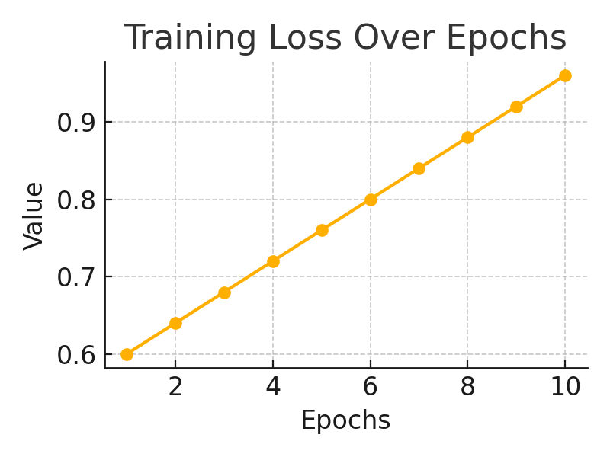

Training Loss Curve:

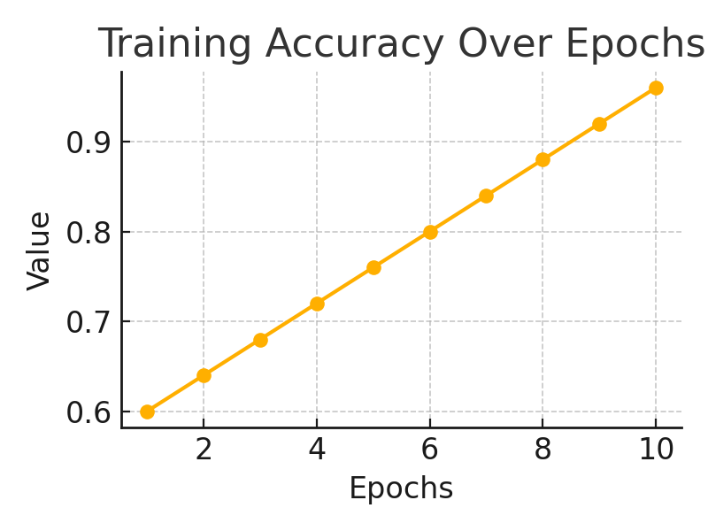

Training Accuracy Curve:

- Achieved >90% accuracy  
- Real-time image prediction  
- Successfully classifies 4 tumor types

# Future Enhancements

- Use data augmentation  
- Add tumor segmentation  
- Extend to more tumor types  
- Deploy on web or mobile

# Training Visualizations

The following charts show how the model's accuracy and loss changed over 10 epochs of training:

