Tech4all · Bentonville Schools · Mission 1: Data
Data Is Everywhere
collecting · cleaning · analyzing · turning numbers into insight
Prepared by Dr. Swarna Sethu, Assistant Professor, Computer Information Science, Technology Department, Missouri Southern State University
Today you will learn to:
- Tell numerical data from categorical data, and see why data lives in rows and columns.
- Follow the five stages every data job uses: collect, clean, analyze, visualize, decide.
- Choose the right data to collect, and write a fair survey question.
- Clean, summarize and compare data with free no-code tools.
- Pick the right chart and turn numbers into an insight someone can act on.
- Find free public datasets, and use AI tools safely.
Your program roadmap
Your team builds one product in four missions, then presents the full journey (data → plan → design → AI → app) to speakers, parents and local tech leaders.
Mission | What’s covered | What your team delivers
1. Data (today) | What data is, where it comes from, how to collect it (surveys, observation, public datasets), basic analysis, turning numbers into insight | A one-page problem brief backed by data
2. Plan | Users vs. stakeholders, business outcomes and success metrics, must-have vs. nice-to-have, saying no and handling competing opinions | A one-page product spec and a pitch to a mock stakeholder panel
3. Design | User research, user journeys, wireframing, usability testing, accessibility, why good design is invisible | A clickable prototype tested with 5 real users, plus a “what we changed and why” summary
4. AI & App | How AI works, where AI adds real value (and where it doesn’t), responsible AI and bias, building with no-code and AI tools | A live app with one AI feature and a success metric, plus a demo pitch
1. What data is
Data is a record of what people and machines actually do: a phone unlock, a song played, a school ID scan, a checkout scan at a store. It comes in two kinds.
Numerical: you can measure or count it | Categorical: labels or groups
Minutes waited in the lunch line | Grade: 9th, 10th, 11th, 12th
Songs played today | How you get to school: bus, car, walk
Points scored in a game | Favorite club
Data lives in rows and columns
response | grade | travel | wait_minutes
1 | 9th | bus | 12
2 | 11th | walk | 8
3 | 10th | car | 10
One row = one record (one person’s answers). One column = one thing asked of everyone. Every tool in this handout expects this shape.
Raw data → information
12, 8, 10 → “The lunch-line wait averages 10 minutes.”

THINK ABOUT IT
Is bus a number or a category? Is 12 minutes?
Answer: bus is categorical; 12 minutes is numerical.
2. The five stages of every data job
A network engineer, a store planner and your team all turn an opinion into evidence the same way.
1 Collect | 2 Clean & store | 3 Analyze | 4 Visualize | 5 Decide

Stage | The question it answers | Free no-code tools
1. Collect | What evidence do we need? | Google Forms, Microsoft Forms, Speedtest app
2. Clean & store | Can we trust every row? | Google Sheets
3. Analyze | What pattern is in the data? | Sheets pivot tables, AI assistants
4. Visualize | How do we show it so anyone sees it? | Sheets charts, Looker Studio, Canva
5. Decide | So what should happen? | Google Slides, Canva
3. Our case: why is the school Wi-Fi slow?
Everyone says the school Wi-Fi is terrible. That is an opinion, and nobody can fix “terrible.” Terrible where? When? How bad? A network engineer turns it into evidence.
Problem: Find out when and where the school Wi-Fi is slowest, and what to do about it.
INPUT | Survey answers, speed tests, connected-device counts
PROCESS | Clean it, summarize it, compare places and times
OUTPUT | One insight backed by numbers, and a decision

All Wi-Fi numbers in this handout are sample data, made up for teaching. The GitHub project in section 12 is real; the JSON file shown there is our own example in the same format.
4. Stage 1 · Collect
THINK ABOUT IT
What data would you collect to find out why the Wi-Fi is slow?
Hint: what do people experience? What can you measure yourself? What does the network itself know?
Source 1: ask the people who use it (survey)
Google Forms · School Wi-Fi survey
At what time of day is the Wi-Fi slowest?
○ Morning
○ Mid-morning
○ Lunch
○ Afternoon
Fixed answers, not a text box, so the answers can be counted. Responses land in a Google Sheet automatically.
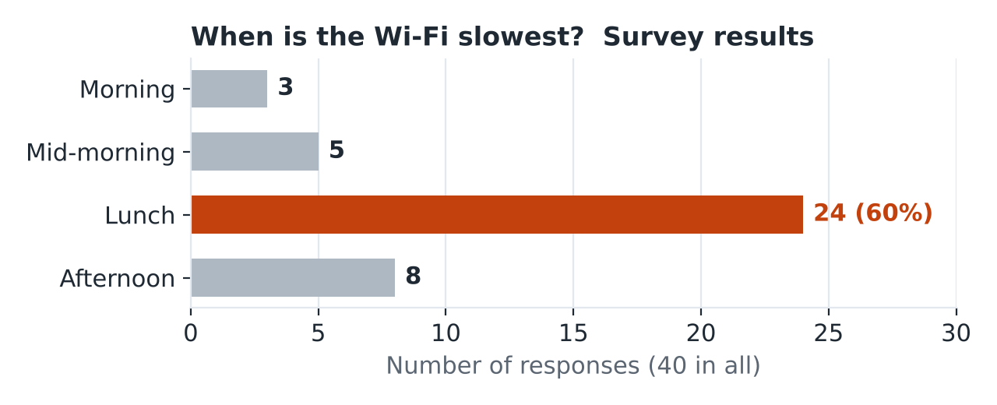
Output: 24 of 40 people (60%) said lunch. That’s what people say; next, check what actually happens.
Source 2: measure it yourself (observation)
Run the Speedtest app 5 times at each place and time. Each result is one row in the Sheet.
test_id | location | time | device | speed_mbps
1 | Library | 08:00 | phone | 91
2 | Library | 08:00 | laptop | 88
3 | Library | 08:00 | tablet | 92
4 | Library | 08:00 | phone | 96
5 | Library | 08:00 | laptop | 93
Source 3: what the network already knows (system data)
The router counts the devices on each access point: a possible cause. 60 rows in all; here are 5.
test_id | location | time | device | speed_mbps | devices_connected
51 | Cafeteria | 12:00 | phone | 18 | 310
52 | Cafeteria | 12:00 | laptop | 25 | 310
53 | Cafeteria | 12:00 | tablet | 20 | 310
54 | Cafeteria | 12:00 | phone | 27 | 310
55 | Cafeteria | 12:00 | laptop | 20 | 310

THINK ABOUT IT
Is there any data we should NOT collect?

REMEMBER
Leave out anything that doesn’t answer the question, and anything private: names, phone brands, favorite apps, student IDs. More data is not always better data.
The strongest evidence is when two sources point the same way.
Writing a good survey question
 | Question | Why
Bad | “Don’t you hate how slow the Wi-Fi is?” | Hints at the answer; nothing to count
Good | “At what time of day is the Wi-Fi slowest? Morning / Mid-morning / Lunch / Afternoon” | Neutral, with fixed answers
5. Stage 2 · Clean & store
THINK ABOUT IT
You have 60 rows. Can you trust every one? What could go wrong?
Spot the problems
test_id | location | time | speed_mbps | problem
51 | Cafeteria | 12:00 | 18 | OK
56 | cafeteria | 12:00 | 21 | lowercase label
57 | Cafetria | 12:00 | 24 | typo
58 | Cafeteria | 12:00 |  | missing value
59 | Cafeteria | 12:00 | 2000 | impossible value
59 | Cafeteria | 12:00 | 2000 | duplicate row
“Cafetria” would count as a fourth location. One 2000 Mbps reading would make the cafeteria look fast.
After cleaning
test_id | location | time | speed_mbps | what we did
51 | Cafeteria | 12:00 | 18 | OK
56 | Cafeteria | 12:00 | 21 | fixed label
57 | Cafeteria | 12:00 | 24 | fixed typo
58 | Cafeteria | 12:00 |  | removed: retest
59 | Cafeteria | 12:00 | 2000 | removed: impossible
59 | Cafeteria | 12:00 | 2000 | removed: duplicate

Problem | Fix in Google Sheets
Inconsistent labels, typos | Edit → Find and replace
Duplicates | Data → Data cleanup → Remove duplicates
Missing or impossible values | Check it; retest or delete the row
Prevent it next time | Use dropdown answers in your Google Form

REMEMBER
Garbage in, garbage out. One bad row can change the whole result. Professionals often say most of their time goes into cleaning.
6. Stage 3 · Analyze
THINK ABOUT IT
Sixty rows are too many to read. How do you turn them into a few numbers?
A pivot table: no formulas (Google Sheets → Insert → Pivot table)
Rows | Columns | Values
location | time | AVERAGE of speed_mbps
It groups every test by place and time, and gives one average per group: 60 rows become 12 numbers.
Output: pivot table result (average Mbps)
AVERAGE of speed_mbps | 8 AM | 10 AM | Noon | 2 PM
Library | 92 | 84 | 80 | 86
Classrooms | 88 | 70 | 78 | 68
Cafeteria | 95 | 90 | 22 | 88
The cafeteria at noon, 22 Mbps, is the only number below 68.
Another way: ask an AI assistant
Question to an AI assistant (Sheet uploaded): Which location and time has the slowest average speed?
AI assistant (example reply): The cafeteria at 12:00, averaging 22 Mbps. At the same time, connected devices on that access point jump to 310.
✓ Checked against the pivot table: 22.

THINK ABOUT IT
Is 22 Mbps bad? Compared to what?
Compare: put the key numbers side by side
Cafeteria speed | Devices on that access point | Survey
95 → 22 Mbps | 25 → 310 | 60%
8 AM vs. noon: about 77% slower | more than 12 times as many | said lunch is the slowest time
A number means nothing alone: 22 Mbps is only bad next to 95. And the survey agrees with the measurements.
7. Stage 4 · Visualize
THINK ABOUT IT
Which chart would show how speed changes during the day: bar, line or pie?
Your question | Chart
How does it change over time? | Line chart
How do groups compare? | Bar chart
What share of the whole is each part? | Pie chart, only with a few parts
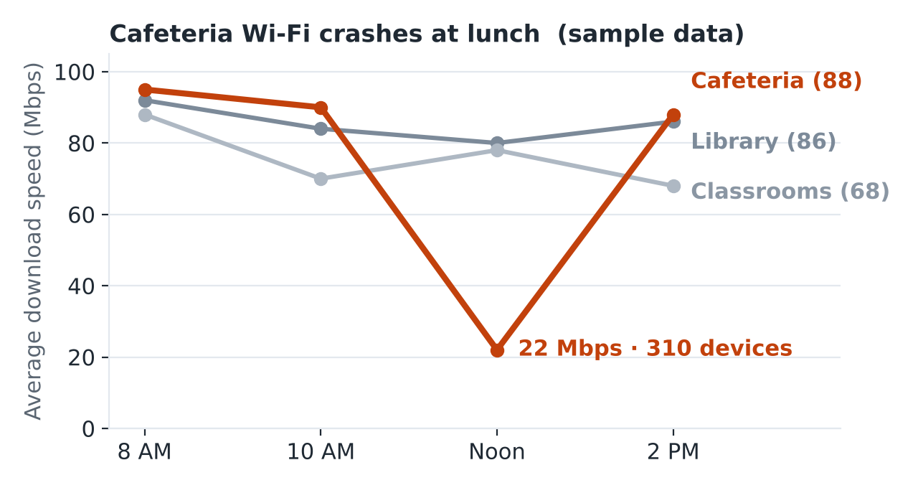
Output: a line chart, built in Google Sheets, Looker Studio or Canva. Anyone can see the problem in two seconds.
8. Stage 5 · Decide
THINK ABOUT IT
What would you tell the principal, in one sentence? And what should happen next?
The insight formula
Number | + | Who or where | + | What happens | → | SO: why it matters

OUTPUT: THE FINISHED INSIGHT
“At lunch, cafeteria Wi-Fi drops about 77%, from 95 to 22 Mbps, as connected devices jump from 25 to 310. So the cafeteria needs another access point, not a new network for the whole school.”
Decision: add one access point in the cafeteria, then measure again.
Success metric: cafeteria lunch speed above 60 Mbps. You will set your own in Mission 2.

Opinion | Evidence
“The Wi-Fi is terrible.” | “Cafeteria Wi-Fi drops 77% at lunch.”
Input = Collect · Process = Clean, Analyze, Visualize · Output = Decide
9. Is 60 tests enough?
Small data gives you a clue. More data gives you confidence.
Amount of data | You can say | You can’t say yet
1 test | One reading was slow: 18 Mbps. | Anything about the cafeteria. It could be one bad moment.
5 tests | Noon was slow that day: about 22 Mbps. | Whether it happens every day.
60 tests (our sample) | The cafeteria at noon is the outlier, and it lines up with device count. | That devices caused it, or that the day was normal.
Weeks of logs | Lunch slows down on most school days. | The cause, until you change one thing and measure again.
Public data | How your town’s internet compares with the region. | What happens inside one building.
10. Where to find free data
Source | What’s there | Web address
Kaggle Datasets | Thousands of datasets on almost any topic | kaggle.com/datasets
Data.gov | U.S. government data: education, transportation, health | data.gov
U.S. Census Bureau | Population, income and internet access for any town or county | data.census.gov
FCC National Broadband Map | Internet providers and speeds at any address | broadbandmap.fcc.gov
Ookla Open Data | Average speeds from Speedtest users worldwide, updated quarterly | registry.opendata.aws/speedtest-global-performance
Google Dataset Search | A search engine just for datasets | datasetsearch.research.google.com
Our World in Data | Charts and data on global topics | ourworldindata.org
UCI Data Repository | Hundreds of classic teaching datasets | archive.ics.uci.edu

THINK ABOUT IT
Before you trust a dataset: Who collected it, and why? When? How much is there? Can you use it? Check the license.
11. AI tools for data (no code needed)
You can ask AI to… | Example
Answer questions about your data | “Which location has the slowest average speed?”
Summarize open-ended answers | “What are the top three complaints in these 100 comments?”
Find messy data | “Find typos, duplicates and impossible values in this sheet.”
Suggest a chart | “What chart best shows speed by time of day?”

REMEMBER
1. Check one number yourself. AI can be confidently wrong.
2. Keep private data out. No names, emails or student IDs.
3. Say when you used AI in your work.
AI tools learned from huge amounts of data, so bad data in means bad answers out. In Mission 4 you add one AI feature to your app.
12. A real project on GitHub
github.com/BigBangData/Speedtest: one person measuring Wi-Fi speed in the rooms of their house, after moving in with an older, separate router. Same question, same five stages.
Stage | What they did | The no-code version
Collect | A small script ran Ookla’s Speedtest several times per room, waiting a random time between tests. Each test recorded download, upload, latency (delay) and jitter (how much the delay jumps around). | The Speedtest app + a Google Form with a room dropdown
Clean & store | Each run saved as one JSON file. Room names made lowercase and trimmed before saving. | One row per test in a Google Sheet; dropdowns keep names consistent
Analyze | Compared runs and rooms. Caught that different laptops and router spots were mixed together. | Change one thing at a time
Visualize | Line chart of one run; heatmap of all runs; box plots by room. | Sheets or Looker Studio charts
Decide | Speeds varied far more than expected; the obvious explanations weren’t proven; the sample was too small. | Say honestly what your data can’t prove
Where the JSON file comes from
Speedtest can report its results as plain text or as JSON, a labeled format that computers read easily. Their script asked Speedtest for JSON, kept the numbers they needed, and added labels like the room and the date. Below is a made-up example in the same format; their repository has the real runs.
Example saved run, in the same format as theirs (made up for teaching)
{
"test": 1,
"day": "2026-10-20",
"location": "living_room",
"computer": "school_laptop",
"access_point": "None",
"data": {
"time": ["14:05:12", "14:07:48", "14:11:30", "14:13:02", "14:16:41"],
"jitter": [0.9, 2.3, 1.1, 2.8, 0.7],
"latency": [13.2, 15.8, 12.6, 16.4, 12.9],
"download": [142.6, 98.3, 131.9, 87.4, 155.2],
"upload": [9.8, 7.1, 10.4, 6.9, 11.2]
}
}

Part | How to read it
Top part | Labels for the whole run: run number, date, room, laptop, access point
data | Five lists, one value per test, in order. Test 1 ran at 14:05:12 and downloaded at about 143 Mbps.
download list | 143, 98, 132, 87, 155 Mbps: same room, minutes apart. Their real runs jumped around like this too, which is why they found speeds “varied far more than expected.”

THINK ABOUT IT
Their data design grew one field at a time: “which laptop?” became a field only after one laptop looked slow. What would you add if your data surprised you?
13. Common data mistakes
Mistake | Example | Result
Leading question | “Don’t you hate the Wi-Fi?” | Answers you can’t trust
Open text when you need counts | A text box for “when is it slow?” | 40 different sentences, nothing to count
Inconsistent labels | “Cafeteria”, “cafeteria”, “Cafetria” | One place counted as three
Not cleaning | Keeping a 2000 Mbps reading | A fake finding
No comparison | “Speed is 22 Mbps.” | Nobody knows if that’s bad
Too little data | One test, one day | A clue, not proof
Trusting AI without checking | Copying its number | Confidently wrong answers
Collecting private data | Names, student IDs | Privacy risk, no benefit
Summary
REMEMBER
Data is a record of what people and machines do: numerical or categorical, stored in rows and columns.
Five stages: collect → clean & store → analyze → visualize → decide.
Collect only what answers the question, from more than one source. Fixed answers make surveys countable.
Clean before you trust. Summarize with a pivot table. Compare before you judge.
Line charts for change over time; bar charts to compare groups.
Insight = number + who or where + what happens → so. Then measure again.
Action item: Mission 1
YOUR TURN
Your mission: as a team, pick a real school or community problem (lunch lines, club discovery, volunteering, study groups, local events) and gather evidence that it’s real.
What’s expected: run a survey or collect data on your problem, analyze it, and surface 3 key insights with simple charts.
Deliverable: a one-page problem brief backed by data.
Checklist for your problem brief
☐ The problem in one sentence, written as a question you can measure
☐ Where your data came from (survey, observation or public data) and how many responses or measurements
☐ One line on how you cleaned it
☐ 3 insights, each written with the insight formula and shown with one simple chart
☐ One thing your data can’t prove yet
☐ Any AI tool you used, and how you checked its answers
Your club mentors will share the due date and how to turn it in.

