Step 1:

POST: <http://localhost:7445/security/auth/token>

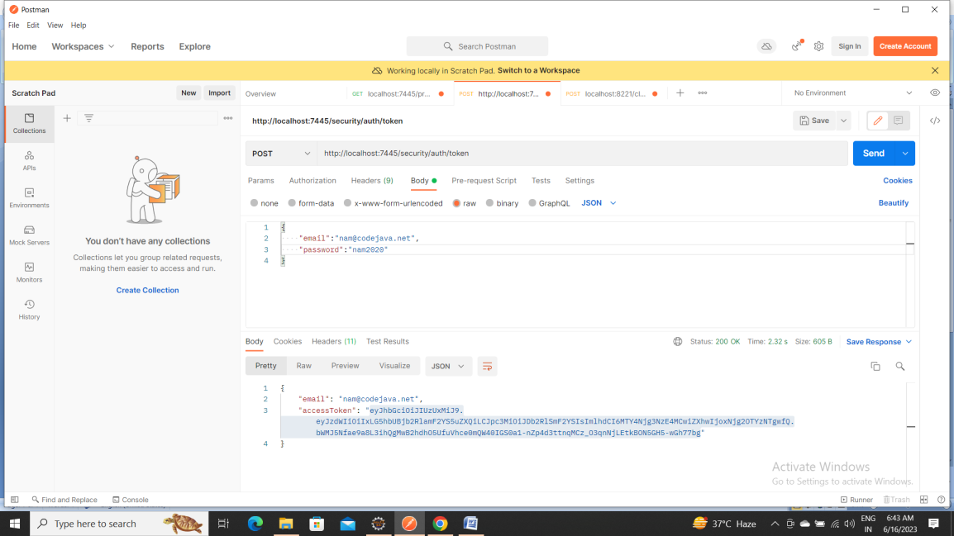

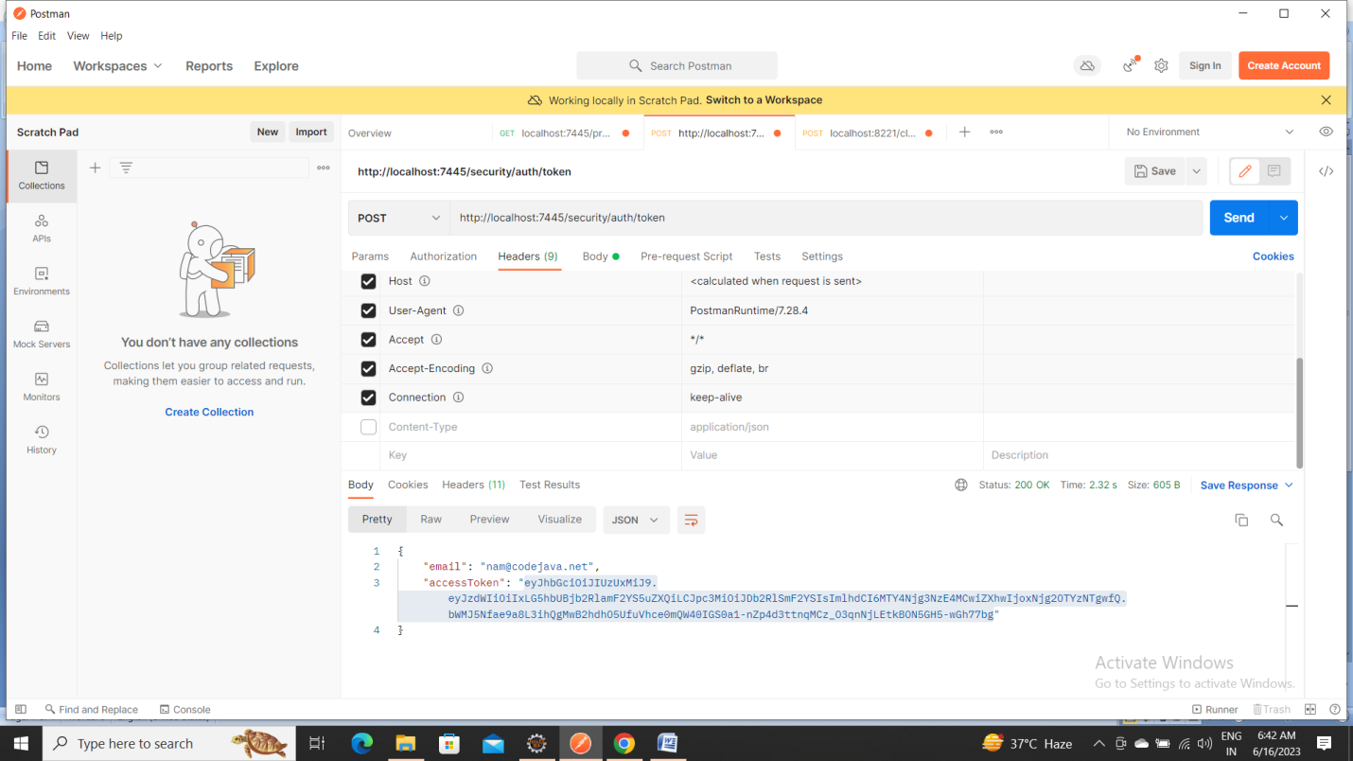

Step 2:

GET: ocalhost:7445/products/getProducts

