AI-Powered Full Stack Development
AI POWERED DEBT RELIEF &
FINANCIAL RECOVERY PLATFORM
An AI-Powered Web Application for Debt Management and Financial Recovery
BACHELOR OF TECHNOLOGY
In
ELECTRONICS AND COMMUNICATION ENGINEERING
Submitted by
SWARNA RAJU GOVINDALAPUDI (TEAM LEAD)
RAJIV GANDHI UNIVERSITY OF KNOWLEDGE TECHNOLOGIES (RGUKT)
SRIKAKULAM
Semester: 4-1

ACKNOWLEDGEMENT
I would like to express my sincere gratitude to the faculty of Rajiv Gandhi University of Knowledge Technologies (RGUKT), Srikakulam, for their continuous guidance and encouragement throughout the development of this project.
Working on the AI Powered Debt Relief & Financial Recovery Platform gave me the opportunity to gain practical, hands-on experience in building a full-stack AI-integrated web application — covering frontend development with React.js, backend API development with FastAPI, database design using SQLite and SQLAlchemy ORM, and the integration of the Google Gemini API for AI-driven financial insights.
I am thankful for the learning environment that allowed me to independently plan, build, test, and deploy this project from the ground up, strengthening my skills in full-stack development, AI integration, and real-world problem solving.

ABSTRACT
FinRelief AI — the AI Powered Debt Relief & Financial Recovery Platform — is an intelligent web application developed to simplify and automate the debt management and financial recovery process for borrowers. The platform allows users to manage loan details, analyze their financial health, generate AI-powered negotiation strategies, and receive adaptive settlement recommendations through a secure, modern digital workspace.
The application is built using React.js on the frontend and FastAPI (Python) on the backend, with SQLite and SQLAlchemy ORM providing structured, reliable data storage. The Google Gemini API powers the platform's intelligent features, including automated negotiation letter generation and AI-assisted settlement prediction, giving borrowers actionable guidance during financial hardship.
Core capabilities include a financial health analysis engine that calculates debt-to-income and EMI-to-income ratios, a settlement predictor that estimates a recommended settlement percentage and confidence score, an AI negotiation module that drafts lender-specific settlement letters, and a borrower rights reference section. A dashboard and activity history give users a consolidated view of their debt position and past AI-assisted actions.
FinRelief AI demonstrates practical full-stack development combined with applied generative AI — REST API integration, responsive UI design, financial data processing, and cloud deployment — aiming to make debt recovery guidance more accessible, consistent, and less overwhelming for borrowers under financial stress.

1. Introduction
Managing debt and negotiating with lenders can be an overwhelming experience — borrowers often don't know where they stand financially, what a fair settlement looks like, or how to even start a conversation with a bank about hardship. FinRelief AI was built to close that gap.
The platform gives borrowers a single, secure workspace to enter their financial details and immediately see where they stand — their debt stress level, EMI burden, and monthly surplus — and then goes a step further by using AI to suggest realistic settlement figures and draft the actual negotiation letter a borrower would send to their lender. Instead of generic advice, FinRelief AI turns a borrower's real numbers into a concrete, ready-to-use action plan.

2. Project Overview
Purpose:
FinRelief AI is developed to provide borrowers with a modern, AI-assisted platform for understanding their debt position and taking concrete steps toward resolving it. Built on React.js, FastAPI, and the Google Gemini API, the platform combines financial calculation logic with generative AI to turn raw financial inputs into personalized settlement recommendations and negotiation material — reducing the guesswork and stress typically involved in debt recovery.
Key Features:
- Borrower Dashboard: A portfolio snapshot showing total debt, monthly income/expenses, active loans, settlement predictions, and negotiation history at a glance.
- AI-Powered Financial Health Analysis: Borrowers enter monthly income, expenses, total debt, and EMI to receive live-calculated metrics — Debt-to-Income Ratio, EMI-to-Income Ratio, Monthly Surplus, and a Financial Stress rating.
- Settlement Predictor: An AI-assisted engine that recommends a settlement percentage, an estimated settlement amount, and a confidence score based on the borrower's financial profile.
- Intelligent Negotiation Letter Generation: Uses the Google Gemini API to draft a lender-specific settlement negotiation letter automatically, based on the borrower's name, lender, loan amount, and hardship reason.
- Know Your Rights: A borrower-protection reference section covering fair treatment, loan statement access, transparent loan terms, and the right to negotiate a settlement, with practical guidance for the negotiation process.
- Activity History: A timeline of the borrower's past AI-generated negotiation letters and settlement predictions.
- Secure Authentication: Gmail-based sign-in protecting the borrower workspace, with a demo-authentication fallback when the backend login endpoint is unavailable.
- Live API-Driven Architecture: The React frontend communicates directly with FastAPI backend endpoints for real-time financial analysis, rather than relying on static or mocked data.
Future Enhancements:
- Integration with real payment/settlement gateways to allow borrowers to act on a negotiated settlement directly within the platform.
- Predictive, AI-based debt forecasting to project a borrower's financial trajectory over time.
- Multi-lender comparison tools to help borrowers prioritize which debts to negotiate first.

3. Architecture
FinRelief AI follows a modular full-stack architecture separating the presentation layer, business/AI logic, and data storage, documented in full in the project repository (FinRelief.drawio.png / docs/).
- Frontend: The UI is built with React.js, providing the borrower workspace — Dashboard, Financial Health, Settlement Predictor, AI Negotiation, Know Your Rights, History, and About screens — with a consistent dark, dashboard-style layout across all views.
- Backend: Built on FastAPI (Python), exposing REST endpoints for financial analysis, settlement prediction, and AI negotiation letter generation. Backend logic includes financial calculation modules and fallback handling for when AI services are unavailable.
- Database: SQLite is used as the data store, accessed through the SQLAlchemy ORM, structuring borrower, loan, settlement, and negotiation-history data.
- AI Layer: The Google Gemini API powers the negotiation letter generation and contributes to the settlement recommendation logic, turning structured financial inputs into natural-language, borrower-ready output.

4. Setup Instructions
Prerequisites:
Before running FinRelief AI locally, make sure the following are installed:
- Node.js (LTS version) and npm
- Python 3.8 or above
- Git
- A Google Gemini API key
- Visual Studio Code (or any preferred IDE)
Frontend Dependencies:
- React.js
- Axios (or equivalent HTTP client for API calls)
Backend Dependencies (see requirements.txt):
- FastAPI
- SQLAlchemy
- Uvicorn (ASGI server)
- Google Gemini API client library
- python-dotenv
Installation Steps:
1. Clone the repository:
git clone https://github.com/swarnarajugovindalapudi/AI-Powered-Debt-Relief-Financial-Recovery-Platform.git

2. Move into the project folder:
cd AI-Powered-Debt-Relief-Financial-Recovery-Platform

3. Install frontend dependencies:
cd frontend && npm install

4. Install backend dependencies:
cd ../backend && pip install -r requirements.txt

5. Create a .env file in the backend folder with your own values, e.g.:
DATABASE_URL=sqlite:///./finrelief.db
GEMINI_API_KEY=your_google_gemini_api_key
PORT=8000
Note: exact environment variable names should match those used in your backend/config code — update the above to fit your actual .env setup.

5. Folder Structure
Repository root:
AI-Powered-Debt-Relief-Financial-Recovery-Platform/
├── backend/
├── docs/
├── frontend/
├── tests/
├── .gitignore
├── FinRelief.drawio.png
├── LICENSE
├── README.md
├── check_db.py
├── package.json
├── package-lock.json
├── render.yaml
├── requirements.txt
└── test-hash.py

Description:
- backend/ — FastAPI application: API endpoints, financial calculation engine, settlement prediction logic, and Gemini AI integration.
- frontend/ — React.js application: Dashboard, Financial Health, Settlement Predictor, AI Negotiation, Know Your Rights, History, and About pages.
- docs/ — Project documentation and architecture references.
- tests/ — Test scripts for validating backend and application logic.
- FinRelief.drawio.png — Technical architecture diagram for the platform.
- check_db.py — Utility script for inspecting the SQLite database.
- render.yaml — Deployment configuration (Render).
- requirements.txt — Python backend dependencies.

6. Running the Application
Backend: Start the Backend Server
Step 1: Navigate to the backend directory:
cd backend
Step 2: Install dependencies (if not already installed):
pip install -r requirements.txt
Step 3: Start the FastAPI server:
uvicorn main:app --reload
Step 4: The backend API will run on:
http://localhost:8000

Frontend: Start the Frontend Server
Step 1: Navigate to the frontend directory:
cd frontend
Step 2: Install dependencies:
npm install
Step 3: Start the development server:
npm run dev
Step 4: The frontend application will run on:
http://localhost:5173 (or http://localhost:3000)
Live deployed version: https://ai-powered-debt-relief-financial-re-nine.vercel.app/dashboard

7. API Documentation
The FastAPI backend exposes REST endpoints that power each of the platform's AI-assisted features. The core endpoint groups are:
- Financial Analysis — accepts monthly income, expenses, total debt, and EMI, and returns calculated Debt-to-Income Ratio, EMI-to-Income Ratio, Monthly Surplus, and Financial Stress level.
- Settlement Prediction — accepts the same financial inputs and returns a recommended settlement percentage, estimated settlement amount, and a confidence score.
- AI Negotiation Letter Generation — accepts borrower name, lender name, loan amount, and hardship reason, and returns a Gemini-generated negotiation letter.
- Borrower Rights — returns the list of borrower protections shown in the Know Your Rights section, with a local fallback list if the backend is unavailable.
- Activity History — returns the borrower's past negotiation letters and settlement predictions for the History timeline.
Note: exact endpoint paths, request/response schemas, and authentication headers should be filled in from your actual FastAPI route definitions for a complete reference.

8. Testing
Testing was carried out to verify that the core modules of FinRelief AI function correctly and reliably. This included system testing of the Dashboard, Financial Health analysis, Settlement Predictor, and AI Negotiation letter generation to confirm each feature produced accurate, expected output from live financial inputs.
Backend error handling and AI fallback behavior were specifically tested — for example, confirming that the Know Your Rights section correctly falls back to a local rights list when the backend API is unavailable, and that the sign-in flow falls back to demo authentication under the same condition. Performance and secure session handling were also reviewed as part of the platform's testing and optimization pass, alongside integration testing to confirm smooth communication between the React frontend and FastAPI backend.

9. Project Flow
Project demo: https://ai-powered-debt-relief-financial-re-nine.vercel.app/dashboard
Source code: https://github.com/swarnarajugovindalapudi/AI-Powered-Debt-Relief-Financial-Recovery-Platform
Milestone 1: FinRelief AI Application Development & System Setup
Established the foundational architecture and development environment of the FinRelief AI platform — configuring the Python backend, React.js frontend, project dependencies, and application structure to support the AI-powered financial analysis, database management, and debt recovery functionalities built in later milestones.
- Python backend environment setup
- Backend dependency installation using requirements.txt
- Frontend setup with React.js
- Project structure and full-stack directory organization
Milestone 2: AI Integration & Financial Processing Setup
Integrated AI and financial analysis capabilities into the platform, including financial calculation modules, settlement prediction mechanisms, AI-powered negotiation strategy generation, backend API development, and intelligent decision-making using the Google Gemini API.
- FastAPI backend and API endpoints
- Financial engine module
- Settlement prediction system
- AI negotiation strategy engine (Google Gemini API)
- Fallback logic implementation
Milestone 3: Database Management & Financial Data Storage Setup
Configured and managed the database infrastructure required for secure storage and processing of borrower information, loan records, settlement data, and AI-generated negotiation history — ensuring efficient data handling, structured relationships, and reliable communication between system components.
- API development functionality
- Loan and settlement processing functionality
- Data handling
Milestone 4: Frontend Integration & User Interface Development
Developed and integrated the user-facing components of the platform using React.js, delivering responsive dashboards, financial data visualizations, settlement insights, and seamless interaction with backend services through secure API communication.
- User interface development
- Frontend-to-FastAPI communication
- Financial health metrics and settlement data visualization
- UI enhancements
Milestone 5: Testing, Debugging & Performance Optimization
Validated, tested, and optimized the overall functionality of the platform, including system testing, error handling, AI fallback management, performance improvements, and secure session handling to ensure reliable and stable application performance.
- System testing
- Backend error handling and AI fallback management
- Performance optimization and secure session management
Milestone 6: Version Control, Project Finalization & Deployment Readiness
Prepared the FinRelief AI platform for deployment and production use — project cleanup, modular architecture organization, GitHub version control management, and deployment configuration to ensure secure, scalable, and maintainable application delivery.
- GitHub repository setup and version control management
- Project cleanup and modular folder structure organization
- Deployment configuration and production readiness setup (Render, Vercel)

10. Project Implementation — Screens
The following screens illustrate the platform's core, borrower-facing workflow, from sign-in through financial analysis, AI-assisted settlement and negotiation, and activity history.
Sign In
Gmail-based sign-in protecting the borrower workspace, with demo-authentication fallback when the backend login endpoint is unavailable.
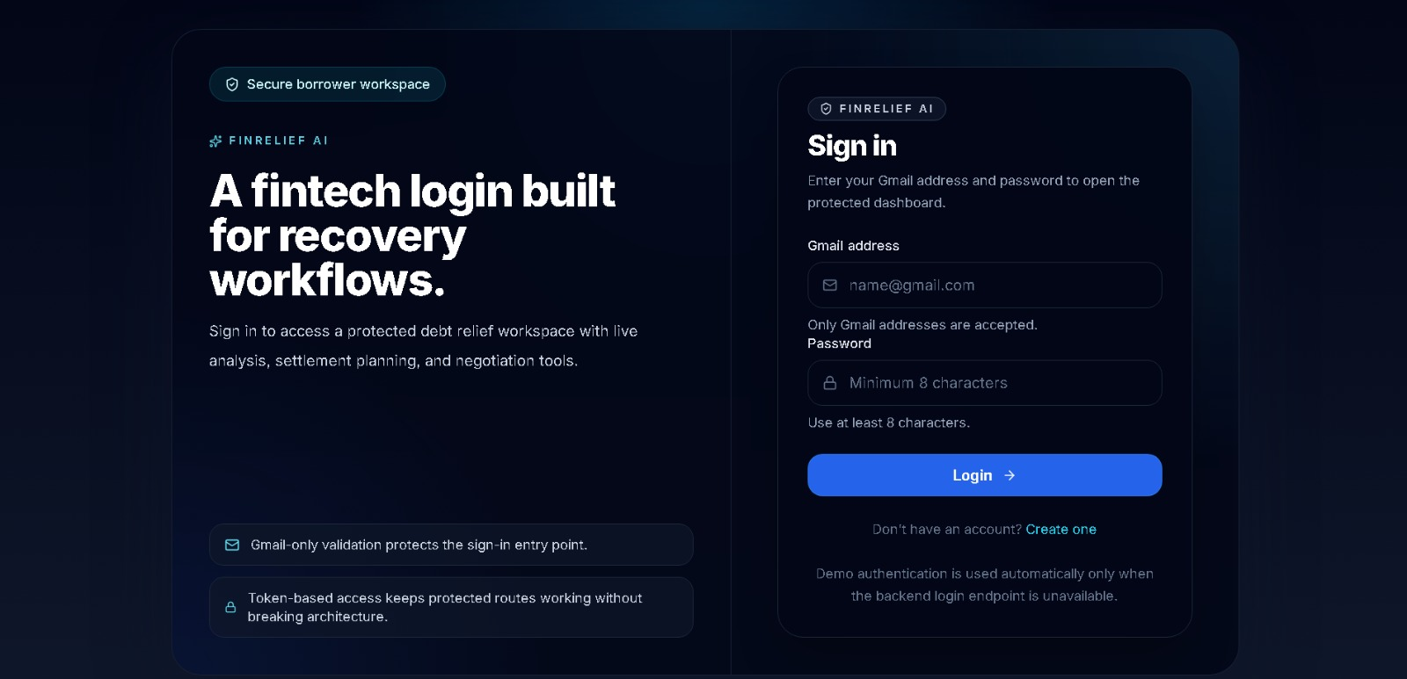
Dashboard — Portfolio Snapshot
The borrower's landing view: total debt, monthly income/expenses, active loans, settlement predictions, negotiation history, financial health score, and cash flow overview at a glance.
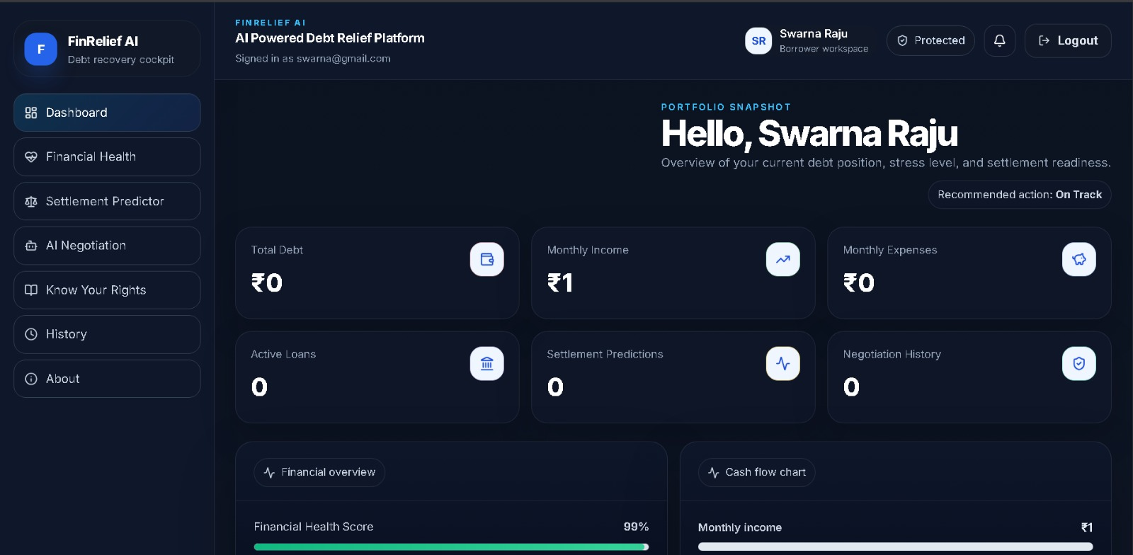
Financial Health Analysis
Borrowers enter income, expenses, debt, and EMI to receive a live, API-driven breakdown of Debt-to-Income Ratio, EMI-to-Income Ratio, Monthly Surplus, and Financial Stress level.
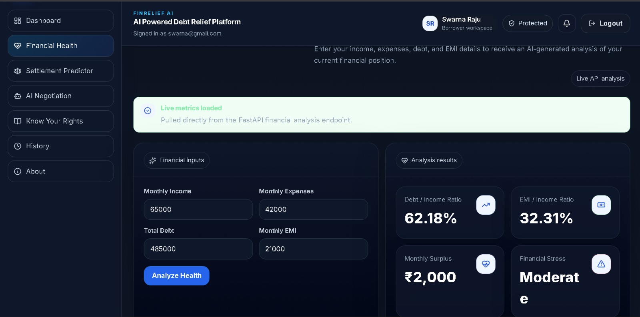
Settlement Predictor
Given the same financial inputs, the AI-assisted predictor returns a recommended settlement percentage, estimated settlement amount, and a confidence score.
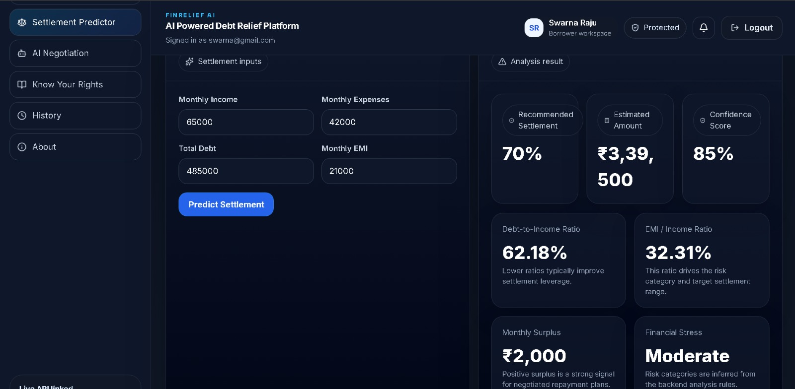
AI Negotiation — Letter Generation
Using borrower name, lender name, loan amount, and hardship reason, the Google Gemini API drafts a ready-to-send negotiation letter.
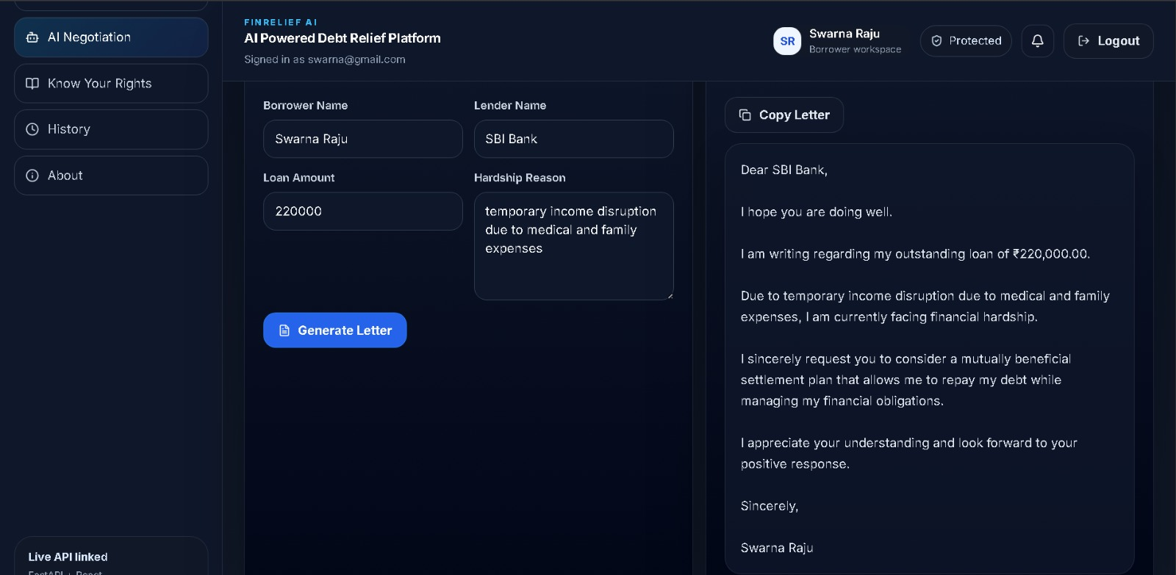
Know Your Rights
A borrower-protection reference covering fair treatment, loan statement access, transparent loan terms, and the right to negotiate — alongside practical negotiation guidance.
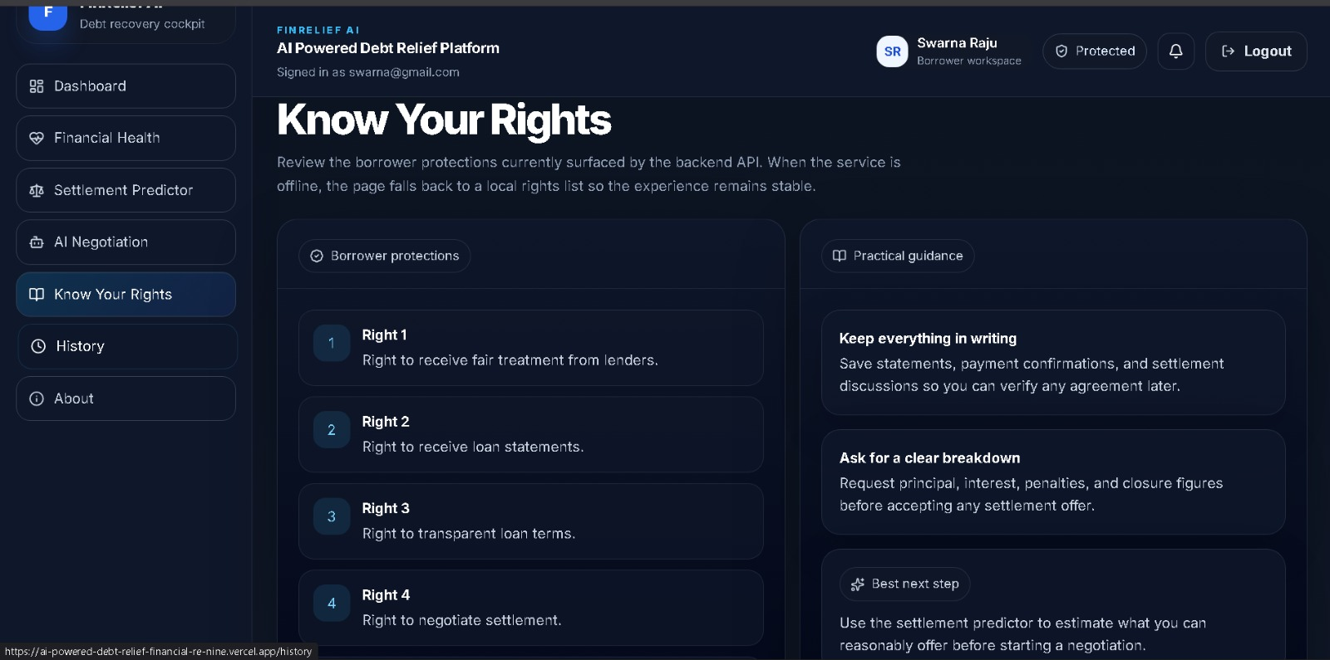
History — Activity Timeline
A chronological record of the borrower's past AI-generated negotiation letters and settlement predictions.
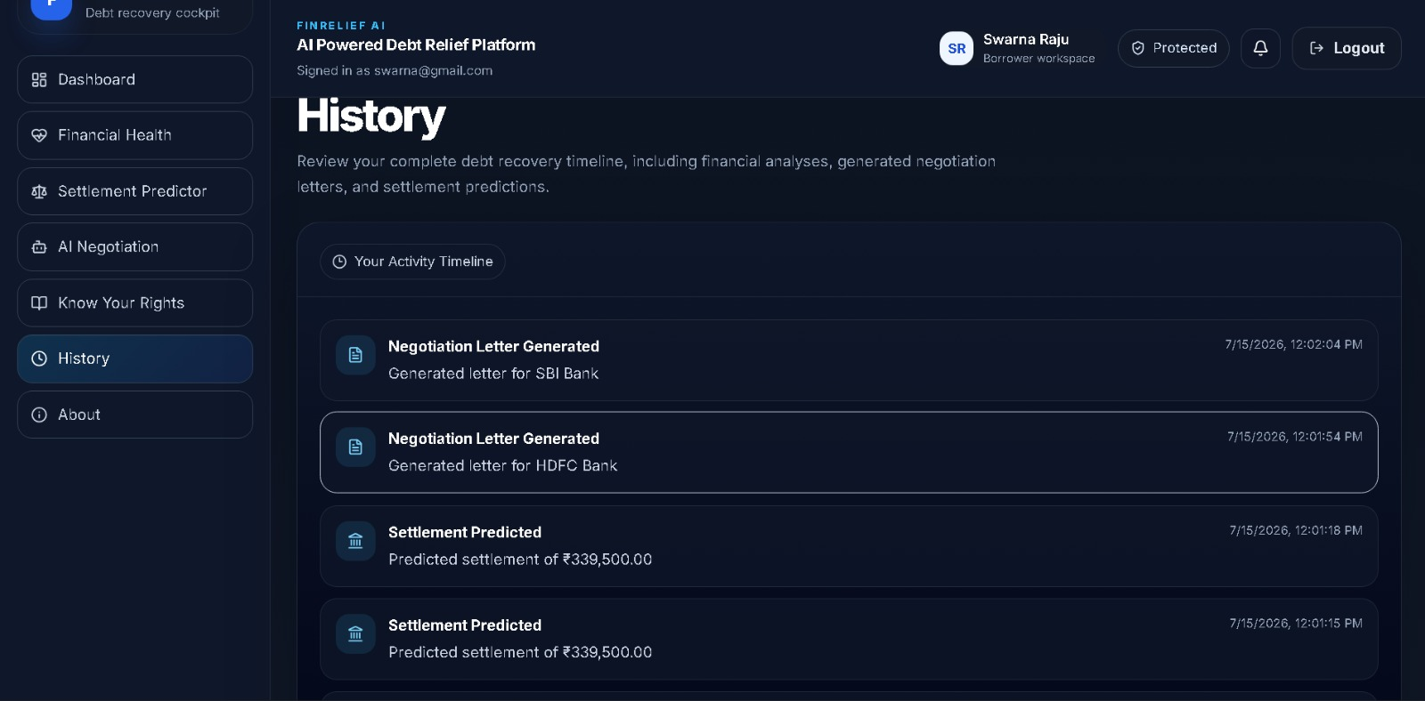
About FinRelief AI
A summary of the platform's purpose, how the frontend and FastAPI backend work together, and its trust/security posture.
